Anatomy and Physiology, 5e (Marieb/Mitchell/Smith)
Chapter 2 Chemistry Comes Alive

2.1 Matching Questions

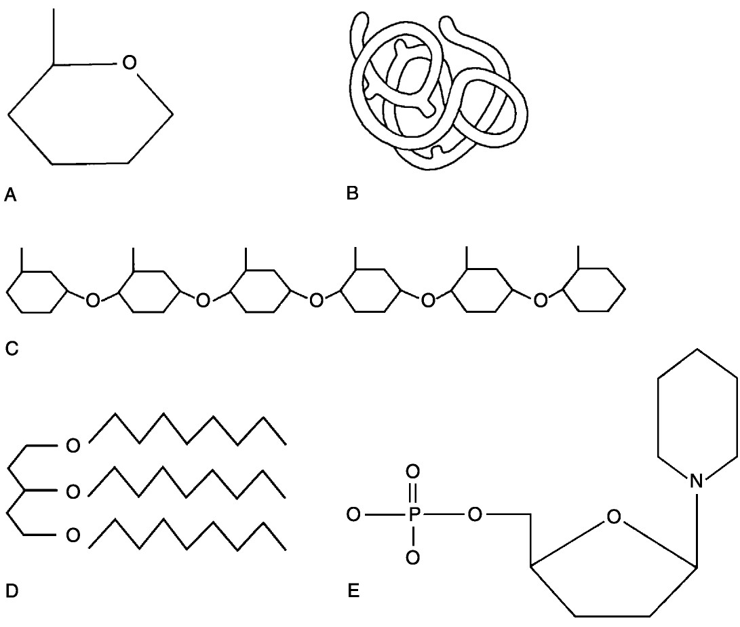

Figure 2.1

Using Figure 2.1, match the following:

1) Lipid
Answer: D
Diff: 2 Page Ref: 41; Fig. 2.16a

2) Functional protein
Answer: B
Diff: 2 Page Ref: 45; Fig. 2.19c

3) Nucleotide
Answer: E
Diff: 2 Page Ref: 49; Fig. 2.22a

4) Polysaccharide.
Answer: C
Diff: 2 Page Ref: 39; Fig. 2.15c

5) Monosaccharide
Answer: A
Diff: 2 Page Ref: 39; Fig. 2.15a
6) Polymer
Answer: C
Diff: 2 Page Ref: 39; Fig. 2.15c

7) Tertiary (protein) structure
Answer: B
Diff: 2 Page Ref: 45; Fig. 2.19c

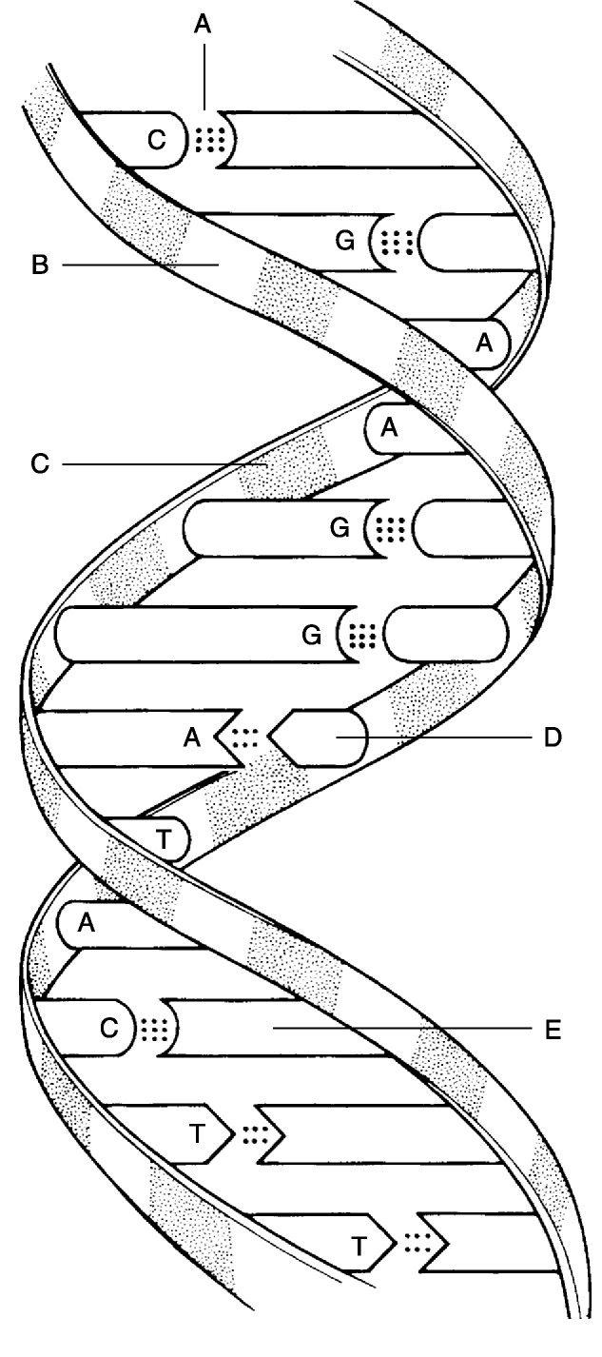

Figure 2.2

Using Figure 2.2, match the following:

8) Deoxyribose sugar.
Answer: B
Diff: 2 Page Ref: 49; Fig. 2.22

9) Thymine
Answer: D
Diff: 2 Page Ref: 49; Fig. 2.22
10) Guanine
Answer: E
Diff: 2 Page Ref: 49; Fig. 2.22

11) Phosphate
Answer: C
Diff: 2 Page Ref: 49; Fig. 2.22

12) Hydrogen bonds
Answer: A
Diff: 3 Page Ref: 49; Fig. 2.22

Match the following chemical bonds to the correct description:

A) Ionic bond
B) Hydrogen bond
C) Polar covalent bond
D) Nonpolar covalent bond

13) A bond in which electrons are shared unequally.
Diff: 1 Page Ref: 30; Fig. 2.9

14) A bond in which electrons are completely lost or gained by the atoms involved.
Diff: 1 Page Ref: 27, 30; Fig. 2.9

15) A bond in which electrons are shared equally.
Diff: 1 Page Ref: 30; Fig. 2.9

16) A type of bond important in tying different parts of the same molecule together into a three-dimensional structure.
Diff: 2 Page Ref: 30

Answers: 13) C 14) A 15) D 16) B
Match the following particles to the correct description:

A) Neutron
B) Atom
C) Cation
D) Molecule

17) Electrically charged particle due to loss of an electron.
Diff: 1 Page Ref: 27

18) Neutral subatomic particle.
Diff: 1 Page Ref: 22

19) Smallest particle of an element that retains its properties.
Diff: 1 Page Ref: 21

20) Smallest particle of a compound that still retains its properties.
Diff: 2 Page Ref: 24

Answers: 17) C 18) A 19) B 20) D

Match the following:

A) Compound
B) Mixture
C) Element

21) Water.
Diff: 1 Page Ref: 24

22) Carbon.
Diff: 1 Page Ref: 20

23) Dry ice (frozen carbon dioxide).
Diff: 1 Page Ref: 24

24) Blood.
Diff: 1 Page Ref: 24-26

Answers: 21) A 22) C 23) A 24) B
Match the following:

A) Weight
B) Energy
C) Mass
D) Matter

25) Can be measured only by its effects on matter.
Diff: 1 Page Ref: 19-20

26) Anything that occupies space and has mass.
Diff: 1 Page Ref: 19

27) Although a man who weighs 175 pounds on Earth would be lighter on the moon and heavier on Jupiter, his ________ would not be different.
Diff: 2 Page Ref: 19

28) Is a function of, and varies with, gravity.
Diff: 2 Page Ref: 19

Answers: 25) B 26) D 27) C 28) A

Match the following:

A) Mechanical energy
B) Radiant energy
C) Electrical energy
D) Chemical energy

29) Legs moving the pedals of a bicycle.
Diff: 1 Page Ref: 20

30) When the bonds of ATP are broken, energy is released to do cellular work.
Diff: 1 Page Ref: 20

31) Energy that travels in waves. Part of the electromagnetic spectrum.
Diff: 1 Page Ref: 20

32) Represented by the flow of charged particles along a conductor, or the flow of ions across a membrane.
Diff: 1 Page Ref: 20

Answers: 29) A 30) D 31) B 32) C
Match the following:

A) Suspensions
B) Colloids
C) Solutions

33) Heterogeneous, will not settle.
Diff: 1 Page Ref: 25-26

34) Heterogeneous, will settle.
Diff: 1 Page Ref: 26

35) Homogeneous, will not settle.
Diff: 1 Page Ref: 24-25

36) Will not scatter light.
Diff: 1 Page Ref: 24-25

Answers: 33) B 34) A 35) C 36) C

Match the following:

A) Mass number of an element
B) Atomic symbol
C) Atomic number

37) First one or two letters of an element's name
Diff: 1 Page Ref: 21

38) Number of protons in an atom
Diff: 1 Page Ref: 22

39) Combined number of protons and neutrons in an atom
Diff: 1 Page Ref: 22

Answers: 37) B 38) C 39) A

2.2 True/False Questions

1) The atomic weight is only an average of relative weights of an atom and its isotopes, and it may vary from the weight of a specific isotope.
Answer: TRUE
Diff: 2 Page Ref: 23

2) It is the difference in the R group that makes each amino acid chemically unique.
Answer: TRUE
Diff: 2 Page Ref: 43

3) Chemical properties are determined primarily by neutrons.
Answer: FALSE
Diff: 1 Page Ref: 22

4) A charged particle is generally called an ion or electrolyte.
Answer: TRUE
Diff: 1 Page Ref: 27
5) Isotopes differ from each other only in the number of electrons the atom contains.
Answer: FALSE
Diff: 1 Page Ref: 23

6) About 60% to 80% of the volume of most living cells consists of organic compounds.
Answer: FALSE
Diff: 1 Page Ref: 33

7) Lipids are a poor source of stored energy.
Answer: FALSE
Diff: 1 Page Ref: 42; Tbl. 2.2

8) Current information suggests that omega-3 fatty acids decrease the risk of heart disease.
Answer: TRUE
Diff: 1 Page Ref: 40

9) Glucose is an example of a monosaccharide.
Answer: TRUE
Diff: 1 Page Ref: 37

10) Glycogen, the storage form of glucose, is primarily stored in muscle tissue only.
Answer: FALSE
Diff: 1 Page Ref: 38, 40

11) The lower the pH, the higher the hydrogen ion concentration.
Answer: TRUE
Diff: 1 Page Ref: 35

12) Covalent bonds are generally less stable than ionic bonds.
Answer: FALSE
Diff: 2 Page Ref: 27-29

13) Hydrogen bonds are too weak to bind atoms together to form molecules but are important intramolecular bonds.
Answer: TRUE
Diff: 1 Page Ref: 30

14) The fact that no chemical bonding occurs between the components of a mixture is the chief difference between mixtures and compounds.
Answer: TRUE
Diff: 1 Page Ref: 26

15) The acidity of a solution reflects the free hydrogen ions in the solution
Answer: TRUE
Diff: 2 Page Ref: 35

16) A chemical bond is an energy relationship between outer electrons and neighboring atoms.
Answer: TRUE
Diff: 1 Page Ref: 26
17) All organic compounds contain carbon.
Answer: TRUE
Diff: 1 Page Ref: 37

18) A dipeptide can be broken into two amino acids by dehydration synthesis.
Answer: FALSE
Diff: 1 Page Ref: 43; Fig. 2.18

19) The pH of body fluids must remain fairly constant for the body to maintain homeostasis.
Answer: TRUE
Diff: 1 Page Ref: 35-36

20) Mixtures are combinations of elements or compounds that are physically blended together but are not bound by chemical bonds.
Answer: TRUE
Diff: 2 Page Ref: 24

21) Buffers resist abrupt and large changes in the pH of the body by releasing or binding ions.
Answer: TRUE
Diff: 2 Page Ref: 36

2.3 Multiple-Choice Questions

1) Which of the following elements is necessary for proper conduction of nervous impulses?
A) Fe
B) I
C) P
D) Na
Answer: D
Diff: 2 Page Ref: 21; Tbl. 2.1

2) The basic structural material of the body consists of ________.
A) Carbohydrates
B) Lipids.
C) Proteins.
D) Nucleic acids.
Answer: C
Diff: 2 Page Ref: 43

3) In general, the lipids that we refer to as oils have ________.
A) a high water content
B) long fatty acid chains
C) a high degree of saturated bonds
D) a high degree of unsaturated bonds
Answer: D
Diff: 2 Page Ref: 40
4) The genetic information is coded in DNA by the ________.
A) regular alteration of sugar and phosphate molecules
B) sequence of the nucleotides
C) three-dimensional structure of the double helix
D) arrangement of the histones
Answer: B
Diff: 2 Page Ref: 49-50

5) Which of the following is not true of proteins?
A) They may be denatured or coagulated by heat or acidity.
B) They have both functional and structural roles in the body.
C) They appear to be the molecular carriers of coded hereditary information.
D) Their function depends on their three-dimensional shape.
Answer: C
Diff: 2 Page Ref: 42-48

6) The single most abundant protein in the body is ________.
A) DNA
B) hemoglobin
C) collagen
D) glucose
Answer: C
Diff: 2 Page Ref: 46; Tbl. 2.3

7) Carbohydrates are stored in the liver and muscles in the form of ________.
A) glucose
B) triglycerides
C) glycogen
D) cholesterol
Answer: C
Diff: 2 Page Ref: 40

8) Which of the following does NOT describe enzymes?
A) Some enzymes are purely protein.
B) Some enzymes are protein plus a cofactor.
C) Each enzyme is chemically specific.
D) Enzymes work by raising the energy of activation.
Answer: D
Diff: 2 Page Ref: 47

9) Which of the following is not a role of molecular chaperonins?
A) prevent accidental, premature, or incorrect folding of polypeptide chains
B) aid the desired folding and association process of polypeptides
C) help to translocate proteins and certain metal ions across cell membranes
D) promote the breakdown of damaged or denatured proteins
E) act as a platform for assembling primary protein structure
Answer: E
Diff: 2 Page Ref: 46-47
10) A chemical reaction in which bonds are broken is usually associated with ________.
A) the release of energy
B) the consumption of energy
C) a synthesis
D) forming a larger molecule
Answer: A
Diff: 2 Page Ref: 32

11) Salts are always ________.
A) ionic compounds
B) single covalent compounds
C) double covalent compounds
D) hydrogen bonded
Answer: A
Diff: 2 Page Ref: 27

12) The numbers listed represent the number of electrons in the first, second, and third energy levels, respectively. On this basis, which of the following is an unstable or reactive atom?
A) 2, 8, 8
B) 2, 8
C) 2
D) 2, 8, 1
Answer: D
Diff: 3 Page Ref: 26-27

13) Which of the following statements is false?
A) When acids and bases are mixed, they react with each other to form water and a salt.
B) The more hydrogen ions in a solution, the more acidic the solution.
C) When the hydrogen ion concentration decreases, the hydroxyl ion concentration also decreases.
D) The pH of blood is slightly basic.
Answer: C
Diff: 3 Page Ref: 35-37

14) Which of the following is the major positive ion outside cells?
A) magnesium
B) hydrogen
C) potassium
D) sodium
Answer: D
Diff: 2 Page Ref: 21; Tbl. 2.1

15) Which of the following would be regarded as an organic molecule?
A) H2O
B) NaCl
C) NaOH
D) CH4
Answer: D
Diff: 1 Page Ref: 37
16) What is a chain of more than 50 amino acids called?
A) polypeptide
B) polysaccharide
C) protein
D) nucleic acid
Answer: C
Diff: 3 Page Ref: 43

17) What level of protein synthesis is represented by the coiling of the protein chain backbone into an alpha helix?
A) primary structure
B) secondary structure
C) tertiary structure
D) quaternary structure
Answer: B
Diff: 1 Page Ref: 44-45; Fig. 2.19

18) Carbohydrates and proteins are built up from their basic building blocks by the ________.
A) addition of a water molecule between each two units
B) addition of a carbon atom between each two units
C) removal of a water molecule between each two units
D) removal of a carbon atom between each two units
Answer: C
Diff: 2 Page Ref: 37-38

19) Which statement about enzymes is false?
A) Enzymes require contact with substrate in order to assume their active form.
B) Enzymes have the ability to accelerate reactions as much as a billion-fold.
C) Enzymes may use coenzymes derived from vitamins or cofactors from metallic elements.
D) Enzymes may be damaged by high temperature.
Answer: A
Diff: 2 Page Ref: 47-48

20) Which of the following statements is false?
A) Chemical reactions proceed more quickly at higher temperatures.
B) Chemical reactions progress at a faster rate when the reacting particles are present in higher numbers.
C) Larger particles move faster than smaller ones and thus collide more frequently and more forcefully.
D) Catalysts increase the rate of chemical reactions, sometimes while undergoing reversible changes in shape.
Answer: C
Diff: 2 Page Ref: 33

21) Choose the answer that best describes HCO3-.
A) a bicarbonate ion
B) common in the liver
C) a weak acid
D) a proton donor
Answer: A
Diff: 1 Page Ref: 37
22) Select which reactions will usually be irreversible regarding chemical equilibrium in human bodies.
A) glucose to CO2 and H2O
B) ADP + Pi to make ATP
C) H2O + CO2 to make H2CO3
D) glucose molecules joined to make glycogen
Answer: A
Diff: 3 Page Ref: 32-33

23) What happens in redox reactions?
A) both decomposition and electron exchange occur
B) the electron acceptor is oxidized
C) the organic substance that loses hydrogen is usually reduced
D) the reaction is uniformly reversible
Answer: A
Diff: 2 Page Ref: 31-32

24) Choose the answer that best describes fibrous proteins.
A) rarely exhibit secondary structure
B) are very stable and insoluble in water
C) are usually called enzymes
D) are cellular catalysts
Answer: B
Diff: 2 Page Ref: 44

25) Which of the following does not describe uses for the ATP molecule?
A) chemical work
B) mechanical work
C) transport across membranes
D) pigment structure
Answer: D
Diff: 1 Page Ref: 50-51; Fig. 2.24

26) Select the most correct statement regarding nucleic acids.
A) Three forms exist: DNA, RNA, and tDNA.
B) DNA is a long, double-stranded molecule made up of A, T, G, and C bases.
C) RNA is a long, single-stranded molecule made up of the bases A, T, G, and C.
D) tDNA is considered a molecular slave of DNA during protein synthesis.
Answer: B
Diff: 2 Page Ref: 48-50

27) Which of the following is an example of a suspension?
A) cytoplasm
B) salt water
C) rubbing alcohol
D) blood
Answer: D
Diff: 2 Page Ref: 25-26; Fig. 2.4
28) Select the correct statement about isotopes.
A) Isotopes of the same element have the same atomic number but differ in their atomic masses.
B) All the isotopes of an element have the same number of neutrons but differing numbers of electrons.
C) All the isotopes of an element are radioactive.
D) Isotopes occur only in the heavier elements.
Answer: A
Diff: 2 Page Ref: 23

29) The four elements that make up about 96% of body matter are ________.
A) carbon, oxygen, phosphorus, calcium
B) nitrogen, hydrogen, calcium, sodium
C) carbon, oxygen, hydrogen, nitrogen
D) sodium, potassium, hydrogen, oxygen
Answer: C
Diff: 2 Page Ref: 21; Tbl. 2.1

30) ________ is fat soluble, produced in the skin on exposure to UV radiation, and necessary for normal bone growth and function.
A) Vitamin K
B) Cortisol
C) Vitamin A
D) Vitamin D
Answer: D
Diff: 1 Page Ref: 42; Tbl. 2.2

31) You notice that you cannot read your book through a test tube of patient fluid held against the print, making it so blurred as to be unreadable. There is no precipitant in the bottom of the beaker, though it has been sitting for several days in a rack. What type of liquid is this?
A) solution
B) suspension
C) colloid
D) mixture
Answer: C
Diff: 3 Page Ref: 25-26

32) Atom X has 17 protons. How many electrons are in its valence shell?
A) 3
B) 5
C) 7
D) 10
Answer: C
Diff: 3 Page Ref: 26-27
33) Which protein types are vitally important to cell function in all types of stressful circumstances?
A) structural proteins
B) molecular chaperones
C) catalytic proteins
D) regulatory proteins
Answer: B
Diff: 2 Page Ref: 46-47

34) If atom X has an atomic number of 74 it would have which of the following?
A) 37 protons and 37 neutrons
B) 37 electrons
C) 74 protons
D) 37 protons and 37 electrons
Answer: C
Diff: 2 Page Ref: 22

35) What does the formula C6H12O6 mean?
A) There are 6 calcium, 12 hydrogen, and 6 oxygen atoms.
B) There are, 6 carbon, 12 hydrogen, and 6 oxygen atoms.
C) The molecular weight is 24.
D) The substance is a colloid.
Answer: B
Diff: 2 Page Ref: 24

36) An atom with a valence of 3 may have a total of ________ electrons.
A) 3
B) 8
C) 13
D) 17
Answer: C
Diff: 3 Page Ref: 26-27

37) Which of the following is a neutralization reaction?
A) HCl → H+ + Cl-
B) NaOH → Na+ + OH-
C) NH3 + H+ → NH4+2
D) HCl + NaOH → NaCl + H2O
Answer: D
Diff: 2 Page Ref: 35-36

38) The chemical symbol OO means ________.
A) zero equals zero
B) both atoms are bonded and have zero electrons in the outer orbit
C) the atoms are double bonded
D) this is an ionic bond with two shared electrons
Answer: C
Diff: 1 Page Ref: 28-29
39) What is a dipole?
A) a type of bond
B) a polar molecule
C) a type of reaction
D) an organic molecule
Answer: B
Diff: 2 Page Ref: 28-29

40) What does CH4 mean?
A) There is one carbon and four hydrogen atoms.
B) There are four carbon and four hydrogen atoms.
C) This is an inorganic molecule.
D) This was involved in a redox reaction.
Answer: A
Diff: 1 Page Ref: 24

41) Amino acids joining together to make a peptide is a good example of a(n) ________ reaction.
A) synthesis
B) decomposition
C) exchange
D) reversible
Answer: A
Diff: 1 Page Ref: 31

42) Which of the following is not considered a factor in influencing a reaction rate?
A) temperature
B) concentration
C) particle size
D) time
Answer: D
Diff: 2 Page Ref: 33

43) Which property of water is demonstrated when we sweat?
A) high heat capacity
B) high heat of vaporization
C) polar solvent properties
D) reactivity
E) cushioning
Answer: B
Diff: 2 Page Ref: 33-34

44) Sucrose is a ________.
A) monosaccharide
B) disaccharide
C) polysaccharide
D) triglyceride
Answer: B
Diff: 1 Page Ref: 38
45) What is the ratio of fatty acids to glycerol in neutral fats?
A) 1:1
B) 2:1
C) 3:1
D) 4:1
Answer: C
Diff: 1 Page Ref: 40

46) In a DNA molecule, the phosphate serves ________.
A) as a code
B) to hold the molecular backbone together
C) to bind the sugars to their bases
D) as nucleotides
Answer: B
Diff: 1 Page Ref: 49-50; Fig. 2.22

47) Stress proteins are a type of protein called ________.
A) coenzymes
B) cofactors
C) eicosanoids
D) chaperones
Answer: D
Diff: 2 Page Ref: 46-47

48) Which bonds often bind different parts of a molecule into a specific three-dimensional shape?
A) Carbon
B) Hydrogen
C) Oxygen
D) Amino acid
Answer: B
Diff: 2 Page Ref: 30

2.4 Fill-in-the-Blank/Short Answer Questions

1) The atomic number is equal to the number of ________.
Answer: protons (and electrons)
Diff: 1 Page Ref: 22

2) Molecules such as methane that are made of atoms that share electrons have ________ bonds.
Answer: covalent
Diff: 1 Page Ref: 27-28; Fig. 2.7

3) An atom with three electrons would have a valence of ________.
Answer: one
Diff: 2 Page Ref: 26-27

4) AB → A + B is an example of a(n) ________ reaction.
Answer: decomposition
Diff: 2 Page Ref: 31
5) ________ have a bitter taste, feel slippery, and are proton acceptors.
Answer: Bases
Diff: 1 Page Ref: 35

6) A holoenzyme is composed of an apoenzyme and a(n) ________.
Answer: cofactor
Diff: 2 Page Ref: 47

7) In a DNA molecule, guanine would connect to ________.
Answer: cytosine
Diff: 1 Page Ref: 50

8) The ________ molecule directly provides energy for cellular work.
Answer: ATP
Diff: 1 Page Ref: 50

9) Hydrogen bonds are more like a type of weak ________ than true bonds.
Answer: attraction
Diff: 2 Page Ref: 30

10) Weak acids and bases make good ________.
Answer: buffers
Diff: 2 Page Ref: 36-37

11) Starch is the stored carbohydrate in plants, while ________ is the stored carbohydrate in animals.
Answer: glycogen
Diff: 2 Page Ref: 40

12) How many phosphates would AMP have attached to it?
Answer: one
Diff: 2 Page Ref: 50-51

13) What does the polar end of a phospholipid contain?
Answer: a phosphorus-containing group
Diff: 1 Page Ref: 40-41

14) What type of chemical bond can form between an element with 11 protons and an element with 17 protons?
Answer: ionic
Diff: 3 Page Ref: 27

15) What happens when globular proteins are denatured?
Answer: The active sites are destroyed.
Diff: 3 Page Ref: 46

16) Explain the difference between potential and kinetic energy.
Answer: Potential energy is inactive stored energy that has potential to do work. Kinetic energy is energy in action.
Diff: 3 Page Ref: 20
17) How can phospholipids form a film when mixed in water?
Answer: Phospholipids have both polar and nonpolar ends. The polar end interacts with water, leaving the nonpolar end oriented in the opposite direction.
Diff: 3 Page Ref: 40-41

18) What properties does water have that make it a very versatile fluid?
Answer: High heat capacity, high heat of vaporization, polarity and solvent properties, reactivity, and cushioning.
Diff: 3 Page Ref: 33-34

19) What advantages does ATP have in being the energy currency molecule?
Answer: Its energy is easy to capture and store; it releases just the right amount of energy for the cell's needs so it is protected from excessive energy release. A universal energy currency is efficient because a single system can be used by all the cells in the body.
Diff: 3 Page Ref: 50-51

20) Explain why chemical reactions in the body are often irreversible.
Answer: Chemical reactions that release energy cannot be reversed unless energy is put back into the system. Also, some reactions produce molecules in excessive quantities (like CO2 and NH4) that the body then eliminates, but which are needed to reverse a reaction.
Diff: 3 Page Ref: 32-33

21) When a set of electrodes connected to a light bulb is placed in a solution of dextrose and a current is applied, the light bulb does not light up. When the same unit is placed in HCl, it does. Why?
Answer: HCl ionizes to form current-conducting electrolytes. Dextrose does not ionize, and therefore does not conduct current.
Diff: 3 Page Ref: 35

22) Describe the factors that affect chemical reaction rates.
Answer: Temperature increases kinetic energy and therefore the force of molecular collisions. Particle size: smaller particles move faster at the same temperature and therefore collide more frequently; also, smaller particles have more surface area given the same concentration of reactants. Concentration: the higher the concentration, the greater the chance of particles colliding. Catalysts increase the rate of the reaction at a given temperature. Enzymes are biological catalysts.
Diff: 3 Page Ref: 33

23) Protons and electrons exist in every atom nucleus except hydrogen. Is this statement true or false and why?
Answer: False. Hydrogen has one proton and one electron. It is the neutron, not the electron that can coexist in the nucleus and that hydrogen does not have.
Diff: 3 Page Ref: 22-23; Fig. 2.2

24) A chemical bond never occurs between components of a mixture. Discuss this.
Answer: Mixtures come in three forms–solutions, colloids, and suspensions. Components of these mixtures always retain their original makeup and can be separated into their individual components; therefore no chemical bonding has taken place.
Diff: 3 Page Ref: 24-26
25) All chemical reactions are theoretically reversible. Comment on this statement.
Answer: It is possible to reverse any reaction if the products are still present. Those that are only slightly exergonic are easily reversible. Some would require an enormous amount of energy to reverse. In the simple reaction Na + Cl → NaCl the amount of energy it takes to reverse table salt to chlorine gas and sodium metal is enormous. The reversing of the covalently bonded sugar molecule once it is reduced to ATP molecules is even harder or next to impossible without plant-like systems.
Diff: 3 Page Ref: 32-33

26) What is the major difference between polar and nonpolar covalent bonds?
Answer: Polar bonds have an unequal sharing of electrons resulting in a slight negative charge at one end of the molecule and a slight positive charge at the other end. Nonpolar bonds have an equal sharing of electrons, resulting in a balanced charge among the atoms.
Diff: 3 Page Ref: 28-29; Fig. 2.9

27) An amino acid may act as a proton acceptor or donor. Explain.
Answer: Amino acids have two components—a base group (proton acceptor) and an organic acid part (a proton donor). Some have additional base or acid groups on the ends of their R groups as well.
Diff: 3 Page Ref: 43

28) Name at least four things you know about enzymes.
Answer:
1. They are proteins.
2. They have specific binding sites for specific substrates.
3. They lower the activation barrier for a specific reaction.
4. The names end in "ase."
5. They can be denatured.
6. They can be used again and again.
Diff: 2 Page Ref: 47-48

29) In the compound H2CO3, what do the numbers 2 and 3 represent?
Answer: The 2 indicates that there are two hydrogen atoms in the compound and the 3 indicates that there are three oxygen atoms in the compound.
Diff: 2 Page Ref: 24

30) Are all chemical reactions reversible? If not, why aren't they all reversible?
Answer: All chemical reactions are theoretically reversible, but only if the products are not consumed.
Diff: 3 Page Ref: 32-33

31) If all protons, electrons, and neutrons are alike, regardless of the atom considered, what determines the unique properties of each element?
Answer: Atoms of different elements are composed of different numbers of protons, electrons, and neutrons.
Diff: 2 Page Ref: 22
2.5 Clinical Questions

1) Mrs. Mulligan goes to her dentist and, after having a couple of cavities filled, her dentist strongly suggests that she reduce her intake of sodas and increase her intake of calcium phosphates in the foods she eats. Why?
Answer: Sodas are strong acids that can reduce bone and tooth salts. Calcium phosphate makes teeth hard and therefore more resistant to tooth decay.
Diff: 2 Page Ref: 35-37

2) Although his cholesterol levels were not high, Mr. Martinez read that cholesterol was bad for his health, so he eliminated all foods and food products containing this molecule. He later found that his cholesterol level dropped only 20%. Why did it not drop more?
Answer: Cholesterol is produced by the liver, in addition to being ingested in foods.
Diff: 3 Page Ref: 41-42

3) How can DNA be used to "fingerprint" a suspect in a crime?
Answer: The DNA of a person is unique to that individual. By obtaining the DNA from nucleated cells from the crime scene (e.g., tissue, sperm), enzymes may be used to break up the DNA into fragments. Because nearly everyone's DNA is different, it also breaks up into fragments differently. When the fragments are separated, they form patterns even more unique than fingerprint patterns. A match of suspect and crime scene DNA is strong evidence.
Diff: 3 Page Ref: 48-50

4) Why is it possible for us to drink a solution that contains a mixture of equal concentration of a strong acid and a strong base, either of which, separately, would be very caustic?
Answer: When an acid and base of equal strength are mixed, they undergo a displacement reaction to form a water and a salt.
Diff: 3 Page Ref: 35-36

5) A 65-year-old patient came to the emergency room with complaints of severe heartburn unrelieved by taking a "large handful" of antacids. Would you expect the pH to be high or low? Explain why.
Answer: You would expect a high pH. Taking antacids will neutralize the acidic stomach. Taking a "handful" of antacids can cause an alkaloid state. Certain drugs, such as corticosteroids and antacids that contain baking soda, will lead to metabolic alkalosis.
Diff: 3 Page Ref: 36-37

6) A 23-year-old male was riding his road bike in 100-degree heat, when he suddenly became nauseated and weak. He called 911 from his cell phone. When the ambulance came, the paramedics started intravenous therapy for severe dehydration. Explain the critical role of water to maintain homeostasis.
Answer: Water is the most abundant and important inorganic compound in living material. It makes up 60% to 80% of the volume of most living cells. The properties of water are: high heat capacity, high heat of vaporization, polar solvent properties, reactivity, and cushioning. In this case the bicyclist lost a large amount of water through perspiration in an effort to cool his body. This caused a disruption in homeostasis.
Diff: 3 Page Ref: 33-34
7) Brenda is a 26-year-old female who is being discharged from the hospital after a vaginal delivery of an 8-pound healthy infant. Brenda is instructed by the nurse to eat a diet high in fiber and to drink 8 glasses of water per day to prevent constipation. Explain the role of fiber and water to promote defecation.
Answer: Cellulose is a polysaccharide found in all plant products that adds bulk to the diet to promote feces through the colon. Water acts as a lubricating liquid within the colon, which eases feces through the bowel.
Diff: 3 Page Ref: 34, 40

