Campbell Biology: Concepts and Connections, 8e (Reece et al.)
Chapter 2 The Chemical Basis of Life

2.1 Multiple-Choice Questions

1) The four most common elements in living organisms are
A) C, H, O, Fe.
B) C, H, O, Na.
C) C, H, O, N.
D) C, N, O, Na.
Answer: C
Topic: 2.1
Skill: Knowledge/Comprehension
Learning Outcome: 2.1

2) Which of the following is a trace element in the human body?
A) nitrogen
B) zinc
C) oxygen
D) hydrogen
Answer: B
Topic: 2.1
Skill: Knowledge/Comprehension
Learning Outcome: 2.1

3) Which of the following statements regarding matter is false?
A) All life is composed of matter.
B) All matter has mass.
C) All matter is composed of elements.
D) All matter exists in the form of compounds.
Answer: D
Topic: 2.1
Skill: Knowledge/Comprehension
Learning Outcome: 2.1

4) Which of the following statements best describes a compound?
A) A compound is a pure element.
B) A compound contains two or more different elements in a fixed ratio.
C) A compound is exemplified by sodium.
D) A compound is a solution.
Answer: B
Topic: 2.1
Skill: Knowledge/Comprehension
Learning Outcome: 2.1
5) In the equation 2 H2 + O2 → 2 H2O,
A) H2, O2, and H2O are all compounds.
B) H2, O2, and H2O are all elements.
C) only H2O is a compound.
D) only H2 and O2 are compounds.
Answer: C
Topic: 2.1
Skill: Application/Analysis
Learning Outcome: 2.1
Global LO: 2

6) Which of the following trace elements needed by humans is commonly added to table salt?
A) iodine
B) iron
C) magnesium
D) fluoride
Answer: A
Topic: 2.2
Skill: Knowledge/Comprehension
Learning Outcome: 2.1
Global LO: 5

7) In some areas, fluoride is added during the municipal water treatment process in order to help
A) prevent goiter.
B) prevent the growth of bacteria.
C) prevent the development of mental retardation.
D) reduce tooth decay.
Answer: D
Topic: 2.2
Skill: Knowledge/Comprehension
Learning Outcome: 2.1
Global LO: 5

8) Which of the following particles are found in the nucleus of an atom?
A) protons and neutrons
B) protons and electrons
C) only protons
D) only electrons
Answer: A
Topic: 2.3
Skill: Knowledge/Comprehension
Learning Outcome: 2.2
9) Electrons move about the nucleus of an atom in the same way that
A) insects fly around a bright lamp at night.
B) cars are parked along the sides of a street.
C) boats cross a lake.
D) birds migrate to a new winter home.
Answer: A
Topic: 2.3
Skill: Application/Analysis
Learning Outcome: 2.2
Global LO: 2

10) What is the atomic mass of an atom that has 6 protons, 6 neutrons, and 6 electrons?
A) 6
B) 8
C) 12
D) 18
Answer: C
Topic: 2.3
Skill: Application/Analysis
Learning Outcome: 2.2
Global LO: 2, 4

11) An uncharged atom of boron has an atomic number of 5 and an atomic mass of 11. How many electrons does boron have?
A) 11
B) 15
C) 5
D) 2
Answer: C
Topic: 2.3
Skill: Application/Analysis
Learning Outcome: 2.2
Global LO: 2

12) Which of the following is another term used for atomic mass?
A) darwin
B) mendel
C) dalton
D) calvin
Answer: C
Topic: 2.3
Skill: Knowledge/Comprehension
Learning Outcome: 2.2
13) The sodium atom contains 11 electrons, 11 protons, and 12 neutrons. What is the mass number of sodium?
A) 11
B) 22
C) 23
D) 34
Answer: C
Topic: 2.3
Skill: Application/Analysis
Learning Outcome: 2.2
Global LO: 2, 4

14) Which of the following best describes the atomic number of an atom?
A) the number of protons in the atom
B) the number of electrons in the atom
C) the number of neutrons in the atom
D) the number of protons, electrons, and neutrons in the atom
Answer: A
Topic: 2.3
Skill: Knowledge/Comprehension
Learning Outcome: 2.2

15) Typically, nitrogen atoms are composed of electrons, protons, and neutrons. An isotope of nitrogen could
A) be positively charged.
B) be negatively charged.
C) have more protons than the usual nitrogen atom.
D) have more neutrons than the usual nitrogen atom.
Answer: D
Topic: 2.3
Skill: Knowledge/Comprehension
Learning Outcome: 2.2

16) A radioactive isotope is an isotope that
A) is stable.
B) decays.
C) has more protons than the common variant of the element.
D) has the same atomic mass but a different atomic number than the common variant of the element.
Answer: B
Topic: 2.3
Skill: Knowledge/Comprehension
Learning Outcome: 2.2
17) If you found a fossilized dinosaur bone, what could be done to determine the age of the fossil?
A) Extract and sequence DNA from the bone.
B) Look at pieces of the bone under a microscope.
C) Analyze the isotopes of carbon in the fossil.
D) Compare the appearance of the bone to other fossilized bones.
Answer: C
Topic: 2.3
Skill: Application/Analysis
Learning Outcome: 2.2
Global LO: 2

18) Which of the following statements about radioactive isotopes is true?
A) The nuclei of radioactive isotopes are unusually stable, but the atoms tend to lose electrons.
B) When given a choice between radioactive and nonradioactive isotopes of the same atom, living cells are more likely to incorporate the radioactive isotopes into their structures.
C) The energy emitted by radioactive isotopes can break chemical bonds and cause molecular damage in cells.
D) Radioactive elements are natural and therefore not harmful.
Answer: C
Topic: 2.4
Skill: Knowledge/Comprehension
Learning Outcome: 2.2

19) Radioactive isotopes
A) are frequently added to foods as nutritional supplements.
B) can be used in conjunction with PET scans to diagnose diseases.
C) do not occur naturally.
D) are never incorporated into organic compounds.
Answer: B
Topic: 2.4
Skill: Knowledge/Comprehension
Learning Outcome: 2.2
Global LO: 5

20) When full, the innermost electron shell of argon contains ________ electrons, and the outermost shell contains ________ electrons.
A) 2; 2
B) 2; 8
C) 4; 8
D) 8; 8
Answer: B
Topic: 2.5
Skill: Knowledge/Comprehension
Learning Outcome: 2.3
21) What happens to an atom if the electrons in the outer shell are altered?
A) The atom becomes radioactive.
B) The atom disintegrates.
C) The properties of the atom change.
D) The atom's characteristics change, and it becomes a different element.
Answer: C
Topic: 2.5
Skill: Knowledge/Comprehension
Learning Outcome: 2.3

22) A(n) ________ forms when two atoms share electrons.
A) ion
B) covalent bond
C) ionic bond
D) hydrogen bond
Answer: B
Topic: 2.6
Skill: Knowledge/Comprehension
Learning Outcome: 2.4

23) A hydrogen atom has one electron. How many covalent bonds can hydrogen form?
A) one
B) two
C) four
D) none
Answer: A
Topic: 2.6
Skill: Application/Analysis
Learning Outcome: 2.4
Global LO: 2

24) Table salt is formed when
A) chlorine gives an electron to sodium.
B) a hydrogen bond forms between sodium and chlorine.
C) sodium and chlorine share electrons to form a bond.
D) sodium donates its single outer electron to chlorine.
Answer: D
Topic: 2.7
Skill: Knowledge/Comprehension
Learning Outcome: 2.4
25) The body uses atoms in different ways to accomplish different tasks. For example, one portion of the body's calcium supply strengthens bones, whereas another portion combines with proteins to stimulate blood clotting after tissue injury. Which of the following statements provides the most logical chemical explanation of calcium's ability to perform such different functions?
A) The bone contains calcium salts, which are less reactive than the calcium ions found in the blood.
B) The calcium in blood is a more reactive form of the atom and therefore has fewer protons than the calcium in bone.
C) There are many different isotopes of calcium, and the most reactive isotope is found in the bone.
D) The calcium in blood has a lighter atomic mass than the calcium in bone and is in a more reactive form.
Answer: A
Topic: 2.7
Skill: Synthesis/Evaluation
Learning Outcome: 2.4
Global LO: 2

26) Medicines are often administered in pill form. In many cases, the active ingredient of the pill (the drug) is joined to another substance by ________. This forms a(n) ________, which is stable in the dry environment of a pill bottle but dissociates under the wet conditions of the digestive system to release the drug to the body.
A) ionic bonds; salt
B) hydrogen bonds; base
C) ionic bonds; acid
D) covalent bonds; salt
Answer: A
Topic: 2.7
Skill: Application/Analysis
Learning Outcome: 2.4
Global LO: 2

27) What is the fundamental difference between covalent and ionic bonding?
A) In a covalent bond, the partners share a pair of electrons; in an ionic bond, one partner accepts electrons from the other.
B) In covalent bonding, both partners end up with filled outer electron shells; in ionic bonding, one partner does and the other does not.
C) Covalent bonding involves only the outermost electron shell; ionic bonding also involves the next electron shell inside the outermost shell.
D) Covalent bonds form between atoms of the same element; ionic bonds form between atoms of different elements.
Answer: A
Topic: 2.6, 2.7
Skill: Knowledge/Comprehension
Learning Outcome: 2.4
28) Which of the following statements regarding the oxygen atom of a water molecule is true?
A) Oxygen is more positively charged than the hydrogen atoms.
B) Oxygen attracts electrons less strongly than the hydrogen atoms.
C) Oxygen is more electronegative than the hydrogen atoms.
D) Oxygen is attracted to the negatively charged atoms of other molecules.
Answer: C
Topic: 2.8
Skill: Knowledge/Comprehension
Learning Outcome: 2.4, 2.5

29) In a water molecule, hydrogen and oxygen are held together by a ________ bond.
A) double covalent
B) nonpolar covalent
C) hydrogen
D) polar covalent
Answer: D
Topic: 2.8
Skill: Knowledge/Comprehension
Learning Outcome: 2.4, 2.5

30) A single water molecule (H—O—H) is held together by
A) a single covalent bond.
B) a double covalent bond.
C) two polar covalent bonds.
D) hydrogen bonds.
Answer: C
Topic: 2.8
Skill: Knowledge/Comprehension
Learning Outcome: 2.4, 2.5

31) The hydrogen atoms of a water molecule are bonded to the oxygen atom by ________ bonds, whereas neighboring water molecules are held together by ________ bonds.
A) hydrogen; polar covalent
B) polar covalent; hydrogen
C) ionic; covalent
D) polar covalent; ionic
Answer: B
Topic: 2.8
Skill: Knowledge/Comprehension
Learning Outcome: 2.4, 2.5

32) ________ are weak bonds that are not strong enough to hold atoms together to form molecules but are strong enough to form bonds within and around large molecules.
A) Ionic bonds
B) Covalent bonds
C) Polar covalent bonds
D) Hydrogen bonds
Answer: D
Topic: 2.8
Skill: Knowledge/Comprehension
Learning Outcome: 2.4, 2.5
33) Water molecules stick to other water molecules because
A) water molecules are neutral, and neutral molecules are attracted to each other.
B) hydrogen bonds form between the hydrogen atoms of one water molecule and the oxygen atoms of other water molecules.
C) covalent bonds form between the hydrogen atoms of one water molecule and the oxygen atoms of other water molecules.
D) the oxygen atoms of adjacent water molecules are attracted to one another.
Answer: B
Topic: 2.8
Skill: Knowledge/Comprehension
Learning Outcome: 2.4, 2.5, 2.6

34) Which of the following statements regarding chemical reactions is false?
A) Chemical reactions involve the making and breaking of chemical bonds.
B) Some chemical reactions create electrons; others destroy them.
C) The reactants contain the same number of atoms as the products.
D) Although the atoms of a reaction's reactants and products are identical to each other, their molecular formulas differ.
Answer: B
Topic: 2.9
Skill: Knowledge/Comprehension
Learning Outcome: 2.4

35) In the equation 2 H2 + O2 → 2 H2O, the H2 molecules are ________ and the H2O molecules are ________.
A) reactants; products
B) products; reactants
C) created; destroyed
D) used; stored
Answer: A
Topic: 2.9
Skill: Knowledge/Comprehension
Learning Outcome: 2.4

36) In plants, the process of photosynthesis produces glucose (C6H12O6) and oxygen from carbon dioxide and water. Which of the following statements about photosynthesis is true?
A) All of the carbon atoms from the carbon dioxide atoms are found in glucose.
B) More atoms are present at the beginning than at the end.
C) More carbon dioxide is released from the plant than is absorbed.
D) Water is synthesized by the plant from H2 and O2.
Answer: A
Topic: 2.9
Skill: Knowledge/Comprehension
Learning Outcome: 2.4
37) The tendency of water molecules to stick together is referred to as
A) adhesion.
B) polarity.
C) cohesion.
D) transpiration.
Answer: C
Topic: 2.10
Skill: Knowledge/Comprehension
Learning Outcome: 2.6

38) Water's surface tension and heat storage capacity are accounted for by its
A) orbitals.
B) hydrogen bonds.
C) mass.
D) size.
Answer: B
Topic: 2.10, 2.11
Skill: Knowledge/Comprehension
Learning Outcome: 2.6

39) The temperature of evaporation is much higher for water than for alcohol. Without knowing more about the chemistry of alcohol, which of the following is the most logical chemical explanation for this phenomenon?
A) Ionic bonds form between alcohol molecules. These are the weakest type of bond and are easier to break than the hydrogen bonds between water molecules.
B) Alcohol has a higher surface tension than water. This means that alcohol molecules can easily break away from other alcohol molecules and evaporate at a lower temperature.
C) Alcohol molecules are more cohesive than water molecules. This means that as alcohol molecules evaporate, they pull other alcohol molecules into the air along with them.
D) Fewer hydrogen bonds form between alcohol molecules. As a result, less heat is needed for alcohol molecules to break away from solution and enter the air.
Answer: D
Topic: 2.11
Skill: Application/Analysis
Learning Outcome: 2.6
Global LO: 2

40) As ice melts,
A) hydrogen bonds are broken.
B) water molecules become less tightly packed.
C) the water becomes less dense.
D) heat is released.
Answer: A
Topic: 2.12
Skill: Knowledge/Comprehension
Learning Outcome: 2.6
41) Which of the following statements about water is false?
A) Ice is more dense than liquid water.
B) Water naturally exists in all three physical states on Earth.
C) Floating ice on a pond insulates the liquid water below, slowing its rate of freezing.
D) If ice sank, the oceans would eventually freeze solid.
Answer: A
Topic: 2.12
Skill: Knowledge/Comprehension
Learning Outcome: 2.6

42) You've made a hot drink by dissolving a teaspoon of instant coffee and a teaspoon of sugar in a cup of hot water. Which of the following statements is true?
A) You've just prepared an aqueous solution.
B) The water is the solute portion of the drink.
C) The instant coffee and sugar are solvents.
D) The instant coffee and sugar dissolve because they have no charged regions to repel the partial positive and partial negative regions of the water molecules.
Answer: A
Topic: 2.13
Skill: Application/Analysis
Learning Outcome: 2.6
Global LO: 2

43) Which of the following is dependent on the ability of water molecules to form hydrogen bonds with other molecules besides water?
A) the evaporative cooling of skin surfaces
B) the milder temperatures of coastal regions compared to inland areas
C) the ability of certain insects to walk on the surface of water
D) the universality of water as a solvent
Answer: D
Topic: 2.10, 2.11, 2.13
Skill: Application/Analysis
Learning Outcome: 2.6
Global LO: 2

44) Clots in our blood can lead to a heart attack or stroke by blocking blood flow. If a clot were made up of a mass of proteins, what changed in the proteins to cause them to form the clot?
A) The proteins became more polar.
B) The blood became saturated with proteins.
C) The proteins were no longer soluble in the blood.
D) The proteins became more soluble in the blood.
Answer: C
Topic: 2.13
Skill: Knowledge/Comprehension
Learning Outcome: 2.6
Global LO: 2, 5
45) A pharmaceutical company hires a chemist to analyze the purity of the water being used in its drug preparations. If the water is pure, the chemist would expect to find
A) only molecules of H2O.
B) H2O molecules and H+ ions.
C) H2O molecules, H+ ions, and OH- ions.
D) only H+ ions and OH- ions.
Answer: C
Topic: 2.14
Skill: Knowledge/Comprehension
Learning Outcome: 2.6

46) A solution with a pH of 7 is
A) strongly acidic.
B) weakly acidic.
C) neutral.
D) weakly basic.
Answer: C
Topic: 2.14
Skill: Knowledge/Comprehension
Learning Outcome: 2.6

47) Compared to a solution of pH 3, a solution of pH 1 is
A) 100 times more acidic.
B) 10 times more acidic.
C) 10 times more basic.
D) 100 times more basic.
Answer: A
Topic: 2.14
Skill: Knowledge/Comprehension
Learning Outcome: 2.6
Global LO: 4

48) Which of the following statements about pH is true?
A) The pH scale is a measure of oxygen ion concentration.
B) A single unit change on the pH scale is equivalent to a 1% change in hydrogen ion concentration.
C) An increase in hydrogen ion concentration means a decrease in pH scale units.
D) Basic pH levels are less than 7.
Answer: C
Topic: 2.14
Skill: Knowledge/Comprehension
Learning Outcome: 2.6
49) Household ammonia has a pH of 12; household bleach has a pH of 13. Which of the following statements about these substances is true?
A) Both of these substances are strong acids.
B) The ammonia has 10 times as many OH- ions as the bleach.
C) The ammonia has 10 times as many H+ ions as the bleach.
D) A solution that could buffer the bleach and ammonia would remove excess OH- ions.
Answer: C
Topic: 2.14
Skill: Knowledge/Comprehension
Learning Outcome: 2.6
Global LO: 4

50) A buffer
A) is an acid that is used to offset overly basic conditions in the body.
B) is a base that is used to offset overly acidic conditions in the body.
C) donates H+ ions when conditions become too basic and accepts H+ ions when conditions become too acidic.
D) donates OH- ions when conditions become too basic and accepts OH- ions when conditions become too acidic.
Answer: C
Topic: 2.14
Skill: Knowledge/Comprehension
Learning Outcome: 2.6

51) A diabetic, who does not utilize insulin properly, will metabolize fats instead of glucose. A condition called diabetic ketoacidosis is a common result of excessive fat metabolism, causing blood pH values of 7.1 or less (normal range is 7.35-7.45). What has happened to the blood pH and why?
A) The pH is above normal (basic) because the ketones are too basic.
B) The pH is below normal (acidic) because the buffering capacity was exceeded.
C) The pH is not affected because the blood buffers can absorb the excess H+.
D) The pH is below normal because buffers can donate OH+.
Answer: B
Topic: 2.14
Skill: Application/Analysis
Learning Outcome: 2.6, 2.7
Global LO: 2, 5

52) Which of the following hypotheses would be supported if liquid water were found on Mars and contained evidence of bacteria-like organisms?
A) Life must evolve in the presence of oxygen.
B) The chemical evolution of life is possible.
C) Life on Earth must have originated on Mars.
D) Life is guided by intelligent design.
Answer: B
Topic: 2.16
Skill: Application/Analysis
Learning Outcome: 2.7
Global LO: 2
53) Silicon is an element that is found directly underneath carbon in the periodic table. How many electrons are in the valence shell of a silicon atom?
A) 1
B) 2
C) 4
D) 6
Answer: C
Topic: 2.5
Skill: Application/Analysis
Learning Outcome: 2.3
Global LO: 2

54) Consider the following situations: (1) a magnesium atom and two chlorine atoms join together to form a molecule of magnesium chloride; (2) water molecules interact with each other in a beaker; and (3) two carbon atom and six hydrogen atoms join together to form ethane. Rank the strength of the bonding interactions taking place in each situation, from the weakest bonds to the strongest bonds.
A) 1 < 2 < 3
B) 3 < 2 < 1
C) 2 < 3 < 1
D) 2 < 1 < 3
Answer: D
Topic: 2.6, 2.7, 2.8
Skill: Synthesis/Evaluation
Learning Outcome: 2.4
Global LO: 2

55) In ocean acidification, dissolving CO2 gas ________ the pH of the ocean.
A) lowers
B) does not affect
C) raises
D) triples
Answer: A
Topic: 2.15
Skill: Knowledge/Comprehension
Learning Outcome: 2.7

56) How will a lower ocean pH caused by ocean acidification affect coral reefs?
A) Coral reefs will grow faster because there are more carbonate ions available.
B) Coral reefs will grow slower because there are fewer carbonate ions available.
C) Coral reefs will grow faster because there are more bicarbonate ions available.
D) Coral reefs will grow slower because there are fewer bicarbonate ions available.
Answer: B
Topic: 2.15
Skill: Knowledge/Comprehension
Learning Outcome: 2.7
57) Glycolysis is the first step of cellular respiration, in which glucose is used to generate ATP to power the cell. The major chemical reaction that takes place in glycolysis (ignoring some other reactants and products) is the conversion of glucose (C6H12O6) to pyruvate (C3H4O3) and hydrogen ions (H+). Using this information, what is the correct equation for the glycolysis chemical reaction?
A) C6H12O6 → C3H4O3 + H+
B) C6H12O6 → 2 C3H4O3 + 2 H+
C) C6H12O6 → 2 C3H4O3 + H+
D) 2 C6H12O6 → C3H4O3 + 2 H+
Answer: B
Topic: 2.9
Skill: Application/Analysis
Learning Outcome: 2.4
Global LO: 2, 4

58) Household ammonia, or ammonium hydroxide, is a mixture of ammonia (NH3) and water. What types of bonding interactions will occur between molecules of ammonia and water in a bottle of household ammonia?
A) polar covalent bonds between positively charged nitrogen atoms in ammonia and negatively charged oxygen atoms in water
B) polar covalent bonds between negatively charged nitrogen atoms in ammonia and positively charged hydrogen atoms in water
C) hydrogen bonds between positively charged nitrogen atoms in ammonia and negatively charged oxygen atoms in water
D) hydrogen bonds between negatively charged nitrogen atoms in ammonia and positively charged hydrogen atoms in water
Answer: D
Topic: 2.8
Skill: Application/Analysis
Learning Outcome: 2.4
Global LO: 2

59) A nutrition facts label from a fortified cereal states that in a single serving of cereal there is 8% of the percent daily value of the element phosphorous. The label also says that a single serving of cereal plus one-half cup of skim milk has 20% of the percent daily value of phosphorus. Which of the following statements is false?
A) A half-cup of skim milk contains 12% of the percent daily value of phosphorus.
B) A half-cup of skim milk contains twice as much phosphorus as a serving of cereal.
C) Eating five servings of cereal and two and a half cups of skim milk will give you 100% of the phosphorus that you need for one day.
D) The amount of phosphorus in six servings of cereal is equal to the amount of phosphorus in two cups of skim milk.
Answer: B
Topic: 2.2
Skill: Application/Analysis
Learning Outcome: 2.1
Global LO: 2, 4
2.2 Art Questions

1) What change is occurring in this figure?

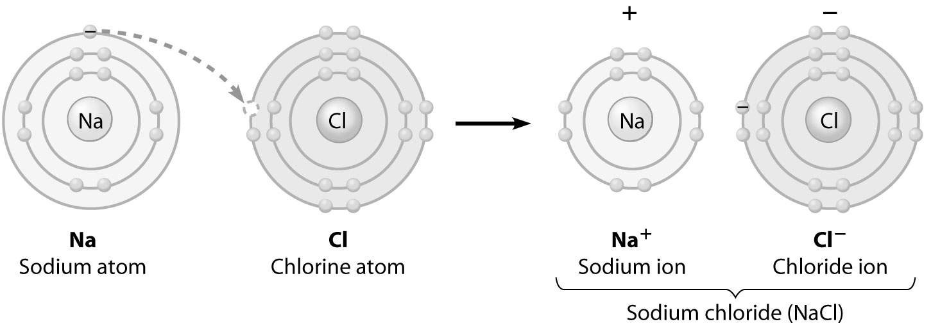
A) Chlorine is losing an electron.
B) Sodium is becoming negatively charged.
C) Sodium is filling its third electron shell.
D) Chlorine is filling its third electron shell.
Answer: D
Topic: 2.7
Skill: Knowledge/Comprehension
Learning Outcome: 2.3, 2.4
Global LO: 3
2) The figure below shows five water molecules. The hydrogen bonds shown in this figure are each

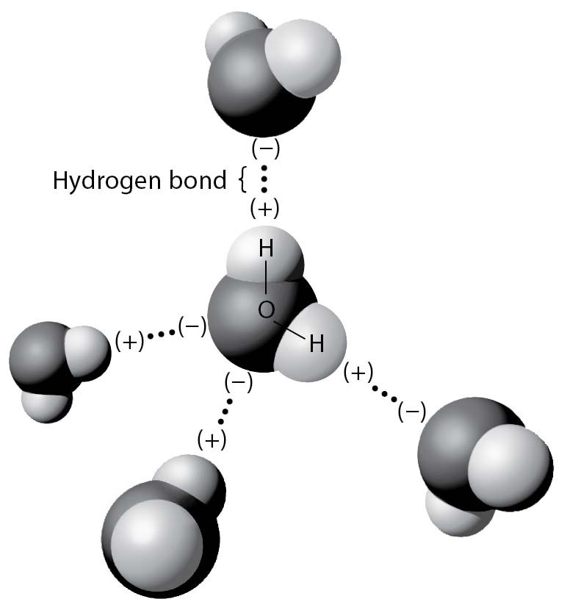
A) between two hydrogen atoms.
B) between an oxygen and a hydrogen atom of the same water molecule.
C) between an oxygen and a hydrogen atom of different water molecules.
D) between two atoms with the same charge.
Answer: C
Topic: 2.8
Skill: Application/Analysis
Learning Outcome: 2.4
Global LO: 2, 3

3) Below is the structure of octane, the major component of gasoline. What type(s) of bond is (are) found in a molecule of octane?

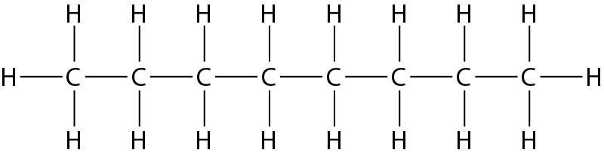
A) only nonpolar covalent bonds
B) only polar covalent bonds
C) hydrogen bonds and polar covalent bonds
D) ionic bonds and nonpolar covalent bonds
Answer: A
Topic: 2.6
Skill: Application/Analysis
Learning Outcome: 2.4, 2.5
Global LO: 2
4) Below is the structure of leucine, an amino acid. What type of bond is the arrow pointing to?

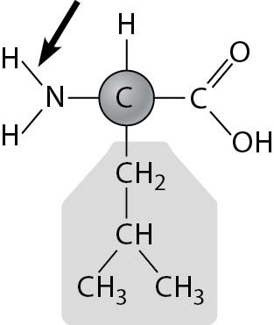
A) a nonpolar covalent bond
B) a polar covalent bond
C) an ionic bond
D) a hydrogen bond
Answer: B
Topic: 2.6
Skill: Application/Analysis
Learning Outcome: 2.4, 2.5
Global LO: 2

5) Below is a figure from an experiment that was performed to measure the effect of carbonate ion (CO32-) concentration on the calcification (growth) rate of coral reefs. At which point on the graph is the ocean pH the lowest?

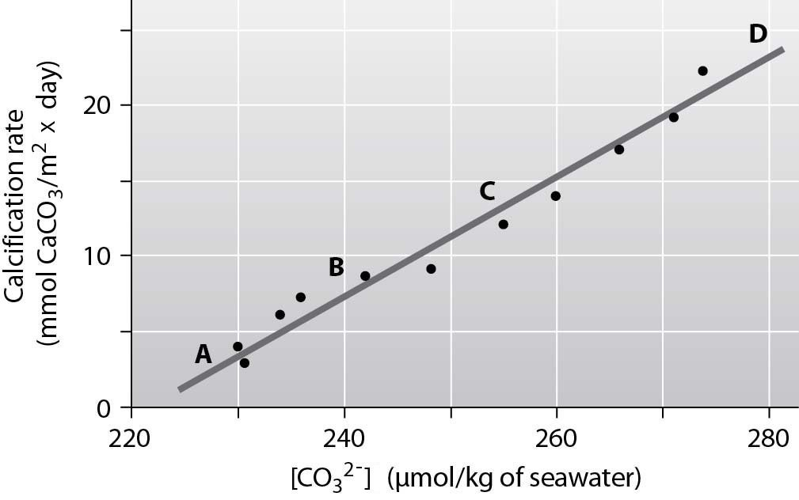
A) A
B) B
C) C
D) D
Answer: A
Topic: 2.15
Skill: Synthesis/Evaluation
Learning Outcome: 2.6
Global LO: 2, 3
2.3 Scenario Questions

After reading the paragraph below, answer the questions that follow.

You've been experiencing acid indigestion lately, and you'd like a quick fix for the problem. You do a little research on the Internet and discover that your problem is caused by excess stomach acid. In the pharmacy aisles, however, you're having a little trouble deciding what to purchase to address the problem. At the pharmacy counter, the clerk recommends that you purchase PEPCID AC or Alka-Seltzer tablets.

1) If you could check the pH of the recommended tablets, you would expect it to be
A) higher than 7.
B) lower than 7.
C) exactly 7.
D) pH neutral.
Answer: A
Topic: 2.14
Skill: Application/Analysis
Learning Outcome: 2.6
Global LO: 2

2) If you were able to chemically analyze your stomach fluids 30 minutes after taking two tablets, you would find
A) more hydrogen ions.
B) fewer hydrogen ions.
C) the same number of hydrogen ions.
D) that the pH in your stomach has decreased.
Answer: B
Topic: 2.14
Skill: Application/Analysis
Learning Outcome: 2.6
Global LO: 2, 5, 6

3) You want to design a controlled experiment to determine which tablet, PEPCID AC or Alka-Seltzer, neutralizes stomach acid the quickest. Which of the following experiments would be the best to perform?
A) Place a PEPCID AC tablet in a beaker of acid at pH 2 and an Alka-Seltzer tablet in a separate beaker of acid at pH 2 and check the pH in the beakers every 2 minutes.
B) Take a PEPCID AC tablet at 8:00 am on Monday and take an Alka-Seltzer tablet at 8:00 am on Tuesday and take note of how long it takes you to feel better.
C) Find a group of your friends and go out to a big dinner. Then give half of them a PEPCID AC tablet and give the other half an Alka-Seltzer tablet and tell them to write down how long it takes them to feel better.
D) Place a PEPCID AC tablet in a beaker of acid at pH 2 and an Alka-Seltzer tablet in a separate beaker of acid at pH 2 and record how long it takes for the tablets to dissolve.
Answer: A
Topic: 2.14
Skill: Synthesis/Evaluation
Learning Outcome: 2.6
Global LO: 1, 2
4) You hypothesize that a tablet of PEPCID AC can neutralize more stomach acid than a tablet of Alka-Seltzer. If you placed a tablet of each antacid in a beaker of acid at an initial pH of 2, which of the following experimental results would support your hypothesis?
A) After 1 hour, the pH of the solution in the PEPCID AC beaker was 9.2 and the pH of the solution in the Alka-Seltzer beaker was 8.3.
B) After 1 hour, the pH of the solution in the PEPCID AC beaker was 7.9 and the pH of the solution in the Alka-Seltzer beaker was 9.6.
C) After 1 hour, the pH of the solution in the PEPCID AC beaker was equal to that of the pH of the solution in the Alka-Seltzer beaker.
D) It took 3 minutes for the PEPCID AC tablet to fully dissolve and it took 5 minutes for the Alka-Seltzer tablet to fully dissolve.
Answer: A
Topic: 2.14
Skill: Synthesis/Evaluation
Learning Outcome: 2.6
Global LO: 1, 2

5) You want to design an experiment to compare the effectiveness of Pepcid AC tablets and Alka-Seltzer tablets. Which of the following facts would be least likely to complicate your experiment and the analysis of your results?
A) PEPCID AC and Alka-Seltzer tablets contain different concentrations of the antacid drug.
B) PEPCID AC and Alka-Seltzer tablets contain different ingredients.
C) The recommended dosage for PEPCID AC and Alka-Seltzer tablets is different.
D) PEPCID AC and Alka-Seltzer tablets are sold in different countries throughout the world.
Answer: D
Topic: 2.14
Skill: Synthesis/Evaluation
Learning Outcome: 2.6
Global LO: 1, 2

After reading the paragraph below, answer the questions that follow.

Uranium is a metallic element that is used in nuclear reactors and nuclear weapons. The vast majority of uranium found on Earth is in the form of uranium-238, an isotope with a mass number of 238, while the uranium that is used for nuclear reactors and weapons is uranium-235, an isotope with a mass number of 235.

6) What is the atomic difference between uranium-235 and uranium-238?
A) Uranium-235 has three fewer protons than uranium-238.
B) Uranium-235 has three fewer neutrons than uranium-238.
C) Uranium-235 has three fewer electrons than uranium-238.
D) Uranium-235 has three fewer atoms than uranium-238.
Answer: B
Topic: 2.3
Skill: Application/Analysis
Learning Outcome: 2.2
Global LO: 2, 5
7) If the atomic mass of uranium is 92, how many neutrons does an atom of uranium-235 have in its nucleus?
A) 92
B) 143
C) 146
D) 235
Answer: B
Topic: 2.3
Skill: Application/Analysis
Learning Outcome: 2.2
Global LO: 2, 4, 5

8) In a certain type of nuclear reactor, uranium-238 can be converted to plutonium-239, another radioactive element (with an atomic number of 94) that can be used to power nuclear reactions. Which of the following statements regarding uranium-238 and plutonium-239 is false?
A) An atom of plutonium-239 contains one more proton than an atom of uranium-238.
B) An atom of plutonium-239 contains 145 neutrons.
C) An atom of uranium-238 has a smaller mass than an atom of plutonium-239.
D) An atom of plutonium-239 contains two more protons and one fewer neutron than an atom of uranium-238.
Answer: A
Topic: 2.3
Skill: Application/Analysis
Learning Outcome: 2.2
Global LO: 2, 4, 5

