Chapter 02
Financial Statements and Cash Flow

Multiple Choice Questions
1. | Assume both current and deferred taxes are positive values. Given this, deferred taxes will:  A. reduce the current tax expense and thus increase net income.  B. increase expenses and increase operating cash flows.  C. increase expenses and lower operating cash flows.  D. reduce net income but not affect the operating cash flows.  E. reduce both net income and operating cash flows.

2. | Which one of these is handled differently in calculating cash flows for accounting versus financial purposes?  A. Change in net working capital  B. Depreciation expense  C. Interest expense  D. Deferred taxes  E. Dividends paid

3. | Which one of these will increase earnings per share?  A. Decreasing deferred taxes  B. Increasing depreciation expense  C. Lowering the operating income  D. Increasing the corporate tax rate  E. Lowering the percentage of net income added to retained earnings

4. | A current asset is best defined as:  A. the market value of all assets currently owned by the firm.  B. an asset the firm expects to purchase within the next year.  C. the amount of cash on hand the firm currently shows on its balance sheet.  D. cash and other assets owned by the firm that will convert to cash within the next year.  E. the value of fixed assets the firm expects to sell within the next year.

5. | The long-term debts of a firm are liabilities:  A. owed to the firm's shareholders.  B. that do not come due for at least 12 months.  C. owed to the firm's suppliers.  D. that come due within the next 12 months.  E. the firm expects to incur within the next 12 months.

6. | A(n) ____ asset is one which can be quickly converted into cash without significant loss in value.  A. tangible  B. fixed  C. intangible  D. liquid  E. long-term

7. | Noncash items refer to:  A. the credit sales of a firm.  B. the accounts payable of a firm.  C. all accounts on the balance sheet other than cash on hand.  D. the costs incurred for the purchase of intangible fixed assets.  E. expenses charged against revenues that do not directly affect cash flow.

8. | Your _____ tax rate is the percentage of the next taxable dollar of income you earn that is payable as a tax.  A. deductible  B. residual  C. marginal  D. average  E. total

9. | Your _____ tax rate measures the total taxes you pay divided by your total taxable income.  A. average  B. marginal  C. total  D. deductible  E. residual

10. | _____ refers to the cash flow resulting from a firm's ongoing, normal business activities.  A. Cash flow from assets  B. Net working capital  C. Capital spending  D. Cash flow from operating activities  E. Cash flow to creditors

11. | _____ refers to the changes in net capital assets.  A. Cash flow from assets  B. Net working capital  C. Cash flow from investing  D. Operating cash flow  E. Cash flow to creditors

12. | _____ refers to the difference between a firm's current assets and its current liabilities.  A. Operating cash flow  B. Capital spending  C. Net working capital  D. Cash flow from assets  E. Cash flow to creditors

13. | _____ is calculated by adding back noncash expenses to earnings before interest and taxes, subtracting taxes, and adjusting for any changes in total assets or current liabilities that affect cash flows.  A. Distributable cash flow  B. Capital spending  C. Cash flow from assets  D. Cash flow from investing activities  E. Cash flow to creditors

14. | _____ refers to a firm's interest payments minus any net new borrowing.  A. Operating cash flow  B. Distributable cash flow  C. Net working capital  D. Cash flow to equity investors  E. Cash flow to creditors

15. | _____ refers to a firm's dividend payments minus any net new equity raised.  A. Operating cash flow  B. Capital spending  C. Net working capital  D. Cash flow to equity investors  E. Cash flow from creditors

16. | Which of the following are included in current assets?  I. Equipment  II. Inventory  III. Accounts payable  IV. Cash  A. II and IV only  B. I and III only  C. I, II, and IV only  D. III and IV only  E. II, III, and IV only

17. | Which of the following are included in current liabilities?  I. Debt payable to a mortgage company in nine months  II. Note payable to a supplier in eighteen months  III. Accounts payable to suppliers  IV. Loan payable to a bank in fourteen months  A. I and III only  B. II and III only  C. III and IV only  D. II, III, and IV only  E. I, II, and III only

18. | Which one of the following accounts is generally the most liquid?  A. Patent  B. Building  C. Accounts receivable  D. Equipment  E. Inventory

19. | Which one of the following statements concerning liquidity is correct?  A. Fixed assets are more liquid than current assets.  B. Balance sheet accounts are listed in order of decreasing liquidity.  C. Liquid assets tend to be highly profitable.  D. The less liquidity a firm has, the lower the probability the firm will encounter financial difficulties.  E. Trademarks and patents are highly liquid.

20. | Liquidity is:  A. a measure of the use of debt in a firm's capital structure.  B. equal to current assets minus current liabilities.  C. equal to the market value of a firm's total assets minus its current liabilities.  D. generally associated with intangible assets.  E. valuable to a firm even though liquid assets tend to be less profitable to own.

21. | Book value is:  A. based on historical cost.  B. equivalent to market value for firms with fixed assets.  C. more of a financial than an accounting valuation.  D. the amount a willing buyer will pay for an asset.  E. adjusted to market value whenever the market value exceeds the stated book value.

22. | When making financial decisions related to assets, you should:  A. place primary emphasis on historical costs.  B. place more emphasis on book values than on market values.  C. rely primarily on the value of assets as shown on the balance sheet.  D. always consider market values.  E. only consider market values if they are less than book values.

23. | As seen on an income statement:  A. interest is deducted from income and increases the total taxes incurred.  B. depreciation reduces both the pretax income and the net income.  C. depreciation is shown as an expense but does not affect the taxes payable.  D. the tax rate is applied to the earnings before interest and taxes when the firm has both depreciation and interest expenses.  E. interest expense is added to earnings before interest and taxes to get pretax income.

24. | Depreciation:  A. reduces both the net fixed assets and the costs of a firm.  B. decreases net fixed assets, net income, and operating cash flows.  C. is a non-cash expense that decreases the selling, general, and administrative expenses.  D. is a non-cash expense that reduces the pretax income.  E. increases the net fixed assets as shown on the balance sheet.

25. | When you are making a financial decision, the most relevant tax rate is the _____ rate.  A. average  B. fixed  C. marginal  D. total  E. variable

26. | Al's has a positive net income and a tax rate of 34 percent. Given this, an increase in which one of the following will cause the operating cash flow to increase?  A. Fixed assets  B. Taxes  C. Net working capital  D. Cost of goods sold  E. Depreciation

27. | A firm starts its year with a positive net working capital. During the year, the firm acquires more short-term debt than it does short-term assets. This means that:  A. the ending net working capital might be positive, negative, or equal to zero.  B. both accounts receivable and inventory decreased during the year.  C. the beginning current assets were less than the beginning current liabilities.  D. accounts payable increased and inventory decreased during the year.  E. the ending net working capital will be negative.

28. | The cash flow to creditors increases when:  A. cash is used to reduce accounts payable.  B. new shares of stock are sold for cash.  C. interest is paid on outstanding debt.  D. an asset is sold for cash.  E. a long-term debt is incurred.

29. | Cash flow to stockholders must be positive when:  A. the net sale of common stock exceeds the amount of dividends paid.  B. no income is distributed but new shares of stock are sold.  C. both the cash flow to assets and the cash flow to creditors are negative.  D. both the cash flow to assets and the cash flow to creditors are positive.  E. the dividends paid exceed the net new equity raised.

30. | Which one of these, all else held constant, will increase the value of stockholders' equity?  A. Decrease in accounts receivable  B. Increase in long-term debt  C. Decrease in retained earnings  D. Increase in accounts payable  E. Increase in fixed assets

31. | Which one of these statements is correct?  A. Long-term debt is the residual difference between assets and liabilities.  B. Net income that is not paid out in dividends decreases retained earnings.  C. Long-term debt requires a payout of cash within a stated time period.  D. Stockholders' equity is stated at market value on the balance sheet.  E. Stockholders' equity increases as the liquidity of a firm increases.

32. | The carrying value or book value of assets:  A. is always the best measure of a company's value to an investor.  B. represents an average market value over time.  C. is always higher than the replacement cost of the assets.  D. is determined under GAAP and is based on the cost of the assets.  E. is determined under GAPP and is based on the current market value of the assets.

33. | When evaluating a balance sheet, a financial manager should consider which of the following?  I. Value versus cost  II. Debt versus equity  III. Accounting liquidity  A. I only  B. I and III only  C. II only  D. I and II only  E. I, II, and III

34. | The income statement:  A. measures a firm's performance as of a specific date.  B. determines the aftertax income of a firm.  C. excludes deferred taxes.  D. includes dividends as an expense.  E. determines the value of a firm to its shareholders.

35. | What is the formula for computing operating cash flow?  A. EBIT + Depreciation - Current taxes  B. EBIT + Depreciation - Interest expense - Taxes  C. EBIT + NWC - Depreciation  D. EBIT - Depreciation + Current taxes  E. EBIT - NWC + Depreciation - Current taxes

36. | Net capital spending is equal to:  A. the net purchases and sales of fixed assets.  B. total cash flow to stockholders less interest and dividends paid.  C. net income plus depreciation.  D. the change in total assets.  E. the change in current assets minus the change in current liabilities.

37. | Cash flow to equity holders is defined as:  A. the total dividends paid.  B. the cash flow from assets plus the cash flow to creditors.  C. cash dividends plus repurchases of equity minus new equity financing.  D. repurchases of equity less cash dividends paid plus new equity sold.  E. the net change in common stock and capital surplus.

38. | Free cash flow is:  A. without cost to the firm.  B. equal to net income plus taxes.  C. a term used to describe an increase in net working capital.  D. cash that is available to distribute to creditors and equity holders.  E. another term for operating cash flow.

39. | The cash flow of a firm, also referred to as cash flow from assets, must be equal to the cash flow to:  A. debt holders minus the cash flow to equity holders.  B. equity holders plus the cash flow to debt holders.  C. the government plus the cash flow to equity holders.  D. equity holders minus the cash flow to debt holders.  E. the government, the debt holders, and the equity holders.

40. | A change in which one of these accounts will appear as an investing activity in an accounting statement of cash flows?  A. Accounts payable  B. Inventory  C. Interest expense  D. Fixed assets  E. Sales

41. | A firm has total equity of $1,890, net working capital of $150, long-term debt of $890, and current liabilities of $720. What is the amount of the net fixed assets?  A. $2,330  B. $2,930  C. $2,630  D. $3,050  E. $3,350

42. | A firm has beginning retained earnings of $4,200 and ending retained earnings of $4,650. What is the amount of dividends paid if the firm earned a net income of $1,950?  A. $450  B. $1,950  C. $2,400  D. $1,500  E. $900

43. | Lester's has $23,600 in sales, $13,200 in cost of goods sold, $2,300 in depreciation, $900 in interest expense, and $6,200 in selling, general, and administrative expenses. The firm owes no taxes for this year. What is the amount of the period costs that are included in the operating cash flow?  A. $19,400  B. $7,000  C. $9,300  D. $20,300  E. $6,200

44. | A firm has $800 in inventory, $1,400 in fixed assets, $500 in accounts receivables, $100 in net working capital, and $50 in cash. What is the amount of the current liabilities?  A. $3,750  B. $1,350  C. $3,950  D. $1,150  E. $1,250

45. | Total assets are $1,500, fixed assets are $1,100, long-term debt is $600, and short-term debt is $300. What is the amount of net working capital?  A. $0  B. $100  C. $200  D. $300  E. $400

46. | Brad's Company has equipment with a book value of $500 that could be sold today at a 50 percent discount. Its inventory is valued at $400 and could be sold to a competitor for that amount. The firm has $50 in cash and customers owe them $300. What is the accounting value of its liquid assets?  A. $50  B. $350  C. $700  D. $750  E. $1,000

47. | Martha's Enterprises spent $2,400 to purchase equipment three years ago. This equipment is currently valued at $2,000 on today's balance sheet but could actually be sold for $2,200. Net working capital is $300 and long-term debt is $1,100. Assuming the equipment is the firm's only fixed asset, what is the book value of shareholders' equity?  A. $1,000  B. $800  C. $1,200  D. $1,400  E. $1,600

48. | Art's Boutique has sales of $640,000 and costs of $480,000. Interest expense is $40,000 and depreciation is $60,000. The tax rate is 34 percent. What is the net income?  A. $20,400  B. $39,600  C. $50,400  D. $79,200  E. $99,600

49. | Given the tax rates as shown, what is the average tax rate for a firm with taxable income of $126,500?  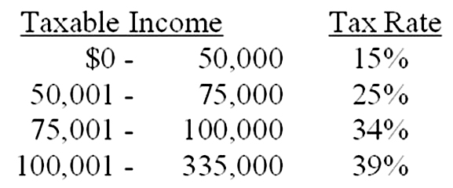  A. 21.38%  B. 23.88%  C. 25.76%  D. 34.64%  E. 39.00%

50. | The tax rates are as shown. Your firm currently has taxable income of $74,000. How much additional tax will the firm owe if it increases its taxable income by $25,000?  A. $9,700  B. $8,500  C. $6,250  D. $7,560  E. $8,410

51. | Nel's Place has total sales of $1,200, costs are $715, and depreciation is $145. The tax rate is 34 percent. The firm does not have any interest expense. What is the operating cash flow?  A. $93.08  B. $224.40  C. $310.60  D. $369.40  E. $600.60

52. | Teddy's Pillows had beginning net fixed assets of $600 and ending net fixed assets of $730. Assets valued at $400 were sold during the year. Depreciation was $50. What is the amount of net capital spending?  A. $130  B. $80  C. $450  D. $180  E. $350

53. | At the beginning of the year, a firm had current assets of $360 and current liabilities of $190. At the end of the year, the current assets are $510 and the current liabilities are $240. What is the change in net working capital?  A. -$30  B. -$10  C. $440  D. $220  E. $100

54. | At the beginning of the year, long-term debt of a firm is $270 and total debt is $340. At the end of the year, long-term debt is $290 and total debt is $390. The interest paid is $70. What is the amount of the cash flow to creditors?  A. -$50  B. -$120  C. $20  D. $50  E. $60

55. | Pete's Boats has beginning long-term debt of $180 and ending long-term debt of $210. The beginning and ending total debt balances are $340 and $360, respectively. The interest paid is $30. What is the amount of the cash flow to creditors?  A. -$10  B. $0  C. $10  D. $40  E. $50

56. | Peggy Grey's Cookies has net income of $360. The firm pays out 50 percent of the net income to its shareholders as dividends. During the year, the company sold $44 worth of common stock. What is the cash flow to stockholders?  A. $64  B. $136  C. $144  D. $224  E. $296

57. | Thompson's Jet Skis has operating cash flow of $258. Depreciation is $45 and interest paid is $53. A net total of $79 was paid on long-term debt. The firm spent $210 on fixed assets and increased net working capital by $48. What is the amount of the cash flow to stockholders?  A. -$104  B. -$132  C. $28  D. $114  E. $142

58. | 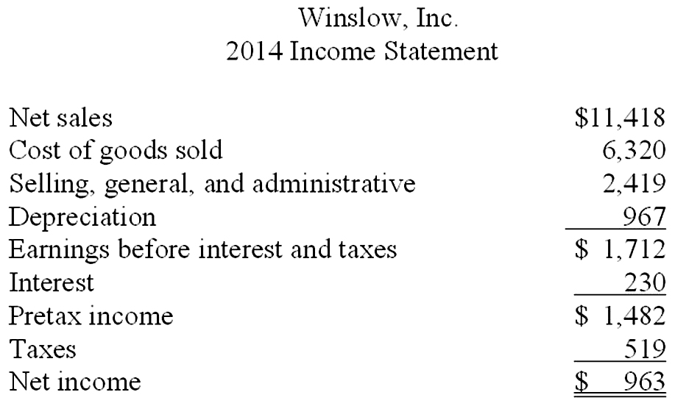  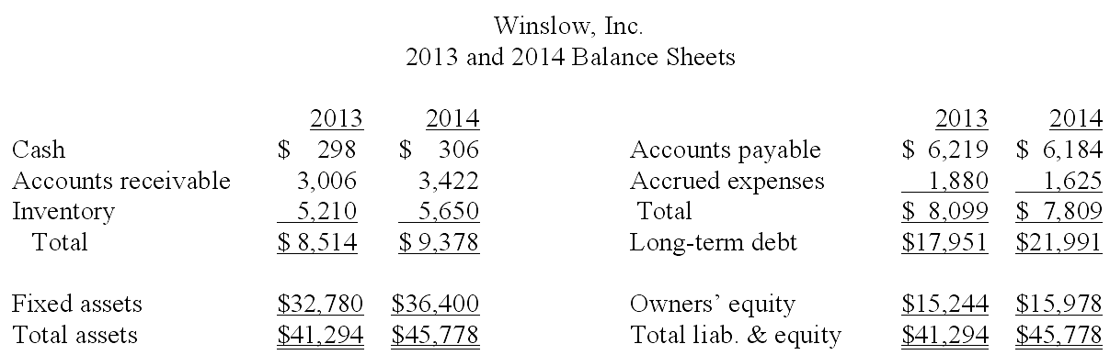  What is the change in the net working capital from 2013 to 2014?  A. $1,235  B. $1,035  C. $1,154  D. $1,984  E. $1,569

59. | 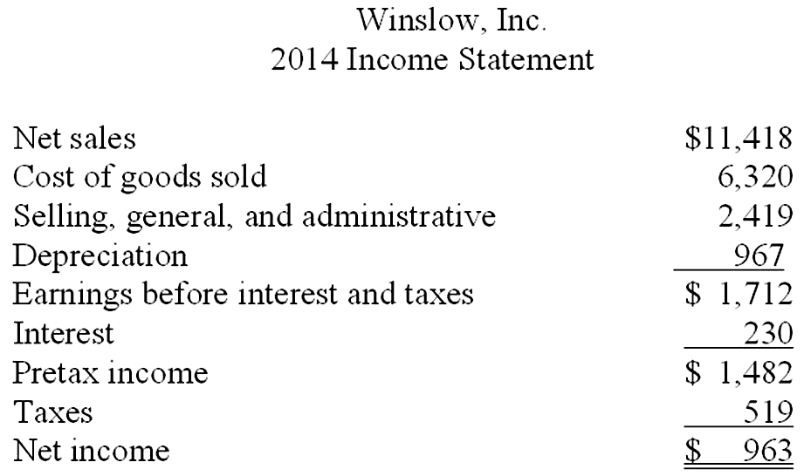  What is the average tax rate for 2014?  A. 34.00%  B. 34.21%  C. 35.02%  D. 35.00%  E. 30.32%

60. | 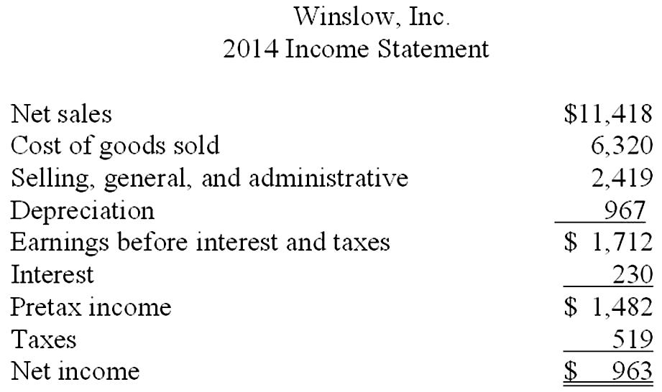  What is the amount of the net capital spending for 2014?  A. $3,517  B. $5,451  C. $4,484  D. $3,620  E. $4,587

61. | 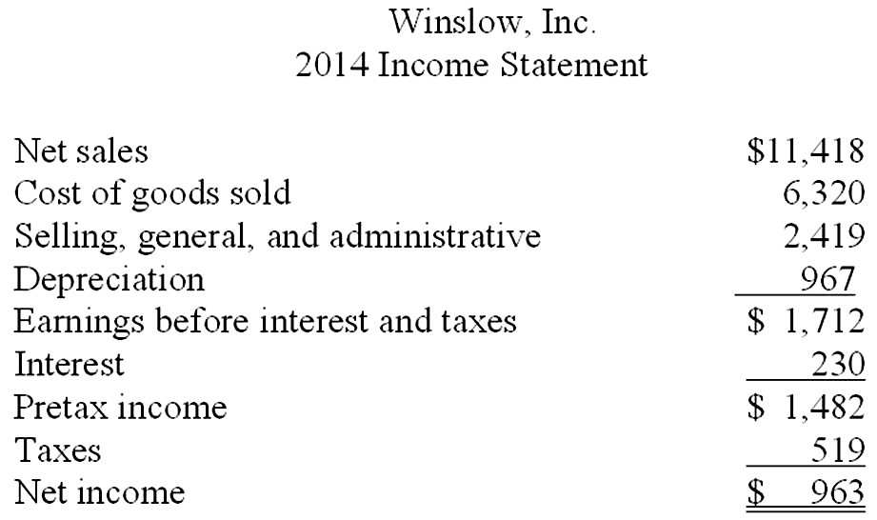  What is the amount of net working capital for 2014?  A. $415  B. $1,154  C. $1,569  D. $1,734  E. $734

62. | What is the cash flow of the firm, or (CF(A)), for 2014?  A. -$1,273  B. -$3,581  C. $1,273  D. $2,160  E. $3,414

63. | What is the amount of net new borrowing for 2014?  A. $3,750  B. $3,250  C. $3,360  D. $4,040  E. $3,480

64. | What is the cash flow to creditors for 2014?  A. -$3,650  B. -$4,040  C. -$3,350  D. -$4,270  E. -$3,810

65. | 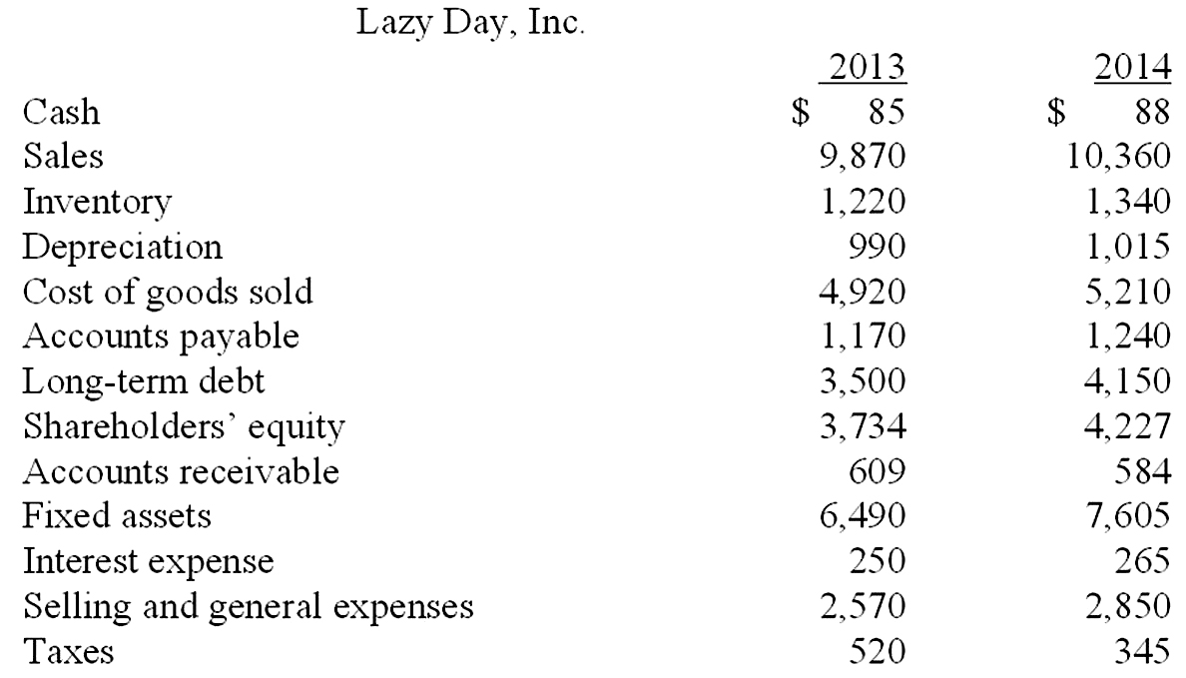  What is the net working capital for 2014?  A. $28  B. $34  C. $2,012  D. $744  E. $772

66. | 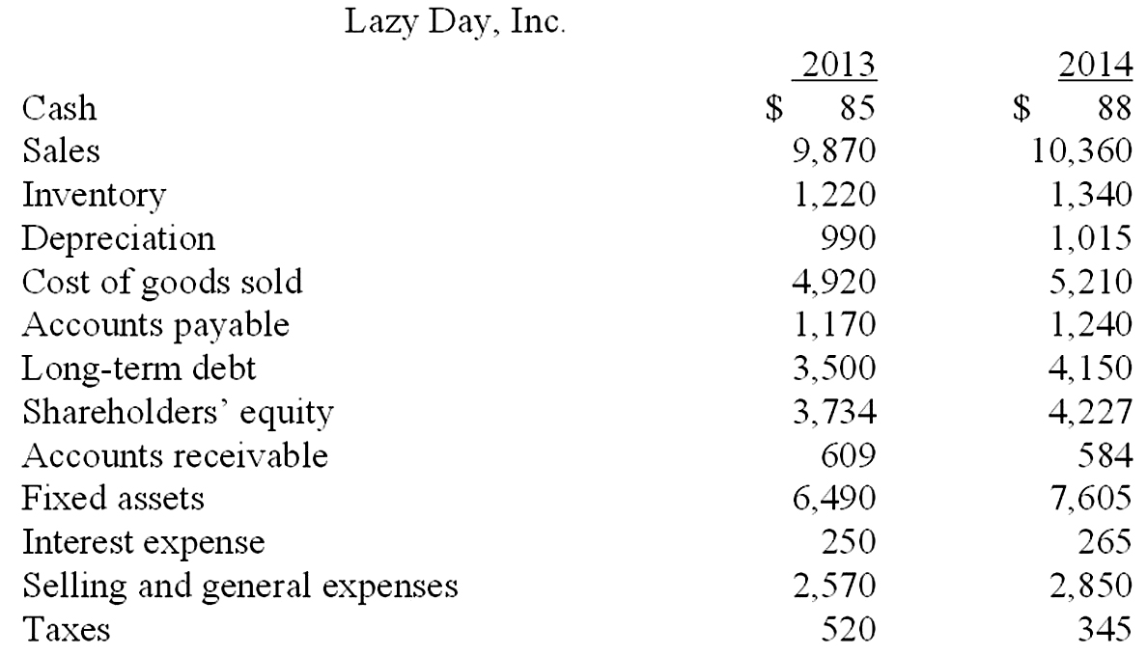  What is the amount of the additions to net working capital?  A. $28  B. $46  C. -$28  D. -$46  E. -$98

67. | What is net capital spending for 2014?  A. $1,115  B. $2,130  C. -$28  D. $0  E. $2,105

68. | What is the operating cash flow for 2014?  A. $1,690  B. $1,955  C. $2,645  D. $595  E. $2,300

69. | What is the cash flow of the firm, CF(A), for 2014?  A. $150  B. $113  C. $297  D. -$147  E. -$203

70. | What is net new borrowing for 2014?  A. $665  B. $635  C. $385  D. $915  E. $650

71. | What is the cash flow to creditors, CF(B), for 2014?  A. $385  B. -$915  C. -$385  D. $265  E. $915

72. | What is the cash flow to stockholders, CF(S), for 2014?  A. $588  B. $493  C. $182  D. -$428  E. $1,168

73. | 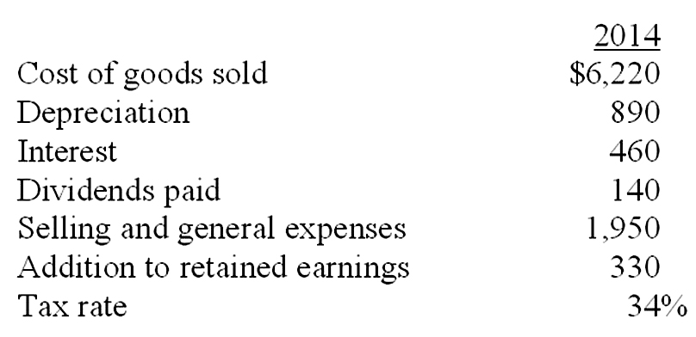  What is the taxable income for 2014?  A. $629.80  B. $500.00  C. $187.60  D. $712.12  E. $470.00

74. | What is the operating cash flow for 2014?  A. $1,423.14  B. $2,072.12  C. $1,820.00  D. $1,250.00  E. $1,360.00

75. | What are the sales for 2014?  A. $9,584.24  B. $4,385.76  C. $10,232.12  D. $4,815.00  E. $10,474.24

76. | Assume sales are $1,780; cost of goods sold is $545, general expenses are $100, depreciation expense is $185, interest paid is $35, and the tax rate is 35 percent. What is the net income amount?  A. $779.75  B. $615.30  C. $594.75  D. $320.25  E. $575.25

77. | 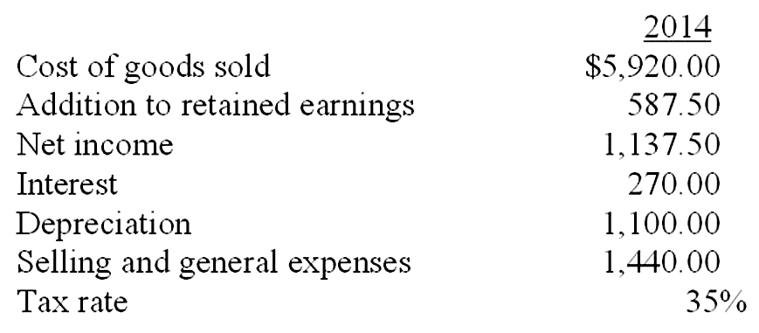  What is the taxable income for 2014?  A. $1,380.45  B. $1,805.62  C. $1,640.25  D. $1,535.63  E. $1,750.00

78. | 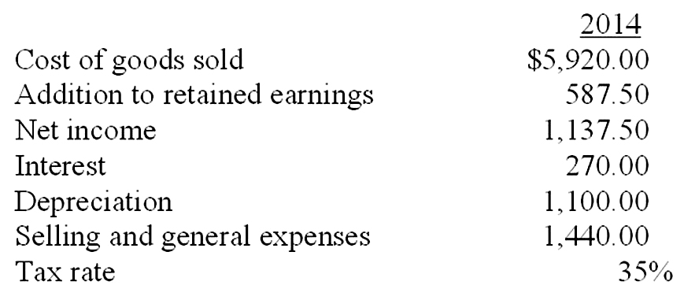  What is the operating cash flow for 2014?  A. $2,225.50  B. $2,850.00  C. $2,020.00  D. $2,507.50  E. $2,354.55

79. | 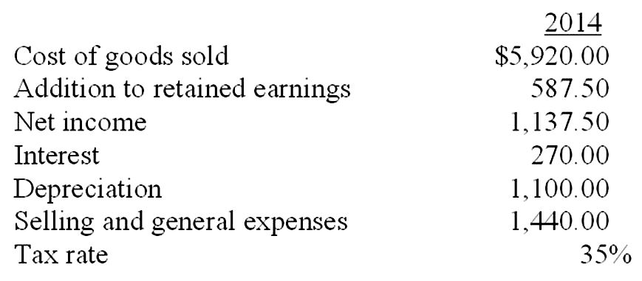  What is the amount of dividends paid in 2014?  A. $0  B. $1,162.50  C. $550.00  D. $1,725.00  E. $950.00

80. | Assume sales are $900, cost of goods sold is $450, depreciation expense is $80, interest paid is $40, selling and general expenses are $220, dividends paid is $10, and the tax rate is 34 percent. What is the addition to retained earnings?  A. $82.60  B. $62.60  C. $66.00  D. $79.20  E. $102.60

Essay Questions
81. | Identify three items that are included on an income statement but excluded from operating cash flows. Explain the reason for each exclusion.

82. | Identify three cash flows that occur between a firm and its stockholders. Indicate the direction of the cash flow in each case.

83. | Why is depreciation added as a part of the capital spending formula?

84. | Discuss the difference between the book value and market value of assets and explain which is more important to the financial manager and why.

85. | Interpret, in words, what cash flow of the firm, or CF(A), represents by discussing operating cash flow, changes in net working capital, and additions to fixed assets.

Chapter 02 Financial Statements and Cash Flow Answer Key

Multiple Choice Questions
1. | Assume both current and deferred taxes are positive values. Given this, deferred taxes will:  A. reduce the current tax expense and thus increase net income.  B. increase expenses and increase operating cash flows.  C. increase expenses and lower operating cash flows.  D. reduce net income but not affect the operating cash flows.  E. reduce both net income and operating cash flows.

Difficulty Level: 2 Medium
Topic: Deferred Taxes

2. | Which one of these is handled differently in calculating cash flows for accounting versus financial purposes?  A. Change in net working capital  B. Depreciation expense  C. Interest expense  D. Deferred taxes  E. Dividends paid

Difficulty Level: 1 Easy
Topic: Accounting versus Financial Cash Flows

3. | Which one of these will increase earnings per share?  A. Decreasing deferred taxes  B. Increasing depreciation expense  C. Lowering the operating income  D. Increasing the corporate tax rate  E. Lowering the percentage of net income added to retained earnings

Difficulty Level: 2 Medium
Topic: Earnings per share

4. | A current asset is best defined as:  A. the market value of all assets currently owned by the firm.  B. an asset the firm expects to purchase within the next year.  C. the amount of cash on hand the firm currently shows on its balance sheet.  D. cash and other assets owned by the firm that will convert to cash within the next year.  E. the value of fixed assets the firm expects to sell within the next year.

Difficulty Level: 1 Easy
Topic: Current Asset

5. | The long-term debts of a firm are liabilities:  A. owed to the firm's shareholders.  B. that do not come due for at least 12 months.  C. owed to the firm's suppliers.  D. that come due within the next 12 months.  E. the firm expects to incur within the next 12 months.

Difficulty Level: 1 Easy
Topic: Long-Term Debt

6. | A(n) ____ asset is one which can be quickly converted into cash without significant loss in value.  A. tangible  B. fixed  C. intangible  D. liquid  E. long-term

Difficulty Level: 1 Easy
Topic: Liquid Assets

7. | Noncash items refer to:  A. the credit sales of a firm.  B. the accounts payable of a firm.  C. all accounts on the balance sheet other than cash on hand.  D. the costs incurred for the purchase of intangible fixed assets.  E. expenses charged against revenues that do not directly affect cash flow.

Difficulty Level: 1 Easy
Topic: Noncash Items

8. | Your _____ tax rate is the percentage of the next taxable dollar of income you earn that is payable as a tax.  A. deductible  B. residual  C. marginal  D. average  E. total

Difficulty Level: 1 Easy
Topic: Marginal Tax Rate

9. | Your _____ tax rate measures the total taxes you pay divided by your total taxable income.  A. average  B. marginal  C. total  D. deductible  E. residual

Difficulty Level: 1 Easy
Topic: Average Tax Rates

10. | _____ refers to the cash flow resulting from a firm's ongoing, normal business activities.  A. Cash flow from assets  B. Net working capital  C. Capital spending  D. Cash flow from operating activities  E. Cash flow to creditors

Difficulty Level: 2 Medium
Topic: Cash Flow from Operating Activities

11. | _____ refers to the changes in net capital assets.  A. Cash flow from assets  B. Net working capital  C. Cash flow from investing  D. Operating cash flow  E. Cash flow to creditors

Difficulty Level: 2 Medium
Topic: Cash Flow from Investing

12. | _____ refers to the difference between a firm's current assets and its current liabilities.  A. Operating cash flow  B. Capital spending  C. Net working capital  D. Cash flow from assets  E. Cash flow to creditors

Difficulty Level: 1 Easy
Topic: Net Working Capital

13. | _____ is calculated by adding back noncash expenses to earnings before interest and taxes, subtracting taxes, and adjusting for any changes in total assets or current liabilities that affect cash flows.  A. Distributable cash flow  B. Capital spending  C. Cash flow from assets  D. Cash flow from investing activities  E. Cash flow to creditors

Difficulty Level: 2 Medium
Topic: Distributable cash flow

14. | _____ refers to a firm's interest payments minus any net new borrowing.  A. Operating cash flow  B. Distributable cash flow  C. Net working capital  D. Cash flow to equity investors  E. Cash flow to creditors

Difficulty Level: 1 Easy
Topic: Cash Flow to Creditors

15. | _____ refers to a firm's dividend payments minus any net new equity raised.  A. Operating cash flow  B. Capital spending  C. Net working capital  D. Cash flow to equity investors  E. Cash flow from creditors

Difficulty Level: 1 Easy
Topic: Cash Flow to Equity Investors

16. | Which of the following are included in current assets?  I. Equipment  II. Inventory  III. Accounts payable  IV. Cash  A. II and IV only  B. I and III only  C. I, II, and IV only  D. III and IV only  E. II, III, and IV only

Difficulty Level: 1 Easy
Topic: Current Asset

17. | Which of the following are included in current liabilities?  I. Debt payable to a mortgage company in nine months  II. Note payable to a supplier in eighteen months  III. Accounts payable to suppliers  IV. Loan payable to a bank in fourteen months  A. I and III only  B. II and III only  C. III and IV only  D. II, III, and IV only  E. I, II, and III only

Difficulty Level: 2 Medium
Topic: Current Liabilities

18. | Which one of the following accounts is generally the most liquid?  A. Patent  B. Building  C. Accounts receivable  D. Equipment  E. Inventory

Difficulty Level: 1 Easy
Topic: Liquidity

19. | Which one of the following statements concerning liquidity is correct?  A. Fixed assets are more liquid than current assets.  B. Balance sheet accounts are listed in order of decreasing liquidity.  C. Liquid assets tend to be highly profitable.  D. The less liquidity a firm has, the lower the probability the firm will encounter financial difficulties.  E. Trademarks and patents are highly liquid.

Difficulty Level: 1 Easy
Topic: Liquidity

20. | Liquidity is:  A. a measure of the use of debt in a firm's capital structure.  B. equal to current assets minus current liabilities.  C. equal to the market value of a firm's total assets minus its current liabilities.  D. generally associated with intangible assets.  E. valuable to a firm even though liquid assets tend to be less profitable to own.

Difficulty Level: 1 Easy
Topic: Liquidity

21. | Book value is:  A. based on historical cost.  B. equivalent to market value for firms with fixed assets.  C. more of a financial than an accounting valuation.  D. the amount a willing buyer will pay for an asset.  E. adjusted to market value whenever the market value exceeds the stated book value.

Difficulty Level: 1 Easy
Topic: Book Value

22. | When making financial decisions related to assets, you should:  A. place primary emphasis on historical costs.  B. place more emphasis on book values than on market values.  C. rely primarily on the value of assets as shown on the balance sheet.  D. always consider market values.  E. only consider market values if they are less than book values.

Difficulty Level: 1 Easy
Topic: Market Value

23. | As seen on an income statement:  A. interest is deducted from income and increases the total taxes incurred.  B. depreciation reduces both the pretax income and the net income.  C. depreciation is shown as an expense but does not affect the taxes payable.  D. the tax rate is applied to the earnings before interest and taxes when the firm has both depreciation and interest expenses.  E. interest expense is added to earnings before interest and taxes to get pretax income.

Difficulty Level: 2 Medium
Topic: Income Statement

24. | Depreciation:  A. reduces both the net fixed assets and the costs of a firm.  B. decreases net fixed assets, net income, and operating cash flows.  C. is a non-cash expense that decreases the selling, general, and administrative expenses.  D. is a non-cash expense that reduces the pretax income.  E. increases the net fixed assets as shown on the balance sheet.

Difficulty Level: 2 Medium
Topic: Noncash Items

25. | When you are making a financial decision, the most relevant tax rate is the _____ rate.  A. average  B. fixed  C. marginal  D. total  E. variable

Difficulty Level: 1 Easy
Topic: Marginal Tax Rate

26. | Al's has a positive net income and a tax rate of 34 percent. Given this, an increase in which one of the following will cause the operating cash flow to increase?  A. Fixed assets  B. Taxes  C. Net working capital  D. Cost of goods sold  E. Depreciation

Difficulty Level: 2 Medium
Topic: Operating Cash Flow

27. | A firm starts its year with a positive net working capital. During the year, the firm acquires more short-term debt than it does short-term assets. This means that:  A. the ending net working capital might be positive, negative, or equal to zero.  B. both accounts receivable and inventory decreased during the year.  C. the beginning current assets were less than the beginning current liabilities.  D. accounts payable increased and inventory decreased during the year.  E. the ending net working capital will be negative.

Difficulty Level: 2 Medium
Topic: Change in Net Working Capital

28. | The cash flow to creditors increases when:  A. cash is used to reduce accounts payable.  B. new shares of stock are sold for cash.  C. interest is paid on outstanding debt.  D. an asset is sold for cash.  E. a long-term debt is incurred.

Difficulty Level: 1 Easy
Topic: Cash Flow to Creditors

29. | Cash flow to stockholders must be positive when:  A. the net sale of common stock exceeds the amount of dividends paid.  B. no income is distributed but new shares of stock are sold.  C. both the cash flow to assets and the cash flow to creditors are negative.  D. both the cash flow to assets and the cash flow to creditors are positive.  E. the dividends paid exceed the net new equity raised.

Difficulty Level: 2 Medium
Topic: Cash Flow to Stockholders

30. | Which one of these, all else held constant, will increase the value of stockholders' equity?  A. Decrease in accounts receivable  B. Increase in long-term debt  C. Decrease in retained earnings  D. Increase in accounts payable  E. Increase in fixed assets

Difficulty Level: 2 Medium
Topic: Balance Sheet

31. | Which one of these statements is correct?  A. Long-term debt is the residual difference between assets and liabilities.  B. Net income that is not paid out in dividends decreases retained earnings.  C. Long-term debt requires a payout of cash within a stated time period.  D. Stockholders' equity is stated at market value on the balance sheet.  E. Stockholders' equity increases as the liquidity of a firm increases.

Difficulty Level: 2 Medium
Topic: Balance Sheet

32. | The carrying value or book value of assets:  A. is always the best measure of a company's value to an investor.  B. represents an average market value over time.  C. is always higher than the replacement cost of the assets.  D. is determined under GAAP and is based on the cost of the assets.  E. is determined under GAPP and is based on the current market value of the assets.

Difficulty Level: 2 Medium
Topic: Carrying Value

33. | When evaluating a balance sheet, a financial manager should consider which of the following?  I. Value versus cost  II. Debt versus equity  III. Accounting liquidity  A. I only  B. I and III only  C. II only  D. I and II only  E. I, II, and III

Difficulty Level: 2 Medium
Topic: Balance Sheet

34. | The income statement:  A. measures a firm's performance as of a specific date.  B. determines the aftertax income of a firm.  C. excludes deferred taxes.  D. includes dividends as an expense.  E. determines the value of a firm to its shareholders.

Difficulty Level: 2 Medium
Topic: Income Statement

35. | What is the formula for computing operating cash flow?  A. EBIT + Depreciation - Current taxes  B. EBIT + Depreciation - Interest expense - Taxes  C. EBIT + NWC - Depreciation  D. EBIT - Depreciation + Current taxes  E. EBIT - NWC + Depreciation - Current taxes

Difficulty Level: 2 Medium
Topic: Operating Cash Flow

36. | Net capital spending is equal to:  A. the net purchases and sales of fixed assets.  B. total cash flow to stockholders less interest and dividends paid.  C. net income plus depreciation.  D. the change in total assets.  E. the change in current assets minus the change in current liabilities.

Difficulty Level: 2 Medium
Topic: Net Capital Spending

37. | Cash flow to equity holders is defined as:  A. the total dividends paid.  B. the cash flow from assets plus the cash flow to creditors.  C. cash dividends plus repurchases of equity minus new equity financing.  D. repurchases of equity less cash dividends paid plus new equity sold.  E. the net change in common stock and capital surplus.

Difficulty Level: 2 Medium
Topic: Cash Flow to Equity Holders

38. | Free cash flow is:  A. without cost to the firm.  B. equal to net income plus taxes.  C. a term used to describe an increase in net working capital.  D. cash that is available to distribute to creditors and equity holders.  E. another term for operating cash flow.

Difficulty Level: 2 Medium
Topic: Free Cash Flow

39. | The cash flow of a firm, also referred to as cash flow from assets, must be equal to the cash flow to:  A. debt holders minus the cash flow to equity holders.  B. equity holders plus the cash flow to debt holders.  C. the government plus the cash flow to equity holders.  D. equity holders minus the cash flow to debt holders.  E. the government, the debt holders, and the equity holders.

Difficulty Level: 2 Medium
Topic: Cash Flow

40. | A change in which one of these accounts will appear as an investing activity in an accounting statement of cash flows?  A. Accounts payable  B. Inventory  C. Interest expense  D. Fixed assets  E. Sales

Difficulty Level: 2 Medium
Topic: Statement of Cash Flows

41. | A firm has total equity of $1,890, net working capital of $150, long-term debt of $890, and current liabilities of $720. What is the amount of the net fixed assets?  A. $2,330  B. $2,930  C. $2,630  D. $3,050  E. $3,350  Net fixed assets = $890 + 1,890 - 150 = $2,630

Difficulty Level: 2 Medium
Topic: Balance Sheet

42. | A firm has beginning retained earnings of $4,200 and ending retained earnings of $4,650. What is the amount of dividends paid if the firm earned a net income of $1,950?  A. $450  B. $1,950  C. $2,400  D. $1,500  E. $900  Dividends paid = $1,950 - ($4,650 - 4,200) = $1,500

Difficulty Level: 2 Medium
Topic: Dividends paid

43. | Lester's has $23,600 in sales, $13,200 in cost of goods sold, $2,300 in depreciation, $900 in interest expense, and $6,200 in selling, general, and administrative expenses. The firm owes no taxes for this year. What is the amount of the period costs that are included in the operating cash flow?  A. $19,400  B. $7,000  C. $9,300  D. $20,300  E. $6,200  Period costs = Selling, general, and administrative expenses = $6,200  Cost of goods sold is a product cost, depreciation is a non-cash expense, and interest expense is a cash flow to creditors.

Difficulty Level: 2 Medium
Topic: Period Costs and Operating Cash Flow

44. | A firm has $800 in inventory, $1,400 in fixed assets, $500 in accounts receivables, $100 in net working capital, and $50 in cash. What is the amount of the current liabilities?  A. $3,750  B. $1,350  C. $3,950  D. $1,150  E. $1,250  Current liabilities = ($50 + 500 + 800) - $100 = $1,250

Difficulty Level: 2 Medium
Topic: Net Working Capital

45. | Total assets are $1,500, fixed assets are $1,100, long-term debt is $600, and short-term debt is $300. What is the amount of net working capital?  A. $0  B. $100  C. $200  D. $300  E. $400  Net working capital = ($1,500 - 1,100) - $300 = $100

Difficulty Level: 2 Medium
Topic: Net Working Capital

46. | Brad's Company has equipment with a book value of $500 that could be sold today at a 50 percent discount. Its inventory is valued at $400 and could be sold to a competitor for that amount. The firm has $50 in cash and customers owe them $300. What is the accounting value of its liquid assets?  A. $50  B. $350  C. $700  D. $750  E. $1,000  Liquid assets = $400 + 50 + 300 = $750

Difficulty Level: 2 Medium
Topic: Liquidity

47. | Martha's Enterprises spent $2,400 to purchase equipment three years ago. This equipment is currently valued at $2,000 on today's balance sheet but could actually be sold for $2,200. Net working capital is $300 and long-term debt is $1,100. Assuming the equipment is the firm's only fixed asset, what is the book value of shareholders' equity?  A. $1,000  B. $800  C. $1,200  D. $1,400  E. $1,600  Book value of shareholders' equity = $2,000 + 300 - 1,100 = $1,200

Difficulty Level: 2 Medium
Topic: Book Value

48. | Art's Boutique has sales of $640,000 and costs of $480,000. Interest expense is $40,000 and depreciation is $60,000. The tax rate is 34 percent. What is the net income?  A. $20,400  B. $39,600  C. $50,400  D. $79,200  E. $99,600  Taxable income = ($640,000 - 480,000 - 40,000 - 60,000)(1 - .34) = $39,600

Difficulty Level: 2 Medium
Topic: Net Income

49. | Given the tax rates as shown, what is the average tax rate for a firm with taxable income of $126,500?  A. 21.38%  B. 23.88%  C. 25.76%  D. 34.64%  E. 39.00%  Tax = .15($50,000) + .25($25,000) + .34($25,000) + .39($126,500 - 100,000) = $32,585  Average tax rate = $32,585/$126,500 = .2576, or 25.76%

Difficulty Level: 2 Medium
Topic: Marginal Tax Rate

50. | The tax rates are as shown. Your firm currently has taxable income of $74,000. How much additional tax will the firm owe if it increases its taxable income by $25,000?  A. $9,700  B. $8,500  C. $6,250  D. $7,560  E. $8,410  Additional tax = .25($1,000) + .34($24,000) = $8,410

Difficulty Level: 2 Medium
Topic: Taxes

51. | Nel's Place has total sales of $1,200, costs are $715, and depreciation is $145. The tax rate is 34 percent. The firm does not have any interest expense. What is the operating cash flow?  A. $93.08  B. $224.40  C. $310.60  D. $369.40  E. $600.60  Earnings before interest and taxes = $1,200 - 715 - 145 = $340  Tax = .34($340) = $115.60  Operating cash flow = $340 + 145 - 115.60 = $369.40

Difficulty Level: 2 Medium
Topic: Operating Cash Flow

52. | Teddy's Pillows had beginning net fixed assets of $600 and ending net fixed assets of $730. Assets valued at $400 were sold during the year. Depreciation was $50. What is the amount of net capital spending?  A. $130  B. $80  C. $450  D. $180  E. $350  Net capital spending = $730 - 600 + 50 = $180

Difficulty Level: 2 Medium
Topic: Net Capital Spending

53. | At the beginning of the year, a firm had current assets of $360 and current liabilities of $190. At the end of the year, the current assets are $510 and the current liabilities are $240. What is the change in net working capital?  A. -$30  B. -$10  C. $440  D. $220  E. $100  Change in net working capital = ($510 - 240) - ($360 - 190) = $100

Difficulty Level: 2 Medium
Topic: Change in Net Working Capital

54. | At the beginning of the year, long-term debt of a firm is $270 and total debt is $340. At the end of the year, long-term debt is $290 and total debt is $390. The interest paid is $70. What is the amount of the cash flow to creditors?  A. -$50  B. -$120  C. $20  D. $50  E. $60  Cash flow to creditors = $70 - ($290 - 270) = $50

Difficulty Level: 2 Medium
Topic: Cash Flow to Creditors

55. | Pete's Boats has beginning long-term debt of $180 and ending long-term debt of $210. The beginning and ending total debt balances are $340 and $360, respectively. The interest paid is $30. What is the amount of the cash flow to creditors?  A. -$10  B. $0  C. $10  D. $40  E. $50  Cash flow to creditors = $30 - ($210 - 180) = $0

Difficulty Level: 2 Medium
Topic: Cash Flow to Creditors

56. | Peggy Grey's Cookies has net income of $360. The firm pays out 50 percent of the net income to its shareholders as dividends. During the year, the company sold $44 worth of common stock. What is the cash flow to stockholders?  A. $64  B. $136  C. $144  D. $224  E. $296  Cash flow to stockholders = .50($360) - $44 = $136

Difficulty Level: 2 Medium
Topic: Cash Flow to Stockholders

57. | Thompson's Jet Skis has operating cash flow of $258. Depreciation is $45 and interest paid is $53. A net total of $79 was paid on long-term debt. The firm spent $210 on fixed assets and increased net working capital by $48. What is the amount of the cash flow to stockholders?  A. -$104  B. -$132  C. $28  D. $114  E. $142  CF(A) = $258 - 48 - 210 = $0; CF(B) = $53 - (-$79) = $132; CF(S) = $0 - 132 = -$132

Difficulty Level: 2 Medium
Topic: Cash Flow to Stockholders

58. | What is the change in the net working capital from 2013 to 2014?  A. $1,235  B. $1,035  C. $1,154  D. $1,984  E. $1,569  Change in net working capital = ($9,378 - 7,809) - ($8,514 - 8,099) = $1,154

Difficulty Level: 2 Medium
Topic: Change in Net Working Capital

59. | What is the average tax rate for 2014?  A. 34.00%  B. 34.21%  C. 35.02%  D. 35.00%  E. 30.32%  Average tax rate = $519/$1,482 = .3502, or 35.02%

Difficulty Level: 2 Medium
Topic: Average Tax Rates

60. | What is the amount of the net capital spending for 2014?  A. $3,517  B. $5,451  C. $4,484  D. $3,620  E. $4,587  Net capital spending = $36,400 - 32,780 + 967 = $4,587

Difficulty Level: 2 Medium
Topic: Net Capital Spending

61. | What is the amount of net working capital for 2014?  A. $415  B. $1,154  C. $1,569  D. $1,734  E. $734  Net working capital for 2014 = $9,378 - 7,809 = $1,569

Difficulty Level: 2 Medium
Topic: Net Working Capital

62. | What is the cash flow of the firm, or (CF(A)), for 2014?  A. -$1,273  B. -$3,581  C. $1,273  D. $2,160  E. $3,414  Operating cash flow = $1,712 + 967 - 519 = $2,160  Change in net working capital = ($9,378 - 7,809) - ($8,514 - 8,099) = $1,154  Net capital spending = $36,400 - 32,780 + 967 = $4,587  Cash flow of the firm = $2,160 - 1,154 - 4,587 = -$3,581

Difficulty Level: 3 Hard
Topic: Cash Flow of the Firm

63. | What is the amount of net new borrowing for 2014?  A. $3,750  B. $3,250  C. $3,360  D. $4,040  E. $3,480  Net new borrowing = $21,991 - 17,951 = $4,040

Difficulty Level: 2 Medium
Topic: Net New Borrowing

64. | What is the cash flow to creditors for 2014?  A. -$3,650  B. -$4,040  C. -$3,350  D. -$4,270  E. -$3,810  CF(B) = $230 - ($21,991 - 17,951) = -$3,810

Difficulty Level: 2 Medium
Topic: Cash Flow to Creditors

65. | What is the net working capital for 2014?  A. $28  B. $34  C. $2,012  D. $744  E. $772  NWC₂₀₁₄ = $88 + 584 + 1,340 - 1,240 = $772

Difficulty Level: 2 Medium
Topic: Net Working Capital

66. | What is the amount of the additions to net working capital?  A. $28  B. $46  C. -$28  D. -$46  E. -$98  Additions to net working capital = ($88 + 584 + 1,340 - 1,240) - ($85 + 609 + 1,220 - 1,170) = $28

Difficulty Level: 2 Medium
Topic: Additions to Net Working Capital

67. | What is net capital spending for 2014?  A. $1,115  B. $2,130  C. -$28  D. $0  E. $2,105  NCS₂₀₁₄ = $7,605 - 6,490 + 1,015 = $2,130

Difficulty Level: 2 Medium
Topic: Net Capital Spending

68. | What is the operating cash flow for 2014?  A. $1,690  B. $1,955  C. $2,645  D. $595  E. $2,300  EBIT = $10,360 - 5,210 - 2,850 - 1,015 = $1,285  OCF = $1,285 + 1,015 - 345 = $1,955

Difficulty Level: 3 Hard
Topic: Operating Cash Flow

69. | What is the cash flow of the firm, CF(A), for 2014?  A. $150  B. $113  C. $297  D. -$147  E. -$203  EBIT = $10,360 - 5,210 - 2,850 - 1,015 = $1,285  Operating cash flow = $1,285 + 1,015 - 345 = $1,955  Additions to net working capital = ($88 + 584 + 1,340 - 1,240) - ($85 + 609 + 1,220 - 1,170) = $28  Net capital spending = $7,605 - 6,490 + 1,015 = $2,130  CF(A) = $1,955 - 28 - 2,130 = -$203

Difficulty Level: 3 Hard
Topic: Cash Flow of the Firm

70. | What is net new borrowing for 2014?  A. $665  B. $635  C. $385  D. $915  E. $650  Net new borrowing = $4,150 - 3,500 = $650

Difficulty Level: 2 Medium
Topic: Net New Borrowing

71. | What is the cash flow to creditors, CF(B), for 2014?  A. $385  B. -$915  C. -$385  D. $265  E. $915  Cash flow to creditors or CF(B) = $265 - ($4,150 - 3,500) = -$385

Difficulty Level: 2 Medium
Topic: Cash Flow to Creditors

72. | What is the cash flow to stockholders, CF(S), for 2014?  A. $588  B. $493  C. $182  D. -$428  E. $1,168  EBIT = $10,360 - 5,210 - 2,850 - 1,015 = $1,285  Operating cash flow = $1,285 + 1,015 - 345 = $1,955  Additions to net working capital = ($88 + 584 + 1,340 - 1,240) - ($85 + 609 + 1,220 - 1,170) = $28  Net capital spending = $7,605 - 6,490 + 1,015 = $2,130  CF(A) = $1,955 - 28 - 2,130 = -$203  CF(B) = $265 - ($4,150 - 3,500) = -$385  CF(S) = -$203 - (-$385) = $182

Difficulty Level: 3 Hard
Topic: Cash Flow to Stockholders

73. | What is the taxable income for 2014?  A. $629.80  B. $500.00  C. $187.60  D. $712.12  E. $470.00  Net income = $330 + 140 = $470  Taxable income = $470/(1 - .34) = $712.12

Difficulty Level: 2 Medium
Topic: Taxable Income

74. | What is the operating cash flow for 2014?  A. $1,423.14  B. $2,072.12  C. $1,820.00  D. $1,250.00  E. $1,360.00  Net income = $330 + 140 = $470  Taxable income = $470/(1 - .34) = $712.12  Tax = .34($712.12) = $242.12  Earnings before interest and taxes = $712.12 + 460 = $1,172.12  Operating cash flow = $1,172.12 + 890 - 242.12 = $1,820.00

Difficulty Level: 3 Hard
Topic: Operating Cash Flow

75. | What are the sales for 2014?  A. $9,584.24  B. $4,385.76  C. $10,232.12  D. $4,815.00  E. $10,474.24  Net income = $330 + 140 = $470  Taxable income = $470/(1 - .34) = $712.12  Earnings before interest and taxes = $712.12 + 460 = $1,172.12  Sales = $6,220 + 1,950 + 890 + 1,172.12 = $10,232.12

Difficulty Level: 2 Medium
Topic: Sales

76. | Assume sales are $1,780; cost of goods sold is $545, general expenses are $100, depreciation expense is $185, interest paid is $35, and the tax rate is 35 percent. What is the net income amount?  A. $779.75  B. $615.30  C. $594.75  D. $320.25  E. $575.25  Net Income = (1 - .35)($1,780 - 545 - 100 - 185 - 35) = $594.75

Difficulty Level: 2 Medium
Topic: Net Income

77. | What is the taxable income for 2014?  A. $1,380.45  B. $1,805.62  C. $1,640.25  D. $1,535.63  E. $1,750.00  Taxable income = $1,137.50/(1 - .35) = $1,750.00

Difficulty Level: 2 Medium
Topic: Taxable Income

78. | What is the operating cash flow for 2014?  A. $2,225.50  B. $2,850.00  C. $2,020.00  D. $2,507.50  E. $2,354.55  Taxable income = $1,137.50/(1 - .35) = $1,750.00  Taxes = $1,750 - 1,137.50 = $612.50  Earnings before interest and taxes = $1,750 + 270 = $2,020  Operating cash flow = $2,020 + 1,100 - 612.50 = $2,507.50

Difficulty Level: 3 Hard
Topic: Operating Cash Flow

79. | What is the amount of dividends paid in 2014?  A. $0  B. $1,162.50  C. $550.00  D. $1,725.00  E. $950.00  Dividends paid = $1,137.50 - 587.50 = $550.00

Difficulty Level: 2 Medium
Topic: Dividends paid

80. | Assume sales are $900, cost of goods sold is $450, depreciation expense is $80, interest paid is $40, selling and general expenses are $220, dividends paid is $10, and the tax rate is 34 percent. What is the addition to retained earnings?  A. $82.60  B. $62.60  C. $66.00  D. $79.20  E. $102.60  Net income = (1 - .34)($900 - 450 - 220 - 80 - 40) = $72.60  Addition to retained earnings = $72.60 - 10 = $62.60

Difficulty Level: 2 Medium
Topic: Net Income

Essay Questions
81. | Identify three items that are included on an income statement but excluded from operating cash flows. Explain the reason for each exclusion.  The three items are:  1) Depreciation: Depreciation is a non-cash expense.  2) Deferred taxes: Deferred taxes is a non-cash expense.  3) Interest expense: Interest expense is a cost of financing, not an operating expense.

Difficulty Level: 3 Hard
Topic: Operating Cash Flow

82. | Identify three cash flows that occur between a firm and its stockholders. Indicate the direction of the cash flow in each case.  The three cash flows are:  1) Sale of equity securities: Cash inflow to the firm  2) Repurchase of outstanding securities: Cash outflow from the firm  3) Dividends paid: Cash outflow from the firm

Difficulty Level: 3 Hard
Topic: Cash Flow to Stockholders

83. | Why is depreciation added as a part of the capital spending formula?  The purpose of the capital spending formula is to determine the net fixed asset purchases, or purchases minus dispositions, for the period. Since depreciation expense lowers the ending net fixed asset balance, depreciation must be added back to offset that decrease. Once the depreciation expense has been offset, then the net fixed asset purchases is just the difference between the ending and beginning account values.

Difficulty Level: 2 Medium
Topic: Operating Cash Flow

84. | Discuss the difference between the book value and market value of assets and explain which is more important to the financial manager and why.  The accounts on the balance sheet are generally carried at historical cost, not market values. Although the book value of current assets and current liabilities may closely approximate market values, the same cannot be said for the rest of the balance sheet accounts. Ultimately, the financial manager should focus on the firm's stock price, which is a market value measure. Hence, market values are more meaningful than book values.

Difficulty Level: 3 Hard
Topic: Book Value and Market Value

85. | Interpret, in words, what cash flow of the firm, or CF(A), represents by discussing operating cash flow, changes in net working capital, and additions to fixed assets.  Operating cash flow is the cash flow a firm generates from its day-to-day operations. In other words, it is the cash inflow generated as a result of putting the firm's assets to work. Changes in net working capital and fixed assets represent investments a firm makes in these assets. That is, a firm typically takes some of the cash flow it generates from using assets and reinvests it in new assets. Cash flow of the firm, then, is the cash flow a firm generates by employing its assets, net of any acquisitions.

Difficulty Level: 3 Hard
Topic: Cash Flow of the Firm

