Chapter 02
Consolidation of Financial Information

Multiple Choice Questions
1. | At the date of an acquisition which is not a bargain purchase, the acquisition method  A. consolidates the subsidiary's assets at fair value and the liabilities at book value.  B. consolidates all subsidiary assets and liabilities at book value.  C. consolidates all subsidiary assets and liabilities at fair value.  D. consolidates current assets and liabilities at book value, long-term assets and liabilities at fair value.  E. consolidates the subsidiary's assets at book value and the liabilities at fair value.

2. | In an acquisition where control is achieved, how would the land accounts of the parent and the land accounts of the subsidiary be combined?  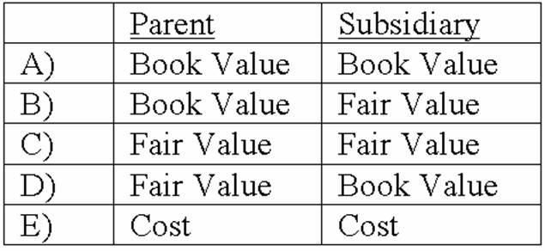  A. Option A  B. Option B  C. Option C  D. Option D  E. Option E

3. | Lisa Co. paid cash for all of the voting common stock of Victoria Corp. Victoria will continue to exist as a separate corporation. Entries for the consolidation of Lisa and Victoria would be recorded in  A. a worksheet.  B. Lisa's general journal.  C. Victoria's general journal.  D. Victoria's secret consolidation journal.  E. the general journals of both companies.

4. | Using the acquisition method for a business combination, goodwill is generally defined as:  A. Cost of the investment less the subsidiary's book value at the beginning of the year.  B. Cost of the investment less the subsidiary's book value at the acquisition date.  C. Cost of the investment less the subsidiary's fair value at the beginning of the year.  D. Cost of the investment less the subsidiary's fair value at acquisition date.  E. is no longer allowed under federal law.

5. | Direct combination costs and stock issuance costs are often incurred in the process of making a controlling investment in another company. How should those costs be accounted for in a pre-2009 purchase transaction?  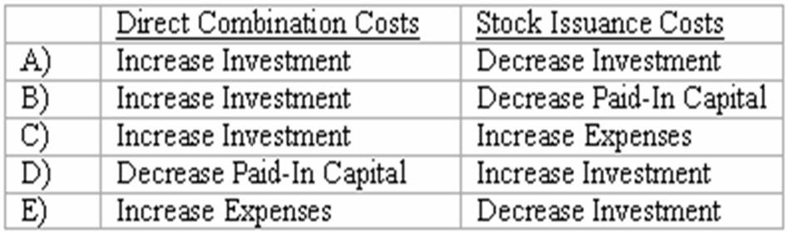  A. Option A  B. Option B  C. Option C  D. Option D  E. Option E

6. | How are direct and indirect costs accounted for when applying the acquisition method for a business combination?  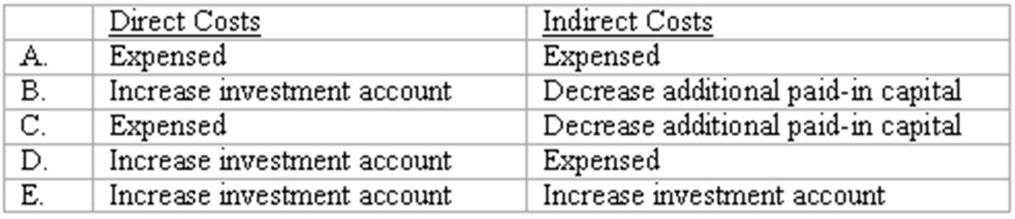  A. Option A  B. Option B  C. Option C  D. Option D  E. Option E

7. | What is the primary accounting difference between accounting for when the subsidiary is dissolved and when the subsidiary retains its incorporation?  A. If the subsidiary is dissolved, it will not be operated as a separate division.  B. If the subsidiary is dissolved, assets and liabilities are consolidated at their book values.  C. If the subsidiary retains its incorporation, there will be no goodwill associated with the acquisition.  D. If the subsidiary retains its incorporation, assets and liabilities are consolidated at their book values.  E. If the subsidiary retains its incorporation, the consolidation is not formally recorded in the accounting records of the acquiring company.

8. | According to GAAP, the pooling of interest method for business combinations  A. Is preferred to the purchase method.  B. Is allowed for all new acquisitions.  C. Is no longer allowed for business combinations after June 30, 2001.  D. Is no longer allowed for business combinations after December 31, 2001.  E. Is only allowed for large corporate mergers like Exxon and Mobil.

9. | An example of a difference in types of business combination is:  A. A statutory merger can only be effected by an asset acquisition while a statutory consolidation can only be effected by a capital stock acquisition.  B. A statutory merger can only be effected by a capital stock acquisition while a statutory consolidation can only be effected by an asset acquisition.  C. A statutory merger requires dissolution of the acquired company while a statutory consolidation does not require dissolution.  D. A statutory consolidation requires dissolution of the acquired company while a statutory merger does not require dissolution.  E. Both a statutory merger and a statutory consolidation can only be effected by an asset acquisition but only a statutory consolidation requires dissolution of the acquired company.

10. | Acquired in-process research and development is considered as  A. a definite-lived asset subject to amortization.  B. a definite-lived asset subject to testing for impairment.  C. an indefinite-lived asset subject to amortization.  D. an indefinite-lived asset subject to testing for impairment.  E. a research and development expense at the date of acquisition.

11. | Which one of the following is a characteristic of a business combination accounted for as an acquisition?  A. The combination must involve the exchange of equity securities only.  B. The transaction establishes an acquisition fair value basis for the company being acquired.  C. The two companies may be about the same size, and it is difficult to determine the acquired company and the acquiring company.  D. The transaction may be considered to be the uniting of the ownership interests of the companies involved.  E. The acquired subsidiary must be smaller in size than the acquiring parent.

12. | Which one of the following is a characteristic of a business combination that is accounted for as an acquisition?  A. Fair value only for items received by the acquirer can enter into the determination of the acquirer's accounting valuation of the acquired company.  B. Fair value only for the consideration transferred by the acquirer can enter into the determination of the acquirer's accounting valuation of the acquired company.  C. Fair value for the consideration transferred by the acquirer as well as the fair value of items received by the acquirer can enter into the determination of the acquirer's accounting valuation of the acquired company.  D. Fair value for only consideration transferred and identifiable assets received by the acquirer can enter into the determination of the acquirer's accounting valuation of the acquired company.  E. Only fair value of identifiable assets received enters into the determination of the acquirer's accounting valuation of the acquired company.

13. | A statutory merger is a(n)  A. business combination in which only one of the two companies continues to exist as a legal corporation.  B. business combination in which both companies continue to exist.  C. acquisition of a competitor.  D. acquisition of a supplier or a customer.  E. legal proposal to acquire outstanding shares of the target's stock.

14. | How are stock issuance costs and direct combination costs treated in a business combination which is accounted for as an acquisition when the subsidiary will retain its incorporation?  A. Stock issuance costs are a part of the acquisition costs, and the direct combination costs are expensed.  B. Direct combination costs are a part of the acquisition costs, and the stock issuance costs are a reduction to additional paid-in capital.  C. Direct combination costs are expensed and stock issuance costs are a reduction to additional paid-in capital.  D. Both are treated as part of the acquisition consideration transferred.  E. Both are treated as a reduction to additional paid-in capital.

15. | Bullen Inc. acquired 100% of the voting common stock of Vicker Inc. on January 1, 2013. The book value and fair value of Vicker's accounts on that date (prior to creating the combination) follow, along with the book value of Bullen's accounts:  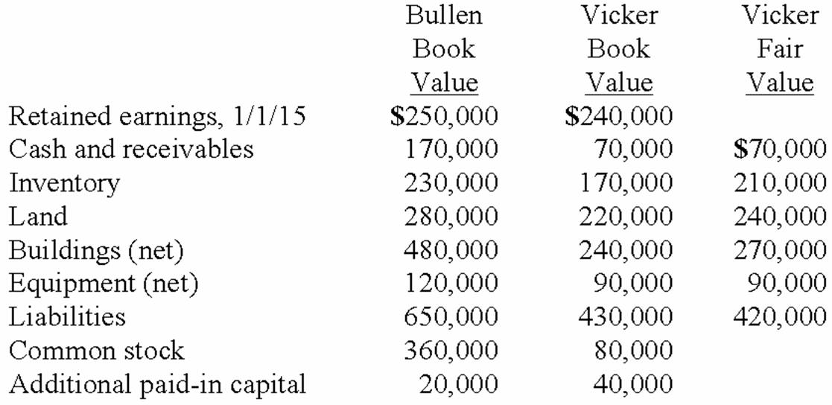  Assume that Bullen issued 12,000 shares of common stock with a $5 par value and a $47 fair value to obtain all of Vicker's outstanding stock. In this acquisition transaction, how much goodwill should be recognized?  A. $144,000.  B. $104,000.  C. $64,000.  D. $60,000.  E. $0.

16. | Bullen Inc. acquired 100% of the voting common stock of Vicker Inc. on January 1, 2013. The book value and fair value of Vicker's accounts on that date (prior to creating the combination) follow, along with the book value of Bullen's accounts:  Assume that Bullen issued 12,000 shares of common stock with a $5 par value and a $42 fair value for all of the outstanding stock of Vicker. What is the consolidated balance for Land as a result of this acquisition transaction?  A. $460,000.  B. $510,000.  C. $500,000.  D. $520,000.  E. $490,000.

17. | Bullen Inc. acquired 100% of the voting common stock of Vicker Inc. on January 1, 2013. The book value and fair value of Vicker's accounts on that date (prior to creating the combination) follow, along with the book value of Bullen's accounts:  Assume that Bullen issued 12,000 shares of common stock with a $5 par value and a $42 fair value for all of the outstanding shares of Vicker. What will be the consolidated Additional Paid-In Capital and Retained Earnings (January 1, 2013 balances) as a result of this acquisition transaction?  A. $60,000 and $490,000.  B. $60,000 and $250,000.  C. $380,000 and $250,000.  D. $464,000 and $250,000.  E. $464,000 and $420,000.

18. | Bullen Inc. acquired 100% of the voting common stock of Vicker Inc. on January 1, 2013. The book value and fair value of Vicker's accounts on that date (prior to creating the combination) follow, along with the book value of Bullen's accounts:  Assume that Bullen issued preferred stock with a par value of $240,000 and a fair value of $500,000 for all of the outstanding shares of Vicker in an acquisition business combination. What will be the balance in the consolidated Inventory and Land accounts?  A. $440,000, $496,000.  B. $440,000, $520,000.  C. $425,000, $505,000.  D. $400,000, $500,000.  E. $427,000, $510,000.

19. | Bullen Inc. acquired 100% of the voting common stock of Vicker Inc. on January 1, 2013. The book value and fair value of Vicker's accounts on that date (prior to creating the combination) follow, along with the book value of Bullen's accounts:  Assume that Bullen paid a total of $480,000 in cash for all of the shares of Vicker. In addition, Bullen paid $35,000 to a group of attorneys for their work in arranging the combination to be accounted for as an acquisition. What will be the balance in consolidated goodwill?  A. $0.  B. $20,000.  C. $35,000.  D. $55,000.  E. $65,000.

20. | Prior to being united in a business combination, Botkins Inc. and Volkerson Corp. had the following stockholders' equity figures:  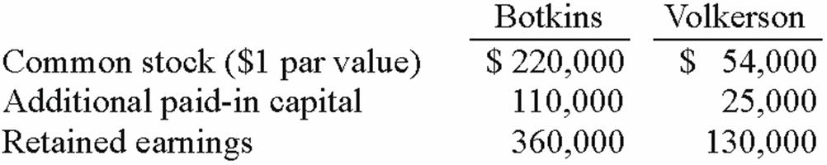  Botkins issued 56,000 new shares of its common stock valued at $3.25 per share for all of the outstanding stock of Volkerson.  Assume that Botkins acquired Volkerson on January 1, 2012. At what amount did Botkins record the investment in Volkerson?  A. $56,000.  B. $182,000.  C. $209,000.  D. $261,000.  E. $312,000.

21. | Prior to being united in a business combination, Botkins Inc. and Volkerson Corp. had the following stockholders' equity figures:  Botkins issued 56,000 new shares of its common stock valued at $3.25 per share for all of the outstanding stock of Volkerson.  Assume that Botkins acquired Volkerson on January 1, 2012. Immediately afterwards, what is consolidated Common Stock?  A. $456,000.  B. $402,000.  C. $274,000.  D. $276,000.  E. $330,000.

22. | Chapel Hill Company had common stock of $350,000 and retained earnings of $490,000. Blue Town Inc. had common stock of $700,000 and retained earnings of $980,000. On January 1, 2013, Blue Town issued 34,000 shares of common stock with a $12 par value and a $35 fair value for all of Chapel Hill Company's outstanding common stock. This combination was accounted for as an acquisition. Immediately after the combination, what was the total consolidated net assets?  A. $2,520,000.  B. $1,190,000.  C. $1,680,000.  D. $2,870,000.  E. $2,030,000.

23. | Which of the following is a not a reason for a business combination to take place?  A. Cost savings through elimination of duplicate facilities.  B. Quick entry for new and existing products into domestic and foreign markets.  C. Diversification of business risk.  D. Vertical integration.  E. Increase in stock price of the acquired company.

24. | Which of the following statements is true regarding a statutory merger?  A. The original companies dissolve while remaining as separate divisions of a newly created company.  B. Both companies remain in existence as legal corporations with one corporation now a subsidiary of the acquiring company.  C. The acquired company dissolves as a separate corporation and becomes a division of the acquiring company.  D. The acquiring company acquires the stock of the acquired company as an investment.  E. A statutory merger is no longer a legal option.

25. | Which of the following statements is true regarding a statutory consolidation?  A. The original companies dissolve while remaining as separate divisions of a newly created company.  B. Both companies remain in existence as legal corporations with one corporation now a subsidiary of the acquiring company.  C. The acquired company dissolves as a separate corporation and becomes a division of the acquiring company.  D. The acquiring company acquires the stock of the acquired company as an investment.  E. A statutory consolidation is no longer a legal option.

26. | In a transaction accounted for using the acquisition method where consideration transferred exceeds book value of the acquired company, which statement is true for the acquiring company with regard to its investment?  A. Net assets of the acquired company are revalued to their fair values and any excess of consideration transferred over fair value of net assets acquired is allocated to goodwill.  B. Net assets of the acquired company are maintained at book value and any excess of consideration transferred over book value of net assets acquired is allocated to goodwill.  C. Acquired assets are revalued to their fair values. Acquired liabilities are maintained at book values. Any excess is allocated to goodwill.  D. Acquired long-term assets are revalued to their fair values. Any excess is allocated to goodwill.

27. | In a transaction accounted for using the acquisition method where consideration transferred is less than fair value of net assets acquired, which statement is true?  A. Negative goodwill is recorded.  B. A deferred credit is recorded.  C. A gain on bargain purchase is recorded.  D. Long-term assets of the acquired company are reduced in proportion to their fair values. Any excess is recorded as a deferred credit.  E. Long-term assets and liabilities of the acquired company are reduced in proportion to their fair values. Any excess is recorded as an extraordinary gain.

28. | Which of the following statements is true regarding the acquisition method of accounting for a business combination?  A. Net assets of the acquired company are reported at their fair values.  B. Net assets of the acquired company are reported at their book values.  C. Any goodwill associated with the acquisition is reported as a development cost.  D. The acquisition can only be effected by a mutual exchange of voting common stock.  E. Indirect costs of the combination reduce additional paid-in capital.

29. | Which of the following statements is true?  A. The pooling of interests for business combinations is an alternative to the acquisition method.  B. The purchase method for business combinations is an alternative to the acquisition method.  C. Neither the purchase method nor the pooling of interests method is allowed for new business combinations.  D. Any previous business combination originally accounted for under purchase or pooling of interests accounting method will now be accounted for under the acquisition method of accounting for business combinations.  E. Companies previously using the purchase or pooling of interests accounting method must report a change in accounting principle when consolidating those subsidiaries with new acquisition combinations.

30. | The financial statements for Goodwin, Inc. and Corr Company for the year ended December 31, 2013, prior to Goodwin's acquisition business combination transaction regarding Corr, follow (in thousands):  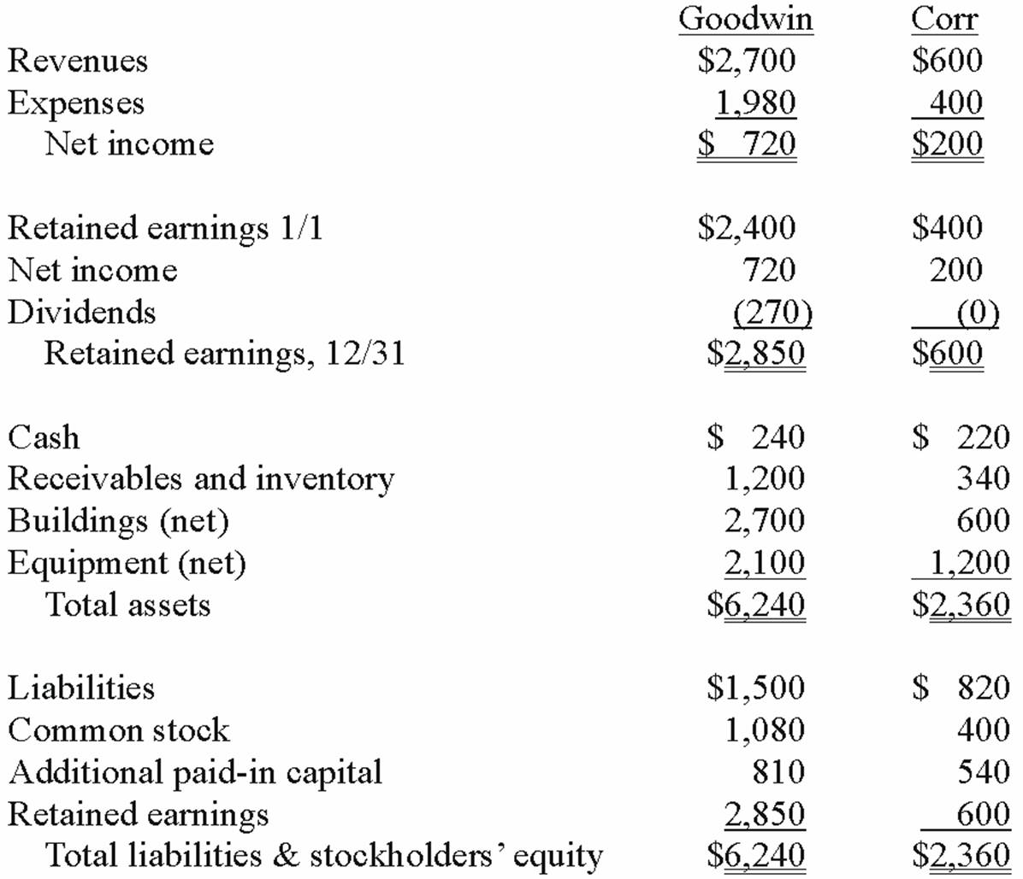  On December 31, 2013, Goodwin issued $600 in debt and 30 shares of its $10 par value common stock to the owners of Corr to acquire all of the outstanding shares of that company. Goodwin shares had a fair value of $40 per share.  Goodwin paid $25 to a broker for arranging the transaction. Goodwin paid $35 in stock issuance costs. Corr's equipment was actually worth $1,400 but its buildings were only valued at $560.  In this acquisition business combination, at what amount is the investment recorded on Goodwin's books?  A. $1,540.  B. $1,800.  C. $1,860.  D. $1,825.  E. $1,625.

31. | The financial statements for Goodwin, Inc. and Corr Company for the year ended December 31, 2013, prior to Goodwin's acquisition business combination transaction regarding Corr, follow (in thousands):  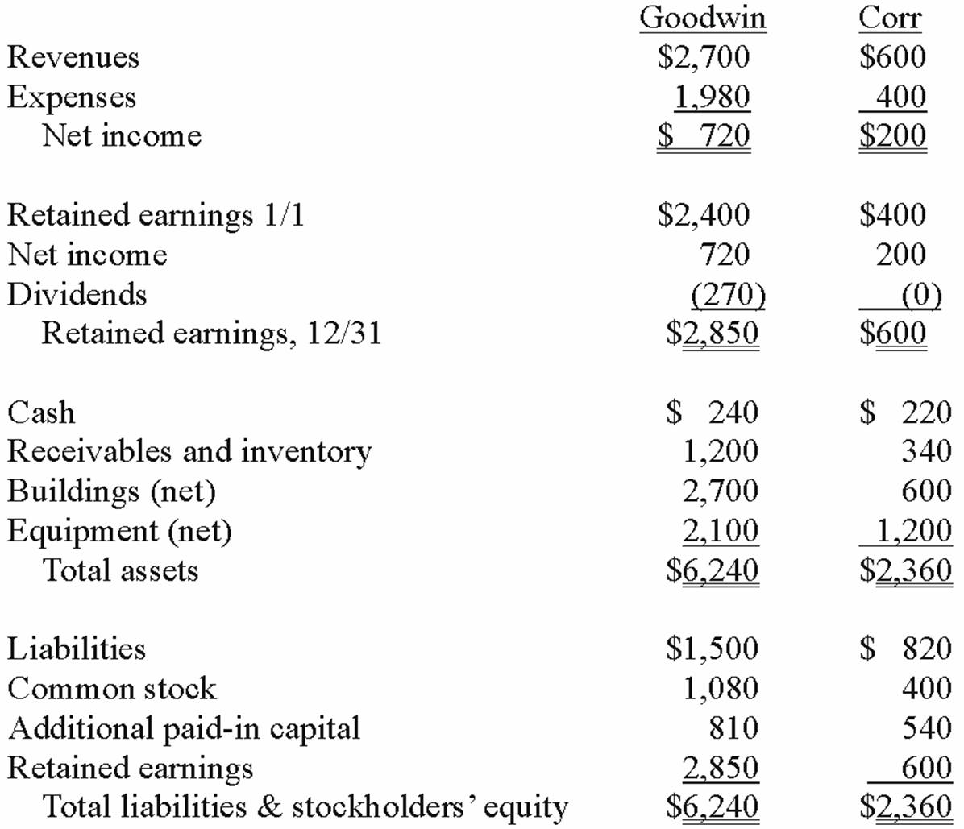  On December 31, 2013, Goodwin issued $600 in debt and 30 shares of its $10 par value common stock to the owners of Corr to acquire all of the outstanding shares of that company. Goodwin shares had a fair value of $40 per share.  Goodwin paid $25 to a broker for arranging the transaction. Goodwin paid $35 in stock issuance costs. Corr's equipment was actually worth $1,400 but its buildings were only valued at $560.  In this acquisition business combination, what total amount of common stock and additional paid-in capital is added on Goodwin's books?  A. $265.  B. $1,165.  C. $1,200.  D. $1,235.  E. $1,765.

32. | The financial statements for Goodwin, Inc. and Corr Company for the year ended December 31, 2013, prior to Goodwin's acquisition business combination transaction regarding Corr, follow (in thousands):  On December 31, 2013, Goodwin issued $600 in debt and 30 shares of its $10 par value common stock to the owners of Corr to acquire all of the outstanding shares of that company. Goodwin shares had a fair value of $40 per share.  Goodwin paid $25 to a broker for arranging the transaction. Goodwin paid $35 in stock issuance costs. Corr's equipment was actually worth $1,400 but its buildings were only valued at $560.  Compute the consolidated revenues for 2013.  A. $2,700.  B. $720.  C. $920.  D. $3,300.  E. $1,540.

33. | The financial statements for Goodwin, Inc. and Corr Company for the year ended December 31, 2013, prior to Goodwin's acquisition business combination transaction regarding Corr, follow (in thousands):  On December 31, 2013, Goodwin issued $600 in debt and 30 shares of its $10 par value common stock to the owners of Corr to acquire all of the outstanding shares of that company. Goodwin shares had a fair value of $40 per share.  Goodwin paid $25 to a broker for arranging the transaction. Goodwin paid $35 in stock issuance costs. Corr's equipment was actually worth $1,400 but its buildings were only valued at $560.  Compute the consolidated receivables and inventory for 2013.  A. $1,200.  B. $1,515.  C. $1,540.  D. $1,800.  E. $2,140.

34. | The financial statements for Goodwin, Inc. and Corr Company for the year ended December 31, 2013, prior to Goodwin's acquisition business combination transaction regarding Corr, follow (in thousands):  On December 31, 2013, Goodwin issued $600 in debt and 30 shares of its $10 par value common stock to the owners of Corr to acquire all of the outstanding shares of that company. Goodwin shares had a fair value of $40 per share.  Goodwin paid $25 to a broker for arranging the transaction. Goodwin paid $35 in stock issuance costs. Corr's equipment was actually worth $1,400 but its buildings were only valued at $560.  Compute the consolidated expenses for 2013.  A. $1,980.  B. $2,005.  C. $2,040.  D. $2,380.  E. $2,405.

35. | The financial statements for Goodwin, Inc. and Corr Company for the year ended December 31, 2013, prior to Goodwin's acquisition business combination transaction regarding Corr, follow (in thousands):  On December 31, 2013, Goodwin issued $600 in debt and 30 shares of its $10 par value common stock to the owners of Corr to acquire all of the outstanding shares of that company. Goodwin shares had a fair value of $40 per share.  Goodwin paid $25 to a broker for arranging the transaction. Goodwin paid $35 in stock issuance costs. Corr's equipment was actually worth $1,400 but its buildings were only valued at $560.  Compute the consolidated cash account at December 31, 2013.  A. $460.  B. $425.  C. $400.  D. $435.  E. $240.

36. | The financial statements for Goodwin, Inc. and Corr Company for the year ended December 31, 2013, prior to Goodwin's acquisition business combination transaction regarding Corr, follow (in thousands):  On December 31, 2013, Goodwin issued $600 in debt and 30 shares of its $10 par value common stock to the owners of Corr to acquire all of the outstanding shares of that company. Goodwin shares had a fair value of $40 per share.  Goodwin paid $25 to a broker for arranging the transaction. Goodwin paid $35 in stock issuance costs. Corr's equipment was actually worth $1,400 but its buildings were only valued at $560.  Compute the consolidated buildings (net) account at December 31, 2013.  A. $2,700.  B. $3,370.  C. $3,300.  D. $3,260.  E. $3,340.

37. | The financial statements for Goodwin, Inc. and Corr Company for the year ended December 31, 2013, prior to Goodwin's acquisition business combination transaction regarding Corr, follow (in thousands):  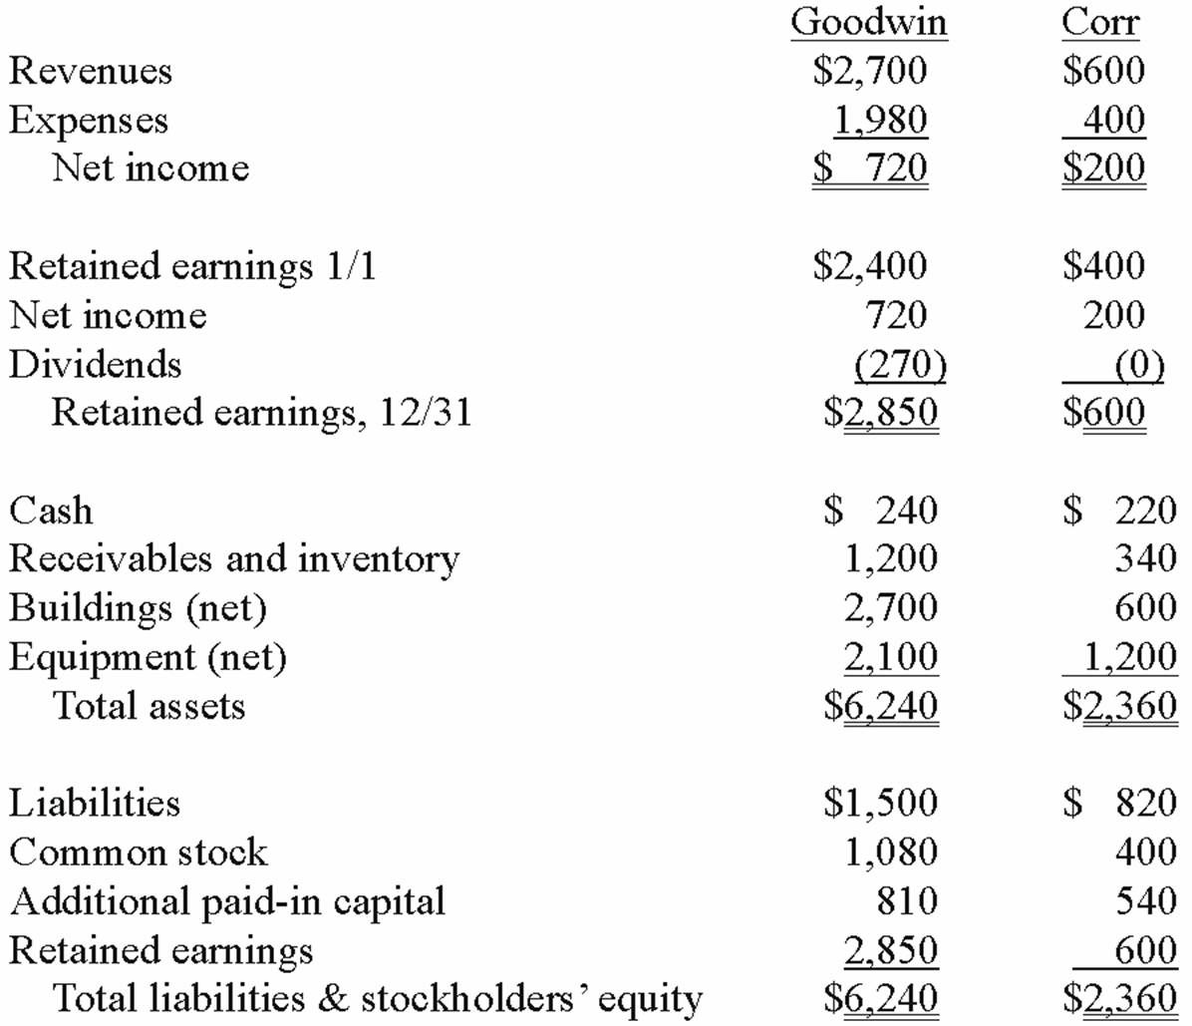  On December 31, 2013, Goodwin issued $600 in debt and 30 shares of its $10 par value common stock to the owners of Corr to acquire all of the outstanding shares of that company. Goodwin shares had a fair value of $40 per share.  Goodwin paid $25 to a broker for arranging the transaction. Goodwin paid $35 in stock issuance costs. Corr's equipment was actually worth $1,400 but its buildings were only valued at $560.  Compute the consolidated equipment (net) account at December 31, 2013.  A. $2,100.  B. $3,500.  C. $3,300.  D. $3,000.  E. $3,200.

38. | The financial statements for Goodwin, Inc. and Corr Company for the year ended December 31, 2013, prior to Goodwin's acquisition business combination transaction regarding Corr, follow (in thousands):  On December 31, 2013, Goodwin issued $600 in debt and 30 shares of its $10 par value common stock to the owners of Corr to acquire all of the outstanding shares of that company. Goodwin shares had a fair value of $40 per share.  Goodwin paid $25 to a broker for arranging the transaction. Goodwin paid $35 in stock issuance costs. Corr's equipment was actually worth $1,400 but its buildings were only valued at $560.  Compute the consideration transferred for this acquisition at December 31, 2013.  A. $900.  B. $1,165.  C. $1,200.  D. $1,765.  E. $1,800.

39. | The financial statements for Goodwin, Inc. and Corr Company for the year ended December 31, 2013, prior to Goodwin's acquisition business combination transaction regarding Corr, follow (in thousands):  On December 31, 2013, Goodwin issued $600 in debt and 30 shares of its $10 par value common stock to the owners of Corr to acquire all of the outstanding shares of that company. Goodwin shares had a fair value of $40 per share.  Goodwin paid $25 to a broker for arranging the transaction. Goodwin paid $35 in stock issuance costs. Corr's equipment was actually worth $1,400 but its buildings were only valued at $560.  Compute the goodwill arising from this acquisition at December 31, 2013.  A. $0.  B. $100.  C. $125.  D. $160.  E. $45.

40. | The financial statements for Goodwin, Inc. and Corr Company for the year ended December 31, 2013, prior to Goodwin's acquisition business combination transaction regarding Corr, follow (in thousands):  On December 31, 2013, Goodwin issued $600 in debt and 30 shares of its $10 par value common stock to the owners of Corr to acquire all of the outstanding shares of that company. Goodwin shares had a fair value of $40 per share.  Goodwin paid $25 to a broker for arranging the transaction. Goodwin paid $35 in stock issuance costs. Corr's equipment was actually worth $1,400 but its buildings were only valued at $560.  Compute the consolidated common stock account at December 31, 2013.  A. $1,080.  B. $1,480.  C. $1,380.  D. $2,280.  E. $2,680.

41. | The financial statements for Goodwin, Inc. and Corr Company for the year ended December 31, 2013, prior to Goodwin's acquisition business combination transaction regarding Corr, follow (in thousands):  On December 31, 2013, Goodwin issued $600 in debt and 30 shares of its $10 par value common stock to the owners of Corr to acquire all of the outstanding shares of that company. Goodwin shares had a fair value of $40 per share.  Goodwin paid $25 to a broker for arranging the transaction. Goodwin paid $35 in stock issuance costs. Corr's equipment was actually worth $1,400 but its buildings were only valued at $560.  Compute the consolidated additional paid-in capital at December 31, 2013.  A. $810.  B. $1,350.  C. $1,675.  D. $1,910.  E. $1,875.

42. | The financial statements for Goodwin, Inc. and Corr Company for the year ended December 31, 2013, prior to Goodwin's acquisition business combination transaction regarding Corr, follow (in thousands):  On December 31, 2013, Goodwin issued $600 in debt and 30 shares of its $10 par value common stock to the owners of Corr to acquire all of the outstanding shares of that company. Goodwin shares had a fair value of $40 per share.  Goodwin paid $25 to a broker for arranging the transaction. Goodwin paid $35 in stock issuance costs. Corr's equipment was actually worth $1,400 but its buildings were only valued at $560.  Compute the consolidated liabilities at December 31, 2013.  A. $1,500.  B. $2,100.  C. $2,320.  D. $2,920.  E. $2,885.

43. | The financial statements for Goodwin, Inc. and Corr Company for the year ended December 31, 2013, prior to Goodwin's acquisition business combination transaction regarding Corr, follow (in thousands):  On December 31, 2013, Goodwin issued $600 in debt and 30 shares of its $10 par value common stock to the owners of Corr to acquire all of the outstanding shares of that company. Goodwin shares had a fair value of $40 per share.  Goodwin paid $25 to a broker for arranging the transaction. Goodwin paid $35 in stock issuance costs. Corr's equipment was actually worth $1,400 but its buildings were only valued at $560.  Compute the consolidated retained earnings at December 31, 2013.  A. $2,800.  B. $2,825.  C. $2,850.  D. $3,425.  E. $3,450.

44. | On January 1, 2013, the Moody Company entered into a transaction for 100% of the outstanding common stock of Osorio Company. To acquire these shares, Moody issued $400 in long-term liabilities and 40 shares of common stock having a par value of $1 per share but a fair value of $10 per share. Moody paid $20 to lawyers, accountants, and brokers for assistance in bringing about this acquisition. Another $15 was paid in connection with stock issuance costs. Prior to these transactions, the balance sheets for the two companies were as follows:  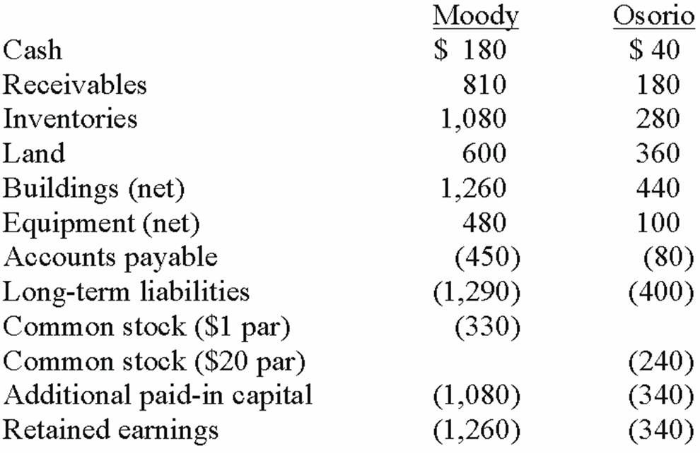  Note: Parentheses indicate a credit balance.  In Moody's appraisal of Osorio, three assets were deemed to be undervalued on the subsidiary's books: Inventory by $10, Land by $40, and Buildings by $60.  What amount was recorded as the investment in Osorio?  A. $930.  B. $820.  C. $800.  D. $835.  E. $815.

45. | On January 1, 2013, the Moody Company entered into a transaction for 100% of the outstanding common stock of Osorio Company. To acquire these shares, Moody issued $400 in long-term liabilities and 40 shares of common stock having a par value of $1 per share but a fair value of $10 per share. Moody paid $20 to lawyers, accountants, and brokers for assistance in bringing about this acquisition. Another $15 was paid in connection with stock issuance costs. Prior to these transactions, the balance sheets for the two companies were as follows:  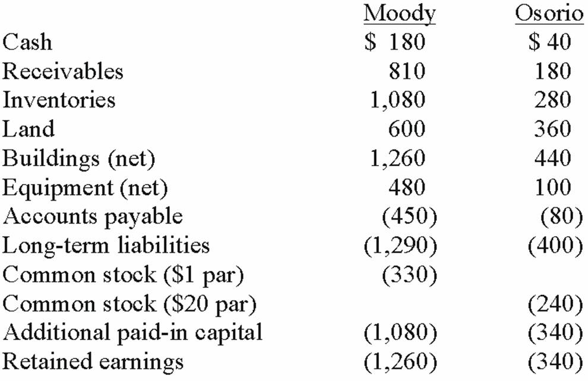  Note: Parentheses indicate a credit balance.  In Moody's appraisal of Osorio, three assets were deemed to be undervalued on the subsidiary's books: Inventory by $10, Land by $40, and Buildings by $60.  What amount was recorded as goodwill arising from this acquisition?  A. $230.  B. $120.  C. $520.  D. None. There is a gain on bargain purchase of $230.  E. None. There is a gain on bargain purchase of $265.

46. | On January 1, 2013, the Moody Company entered into a transaction for 100% of the outstanding common stock of Osorio Company. To acquire these shares, Moody issued $400 in long-term liabilities and 40 shares of common stock having a par value of $1 per share but a fair value of $10 per share. Moody paid $20 to lawyers, accountants, and brokers for assistance in bringing about this acquisition. Another $15 was paid in connection with stock issuance costs. Prior to these transactions, the balance sheets for the two companies were as follows:  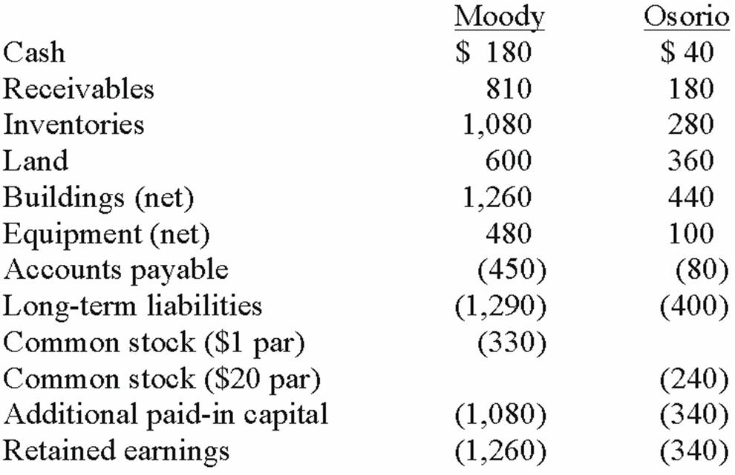  Note: Parentheses indicate a credit balance.  In Moody's appraisal of Osorio, three assets were deemed to be undervalued on the subsidiary's books: Inventory by $10, Land by $40, and Buildings by $60.  Compute the amount of consolidated inventories at date of acquisition.  A. $1,080.  B. $1,350.  C. $1,360.  D. $1,370.  E. $290.

47. | On January 1, 2013, the Moody Company entered into a transaction for 100% of the outstanding common stock of Osorio Company. To acquire these shares, Moody issued $400 in long-term liabilities and 40 shares of common stock having a par value of $1 per share but a fair value of $10 per share. Moody paid $20 to lawyers, accountants, and brokers for assistance in bringing about this acquisition. Another $15 was paid in connection with stock issuance costs. Prior to these transactions, the balance sheets for the two companies were as follows:  Note: Parentheses indicate a credit balance.  In Moody's appraisal of Osorio, three assets were deemed to be undervalued on the subsidiary's books: Inventory by $10, Land by $40, and Buildings by $60.  Compute the amount of consolidated buildings (net) at date of acquisition.  A. $1,700.  B. $1,760.  C. $1,640.  D. $1,320.  E. $500.

48. | On January 1, 2013, the Moody Company entered into a transaction for 100% of the outstanding common stock of Osorio Company. To acquire these shares, Moody issued $400 in long-term liabilities and 40 shares of common stock having a par value of $1 per share but a fair value of $10 per share. Moody paid $20 to lawyers, accountants, and brokers for assistance in bringing about this acquisition. Another $15 was paid in connection with stock issuance costs. Prior to these transactions, the balance sheets for the two companies were as follows:  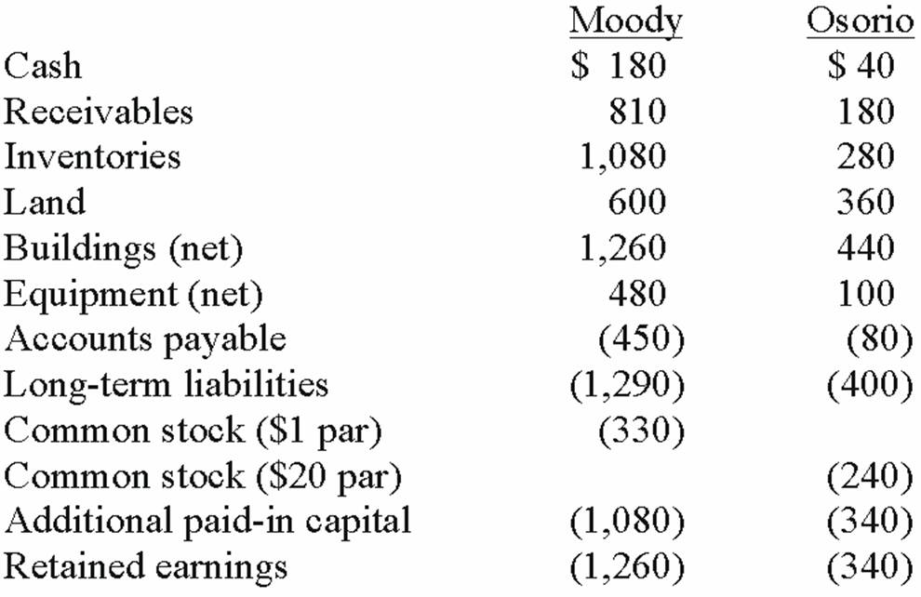  Note: Parentheses indicate a credit balance.  In Moody's appraisal of Osorio, three assets were deemed to be undervalued on the subsidiary's books: Inventory by $10, Land by $40, and Buildings by $60.  Compute the amount of consolidated land at date of acquisition.  A. $1,000.  B. $960.  C. $920.  D. $400.  E. $320.

49. | On January 1, 2013, the Moody Company entered into a transaction for 100% of the outstanding common stock of Osorio Company. To acquire these shares, Moody issued $400 in long-term liabilities and 40 shares of common stock having a par value of $1 per share but a fair value of $10 per share. Moody paid $20 to lawyers, accountants, and brokers for assistance in bringing about this acquisition. Another $15 was paid in connection with stock issuance costs. Prior to these transactions, the balance sheets for the two companies were as follows:  Note: Parentheses indicate a credit balance.  In Moody's appraisal of Osorio, three assets were deemed to be undervalued on the subsidiary's books: Inventory by $10, Land by $40, and Buildings by $60.  Compute the amount of consolidated equipment at date of acquisition.  A. $480.  B. $580.  C. $559.  D. $570.  E. $560.

50. | On January 1, 2013, the Moody Company entered into a transaction for 100% of the outstanding common stock of Osorio Company. To acquire these shares, Moody issued $400 in long-term liabilities and 40 shares of common stock having a par value of $1 per share but a fair value of $10 per share. Moody paid $20 to lawyers, accountants, and brokers for assistance in bringing about this acquisition. Another $15 was paid in connection with stock issuance costs. Prior to these transactions, the balance sheets for the two companies were as follows:  Note: Parentheses indicate a credit balance.  In Moody's appraisal of Osorio, three assets were deemed to be undervalued on the subsidiary's books: Inventory by $10, Land by $40, and Buildings by $60.  Compute the amount of consolidated common stock at date of acquisition.  A. $370.  B. $570.  C. $610.  D. $330.  E. $530.

51. | On January 1, 2013, the Moody Company entered into a transaction for 100% of the outstanding common stock of Osorio Company. To acquire these shares, Moody issued $400 in long-term liabilities and 40 shares of common stock having a par value of $1 per share but a fair value of $10 per share. Moody paid $20 to lawyers, accountants, and brokers for assistance in bringing about this acquisition. Another $15 was paid in connection with stock issuance costs. Prior to these transactions, the balance sheets for the two companies were as follows:  Note: Parentheses indicate a credit balance.  In Moody's appraisal of Osorio, three assets were deemed to be undervalued on the subsidiary's books: Inventory by $10, Land by $40, and Buildings by $60.  Compute the amount of consolidated additional paid-in capital at date of acquisition.  A. $1,080.  B. $1,420.  C. $1,065.  D. $1,425.  E. $1,440.

52. | On January 1, 2013, the Moody Company entered into a transaction for 100% of the outstanding common stock of Osorio Company. To acquire these shares, Moody issued $400 in long-term liabilities and 40 shares of common stock having a par value of $1 per share but a fair value of $10 per share. Moody paid $20 to lawyers, accountants, and brokers for assistance in bringing about this acquisition. Another $15 was paid in connection with stock issuance costs. Prior to these transactions, the balance sheets for the two companies were as follows:  Note: Parentheses indicate a credit balance.  In Moody's appraisal of Osorio, three assets were deemed to be undervalued on the subsidiary's books: Inventory by $10, Land by $40, and Buildings by $60.  Compute the amount of consolidated cash after recording the acquisition transaction.  A. $220.  B. $185.  C. $200.  D. $205.  E. $215.

53. | Carnes has the following account balances as of May 1, 2012 before an acquisition transaction takes place.  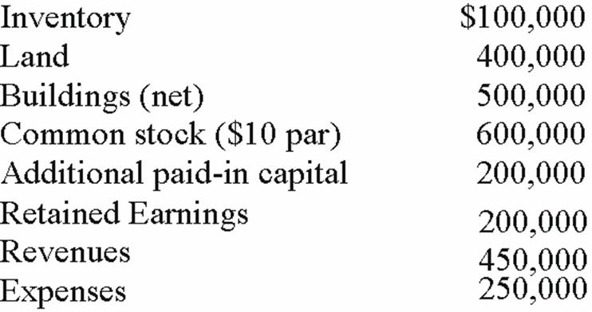  The fair value of Carnes' Land and Buildings are $650,000 and $550,000, respectively. On May 1, 2012, Riley Company issues 30,000 shares of its $10 par value ($25 fair value) common stock in exchange for all of the shares of Carnes' common stock. Riley paid $10,000 for costs to issue the new shares of stock. Before the acquisition, Riley has $700,000 in its common stock account and $300,000 in its additional paid-in capital account.  On May 1, 2012, what value is assigned to Riley's investment account?  A. $150,000.  B. $300,000.  C. $750,000.  D. $760,000.  E. $1,350,000.

54. | Carnes has the following account balances as of May 1, 2012 before an acquisition transaction takes place.  The fair value of Carnes' Land and Buildings are $650,000 and $550,000, respectively. On May 1, 2012, Riley Company issues 30,000 shares of its $10 par value ($25 fair value) common stock in exchange for all of the shares of Carnes' common stock. Riley paid $10,000 for costs to issue the new shares of stock. Before the acquisition, Riley has $700,000 in its common stock account and $300,000 in its additional paid-in capital account.  At the date of acquisition, by how much does Riley's additional paid-in capital increase or decrease?  A. $0.  B. $440,000 increase.  C. $450,000 increase.  D. $640,000 increase.  E. $650,000 decrease.

55. | Carnes has the following account balances as of May 1, 2012 before an acquisition transaction takes place.  The fair value of Carnes' Land and Buildings are $650,000 and $550,000, respectively. On May 1, 2012, Riley Company issues 30,000 shares of its $10 par value ($25 fair value) common stock in exchange for all of the shares of Carnes' common stock. Riley paid $10,000 for costs to issue the new shares of stock. Before the acquisition, Riley has $700,000 in its common stock account and $300,000 in its additional paid-in capital account.  What will be Riley's balance in its common stock account as a result of this acquisition?  A. $300,000.  B. $990,000.  C. $1,000,000.  D. $1,590,000.  E. $1,600,000.

56. | Carnes has the following account balances as of May 1, 2012 before an acquisition transaction takes place.  The fair value of Carnes' Land and Buildings are $650,000 and $550,000, respectively. On May 1, 2012, Riley Company issues 30,000 shares of its $10 par value ($25 fair value) common stock in exchange for all of the shares of Carnes' common stock. Riley paid $10,000 for costs to issue the new shares of stock. Before the acquisition, Riley has $700,000 in its common stock account and $300,000 in its additional paid-in capital account.  What will be the consolidated additional paid-in capital as a result of this acquisition?  A. $440,000.  B. $740,000.  C. $750,000.  D. $940,000.  E. $950,000.

57. | The financial balances for the Atwood Company and the Franz Company as of December 31, 2013, are presented below. Also included are the fair values for Franz Company's net assets.  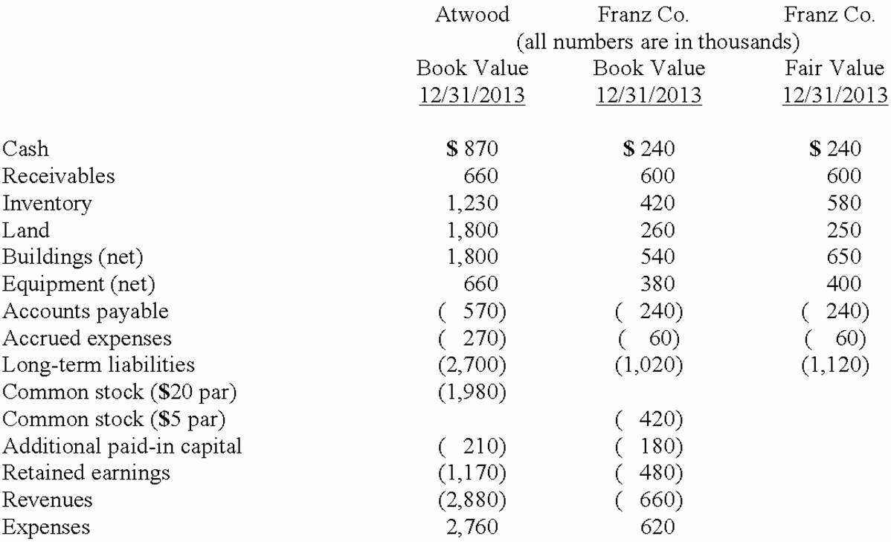  Note: Parenthesis indicate a credit balance  Assume an acquisition business combination took place at December 31, 2013. Atwood issued 50 shares of its common stock with a fair value of $35 per share for all of the outstanding common shares of Franz. Stock issuance costs of $15 (in thousands) and direct costs of $10 (in thousands) were paid.  Compute the investment to be recorded at date of acquisition.  A. $1,750.  B. $1,760.  C. $1,775.  D. $1,300.  E. $1,120.

58. | The financial balances for the Atwood Company and the Franz Company as of December 31, 2013, are presented below. Also included are the fair values for Franz Company's net assets.  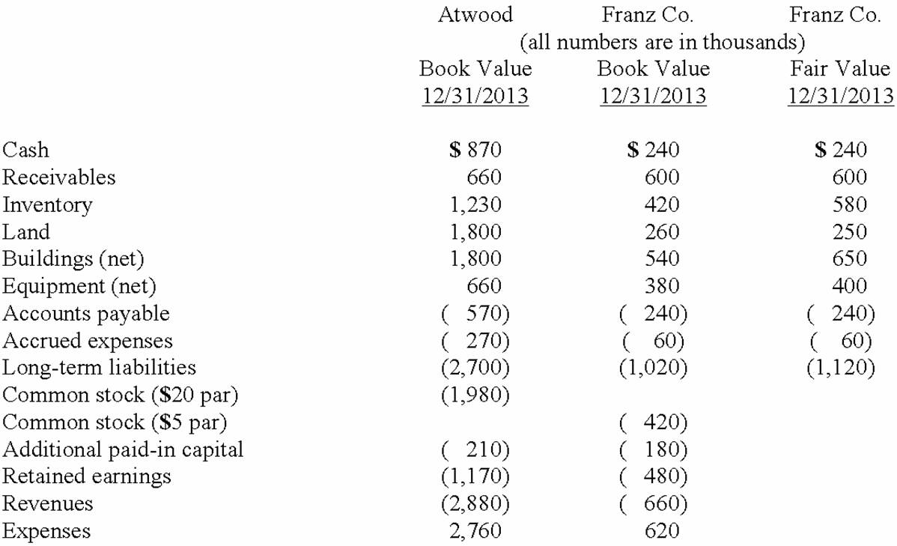  Note: Parenthesis indicate a credit balance  Assume an acquisition business combination took place at December 31, 2013. Atwood issued 50 shares of its common stock with a fair value of $35 per share for all of the outstanding common shares of Franz. Stock issuance costs of $15 (in thousands) and direct costs of $10 (in thousands) were paid.  Compute the consolidated common stock at date of acquisition.  A. $1,000.  B. $2,980.  C. $2,400.  D. $3,400.  E. $3,730.

59. | The financial balances for the Atwood Company and the Franz Company as of December 31, 2013, are presented below. Also included are the fair values for Franz Company's net assets.  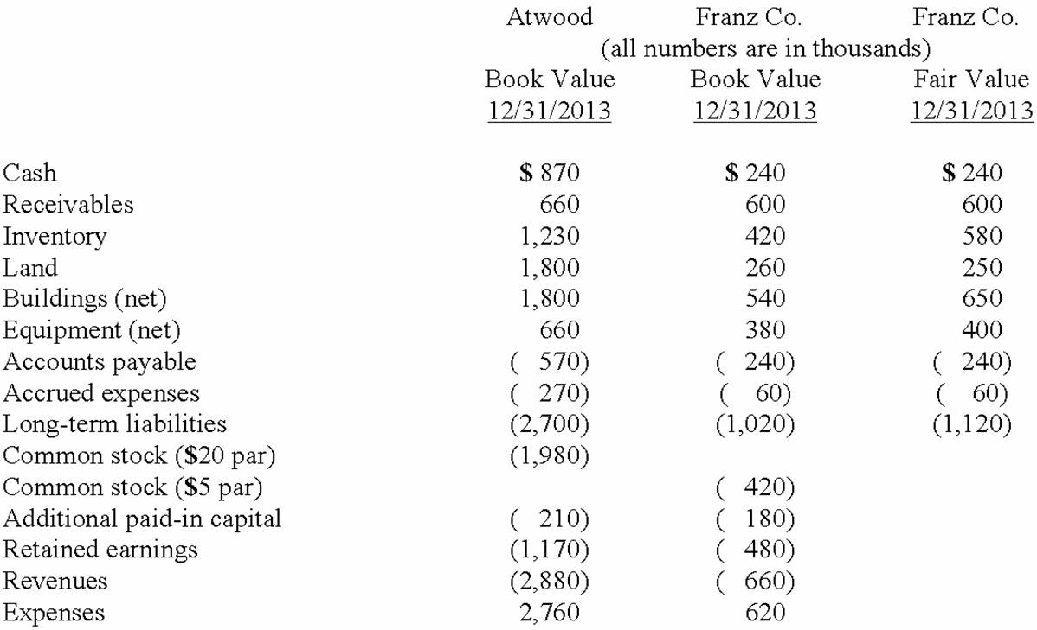  Note: Parenthesis indicate a credit balance  Assume an acquisition business combination took place at December 31, 2013. Atwood issued 50 shares of its common stock with a fair value of $35 per share for all of the outstanding common shares of Franz. Stock issuance costs of $15 (in thousands) and direct costs of $10 (in thousands) were paid.  Compute consolidated inventory at the date of the acquisition.  A. $1,650.  B. $1,810.  C. $1,230.  D. $580.  E. $1,830.

60. | The financial balances for the Atwood Company and the Franz Company as of December 31, 2013, are presented below. Also included are the fair values for Franz Company's net assets.  Note: Parenthesis indicate a credit balance  Assume an acquisition business combination took place at December 31, 2013. Atwood issued 50 shares of its common stock with a fair value of $35 per share for all of the outstanding common shares of Franz. Stock issuance costs of $15 (in thousands) and direct costs of $10 (in thousands) were paid.  Compute consolidated land at the date of the acquisition.  A. $2,060.  B. $1,800.  C. $260.  D. $2,050.  E. $2,070.

61. | The financial balances for the Atwood Company and the Franz Company as of December 31, 2013, are presented below. Also included are the fair values for Franz Company's net assets.  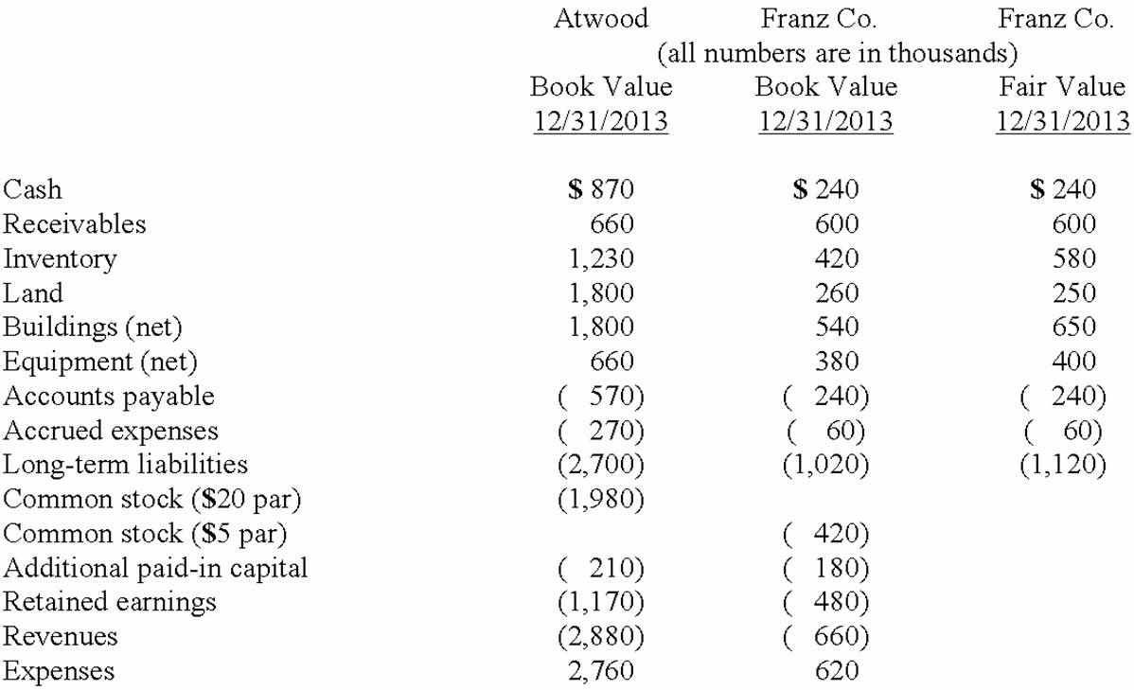  Note: Parenthesis indicate a credit balance  Assume an acquisition business combination took place at December 31, 2013. Atwood issued 50 shares of its common stock with a fair value of $35 per share for all of the outstanding common shares of Franz. Stock issuance costs of $15 (in thousands) and direct costs of $10 (in thousands) were paid.  Compute consolidated buildings (net) at the date of the acquisition.  A. $2,450.  B. $2,340.  C. $1,800.  D. $650.  E. $1,690.

62. | The financial balances for the Atwood Company and the Franz Company as of December 31, 2013, are presented below. Also included are the fair values for Franz Company's net assets.  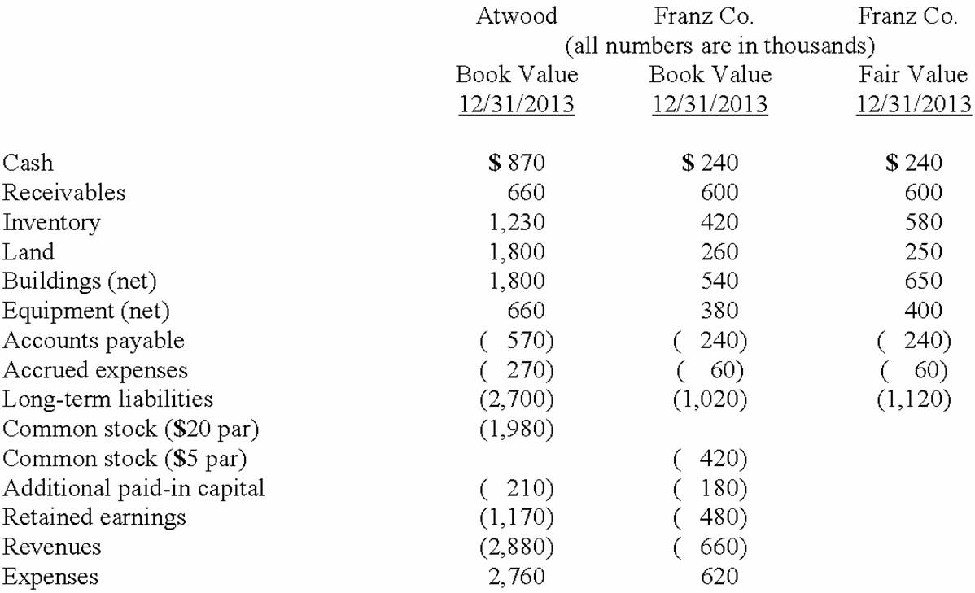  Note: Parenthesis indicate a credit balance  Assume an acquisition business combination took place at December 31, 2013. Atwood issued 50 shares of its common stock with a fair value of $35 per share for all of the outstanding common shares of Franz. Stock issuance costs of $15 (in thousands) and direct costs of $10 (in thousands) were paid.  Compute consolidated long-term liabilities at the date of the acquisition.  A. $2,600.  B. $2,700.  C. $2,800.  D. $3,720.  E. $3,820.

63. | The financial balances for the Atwood Company and the Franz Company as of December 31, 2013, are presented below. Also included are the fair values for Franz Company's net assets.  Note: Parenthesis indicate a credit balance  Assume an acquisition business combination took place at December 31, 2013. Atwood issued 50 shares of its common stock with a fair value of $35 per share for all of the outstanding common shares of Franz. Stock issuance costs of $15 (in thousands) and direct costs of $10 (in thousands) were paid.  Compute consolidated goodwill at the date of the acquisition.  A. $360.  B. $450.  C. $460.  D. $440.  E. $475.

64. | The financial balances for the Atwood Company and the Franz Company as of December 31, 2013, are presented below. Also included are the fair values for Franz Company's net assets.  Note: Parenthesis indicate a credit balance  Assume an acquisition business combination took place at December 31, 2013. Atwood issued 50 shares of its common stock with a fair value of $35 per share for all of the outstanding common shares of Franz. Stock issuance costs of $15 (in thousands) and direct costs of $10 (in thousands) were paid.  Compute consolidated equipment (net) at the date of the acquisition.  A. $400.  B. $660.  C. $1,060.  D. $1,040.  E. $1,050.

65. | The financial balances for the Atwood Company and the Franz Company as of December 31, 2013, are presented below. Also included are the fair values for Franz Company's net assets.  Note: Parenthesis indicate a credit balance  Assume an acquisition business combination took place at December 31, 2013. Atwood issued 50 shares of its common stock with a fair value of $35 per share for all of the outstanding common shares of Franz. Stock issuance costs of $15 (in thousands) and direct costs of $10 (in thousands) were paid.  Compute fair value of the net assets acquired at the date of the acquisition.  A. $1,300.  B. $1,340.  C. $1,500.  D. $1,750.  E. $2,480.

66. | The financial balances for the Atwood Company and the Franz Company as of December 31, 2013, are presented below. Also included are the fair values for Franz Company's net assets.  Note: Parenthesis indicate a credit balance  Assume an acquisition business combination took place at December 31, 2013. Atwood issued 50 shares of its common stock with a fair value of $35 per share for all of the outstanding common shares of Franz. Stock issuance costs of $15 (in thousands) and direct costs of $10 (in thousands) were paid.  Compute consolidated retained earnings at the date of the acquisition.  A. $1,160.  B. $1,170.  C. $1,280.  D. $1,290.  E. $1,640.

67. | The financial balances for the Atwood Company and the Franz Company as of December 31, 2013, are presented below. Also included are the fair values for Franz Company's net assets.  Note: Parenthesis indicate a credit balance  Assume an acquisition business combination took place at December 31, 2013. Atwood issued 50 shares of its common stock with a fair value of $35 per share for all of the outstanding common shares of Franz. Stock issuance costs of $15 (in thousands) and direct costs of $10 (in thousands) were paid.  Compute consolidated revenues at the date of the acquisition.  A. $3,540.  B. $2,880.  C. $1,170.  D. $1,650.  E. $4,050.

68. | The financial balances for the Atwood Company and the Franz Company as of December 31, 2013, are presented below. Also included are the fair values for Franz Company's net assets.  Note: Parenthesis indicate a credit balance  Assume an acquisition business combination took place at December 31, 2013. Atwood issued 50 shares of its common stock with a fair value of $35 per share for all of the outstanding common shares of Franz. Stock issuance costs of $15 (in thousands) and direct costs of $10 (in thousands) were paid.  Compute consolidated cash at the completion of the acquisition.  A. $1,350.  B. $1,085.  C. $1,110.  D. $870.  E. $845.

69. | The financial balances for the Atwood Company and the Franz Company as of December 31, 2013, are presented below. Also included are the fair values for Franz Company's net assets.  Note: Parenthesis indicate a credit balance  Assume an acquisition business combination took place at December 31, 2013. Atwood issued 50 shares of its common stock with a fair value of $35 per share for all of the outstanding common shares of Franz. Stock issuance costs of $15 (in thousands) and direct costs of $10 (in thousands) were paid.  Compute consolidated expenses at the date of the acquisition.  A. $2,760.  B. $2,770.  C. $2,785.  D. $3,380.  E. $3,390.

70. | Presented below are the financial balances for the Atwood Company and the Franz Company as of December 31, 2012, immediately before Atwood acquired Franz. Also included are the fair values for Franz Company's net assets at that date.  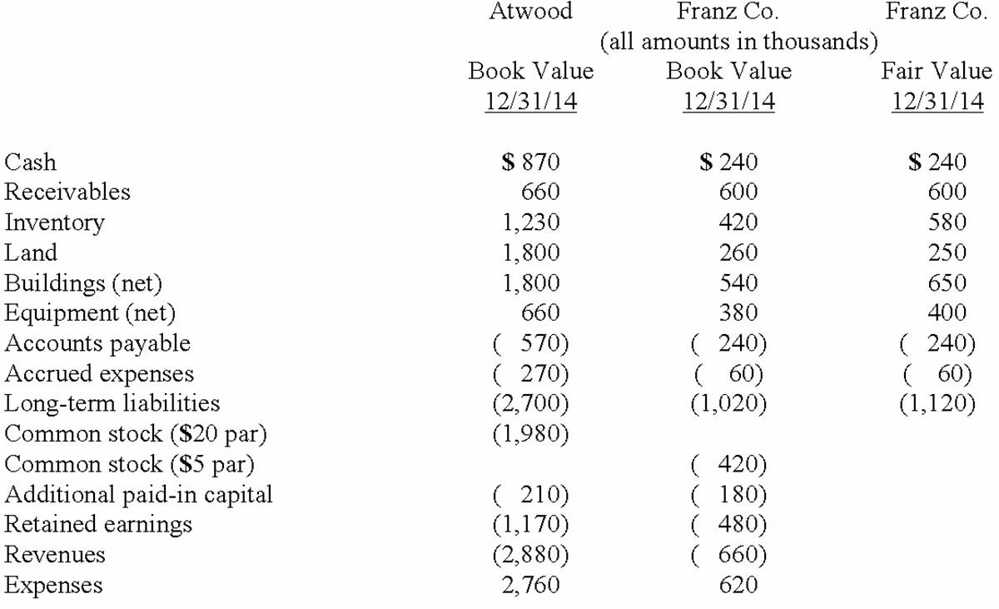  Note: Parenthesis indicate a credit balance  Assume a business combination took place at December 31, 2012. Atwood issued 50 shares of its common stock with a fair value of $35 per share for all of the outstanding common shares of Franz. Stock issuance costs of $15 (in thousands) and direct costs of $10 (in thousands) were paid to effect this acquisition transaction. To settle a difference of opinion regarding Franz's fair value, Atwood promises to pay an additional $5.2 (in thousands) to the former owners if Franz's earnings exceed a certain sum during the next year. Given the probability of the required contingency payment and utilizing a 4% discount rate, the expected present value of the contingency is $5 (in thousands).  Compute the investment to be recorded at date of acquisition.  A. $1,750.  B. $1,755.  C. $1,725.  D. $1,760.  E. $1,765.

71. | Presented below are the financial balances for the Atwood Company and the Franz Company as of December 31, 2012, immediately before Atwood acquired Franz. Also included are the fair values for Franz Company's net assets at that date.  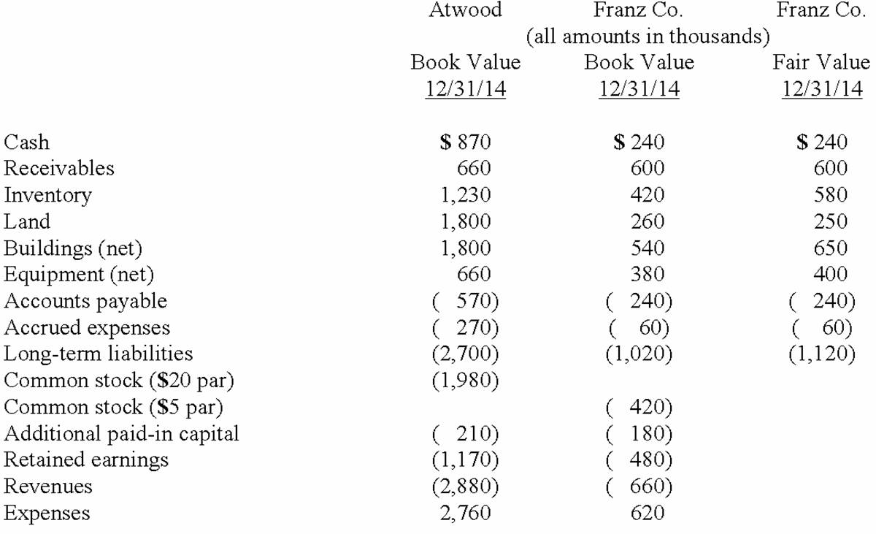  Note: Parenthesis indicate a credit balance  Assume a business combination took place at December 31, 2012. Atwood issued 50 shares of its common stock with a fair value of $35 per share for all of the outstanding common shares of Franz. Stock issuance costs of $15 (in thousands) and direct costs of $10 (in thousands) were paid to effect this acquisition transaction. To settle a difference of opinion regarding Franz's fair value, Atwood promises to pay an additional $5.2 (in thousands) to the former owners if Franz's earnings exceed a certain sum during the next year. Given the probability of the required contingency payment and utilizing a 4% discount rate, the expected present value of the contingency is $5 (in thousands).  Compute consolidated inventory at date of acquisition.  A. $1,650.  B. $1,810.  C. $1,230.  D. $580.  E. $1,830.

72. | Presented below are the financial balances for the Atwood Company and the Franz Company as of December 31, 2012, immediately before Atwood acquired Franz. Also included are the fair values for Franz Company's net assets at that date.  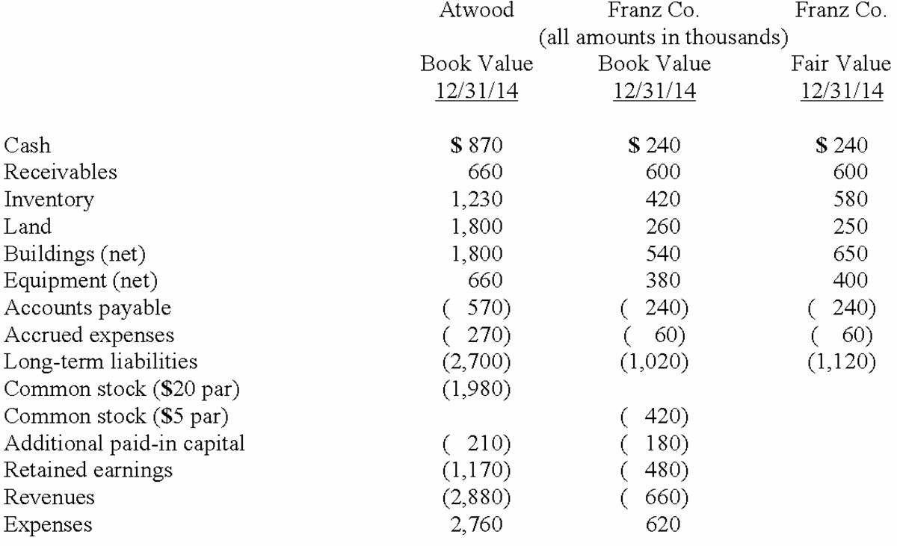  Note: Parenthesis indicate a credit balance  Assume a business combination took place at December 31, 2012. Atwood issued 50 shares of its common stock with a fair value of $35 per share for all of the outstanding common shares of Franz. Stock issuance costs of $15 (in thousands) and direct costs of $10 (in thousands) were paid to effect this acquisition transaction. To settle a difference of opinion regarding Franz's fair value, Atwood promises to pay an additional $5.2 (in thousands) to the former owners if Franz's earnings exceed a certain sum during the next year. Given the probability of the required contingency payment and utilizing a 4% discount rate, the expected present value of the contingency is $5 (in thousands).  Compute consolidated land at date of acquisition.  A. $2,060.  B. $1,800.  C. $260.  D. $2,050.  E. $2,070.

73. | Presented below are the financial balances for the Atwood Company and the Franz Company as of December 31, 2012, immediately before Atwood acquired Franz. Also included are the fair values for Franz Company's net assets at that date.  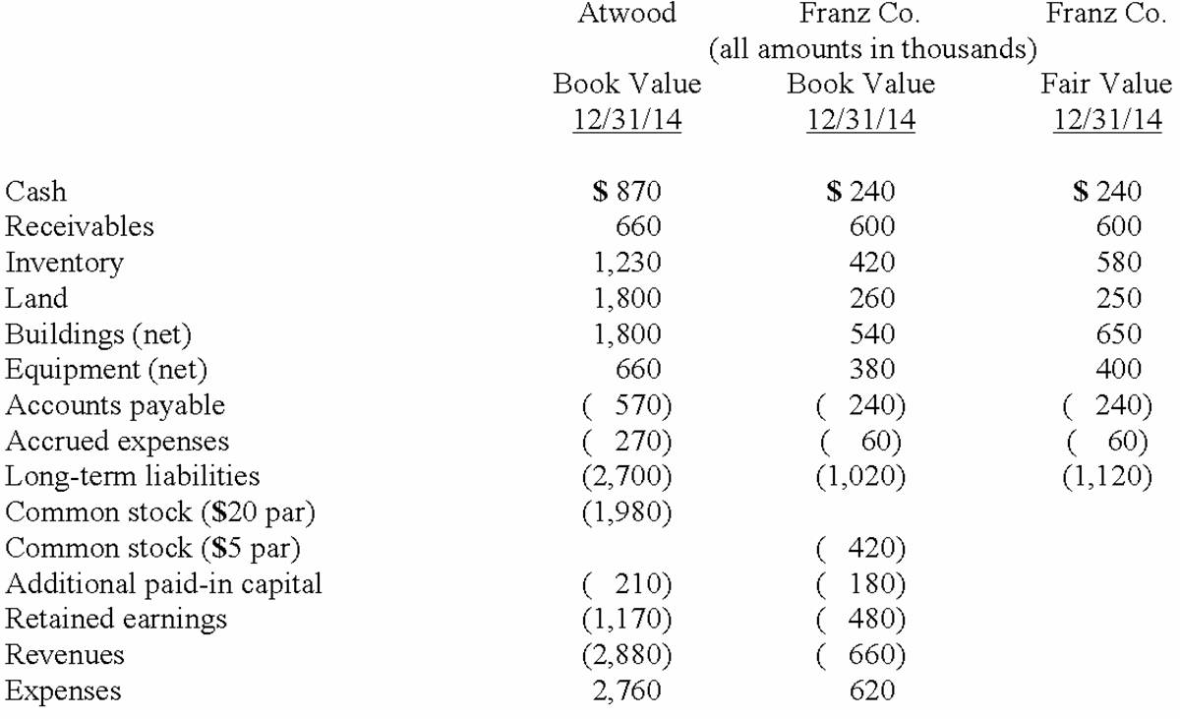  Note: Parenthesis indicate a credit balance  Assume a business combination took place at December 31, 2012. Atwood issued 50 shares of its common stock with a fair value of $35 per share for all of the outstanding common shares of Franz. Stock issuance costs of $15 (in thousands) and direct costs of $10 (in thousands) were paid to effect this acquisition transaction. To settle a difference of opinion regarding Franz's fair value, Atwood promises to pay an additional $5.2 (in thousands) to the former owners if Franz's earnings exceed a certain sum during the next year. Given the probability of the required contingency payment and utilizing a 4% discount rate, the expected present value of the contingency is $5 (in thousands).  Compute consolidated buildings (net) at date of acquisition.  A. $2,450.  B. $2,340.  C. $1,800.  D. $650.  E. $1,690.

74. | Presented below are the financial balances for the Atwood Company and the Franz Company as of December 31, 2012, immediately before Atwood acquired Franz. Also included are the fair values for Franz Company's net assets at that date.  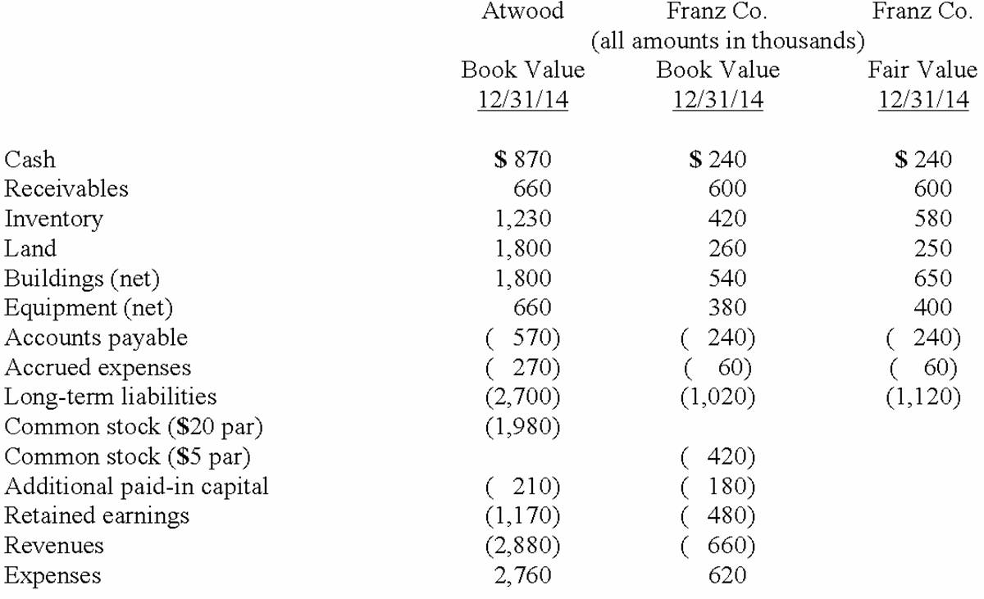  Note: Parenthesis indicate a credit balance  Assume a business combination took place at December 31, 2012. Atwood issued 50 shares of its common stock with a fair value of $35 per share for all of the outstanding common shares of Franz. Stock issuance costs of $15 (in thousands) and direct costs of $10 (in thousands) were paid to effect this acquisition transaction. To settle a difference of opinion regarding Franz's fair value, Atwood promises to pay an additional $5.2 (in thousands) to the former owners if Franz's earnings exceed a certain sum during the next year. Given the probability of the required contingency payment and utilizing a 4% discount rate, the expected present value of the contingency is $5 (in thousands).  Compute consolidated goodwill at date of acquisition.  A. $440.  B. $442.  C. $450.  D. $455.  E. $452.

75. | Presented below are the financial balances for the Atwood Company and the Franz Company as of December 31, 2012, immediately before Atwood acquired Franz. Also included are the fair values for Franz Company's net assets at that date.  Note: Parenthesis indicate a credit balance  Assume a business combination took place at December 31, 2012. Atwood issued 50 shares of its common stock with a fair value of $35 per share for all of the outstanding common shares of Franz. Stock issuance costs of $15 (in thousands) and direct costs of $10 (in thousands) were paid to effect this acquisition transaction. To settle a difference of opinion regarding Franz's fair value, Atwood promises to pay an additional $5.2 (in thousands) to the former owners if Franz's earnings exceed a certain sum during the next year. Given the probability of the required contingency payment and utilizing a 4% discount rate, the expected present value of the contingency is $5 (in thousands).  Compute consolidated equipment at date of acquisition.  A. $400.  B. $660.  C. $1,060.  D. $1,040.  E. $1,050.

76. | Presented below are the financial balances for the Atwood Company and the Franz Company as of December 31, 2012, immediately before Atwood acquired Franz. Also included are the fair values for Franz Company's net assets at that date.  Note: Parenthesis indicate a credit balance  Assume a business combination took place at December 31, 2012. Atwood issued 50 shares of its common stock with a fair value of $35 per share for all of the outstanding common shares of Franz. Stock issuance costs of $15 (in thousands) and direct costs of $10 (in thousands) were paid to effect this acquisition transaction. To settle a difference of opinion regarding Franz's fair value, Atwood promises to pay an additional $5.2 (in thousands) to the former owners if Franz's earnings exceed a certain sum during the next year. Given the probability of the required contingency payment and utilizing a 4% discount rate, the expected present value of the contingency is $5 (in thousands).  Compute consolidated retained earnings as a result of this acquisition.  A. $1,160.  B. $1,170.  C. $1,265.  D. $1,280.  E. $1,650.

77. | Presented below are the financial balances for the Atwood Company and the Franz Company as of December 31, 2012, immediately before Atwood acquired Franz. Also included are the fair values for Franz Company's net assets at that date.  Note: Parenthesis indicate a credit balance  Assume a business combination took place at December 31, 2012. Atwood issued 50 shares of its common stock with a fair value of $35 per share for all of the outstanding common shares of Franz. Stock issuance costs of $15 (in thousands) and direct costs of $10 (in thousands) were paid to effect this acquisition transaction. To settle a difference of opinion regarding Franz's fair value, Atwood promises to pay an additional $5.2 (in thousands) to the former owners if Franz's earnings exceed a certain sum during the next year. Given the probability of the required contingency payment and utilizing a 4% discount rate, the expected present value of the contingency is $5 (in thousands).  Compute consolidated revenues at date of acquisition.  A. $3,540.  B. $2,880.  C. $1,170.  D. $1,650.  E. $4,050.

78. | Presented below are the financial balances for the Atwood Company and the Franz Company as of December 31, 2012, immediately before Atwood acquired Franz. Also included are the fair values for Franz Company's net assets at that date.  Note: Parenthesis indicate a credit balance  Assume a business combination took place at December 31, 2012. Atwood issued 50 shares of its common stock with a fair value of $35 per share for all of the outstanding common shares of Franz. Stock issuance costs of $15 (in thousands) and direct costs of $10 (in thousands) were paid to effect this acquisition transaction. To settle a difference of opinion regarding Franz's fair value, Atwood promises to pay an additional $5.2 (in thousands) to the former owners if Franz's earnings exceed a certain sum during the next year. Given the probability of the required contingency payment and utilizing a 4% discount rate, the expected present value of the contingency is $5 (in thousands).  Compute consolidated expenses at date of acquisition.  A. $2,735.  B. $2,760.  C. $2,770.  D. $2,785.  E. $3,380.

79. | Presented below are the financial balances for the Atwood Company and the Franz Company as of December 31, 2012, immediately before Atwood acquired Franz. Also included are the fair values for Franz Company's net assets at that date.  Note: Parenthesis indicate a credit balance  Assume a business combination took place at December 31, 2012. Atwood issued 50 shares of its common stock with a fair value of $35 per share for all of the outstanding common shares of Franz. Stock issuance costs of $15 (in thousands) and direct costs of $10 (in thousands) were paid to effect this acquisition transaction. To settle a difference of opinion regarding Franz's fair value, Atwood promises to pay an additional $5.2 (in thousands) to the former owners if Franz's earnings exceed a certain sum during the next year. Given the probability of the required contingency payment and utilizing a 4% discount rate, the expected present value of the contingency is $5 (in thousands).  Compute the consolidated cash upon completion of the acquisition.  A. $1,350.  B. $1,110.  C. $1,080.  D. $1,085.  E. $635.

80. | Flynn acquires 100 percent of the outstanding voting shares of Macek Company on January 1, 2013. To obtain these shares, Flynn pays $400 cash (in thousands) and issues 10,000 shares of $20 par value common stock on this date. Flynn's stock had a fair value of $36 per share on that date. Flynn also pays $15 (in thousands) to a local investment firm for arranging the acquisition. An additional $10 (in thousands) was paid by Flynn in stock issuance costs.  The book values for both Flynn and Macek as of January 1, 2013 follow. The fair value of each of Flynn and Macek accounts is also included. In addition, Macek holds a fully amortized trademark that still retains a $40 (in thousands) value. The figures below are in thousands. Any related question also is in thousands.  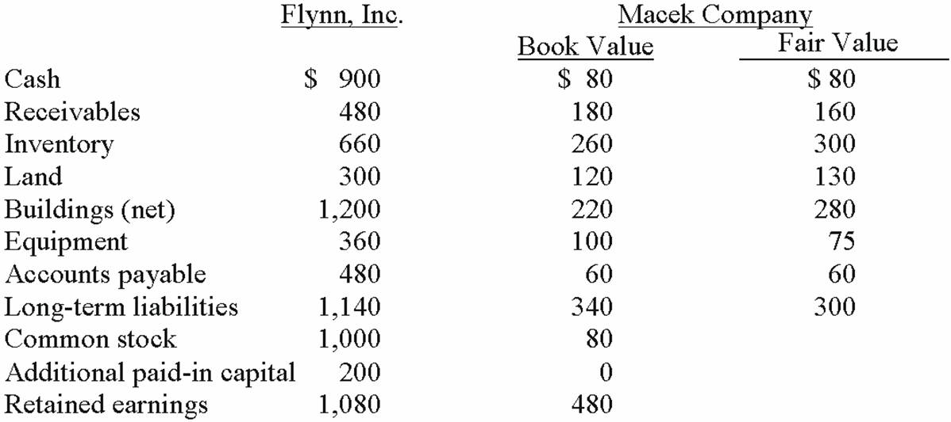  By how much will Flynn's additional paid-in capital increase as a result of this acquisition?  A. $150,000.  B. $160,000.  C. $230,000.  D. $350,000.  E. $360,000.

81. | Flynn acquires 100 percent of the outstanding voting shares of Macek Company on January 1, 2013. To obtain these shares, Flynn pays $400 cash (in thousands) and issues 10,000 shares of $20 par value common stock on this date. Flynn's stock had a fair value of $36 per share on that date. Flynn also pays $15 (in thousands) to a local investment firm for arranging the acquisition. An additional $10 (in thousands) was paid by Flynn in stock issuance costs.  The book values for both Flynn and Macek as of January 1, 2013 follow. The fair value of each of Flynn and Macek accounts is also included. In addition, Macek holds a fully amortized trademark that still retains a $40 (in thousands) value. The figures below are in thousands. Any related question also is in thousands.  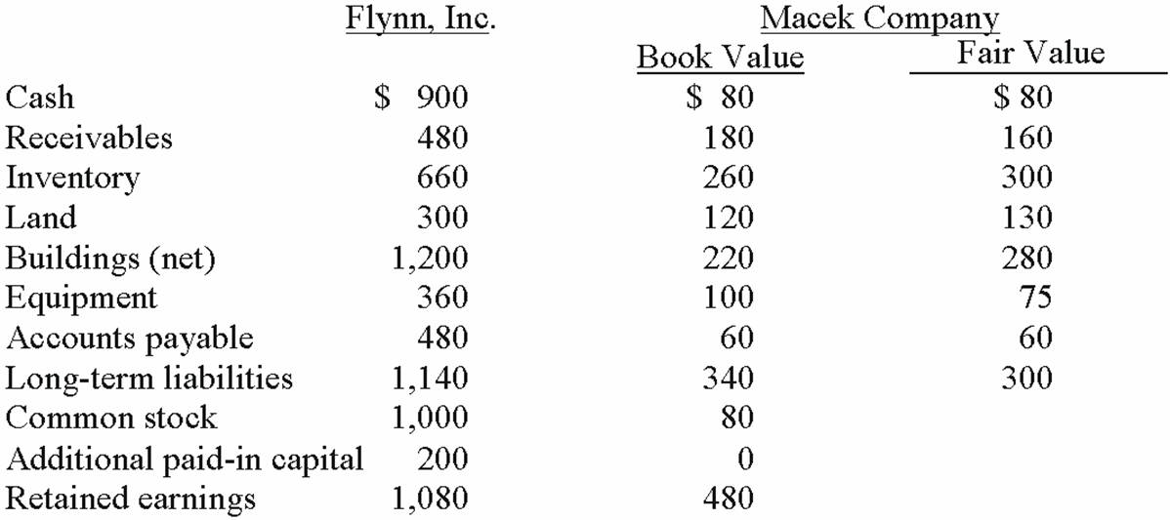  What amount will be reported for goodwill as a result of this acquisition?  A. $30,000.  B. $55,000.  C. $65,000.  D. $175,000.  E. $200,000.

82. | Flynn acquires 100 percent of the outstanding voting shares of Macek Company on January 1, 2013. To obtain these shares, Flynn pays $400 cash (in thousands) and issues 10,000 shares of $20 par value common stock on this date. Flynn's stock had a fair value of $36 per share on that date. Flynn also pays $15 (in thousands) to a local investment firm for arranging the acquisition. An additional $10 (in thousands) was paid by Flynn in stock issuance costs.  The book values for both Flynn and Macek as of January 1, 2013 follow. The fair value of each of Flynn and Macek accounts is also included. In addition, Macek holds a fully amortized trademark that still retains a $40 (in thousands) value. The figures below are in thousands. Any related question also is in thousands.  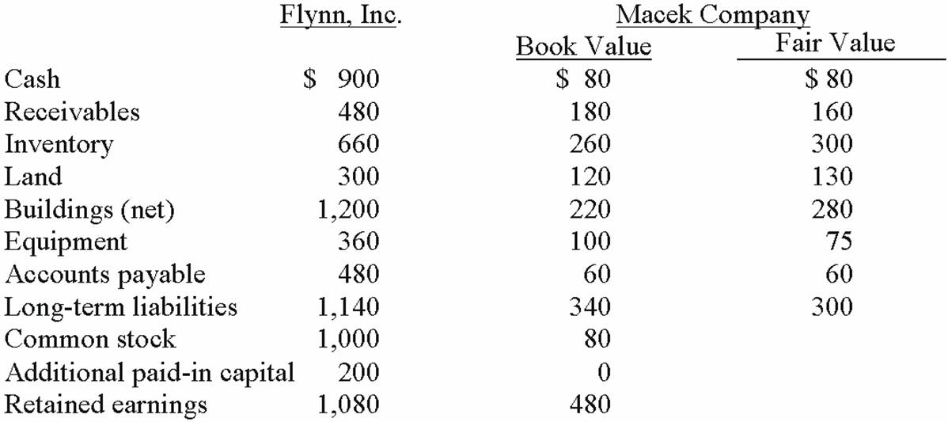  What amount will be reported for consolidated receivables?  A. $660,000.  B. $640,000.  C. $500,000.  D. $460,000.  E. $480,000.

83. | Flynn acquires 100 percent of the outstanding voting shares of Macek Company on January 1, 2013. To obtain these shares, Flynn pays $400 cash (in thousands) and issues 10,000 shares of $20 par value common stock on this date. Flynn's stock had a fair value of $36 per share on that date. Flynn also pays $15 (in thousands) to a local investment firm for arranging the acquisition. An additional $10 (in thousands) was paid by Flynn in stock issuance costs.  The book values for both Flynn and Macek as of January 1, 2013 follow. The fair value of each of Flynn and Macek accounts is also included. In addition, Macek holds a fully amortized trademark that still retains a $40 (in thousands) value. The figures below are in thousands. Any related question also is in thousands.  What amount will be reported for consolidated inventory?  A. $1,000,000.  B. $960,000.  C. $920,000.  D. $660,000.  E. $620,000.

84. | Flynn acquires 100 percent of the outstanding voting shares of Macek Company on January 1, 2013. To obtain these shares, Flynn pays $400 cash (in thousands) and issues 10,000 shares of $20 par value common stock on this date. Flynn's stock had a fair value of $36 per share on that date. Flynn also pays $15 (in thousands) to a local investment firm for arranging the acquisition. An additional $10 (in thousands) was paid by Flynn in stock issuance costs.  The book values for both Flynn and Macek as of January 1, 2013 follow. The fair value of each of Flynn and Macek accounts is also included. In addition, Macek holds a fully amortized trademark that still retains a $40 (in thousands) value. The figures below are in thousands. Any related question also is in thousands.  What amount will be reported for consolidated buildings (net)?  A. $1,420,000.  B. $1,260,000.  C. $1,140,000.  D. $1,480,000.  E. $1,200,000.

85. | Flynn acquires 100 percent of the outstanding voting shares of Macek Company on January 1, 2013. To obtain these shares, Flynn pays $400 cash (in thousands) and issues 10,000 shares of $20 par value common stock on this date. Flynn's stock had a fair value of $36 per share on that date. Flynn also pays $15 (in thousands) to a local investment firm for arranging the acquisition. An additional $10 (in thousands) was paid by Flynn in stock issuance costs.  The book values for both Flynn and Macek as of January 1, 2013 follow. The fair value of each of Flynn and Macek accounts is also included. In addition, Macek holds a fully amortized trademark that still retains a $40 (in thousands) value. The figures below are in thousands. Any related question also is in thousands.  What amount will be reported for consolidated equipment (net)?  A. $385,000.  B. $335,000.  C. $435,000.  D. $460,000.  E. $360,000.

86. | Flynn acquires 100 percent of the outstanding voting shares of Macek Company on January 1, 2013. To obtain these shares, Flynn pays $400 cash (in thousands) and issues 10,000 shares of $20 par value common stock on this date. Flynn's stock had a fair value of $36 per share on that date. Flynn also pays $15 (in thousands) to a local investment firm for arranging the acquisition. An additional $10 (in thousands) was paid by Flynn in stock issuance costs.  The book values for both Flynn and Macek as of January 1, 2013 follow. The fair value of each of Flynn and Macek accounts is also included. In addition, Macek holds a fully amortized trademark that still retains a $40 (in thousands) value. The figures below are in thousands. Any related question also is in thousands.  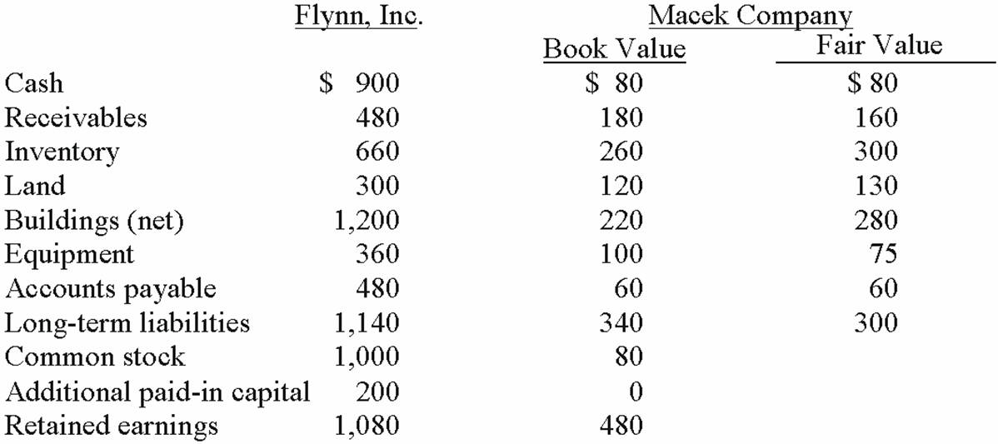  What amount will be reported for consolidated long-term liabilities?  A. $1,520,000.  B. $1,480,000.  C. $1,440,000.  D. $1,180,000.  E. $1,100,000.

87. | Flynn acquires 100 percent of the outstanding voting shares of Macek Company on January 1, 2013. To obtain these shares, Flynn pays $400 cash (in thousands) and issues 10,000 shares of $20 par value common stock on this date. Flynn's stock had a fair value of $36 per share on that date. Flynn also pays $15 (in thousands) to a local investment firm for arranging the acquisition. An additional $10 (in thousands) was paid by Flynn in stock issuance costs.  The book values for both Flynn and Macek as of January 1, 2013 follow. The fair value of each of Flynn and Macek accounts is also included. In addition, Macek holds a fully amortized trademark that still retains a $40 (in thousands) value. The figures below are in thousands. Any related question also is in thousands.  What amount will be reported for consolidated common stock?  A. $1,000,000.  B. $1,080,000.  C. $1,200,000.  D. $1,280,000.  E. $1,360,000.

88. | Flynn acquires 100 percent of the outstanding voting shares of Macek Company on January 1, 2013. To obtain these shares, Flynn pays $400 cash (in thousands) and issues 10,000 shares of $20 par value common stock on this date. Flynn's stock had a fair value of $36 per share on that date. Flynn also pays $15 (in thousands) to a local investment firm for arranging the acquisition. An additional $10 (in thousands) was paid by Flynn in stock issuance costs.  The book values for both Flynn and Macek as of January 1, 2013 follow. The fair value of each of Flynn and Macek accounts is also included. In addition, Macek holds a fully amortized trademark that still retains a $40 (in thousands) value. The figures below are in thousands. Any related question also is in thousands.  Assuming the combination is accounted for as a purchase, what amount will be reported for consolidated retained earnings?  A. $1,830,000.  B. $1,350,000.  C. $1,080,000.  D. $1,560,000.  E. $1,535,000.

89. | Flynn acquires 100 percent of the outstanding voting shares of Macek Company on January 1, 2013. To obtain these shares, Flynn pays $400 cash (in thousands) and issues 10,000 shares of $20 par value common stock on this date. Flynn's stock had a fair value of $36 per share on that date. Flynn also pays $15 (in thousands) to a local investment firm for arranging the acquisition. An additional $10 (in thousands) was paid by Flynn in stock issuance costs.  The book values for both Flynn and Macek as of January 1, 2013 follow. The fair value of each of Flynn and Macek accounts is also included. In addition, Macek holds a fully amortized trademark that still retains a $40 (in thousands) value. The figures below are in thousands. Any related question also is in thousands.  What amount will be reported for consolidated retained earnings?  A. $1,065,000.  B. $1,080,000.  C. $1,525,000.  D. $1,535,000.  E. $1,560,000.

90. | Flynn acquires 100 percent of the outstanding voting shares of Macek Company on January 1, 2013. To obtain these shares, Flynn pays $400 cash (in thousands) and issues 10,000 shares of $20 par value common stock on this date. Flynn's stock had a fair value of $36 per share on that date. Flynn also pays $15 (in thousands) to a local investment firm for arranging the acquisition. An additional $10 (in thousands) was paid by Flynn in stock issuance costs.  The book values for both Flynn and Macek as of January 1, 2013 follow. The fair value of each of Flynn and Macek accounts is also included. In addition, Macek holds a fully amortized trademark that still retains a $40 (in thousands) value. The figures below are in thousands. Any related question also is in thousands.  What amount will be reported for consolidated additional paid-in capital?  A. $365,000.  B. $350,000.  C. $360,000.  D. $375,000.  E. $345,000.

91. | Flynn acquires 100 percent of the outstanding voting shares of Macek Company on January 1, 2013. To obtain these shares, Flynn pays $400 cash (in thousands) and issues 10,000 shares of $20 par value common stock on this date. Flynn's stock had a fair value of $36 per share on that date. Flynn also pays $15 (in thousands) to a local investment firm for arranging the acquisition. An additional $10 (in thousands) was paid by Flynn in stock issuance costs.  The book values for both Flynn and Macek as of January 1, 2013 follow. The fair value of each of Flynn and Macek accounts is also included. In addition, Macek holds a fully amortized trademark that still retains a $40 (in thousands) value. The figures below are in thousands. Any related question also is in thousands.  What amount will be reported for consolidated cash after the acquisition is completed?  A. $475,000.  B. $500,000.  C. $555,000.  D. $580,000.  E. $875,000.

Essay Questions
92. | What term is used to refer to a business combination in which only one of the original companies continues to exist?

93. | How are stock issuance costs accounted for in an acquisition business combination?

94. | What is the primary difference between recording an acquisition when the subsidiary is dissolved and when separate incorporation is maintained?

95. | How are direct combination costs accounted for in an acquisition transaction?

96. | Peterman Co. owns 55% of Samson Co. Under what circumstances would Peterman not be required to prepare consolidated financial statements?

97. | How would you account for in-process research and development acquired in a business combination accounted for as an acquisition?

98. | Elon Corp. obtained all of the common stock of Finley Co., paying slightly less than the fair value of Finley's net assets acquired. How should the difference between the consideration transferred and the fair value of the net assets be treated if the transaction is accounted for as an acquisition?

99. | For acquisition accounting, why are assets and liabilities of the subsidiary consolidated at fair value?

100. | Goodwill is often acquired as part of a business combination. Why, when separate incorporation is maintained, does Goodwill not appear on the Parent company's trial balance as a separate account?

101. | How are direct combination costs, contingent consideration, and a bargain purchase reflected in recording an acquisition transaction?

102. | How is contingent consideration accounted for in an acquisition business combination transaction?

103. | How are bargain purchases accounted for in an acquisition business transaction?

104. | Describe the accounting for direct costs, indirect costs, and issuance costs under the acquisition method of accounting for a business combination.

105. | What is the difference in consolidated results between a business combination whereby the acquired company is dissolved, and a business combination whereby separate incorporation is maintained?

106. | Bale Co. acquired Silo Inc. on December 31, 2013, in an acquisition business combination transaction. Bale's net income for the year was $1,400,000, while Silo had net income of $400,000 earned evenly during the year. Bale paid $100,000 in direct combination costs, $50,000 in indirect costs, and $30,000 in stock issue costs to effect the combination.  Required:  What is consolidated net income for 2013?

107. | Fine Co. issued its common stock in exchange for the common stock of Dandy Corp. in an acquisition. At the date of the combination, Fine had land with a book value of $480,000 and a fair value of $620,000. Dandy had land with a book value of $170,000 and a fair value of $190,000.  Required:  What was the consolidated balance for Land in a consolidated balance sheet prepared at the date of the acquisition combination?

108. | Jernigan Corp. had the following account balances at 12/1/12:  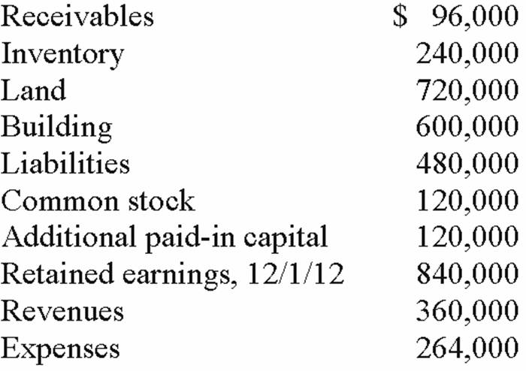  Several of Jernigan's accounts have fair values that differ from book value. The fair values are: Land — $480,000; Building — $720,000; Inventory — $336,000; and Liabilities — $396,000.  Inglewood Inc. acquired all of the outstanding common shares of Jernigan by issuing 20,000 shares of common stock having a $6 par value, but a $66 fair value. Stock issuance costs amounted to $12,000.  Required:  Prepare a fair value allocation and goodwill schedule at the date of the acquisition.

109. | Salem Co. had the following account balances as of December 1, 2012:  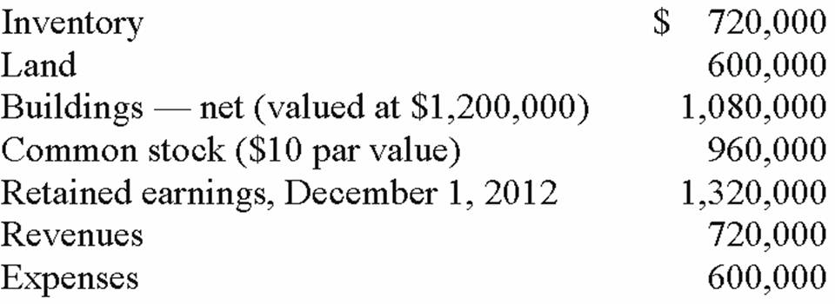  Bellington Inc. transferred $1.7 million in cash and 12,000 shares of its newly issued $30 par value common stock (valued at $90 per share) to acquire all of Salem's outstanding common stock.  Determine the balance for Goodwill that would be included in a December 1, 2012, consolidation.

110. | Salem Co. had the following account balances as of December 1, 2012:  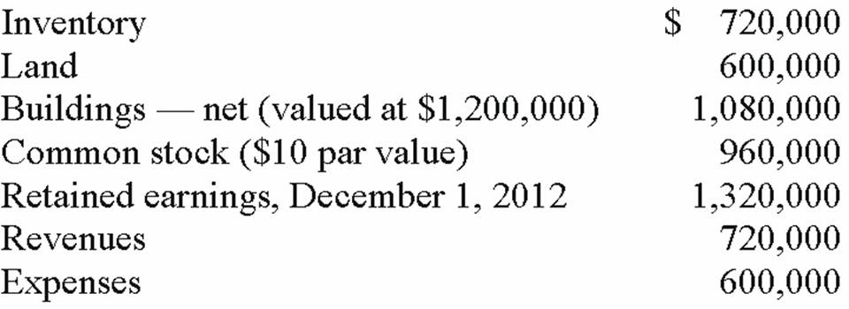  Bellington Inc. transferred $1.7 million in cash and 12,000 shares of its newly issued $30 par value common stock (valued at $90 per share) to acquire all of Salem's outstanding common stock.  Assume that Bellington paid cash of $2.8 million. No stock is issued. An additional $50,000 is paid in direct combination costs.  Required:  For Goodwill, determine what balance would be included in a December 1, 2012 consolidation.

111. | On January 1, 2013, Chester Inc. acquired 100% of Festus Corp.'s outstanding common stock by exchanging 37,500 shares of Chester's $2 par value common voting stock. On January 1, 2013, Chester's voting common stock had a fair value of $40 per share. Festus' voting common shares were selling for $6.50 per share. Festus' balances on the acquisition date, just prior to acquisition are listed below.  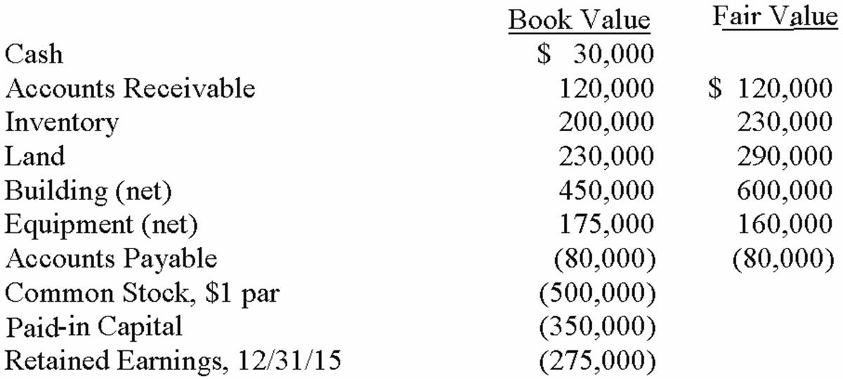  Required:  Compute the value of the Goodwill account on the date of acquisition, 1/1/15.

112. | The financial statements for Jode Inc. and Lakely Corp., just prior to their combination, for the year ending December 31, 2012, follow. Lakely's buildings were undervalued on its financial records by $60,000.  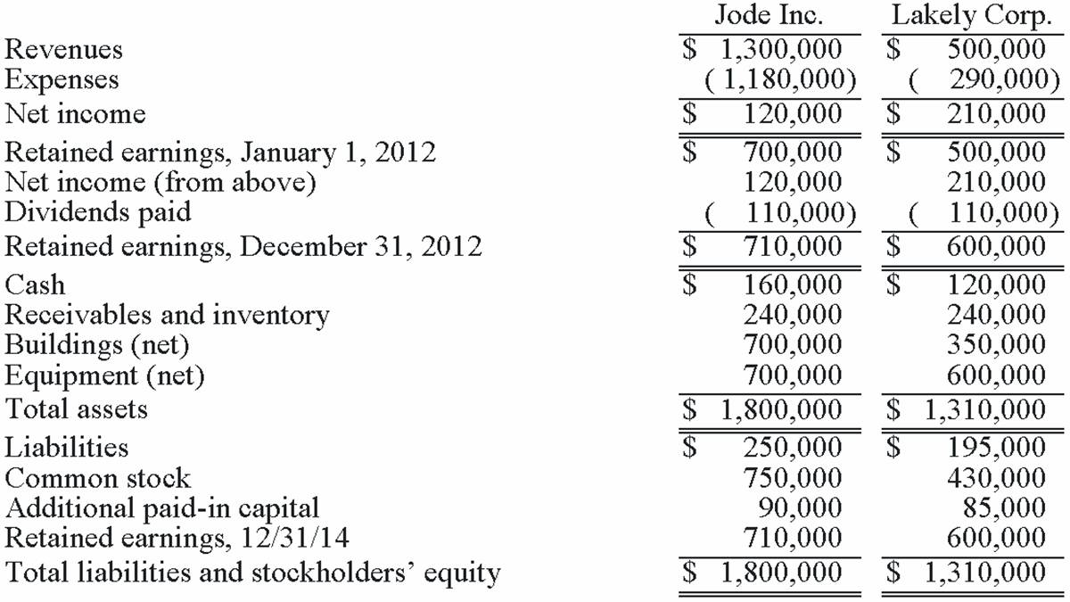  On December 31, 2012, Jode issued 54,000 new shares of its $10 par value stock in exchange for all the outstanding shares of Lakely. Jode's shares had a fair value on that date of $35 per share. Jode paid $34,000 to an investment bank for assisting in the arrangements. Jode also paid $24,000 in stock issuance costs to effect the acquisition of Lakely. Lakely will retain its incorporation.  Prepare the journal entries to record (1) the issuance of stock by Jode and (2) the payment of the combination costs.

113. | The financial statements for Jode Inc. and Lakely Corp., just prior to their combination, for the year ending December 31, 2012, follow. Lakely's buildings were undervalued on its financial records by $60,000.  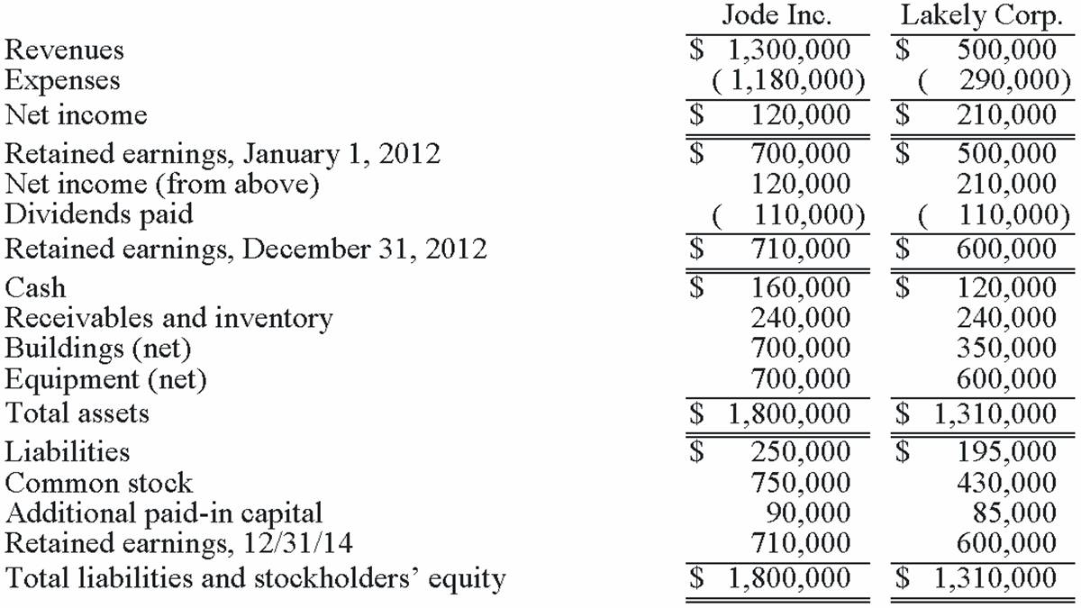  On December 31, 2012, Jode issued 54,000 new shares of its $10 par value stock in exchange for all the outstanding shares of Lakely. Jode's shares had a fair value on that date of $35 per share. Jode paid $34,000 to an investment bank for assisting in the arrangements. Jode also paid $24,000 in stock issuance costs to effect the acquisition of Lakely. Lakely will retain its incorporation.  Required:  Determine consolidated net income for the year ended December 31, 2012.

114. | The financial statements for Jode Inc. and Lakely Corp., just prior to their combination, for the year ending December 31, 2012, follow. Lakely's buildings were undervalued on its financial records by $60,000.  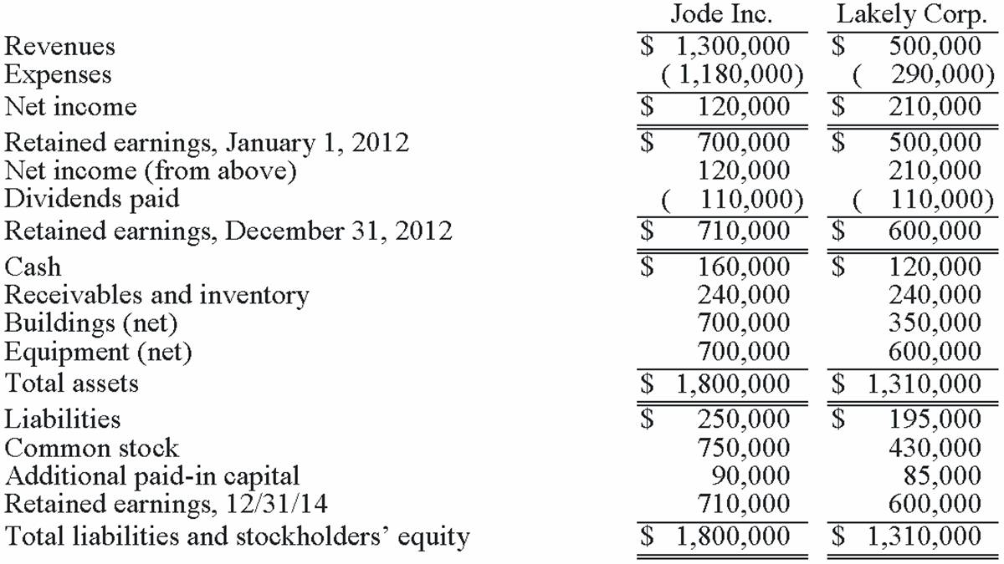  On December 31, 2012, Jode issued 54,000 new shares of its $10 par value stock in exchange for all the outstanding shares of Lakely. Jode's shares had a fair value on that date of $35 per share. Jode paid $34,000 to an investment bank for assisting in the arrangements. Jode also paid $24,000 in stock issuance costs to effect the acquisition of Lakely. Lakely will retain its incorporation.  Determine consolidated Additional paid-in Capital at December 31, 2012.

115. | The following are preliminary financial statements for Black Co. and Blue Co. for the year ending December 31, 2013.  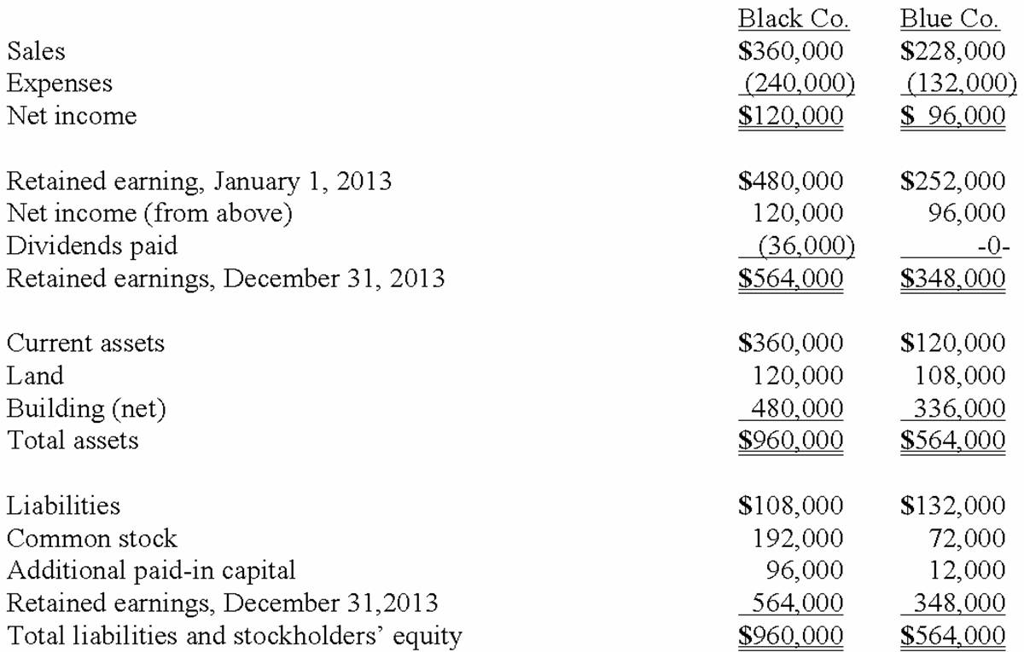  On December 31, 2013 (subsequent to the preceding statements), Black exchanged 10,000 shares of its $10 par value common stock for all of the outstanding shares of Blue. Black's stock on that date has a fair value of $50 per share. Black was willing to issue 10,000 shares of stock because Blue's land was appraised at $204,000. Black also paid $14,000 to several attorneys and accountants who assisted in creating this combination.  Required:  Assuming that these two companies retained their separate legal identities, prepare a consolidation worksheet as of December 31, 2013.

116. | The following are preliminary financial statements for Black Co. and Blue Co. for the year ending December 31, 2013 prior to Black's acquisition of Blue.  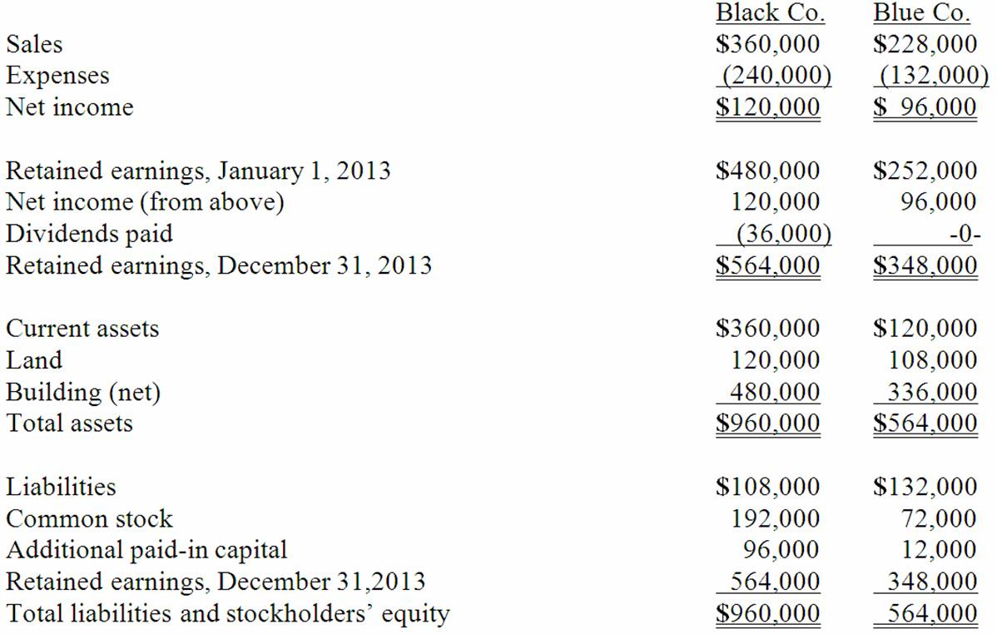  On December 31, 2013 (subsequent to the preceding statements), Black exchanged 10,000 shares of its $10 par value common stock for all of the outstanding shares of Blue. Black's stock on that date has a fair value of $60 per share. Black was willing to issue 10,000 shares of stock because Blue's land was appraised at $204,000. Black also paid $14,000 to several attorneys and accountants who assisted in creating this combination.  Required:  Assuming that these two companies retained their separate legal identities, prepare a consolidation worksheet as of December 31, 2013 after the acquisition transaction is completed.

117. | For each of the following situations, select the best letter answer to reflect the effect of the numbered item on the acquirer's accounting entry at the date of combination when separate incorporation will be maintained. Items (4) and (6) require two selections.  (A) Increase Investment account.  (B) Decrease Investment account.  (C) Increase Liabilities.  (D) Increase Common stock.  (E) Decrease common stock.  (F) Increase Additional paid-in capital.  (G) Decrease Additional paid-in capital.  (H) Increase Retained earnings.  (I) Decrease Retained earnings.  _____1. Direct costs.  _____2. Indirect costs.  _____3. Stock issue costs.  _____4. Contingent consideration.  _____5. Bargain purchase.  _____6. In-process research and development acquired.

Chapter 02 Consolidation of Financial Information Answer Key
Multiple Choice Questions
1. | At the date of an acquisition which is not a bargain purchase, the acquisition method  A. consolidates the subsidiary's assets at fair value and the liabilities at book value.  B. consolidates all subsidiary assets and liabilities at book value.  C. consolidates all subsidiary assets and liabilities at fair value.  D. consolidates current assets and liabilities at book value, long-term assets and liabilities at fair value.  E. consolidates the subsidiary's assets at book value and the liabilities at fair value.

AACSB: Reflective thinking
AICPA BB: Critical Thinking
AICPA FN: Measurement
Accessibility: Keyboard Navigation
Blooms: Remember
Difficulty: 1 Easy
Learning Objective: 02-04 Describe the valuation principles of the acquisition method.
Learning Objective: 02-05 Determine the total fair value of the consideration transferred for an acquisition and allocate that fair value to specific subsidiary assets acquired (including goodwill); and liabilities assumed; or a gain on bargain purchase.
Topic: Acquisition Method When Dissolution Takes Place
Topic: Financial Reporting for Business Combinations

2. | In an acquisition where control is achieved, how would the land accounts of the parent and the land accounts of the subsidiary be combined?  A. Option A  B. Option B  C. Option C  D. Option D  E. Option E

AACSB: Reflective thinking
AICPA BB: Critical Thinking
AICPA FN: Measurement
Blooms: Remember
Difficulty: 2 Medium
Learning Objective: 02-04 Describe the valuation principles of the acquisition method.
Learning Objective: 02-05 Determine the total fair value of the consideration transferred for an acquisition and allocate that fair value to specific subsidiary assets acquired (including goodwill); and liabilities assumed; or a gain on bargain purchase.
Topic: Acquisition Method When Dissolution Takes Place
Topic: Financial Reporting for Business Combinations

3. | Lisa Co. paid cash for all of the voting common stock of Victoria Corp. Victoria will continue to exist as a separate corporation. Entries for the consolidation of Lisa and Victoria would be recorded in  A. a worksheet.  B. Lisa's general journal.  C. Victoria's general journal.  D. Victoria's secret consolidation journal.  E. the general journals of both companies.

AACSB: Reflective thinking
AICPA BB: Critical Thinking
AICPA FN: Measurement
Accessibility: Keyboard Navigation
Blooms: Remember
Difficulty: 1 Easy
Learning Objective: 02-07 Prepare a worksheet to consolidate the accounts of two companies that form a business combination if dissolution does not take place.
Topic: The Acquisition Method When Separate Incorporation Is Maintained

4. | Using the acquisition method for a business combination, goodwill is generally defined as:  A. Cost of the investment less the subsidiary's book value at the beginning of the year.  B. Cost of the investment less the subsidiary's book value at the acquisition date.  C. Cost of the investment less the subsidiary's fair value at the beginning of the year.  D. Cost of the investment less the subsidiary's fair value at acquisition date.  E. is no longer allowed under federal law.

AACSB: Reflective thinking
AICPA BB: Critical Thinking
AICPA FN: Measurement
Accessibility: Keyboard Navigation
Blooms: Remember
Difficulty: 2 Medium
Learning Objective: 02-04 Describe the valuation principles of the acquisition method.
Topic: Financial Reporting for Business Combinations

5. | Direct combination costs and stock issuance costs are often incurred in the process of making a controlling investment in another company. How should those costs be accounted for in a pre-2009 purchase transaction?  A. Option A  B. Option B  C. Option C  D. Option D  E. Option E

AACSB: Reflective thinking
AICPA BB: Critical Thinking
AICPA FN: Measurement
Blooms: Remember
Difficulty: 2 Medium
Learning Objective: 02-09 Appendix: Identify the general characteristics of the legacy purchase and pooling of interest methods of accounting for past business combinations. Understand the effects that persist today in financial statements from the use of these legacy methods.

6. | How are direct and indirect costs accounted for when applying the acquisition method for a business combination?  A. Option A  B. Option B  C. Option C  D. Option D  E. Option E

AACSB: Reflective thinking
AICPA BB: Critical Thinking
AICPA FN: Measurement
Blooms: Remember
Difficulty: 1 Easy
Learning Objective: 02-05 Determine the total fair value of the consideration transferred for an acquisition and allocate that fair value to specific subsidiary assets acquired (including goodwill); and liabilities assumed; or a gain on bargain purchase.
Topic: Acquisition Method When Dissolution Takes Place

7. | What is the primary accounting difference between accounting for when the subsidiary is dissolved and when the subsidiary retains its incorporation?  A. If the subsidiary is dissolved, it will not be operated as a separate division.  B. If the subsidiary is dissolved, assets and liabilities are consolidated at their book values.  C. If the subsidiary retains its incorporation, there will be no goodwill associated with the acquisition.  D. If the subsidiary retains its incorporation, assets and liabilities are consolidated at their book values.  E. If the subsidiary retains its incorporation, the consolidation is not formally recorded in the accounting records of the acquiring company.

AACSB: Reflective thinking
AICPA BB: Critical Thinking
AICPA FN: Measurement
Accessibility: Keyboard Navigation
Blooms: Understand
Difficulty: 2 Medium
Learning Objective: 02-06 Prepare the journal entry to consolidate the accounts of a subsidiary if dissolution takes place.
Learning Objective: 02-07 Prepare a worksheet to consolidate the accounts of two companies that form a business combination if dissolution does not take place.
Topic: Acquisition Method When Dissolution Takes Place
Topic: The Acquisition Method When Separate Incorporation Is Maintained

8. | According to GAAP, the pooling of interest method for business combinations  A. Is preferred to the purchase method.  B. Is allowed for all new acquisitions.  C. Is no longer allowed for business combinations after June 30, 2001.  D. Is no longer allowed for business combinations after December 31, 2001.  E. Is only allowed for large corporate mergers like Exxon and Mobil.

AACSB: Reflective thinking
AICPA BB: Critical Thinking
AICPA FN: Measurement
Accessibility: Keyboard Navigation
Blooms: Remember
Difficulty: 1 Easy
Learning Objective: 02-09 Appendix: Identify the general characteristics of the legacy purchase and pooling of interest methods of accounting for past business combinations. Understand the effects that persist today in financial statements from the use of these legacy methods.

9. | An example of a difference in types of business combination is:  A. A statutory merger can only be effected by an asset acquisition while a statutory consolidation can only be effected by a capital stock acquisition.  B. A statutory merger can only be effected by a capital stock acquisition while a statutory consolidation can only be effected by an asset acquisition.  C. A statutory merger requires dissolution of the acquired company while a statutory consolidation does not require dissolution.  D. A statutory consolidation requires dissolution of the acquired company while a statutory merger does not require dissolution.  E. Both a statutory merger and a statutory consolidation can only be effected by an asset acquisition but only a statutory consolidation requires dissolution of the acquired company.

AACSB: Reflective thinking
AICPA BB: Critical Thinking
AICPA FN: Measurement
Accessibility: Keyboard Navigation
Blooms: Remember
Difficulty: 3 Hard
Learning Objective: 02-03 Define the term business combination and differentiate across various forms of business combinations.
Topic: Business Combinations-Creating a Single Economic Entity

10. | Acquired in-process research and development is considered as  A. a definite-lived asset subject to amortization.  B. a definite-lived asset subject to testing for impairment.  C. an indefinite-lived asset subject to amortization.  D. an indefinite-lived asset subject to testing for impairment.  E. a research and development expense at the date of acquisition.

AACSB: Reflective thinking
AICPA BB: Critical Thinking
AICPA FN: Measurement
Accessibility: Keyboard Navigation
Blooms: Remember
Difficulty: 1 Easy
Learning Objective: 02-08 Describe the two criteria for recognizing intangible assets apart from goodwill in a business combination.
Topic: Acquisition-Date Fair-Value Allocations-Additional Issues

11. | Which one of the following is a characteristic of a business combination accounted for as an acquisition?  A. The combination must involve the exchange of equity securities only.  B. The transaction establishes an acquisition fair value basis for the company being acquired.  C. The two companies may be about the same size, and it is difficult to determine the acquired company and the acquiring company.  D. The transaction may be considered to be the uniting of the ownership interests of the companies involved.  E. The acquired subsidiary must be smaller in size than the acquiring parent.

AACSB: Reflective thinking
AICPA BB: Critical Thinking
AICPA FN: Measurement
Accessibility: Keyboard Navigation
Blooms: Remember
Difficulty: 1 Easy
Learning Objective: 02-04 Describe the valuation principles of the acquisition method.
Topic: Financial Reporting for Business Combinations

12. | Which one of the following is a characteristic of a business combination that is accounted for as an acquisition?  A. Fair value only for items received by the acquirer can enter into the determination of the acquirer's accounting valuation of the acquired company.  B. Fair value only for the consideration transferred by the acquirer can enter into the determination of the acquirer's accounting valuation of the acquired company.  C. Fair value for the consideration transferred by the acquirer as well as the fair value of items received by the acquirer can enter into the determination of the acquirer's accounting valuation of the acquired company.  D. Fair value for only consideration transferred and identifiable assets received by the acquirer can enter into the determination of the acquirer's accounting valuation of the acquired company.  E. Only fair value of identifiable assets received enters into the determination of the acquirer's accounting valuation of the acquired company.

AACSB: Reflective thinking
AICPA BB: Critical Thinking
AICPA FN: Measurement
Accessibility: Keyboard Navigation
Blooms: Understand
Difficulty: 3 Hard
Learning Objective: 02-04 Describe the valuation principles of the acquisition method.
Topic: Financial Reporting for Business Combinations

13. | A statutory merger is a(n)  A. business combination in which only one of the two companies continues to exist as a legal corporation.  B. business combination in which both companies continue to exist.  C. acquisition of a competitor.  D. acquisition of a supplier or a customer.  E. legal proposal to acquire outstanding shares of the target's stock.

AACSB: Reflective thinking
AICPA BB: Critical Thinking
AICPA FN: Measurement
Accessibility: Keyboard Navigation
Blooms: Remember
Difficulty: 2 Medium
Learning Objective: 02-03 Define the term business combination and differentiate across various forms of business combinations.
Topic: Business Combinations-Creating a Single Economic Entity

14. | How are stock issuance costs and direct combination costs treated in a business combination which is accounted for as an acquisition when the subsidiary will retain its incorporation?  A. Stock issuance costs are a part of the acquisition costs, and the direct combination costs are expensed.  B. Direct combination costs are a part of the acquisition costs, and the stock issuance costs are a reduction to additional paid-in capital.  C. Direct combination costs are expensed and stock issuance costs are a reduction to additional paid-in capital.  D. Both are treated as part of the acquisition consideration transferred.  E. Both are treated as a reduction to additional paid-in capital.

AACSB: Reflective thinking
AICPA BB: Critical Thinking
AICPA FN: Measurement
Accessibility: Keyboard Navigation
Blooms: Remember
Difficulty: 2 Medium
Learning Objective: 02-05 Determine the total fair value of the consideration transferred for an acquisition and allocate that fair value to specific subsidiary assets acquired (including goodwill); and liabilities assumed; or a gain on bargain purchase.
Learning Objective: 02-06 Prepare the journal entry to consolidate the accounts of a subsidiary if dissolution takes place.
Topic: Acquisition Method When Dissolution Takes Place

15. | Bullen Inc. acquired 100% of the voting common stock of Vicker Inc. on January 1, 2013. The book value and fair value of Vicker's accounts on that date (prior to creating the combination) follow, along with the book value of Bullen's accounts:  Assume that Bullen issued 12,000 shares of common stock with a $5 par value and a $47 fair value to obtain all of Vicker's outstanding stock. In this acquisition transaction, how much goodwill should be recognized?  A. $144,000.  B. $104,000.  C. $64,000.  D. $60,000.  E. $0.  $47 × 12,000 = $564,000 - ($80,000 + $40,000 + $240,000) = $204,000 - $100,000 = $104,000  FV > BV: Inv +$40,000; Land +$20,000; +Blgs $30,000; +Liab $10,000 = $100,000

AACSB: Analytic
AICPA BB: Critical Thinking
AICPA FN: Measurement
Blooms: Apply
Difficulty: 2 Medium
Learning Objective: 02-04 Describe the valuation principles of the acquisition method.
Learning Objective: 02-05 Determine the total fair value of the consideration transferred for an acquisition and allocate that fair value to specific subsidiary assets acquired (including goodwill); and liabilities assumed; or a gain on bargain purchase.
Learning Objective: 02-06 Prepare the journal entry to consolidate the accounts of a subsidiary if dissolution takes place.
Learning Objective: 02-07 Prepare a worksheet to consolidate the accounts of two companies that form a business combination if dissolution does not take place.
Topic: Acquisition Method When Dissolution Takes Place
Topic: Financial Reporting for Business Combinations
Topic: The Acquisition Method When Separate Incorporation Is Maintained

16. | Bullen Inc. acquired 100% of the voting common stock of Vicker Inc. on January 1, 2013. The book value and fair value of Vicker's accounts on that date (prior to creating the combination) follow, along with the book value of Bullen's accounts:  Assume that Bullen issued 12,000 shares of common stock with a $5 par value and a $42 fair value for all of the outstanding stock of Vicker. What is the consolidated balance for Land as a result of this acquisition transaction?  A. $460,000.  B. $510,000.  C. $500,000.  D. $520,000.  E. $490,000.  $280,000 + $240,000 = $520,000

AACSB: Analytic
AICPA BB: Critical Thinking
AICPA FN: Measurement
Blooms: Apply
Difficulty: 2 Medium
Learning Objective: 02-05 Determine the total fair value of the consideration transferred for an acquisition and allocate that fair value to specific subsidiary assets acquired (including goodwill); and liabilities assumed; or a gain on bargain purchase.
Learning Objective: 02-06 Prepare the journal entry to consolidate the accounts of a subsidiary if dissolution takes place.
Learning Objective: 02-07 Prepare a worksheet to consolidate the accounts of two companies that form a business combination if dissolution does not take place.
Topic: Acquisition Method When Dissolution Takes Place
Topic: The Acquisition Method When Separate Incorporation Is Maintained

17. | Bullen Inc. acquired 100% of the voting common stock of Vicker Inc. on January 1, 2013. The book value and fair value of Vicker's accounts on that date (prior to creating the combination) follow, along with the book value of Bullen's accounts:  Assume that Bullen issued 12,000 shares of common stock with a $5 par value and a $42 fair value for all of the outstanding shares of Vicker. What will be the consolidated Additional Paid-In Capital and Retained Earnings (January 1, 2013 balances) as a result of this acquisition transaction?  A. $60,000 and $490,000.  B. $60,000 and $250,000.  C. $380,000 and $250,000.  D. $464,000 and $250,000.  E. $464,000 and $420,000.  $20,000 + ($37 × 12,000) = $464,000 Add'l Paid-In Capital  $250,000 Parent's R/E Only

AACSB: Analytic
AICPA BB: Critical Thinking
AICPA FN: Measurement
Blooms: Apply
Difficulty: 3 Hard
Learning Objective: 02-04 Describe the valuation principles of the acquisition method.
Learning Objective: 02-05 Determine the total fair value of the consideration transferred for an acquisition and allocate that fair value to specific subsidiary assets acquired (including goodwill); and liabilities assumed; or a gain on bargain purchase.
Learning Objective: 02-06 Prepare the journal entry to consolidate the accounts of a subsidiary if dissolution takes place.
Learning Objective: 02-07 Prepare a worksheet to consolidate the accounts of two companies that form a business combination if dissolution does not take place.
Topic: Acquisition Method When Dissolution Takes Place
Topic: Financial Reporting for Business Combinations
Topic: The Acquisition Method When Separate Incorporation Is Maintained

18. | Bullen Inc. acquired 100% of the voting common stock of Vicker Inc. on January 1, 2013. The book value and fair value of Vicker's accounts on that date (prior to creating the combination) follow, along with the book value of Bullen's accounts:  Assume that Bullen issued preferred stock with a par value of $240,000 and a fair value of $500,000 for all of the outstanding shares of Vicker in an acquisition business combination. What will be the balance in the consolidated Inventory and Land accounts?  A. $440,000, $496,000.  B. $440,000, $520,000.  C. $425,000, $505,000.  D. $400,000, $500,000.  E. $427,000, $510,000.  Inventory $230,000 BV + $210,000 FV = $440,000  Land $280,000 BV + $240,000 FV = $520,000

AACSB: Analytic
AICPA BB: Critical Thinking
AICPA FN: Measurement
Blooms: Apply
Difficulty: 2 Medium
Learning Objective: 02-05 Determine the total fair value of the consideration transferred for an acquisition and allocate that fair value to specific subsidiary assets acquired (including goodwill); and liabilities assumed; or a gain on bargain purchase.
Learning Objective: 02-06 Prepare the journal entry to consolidate the accounts of a subsidiary if dissolution takes place.
Learning Objective: 02-07 Prepare a worksheet to consolidate the accounts of two companies that form a business combination if dissolution does not take place.
Topic: Acquisition Method When Dissolution Takes Place
Topic: The Acquisition Method When Separate Incorporation Is Maintained

19. | Bullen Inc. acquired 100% of the voting common stock of Vicker Inc. on January 1, 2013. The book value and fair value of Vicker's accounts on that date (prior to creating the combination) follow, along with the book value of Bullen's accounts:  Assume that Bullen paid a total of $480,000 in cash for all of the shares of Vicker. In addition, Bullen paid $35,000 to a group of attorneys for their work in arranging the combination to be accounted for as an acquisition. What will be the balance in consolidated goodwill?  A. $0.  B. $20,000.  C. $35,000.  D. $55,000.  E. $65,000.  $480,000 - ($80,000 CS + $40,000 APIC + $240,000 R/E + $100,000 FV) = $20,000 Excess

AACSB: Analytic
AICPA BB: Critical Thinking
AICPA FN: Measurement
Blooms: Apply
Difficulty: 2 Medium
Learning Objective: 02-05 Determine the total fair value of the consideration transferred for an acquisition and allocate that fair value to specific subsidiary assets acquired (including goodwill); and liabilities assumed; or a gain on bargain purchase.
Learning Objective: 02-06 Prepare the journal entry to consolidate the accounts of a subsidiary if dissolution takes place.
Learning Objective: 02-07 Prepare a worksheet to consolidate the accounts of two companies that form a business combination if dissolution does not take place.
Topic: Acquisition Method When Dissolution Takes Place
Topic: The Acquisition Method When Separate Incorporation Is Maintained

20. | Prior to being united in a business combination, Botkins Inc. and Volkerson Corp. had the following stockholders' equity figures:  Botkins issued 56,000 new shares of its common stock valued at $3.25 per share for all of the outstanding stock of Volkerson.  Assume that Botkins acquired Volkerson on January 1, 2012. At what amount did Botkins record the investment in Volkerson?  A. $56,000.  B. $182,000.  C. $209,000.  D. $261,000.  E. $312,000.  $3.25 × 56,000 = $182,000

AACSB: Analytic
AICPA BB: Critical Thinking
AICPA FN: Measurement
Blooms: Apply
Difficulty: 1 Easy
Learning Objective: 02-04 Describe the valuation principles of the acquisition method.
Learning Objective: 02-05 Determine the total fair value of the consideration transferred for an acquisition and allocate that fair value to specific subsidiary assets acquired (including goodwill); and liabilities assumed; or a gain on bargain purchase.
Learning Objective: 02-06 Prepare the journal entry to consolidate the accounts of a subsidiary if dissolution takes place.
Learning Objective: 02-07 Prepare a worksheet to consolidate the accounts of two companies that form a business combination if dissolution does not take place.
Topic: Acquisition Method When Dissolution Takes Place
Topic: Financial Reporting for Business Combinations
Topic: The Acquisition Method When Separate Incorporation Is Maintained

21. | Prior to being united in a business combination, Botkins Inc. and Volkerson Corp. had the following stockholders' equity figures:  Botkins issued 56,000 new shares of its common stock valued at $3.25 per share for all of the outstanding stock of Volkerson.  Assume that Botkins acquired Volkerson on January 1, 2012. Immediately afterwards, what is consolidated Common Stock?  A. $456,000.  B. $402,000.  C. $274,000.  D. $276,000.  E. $330,000.  $220,000 + ($1.00 × 56,000) = $276,000

AACSB: Analytic
AICPA BB: Critical Thinking
AICPA FN: Measurement
Blooms: Apply
Difficulty: 2 Medium
Learning Objective: 02-05 Determine the total fair value of the consideration transferred for an acquisition and allocate that fair value to specific subsidiary assets acquired (including goodwill); and liabilities assumed; or a gain on bargain purchase.
Learning Objective: 02-06 Prepare the journal entry to consolidate the accounts of a subsidiary if dissolution takes place.
Learning Objective: 02-07 Prepare a worksheet to consolidate the accounts of two companies that form a business combination if dissolution does not take place.
Topic: Acquisition Method When Dissolution Takes Place
Topic: The Acquisition Method When Separate Incorporation Is Maintained

22. | Chapel Hill Company had common stock of $350,000 and retained earnings of $490,000. Blue Town Inc. had common stock of $700,000 and retained earnings of $980,000. On January 1, 2013, Blue Town issued 34,000 shares of common stock with a $12 par value and a $35 fair value for all of Chapel Hill Company's outstanding common stock. This combination was accounted for as an acquisition. Immediately after the combination, what was the total consolidated net assets?  A. $2,520,000.  B. $1,190,000.  C. $1,680,000.  D. $2,870,000.  E. $2,030,000.  $700,000 + $980,000 + ($35 × 34,000) = $2,870,000

AACSB: Analytic
AICPA BB: Critical Thinking
AICPA FN: Measurement
Accessibility: Keyboard Navigation
Blooms: Apply
Difficulty: 2 Medium
Learning Objective: 02-05 Determine the total fair value of the consideration transferred for an acquisition and allocate that fair value to specific subsidiary assets acquired (including goodwill); and liabilities assumed; or a gain on bargain purchase.
Learning Objective: 02-06 Prepare the journal entry to consolidate the accounts of a subsidiary if dissolution takes place.
Learning Objective: 02-07 Prepare a worksheet to consolidate the accounts of two companies that form a business combination if dissolution does not take place.
Topic: Acquisition Method When Dissolution Takes Place
Topic: The Acquisition Method When Separate Incorporation Is Maintained

23. | Which of the following is a not a reason for a business combination to take place?  A. Cost savings through elimination of duplicate facilities.  B. Quick entry for new and existing products into domestic and foreign markets.  C. Diversification of business risk.  D. Vertical integration.  E. Increase in stock price of the acquired company.

AACSB: Reflective thinking
AICPA BB: Critical Thinking
AICPA FN: Measurement
Accessibility: Keyboard Navigation
Blooms: Remember
Difficulty: 1 Easy
Learning Objective: 02-01 Discuss the motives for business combinations.
Topic: Expansion through Corporate Takeovers

24. | Which of the following statements is true regarding a statutory merger?  A. The original companies dissolve while remaining as separate divisions of a newly created company.  B. Both companies remain in existence as legal corporations with one corporation now a subsidiary of the acquiring company.  C. The acquired company dissolves as a separate corporation and becomes a division of the acquiring company.  D. The acquiring company acquires the stock of the acquired company as an investment.  E. A statutory merger is no longer a legal option.

AACSB: Reflective thinking
AICPA BB: Critical Thinking
AICPA FN: Measurement
Accessibility: Keyboard Navigation
Blooms: Remember
Difficulty: 2 Medium
Learning Objective: 02-03 Define the term business combination and differentiate across various forms of business combinations.
Topic: Business Combinations-Creating a Single Economic Entity

25. | Which of the following statements is true regarding a statutory consolidation?  A. The original companies dissolve while remaining as separate divisions of a newly created company.  B. Both companies remain in existence as legal corporations with one corporation now a subsidiary of the acquiring company.  C. The acquired company dissolves as a separate corporation and becomes a division of the acquiring company.  D. The acquiring company acquires the stock of the acquired company as an investment.  E. A statutory consolidation is no longer a legal option.

AACSB: Reflective thinking
AICPA BB: Critical Thinking
AICPA FN: Measurement
Accessibility: Keyboard Navigation
Blooms: Remember
Difficulty: 2 Medium
Learning Objective: 02-03 Define the term business combination and differentiate across various forms of business combinations.
Topic: Business Combinations-Creating a Single Economic Entity

26. | In a transaction accounted for using the acquisition method where consideration transferred exceeds book value of the acquired company, which statement is true for the acquiring company with regard to its investment?  A. Net assets of the acquired company are revalued to their fair values and any excess of consideration transferred over fair value of net assets acquired is allocated to goodwill.  B. Net assets of the acquired company are maintained at book value and any excess of consideration transferred over book value of net assets acquired is allocated to goodwill.  C. Acquired assets are revalued to their fair values. Acquired liabilities are maintained at book values. Any excess is allocated to goodwill.  D. Acquired long-term assets are revalued to their fair values. Any excess is allocated to goodwill.

AACSB: Reflective thinking
AICPA BB: Critical Thinking
AICPA FN: Measurement
Accessibility: Keyboard Navigation
Blooms: Analyze
Difficulty: 2 Medium
Learning Objective: 02-04 Describe the valuation principles of the acquisition method.
Learning Objective: 02-05 Determine the total fair value of the consideration transferred for an acquisition and allocate that fair value to specific subsidiary assets acquired (including goodwill); and liabilities assumed; or a gain on bargain purchase.
Topic: Acquisition Method When Dissolution Takes Place
Topic: Financial Reporting for Business Combinations

27. | In a transaction accounted for using the acquisition method where consideration transferred is less than fair value of net assets acquired, which statement is true?  A. Negative goodwill is recorded.  B. A deferred credit is recorded.  C. A gain on bargain purchase is recorded.  D. Long-term assets of the acquired company are reduced in proportion to their fair values. Any excess is recorded as a deferred credit.  E. Long-term assets and liabilities of the acquired company are reduced in proportion to their fair values. Any excess is recorded as an extraordinary gain.

AACSB: Reflective thinking
AICPA BB: Critical Thinking
AICPA FN: Measurement
Accessibility: Keyboard Navigation
Blooms: Remember
Difficulty: 1 Easy
Learning Objective: 02-04 Describe the valuation principles of the acquisition method.
Learning Objective: 02-05 Determine the total fair value of the consideration transferred for an acquisition and allocate that fair value to specific subsidiary assets acquired (including goodwill); and liabilities assumed; or a gain on bargain purchase.
Topic: Acquisition Method When Dissolution Takes Place
Topic: Financial Reporting for Business Combinations

28. | Which of the following statements is true regarding the acquisition method of accounting for a business combination?  A. Net assets of the acquired company are reported at their fair values.  B. Net assets of the acquired company are reported at their book values.  C. Any goodwill associated with the acquisition is reported as a development cost.  D. The acquisition can only be effected by a mutual exchange of voting common stock.  E. Indirect costs of the combination reduce additional paid-in capital.

AACSB: Reflective thinking
AICPA BB: Critical Thinking
AICPA FN: Measurement
Accessibility: Keyboard Navigation
Blooms: Remember
Difficulty: 2 Medium
Learning Objective: 02-05 Determine the total fair value of the consideration transferred for an acquisition and allocate that fair value to specific subsidiary assets acquired (including goodwill); and liabilities assumed; or a gain on bargain purchase.
Topic: Acquisition Method When Dissolution Takes Place

29. | Which of the following statements is true?  A. The pooling of interests for business combinations is an alternative to the acquisition method.  B. The purchase method for business combinations is an alternative to the acquisition method.  C. Neither the purchase method nor the pooling of interests method is allowed for new business combinations.  D. Any previous business combination originally accounted for under purchase or pooling of interests accounting method will now be accounted for under the acquisition method of accounting for business combinations.  E. Companies previously using the purchase or pooling of interests accounting method must report a change in accounting principle when consolidating those subsidiaries with new acquisition combinations.

AACSB: Reflective thinking
AICPA BB: Critical Thinking
AICPA FN: Measurement
Accessibility: Keyboard Navigation
Blooms: Remember
Difficulty: 2 Medium
Learning Objective: 02-09 Appendix: Identify the general characteristics of the legacy purchase and pooling of interest methods of accounting for past business combinations. Understand the effects that persist today in financial statements from the use of these legacy methods.

30. | The financial statements for Goodwin, Inc. and Corr Company for the year ended December 31, 2013, prior to Goodwin's acquisition business combination transaction regarding Corr, follow (in thousands):  On December 31, 2013, Goodwin issued $600 in debt and 30 shares of its $10 par value common stock to the owners of Corr to acquire all of the outstanding shares of that company. Goodwin shares had a fair value of $40 per share.  Goodwin paid $25 to a broker for arranging the transaction. Goodwin paid $35 in stock issuance costs. Corr's equipment was actually worth $1,400 but its buildings were only valued at $560.  In this acquisition business combination, at what amount is the investment recorded on Goodwin's books?  A. $1,540.  B. $1,800.  C. $1,860.  D. $1,825.  E. $1,625.  $600 Cash + ($40 × 30 Shares) = $1,800 Investment

AACSB: Analytic
AICPA BB: Critical Thinking
AICPA FN: Measurement
Blooms: Apply
Difficulty: 2 Medium
Learning Objective: 02-07 Prepare a worksheet to consolidate the accounts of two companies that form a business combination if dissolution does not take place.
Topic: The Acquisition Method When Separate Incorporation Is Maintained

31. | The financial statements for Goodwin, Inc. and Corr Company for the year ended December 31, 2013, prior to Goodwin's acquisition business combination transaction regarding Corr, follow (in thousands):  On December 31, 2013, Goodwin issued $600 in debt and 30 shares of its $10 par value common stock to the owners of Corr to acquire all of the outstanding shares of that company. Goodwin shares had a fair value of $40 per share.  Goodwin paid $25 to a broker for arranging the transaction. Goodwin paid $35 in stock issuance costs. Corr's equipment was actually worth $1,400 but its buildings were only valued at $560.  In this acquisition business combination, what total amount of common stock and additional paid-in capital is added on Goodwin's books?  A. $265.  B. $1,165.  C. $1,200.  D. $1,235.  E. $1,765.  ($10 × 30 shares) Common Stock + ($30 × 30 shares) APIC - $35 APIC = $1,165

AACSB: Analytic
AICPA BB: Critical Thinking
AICPA FN: Measurement
Blooms: Apply
Difficulty: 2 Medium
Learning Objective: 02-04 Describe the valuation principles of the acquisition method.
Learning Objective: 02-05 Determine the total fair value of the consideration transferred for an acquisition and allocate that fair value to specific subsidiary assets acquired (including goodwill); and liabilities assumed; or a gain on bargain purchase.
Learning Objective: 02-06 Prepare the journal entry to consolidate the accounts of a subsidiary if dissolution takes place.
Learning Objective: 02-07 Prepare a worksheet to consolidate the accounts of two companies that form a business combination if dissolution does not take place.
Topic: Acquisition Method When Dissolution Takes Place
Topic: Financial Reporting for Business Combinations
Topic: The Acquisition Method When Separate Incorporation Is Maintained

32. | The financial statements for Goodwin, Inc. and Corr Company for the year ended December 31, 2013, prior to Goodwin's acquisition business combination transaction regarding Corr, follow (in thousands):  On December 31, 2013, Goodwin issued $600 in debt and 30 shares of its $10 par value common stock to the owners of Corr to acquire all of the outstanding shares of that company. Goodwin shares had a fair value of $40 per share.  Goodwin paid $25 to a broker for arranging the transaction. Goodwin paid $35 in stock issuance costs. Corr's equipment was actually worth $1,400 but its buildings were only valued at $560.  Compute the consolidated revenues for 2013.  A. $2,700.  B. $720.  C. $920.  D. $3,300.  E. $1,540.  $2,700 Parent's Revenue Only

AACSB: Analytic
AICPA BB: Critical Thinking
AICPA FN: Measurement
Blooms: Apply
Difficulty: 1 Easy
Learning Objective: 02-06 Prepare the journal entry to consolidate the accounts of a subsidiary if dissolution takes place.
Learning Objective: 02-07 Prepare a worksheet to consolidate the accounts of two companies that form a business combination if dissolution does not take place.
Topic: Acquisition Method When Dissolution Takes Place
Topic: The Acquisition Method When Separate Incorporation Is Maintained

33. | The financial statements for Goodwin, Inc. and Corr Company for the year ended December 31, 2013, prior to Goodwin's acquisition business combination transaction regarding Corr, follow (in thousands):  On December 31, 2013, Goodwin issued $600 in debt and 30 shares of its $10 par value common stock to the owners of Corr to acquire all of the outstanding shares of that company. Goodwin shares had a fair value of $40 per share.  Goodwin paid $25 to a broker for arranging the transaction. Goodwin paid $35 in stock issuance costs. Corr's equipment was actually worth $1,400 but its buildings were only valued at $560.  Compute the consolidated receivables and inventory for 2013.  A. $1,200.  B. $1,515.  C. $1,540.  D. $1,800.  E. $2,140.  $1,200 + $340 = $1,540

AACSB: Analytic
AICPA BB: Critical Thinking
AICPA FN: Measurement
Blooms: Apply
Difficulty: 1 Easy
Learning Objective: 02-05 Determine the total fair value of the consideration transferred for an acquisition and allocate that fair value to specific subsidiary assets acquired (including goodwill); and liabilities assumed; or a gain on bargain purchase.
Learning Objective: 02-06 Prepare the journal entry to consolidate the accounts of a subsidiary if dissolution takes place.
Learning Objective: 02-07 Prepare a worksheet to consolidate the accounts of two companies that form a business combination if dissolution does not take place.
Topic: Acquisition Method When Dissolution Takes Place
Topic: The Acquisition Method When Separate Incorporation Is Maintained

34. | The financial statements for Goodwin, Inc. and Corr Company for the year ended December 31, 2013, prior to Goodwin's acquisition business combination transaction regarding Corr, follow (in thousands):  On December 31, 2013, Goodwin issued $600 in debt and 30 shares of its $10 par value common stock to the owners of Corr to acquire all of the outstanding shares of that company. Goodwin shares had a fair value of $40 per share.  Goodwin paid $25 to a broker for arranging the transaction. Goodwin paid $35 in stock issuance costs. Corr's equipment was actually worth $1,400 but its buildings were only valued at $560.  Compute the consolidated expenses for 2013.  A. $1,980.  B. $2,005.  C. $2,040.  D. $2,380.  E. $2,405.  $1,980 + $25 Fees = $2,005

AACSB: Analytic
AICPA BB: Critical Thinking
AICPA FN: Measurement
Blooms: Apply
Difficulty: 2 Medium
Learning Objective: 02-05 Determine the total fair value of the consideration transferred for an acquisition and allocate that fair value to specific subsidiary assets acquired (including goodwill); and liabilities assumed; or a gain on bargain purchase.
Learning Objective: 02-06 Prepare the journal entry to consolidate the accounts of a subsidiary if dissolution takes place.
Learning Objective: 02-07 Prepare a worksheet to consolidate the accounts of two companies that form a business combination if dissolution does not take place.
Topic: Acquisition Method When Dissolution Takes Place
Topic: The Acquisition Method When Separate Incorporation Is Maintained

35. | The financial statements for Goodwin, Inc. and Corr Company for the year ended December 31, 2013, prior to Goodwin's acquisition business combination transaction regarding Corr, follow (in thousands):  On December 31, 2013, Goodwin issued $600 in debt and 30 shares of its $10 par value common stock to the owners of Corr to acquire all of the outstanding shares of that company. Goodwin shares had a fair value of $40 per share.  Goodwin paid $25 to a broker for arranging the transaction. Goodwin paid $35 in stock issuance costs. Corr's equipment was actually worth $1,400 but its buildings were only valued at $560.  Compute the consolidated cash account at December 31, 2013.  A. $460.  B. $425.  C. $400.  D. $435.  E. $240.  $240 + $220 = $460 - ($25 + $35) = $400

AACSB: Analytic
AICPA BB: Critical Thinking
AICPA FN: Measurement
Blooms: Apply
Difficulty: 2 Medium
Learning Objective: 02-05 Determine the total fair value of the consideration transferred for an acquisition and allocate that fair value to specific subsidiary assets acquired (including goodwill); and liabilities assumed; or a gain on bargain purchase.
Learning Objective: 02-06 Prepare the journal entry to consolidate the accounts of a subsidiary if dissolution takes place.
Learning Objective: 02-07 Prepare a worksheet to consolidate the accounts of two companies that form a business combination if dissolution does not take place.
Topic: Acquisition Method When Dissolution Takes Place
Topic: The Acquisition Method When Separate Incorporation Is Maintained

36. | The financial statements for Goodwin, Inc. and Corr Company for the year ended December 31, 2013, prior to Goodwin's acquisition business combination transaction regarding Corr, follow (in thousands):  On December 31, 2013, Goodwin issued $600 in debt and 30 shares of its $10 par value common stock to the owners of Corr to acquire all of the outstanding shares of that company. Goodwin shares had a fair value of $40 per share.  Goodwin paid $25 to a broker for arranging the transaction. Goodwin paid $35 in stock issuance costs. Corr's equipment was actually worth $1,400 but its buildings were only valued at $560.  Compute the consolidated buildings (net) account at December 31, 2013.  A. $2,700.  B. $3,370.  C. $3,300.  D. $3,260.  E. $3,340.  $2,700 BV + $560 FV = $3,260

AACSB: Analytic
AICPA BB: Critical Thinking
AICPA FN: Measurement
Blooms: Apply
Difficulty: 2 Medium
Learning Objective: 02-05 Determine the total fair value of the consideration transferred for an acquisition and allocate that fair value to specific subsidiary assets acquired (including goodwill); and liabilities assumed; or a gain on bargain purchase.
Learning Objective: 02-06 Prepare the journal entry to consolidate the accounts of a subsidiary if dissolution takes place.
Learning Objective: 02-07 Prepare a worksheet to consolidate the accounts of two companies that form a business combination if dissolution does not take place.
Topic: Acquisition Method When Dissolution Takes Place
Topic: The Acquisition Method When Separate Incorporation Is Maintained

37. | The financial statements for Goodwin, Inc. and Corr Company for the year ended December 31, 2013, prior to Goodwin's acquisition business combination transaction regarding Corr, follow (in thousands):  On December 31, 2013, Goodwin issued $600 in debt and 30 shares of its $10 par value common stock to the owners of Corr to acquire all of the outstanding shares of that company. Goodwin shares had a fair value of $40 per share.  Goodwin paid $25 to a broker for arranging the transaction. Goodwin paid $35 in stock issuance costs. Corr's equipment was actually worth $1,400 but its buildings were only valued at $560.  Compute the consolidated equipment (net) account at December 31, 2013.  A. $2,100.  B. $3,500.  C. $3,300.  D. $3,000.  E. $3,200.  $2,100 BV + $1,400 FV = $3,500

AACSB: Analytic
AICPA BB: Critical Thinking
AICPA FN: Measurement
Blooms: Apply
Difficulty: 2 Medium
Learning Objective: 02-05 Determine the total fair value of the consideration transferred for an acquisition and allocate that fair value to specific subsidiary assets acquired (including goodwill); and liabilities assumed; or a gain on bargain purchase.
Learning Objective: 02-06 Prepare the journal entry to consolidate the accounts of a subsidiary if dissolution takes place.
Learning Objective: 02-07 Prepare a worksheet to consolidate the accounts of two companies that form a business combination if dissolution does not take place.
Topic: Acquisition Method When Dissolution Takes Place
Topic: The Acquisition Method When Separate Incorporation Is Maintained

38. | The financial statements for Goodwin, Inc. and Corr Company for the year ended December 31, 2013, prior to Goodwin's acquisition business combination transaction regarding Corr, follow (in thousands):  On December 31, 2013, Goodwin issued $600 in debt and 30 shares of its $10 par value common stock to the owners of Corr to acquire all of the outstanding shares of that company. Goodwin shares had a fair value of $40 per share.  Goodwin paid $25 to a broker for arranging the transaction. Goodwin paid $35 in stock issuance costs. Corr's equipment was actually worth $1,400 but its buildings were only valued at $560.  Compute the consideration transferred for this acquisition at December 31, 2013.  A. $900.  B. $1,165.  C. $1,200.  D. $1,765.  E. $1,800.  $600 Cash + ($40 × 30 Stock) = $1,800

AACSB: Analytic
AICPA BB: Critical Thinking
AICPA FN: Measurement
Blooms: Apply
Difficulty: 2 Medium
Learning Objective: 02-04 Describe the valuation principles of the acquisition method.
Learning Objective: 02-05 Determine the total fair value of the consideration transferred for an acquisition and allocate that fair value to specific subsidiary assets acquired (including goodwill); and liabilities assumed; or a gain on bargain purchase.
Learning Objective: 02-06 Prepare the journal entry to consolidate the accounts of a subsidiary if dissolution takes place.
Learning Objective: 02-07 Prepare a worksheet to consolidate the accounts of two companies that form a business combination if dissolution does not take place.
Topic: Acquisition Method When Dissolution Takes Place
Topic: Financial Reporting for Business Combinations
Topic: The Acquisition Method When Separate Incorporation Is Maintained

39. | The financial statements for Goodwin, Inc. and Corr Company for the year ended December 31, 2013, prior to Goodwin's acquisition business combination transaction regarding Corr, follow (in thousands):  On December 31, 2013, Goodwin issued $600 in debt and 30 shares of its $10 par value common stock to the owners of Corr to acquire all of the outstanding shares of that company. Goodwin shares had a fair value of $40 per share.  Goodwin paid $25 to a broker for arranging the transaction. Goodwin paid $35 in stock issuance costs. Corr's equipment was actually worth $1,400 but its buildings were only valued at $560.  Compute the goodwill arising from this acquisition at December 31, 2013.  A. $0.  B. $100.  C. $125.  D. $160.  E. $45.  $400 CS + $540 APIC + $600 R/E = $1,540 + $200 Equipt - $40 Blgs = $1,700 Total Equity  $600 Cash + ($40 × 30 Stock) = $1,800 Consideration - $1,700 = $100 Goodwill

AACSB: Analytic
AICPA BB: Critical Thinking
AICPA FN: Measurement
Blooms: Apply
Difficulty: 2 Medium
Learning Objective: 02-04 Describe the valuation principles of the acquisition method.
Learning Objective: 02-05 Determine the total fair value of the consideration transferred for an acquisition and allocate that fair value to specific subsidiary assets acquired (including goodwill); and liabilities assumed; or a gain on bargain purchase.
Learning Objective: 02-06 Prepare the journal entry to consolidate the accounts of a subsidiary if dissolution takes place.
Learning Objective: 02-07 Prepare a worksheet to consolidate the accounts of two companies that form a business combination if dissolution does not take place.
Topic: Acquisition Method When Dissolution Takes Place
Topic: Financial Reporting for Business Combinations
Topic: The Acquisition Method When Separate Incorporation Is Maintained

40. | The financial statements for Goodwin, Inc. and Corr Company for the year ended December 31, 2013, prior to Goodwin's acquisition business combination transaction regarding Corr, follow (in thousands):  On December 31, 2013, Goodwin issued $600 in debt and 30 shares of its $10 par value common stock to the owners of Corr to acquire all of the outstanding shares of that company. Goodwin shares had a fair value of $40 per share.  Goodwin paid $25 to a broker for arranging the transaction. Goodwin paid $35 in stock issuance costs. Corr's equipment was actually worth $1,400 but its buildings were only valued at $560.  Compute the consolidated common stock account at December 31, 2013.  A. $1,080.  B. $1,480.  C. $1,380.  D. $2,280.  E. $2,680.  $1,080 + ($10 × 30 shares) = $1,380

AACSB: Analytic
AICPA BB: Critical Thinking
AICPA FN: Measurement
Blooms: Apply
Difficulty: 2 Medium
Learning Objective: 02-04 Describe the valuation principles of the acquisition method.
Learning Objective: 02-05 Determine the total fair value of the consideration transferred for an acquisition and allocate that fair value to specific subsidiary assets acquired (including goodwill); and liabilities assumed; or a gain on bargain purchase.
Learning Objective: 02-06 Prepare the journal entry to consolidate the accounts of a subsidiary if dissolution takes place.
Learning Objective: 02-07 Prepare a worksheet to consolidate the accounts of two companies that form a business combination if dissolution does not take place.
Topic: Acquisition Method When Dissolution Takes Place
Topic: Financial Reporting for Business Combinations
Topic: The Acquisition Method When Separate Incorporation Is Maintained

41. | The financial statements for Goodwin, Inc. and Corr Company for the year ended December 31, 2013, prior to Goodwin's acquisition business combination transaction regarding Corr, follow (in thousands):  On December 31, 2013, Goodwin issued $600 in debt and 30 shares of its $10 par value common stock to the owners of Corr to acquire all of the outstanding shares of that company. Goodwin shares had a fair value of $40 per share.  Goodwin paid $25 to a broker for arranging the transaction. Goodwin paid $35 in stock issuance costs. Corr's equipment was actually worth $1,400 but its buildings were only valued at $560.  Compute the consolidated additional paid-in capital at December 31, 2013.  A. $810.  B. $1,350.  C. $1,675.  D. $1,910.  E. $1,875.  $810 + ($30 × 30 shares) - $35 Issuance Costs = $1,675

AACSB: Analytic
AICPA BB: Critical Thinking
AICPA FN: Measurement
Blooms: Apply
Difficulty: 3 Hard
Learning Objective: 02-04 Describe the valuation principles of the acquisition method.
Learning Objective: 02-05 Determine the total fair value of the consideration transferred for an acquisition and allocate that fair value to specific subsidiary assets acquired (including goodwill); and liabilities assumed; or a gain on bargain purchase.
Learning Objective: 02-06 Prepare the journal entry to consolidate the accounts of a subsidiary if dissolution takes place.
Learning Objective: 02-07 Prepare a worksheet to consolidate the accounts of two companies that form a business combination if dissolution does not take place.
Topic: Acquisition Method When Dissolution Takes Place
Topic: Financial Reporting for Business Combinations
Topic: The Acquisition Method When Separate Incorporation Is Maintained

42. | The financial statements for Goodwin, Inc. and Corr Company for the year ended December 31, 2013, prior to Goodwin's acquisition business combination transaction regarding Corr, follow (in thousands):  On December 31, 2013, Goodwin issued $600 in debt and 30 shares of its $10 par value common stock to the owners of Corr to acquire all of the outstanding shares of that company. Goodwin shares had a fair value of $40 per share.  Goodwin paid $25 to a broker for arranging the transaction. Goodwin paid $35 in stock issuance costs. Corr's equipment was actually worth $1,400 but its buildings were only valued at $560.  Compute the consolidated liabilities at December 31, 2013.  A. $1,500.  B. $2,100.  C. $2,320.  D. $2,920.  E. $2,885.  $1,500 Parent's + $820 Sub's + $600 Parent's New = $2,920

AACSB: Analytic
AICPA BB: Critical Thinking
AICPA FN: Measurement
Blooms: Apply
Difficulty: 2 Medium
Learning Objective: 02-05 Determine the total fair value of the consideration transferred for an acquisition and allocate that fair value to specific subsidiary assets acquired (including goodwill); and liabilities assumed; or a gain on bargain purchase.
Topic: Acquisition Method When Dissolution Takes Place

43. | The financial statements for Goodwin, Inc. and Corr Company for the year ended December 31, 2013, prior to Goodwin's acquisition business combination transaction regarding Corr, follow (in thousands):  On December 31, 2013, Goodwin issued $600 in debt and 30 shares of its $10 par value common stock to the owners of Corr to acquire all of the outstanding shares of that company. Goodwin shares had a fair value of $40 per share.  Goodwin paid $25 to a broker for arranging the transaction. Goodwin paid $35 in stock issuance costs. Corr's equipment was actually worth $1,400 but its buildings were only valued at $560.  Compute the consolidated retained earnings at December 31, 2013.  A. $2,800.  B. $2,825.  C. $2,850.  D. $3,425.  E. $3,450.  $2,850 - $25 Broker Expense = $2,825

AACSB: Analytic
AICPA BB: Critical Thinking
AICPA FN: Measurement
Blooms: Apply
Difficulty: 2 Medium
Learning Objective: 02-04 Describe the valuation principles of the acquisition method.
Learning Objective: 02-05 Determine the total fair value of the consideration transferred for an acquisition and allocate that fair value to specific subsidiary assets acquired (including goodwill); and liabilities assumed; or a gain on bargain purchase.
Learning Objective: 02-06 Prepare the journal entry to consolidate the accounts of a subsidiary if dissolution takes place.
Learning Objective: 02-07 Prepare a worksheet to consolidate the accounts of two companies that form a business combination if dissolution does not take place.
Topic: Acquisition Method When Dissolution Takes Place
Topic: Financial Reporting for Business Combinations
Topic: The Acquisition Method When Separate Incorporation Is Maintained

44. | On January 1, 2013, the Moody Company entered into a transaction for 100% of the outstanding common stock of Osorio Company. To acquire these shares, Moody issued $400 in long-term liabilities and 40 shares of common stock having a par value of $1 per share but a fair value of $10 per share. Moody paid $20 to lawyers, accountants, and brokers for assistance in bringing about this acquisition. Another $15 was paid in connection with stock issuance costs. Prior to these transactions, the balance sheets for the two companies were as follows:  Note: Parentheses indicate a credit balance.  In Moody's appraisal of Osorio, three assets were deemed to be undervalued on the subsidiary's books: Inventory by $10, Land by $40, and Buildings by $60.  What amount was recorded as the investment in Osorio?  A. $930.  B. $820.  C. $800.  D. $835.  E. $815.  $400 Cash + ($1.00 × 40 shares) CS + ($9 × 40 shares) APIC = $800

AACSB: Analytic
AICPA BB: Critical Thinking
AICPA FN: Measurement
Blooms: Apply
Difficulty: 2 Medium
Learning Objective: 02-07 Prepare a worksheet to consolidate the accounts of two companies that form a business combination if dissolution does not take place.
Topic: The Acquisition Method When Separate Incorporation Is Maintained

45. | On January 1, 2013, the Moody Company entered into a transaction for 100% of the outstanding common stock of Osorio Company. To acquire these shares, Moody issued $400 in long-term liabilities and 40 shares of common stock having a par value of $1 per share but a fair value of $10 per share. Moody paid $20 to lawyers, accountants, and brokers for assistance in bringing about this acquisition. Another $15 was paid in connection with stock issuance costs. Prior to these transactions, the balance sheets for the two companies were as follows:  Note: Parentheses indicate a credit balance.  In Moody's appraisal of Osorio, three assets were deemed to be undervalued on the subsidiary's books: Inventory by $10, Land by $40, and Buildings by $60.  What amount was recorded as goodwill arising from this acquisition?  A. $230.  B. $120.  C. $520.  D. None. There is a gain on bargain purchase of $230.  E. None. There is a gain on bargain purchase of $265.  $800 Consideration Given  $240 CS + $340 APIC + $340 R/E = $920 + $10 Inv FV + $40 Land FV + $60 Blgs FV = $1,030  ($800 Consideration) - ($1,030 BV/FV) = $230 Bargain Purchase Gain

AACSB: Analytic
AICPA BB: Critical Thinking
AICPA FN: Measurement
Blooms: Apply
Difficulty: 2 Medium
Learning Objective: 02-04 Describe the valuation principles of the acquisition method.
Learning Objective: 02-05 Determine the total fair value of the consideration transferred for an acquisition and allocate that fair value to specific subsidiary assets acquired (including goodwill); and liabilities assumed; or a gain on bargain purchase.
Learning Objective: 02-06 Prepare the journal entry to consolidate the accounts of a subsidiary if dissolution takes place.
Learning Objective: 02-07 Prepare a worksheet to consolidate the accounts of two companies that form a business combination if dissolution does not take place.
Topic: Acquisition Method When Dissolution Takes Place
Topic: Financial Reporting for Business Combinations
Topic: The Acquisition Method When Separate Incorporation Is Maintained

46. | On January 1, 2013, the Moody Company entered into a transaction for 100% of the outstanding common stock of Osorio Company. To acquire these shares, Moody issued $400 in long-term liabilities and 40 shares of common stock having a par value of $1 per share but a fair value of $10 per share. Moody paid $20 to lawyers, accountants, and brokers for assistance in bringing about this acquisition. Another $15 was paid in connection with stock issuance costs. Prior to these transactions, the balance sheets for the two companies were as follows:  Note: Parentheses indicate a credit balance.  In Moody's appraisal of Osorio, three assets were deemed to be undervalued on the subsidiary's books: Inventory by $10, Land by $40, and Buildings by $60.  Compute the amount of consolidated inventories at date of acquisition.  A. $1,080.  B. $1,350.  C. $1,360.  D. $1,370.  E. $290.  $1,080 + $280 + $10 = $1,370

AACSB: Analytic
AICPA BB: Critical Thinking
AICPA FN: Measurement
Blooms: Apply
Difficulty: 2 Medium
Learning Objective: 02-05 Determine the total fair value of the consideration transferred for an acquisition and allocate that fair value to specific subsidiary assets acquired (including goodwill); and liabilities assumed; or a gain on bargain purchase.
Learning Objective: 02-06 Prepare the journal entry to consolidate the accounts of a subsidiary if dissolution takes place.
Learning Objective: 02-07 Prepare a worksheet to consolidate the accounts of two companies that form a business combination if dissolution does not take place.
Topic: Acquisition Method When Dissolution Takes Place
Topic: The Acquisition Method When Separate Incorporation Is Maintained

47. | On January 1, 2013, the Moody Company entered into a transaction for 100% of the outstanding common stock of Osorio Company. To acquire these shares, Moody issued $400 in long-term liabilities and 40 shares of common stock having a par value of $1 per share but a fair value of $10 per share. Moody paid $20 to lawyers, accountants, and brokers for assistance in bringing about this acquisition. Another $15 was paid in connection with stock issuance costs. Prior to these transactions, the balance sheets for the two companies were as follows:  Note: Parentheses indicate a credit balance.  In Moody's appraisal of Osorio, three assets were deemed to be undervalued on the subsidiary's books: Inventory by $10, Land by $40, and Buildings by $60.  Compute the amount of consolidated buildings (net) at date of acquisition.  A. $1,700.  B. $1,760.  C. $1,640.  D. $1,320.  E. $500.  $1,260 + $440 + $60 = $1,760

AACSB: Analytic
AICPA BB: Critical Thinking
AICPA FN: Measurement
Blooms: Apply
Difficulty: 2 Medium
Learning Objective: 02-05 Determine the total fair value of the consideration transferred for an acquisition and allocate that fair value to specific subsidiary assets acquired (including goodwill); and liabilities assumed; or a gain on bargain purchase.
Learning Objective: 02-06 Prepare the journal entry to consolidate the accounts of a subsidiary if dissolution takes place.
Learning Objective: 02-07 Prepare a worksheet to consolidate the accounts of two companies that form a business combination if dissolution does not take place.
Topic: Acquisition Method When Dissolution Takes Place
Topic: The Acquisition Method When Separate Incorporation Is Maintained

48. | On January 1, 2013, the Moody Company entered into a transaction for 100% of the outstanding common stock of Osorio Company. To acquire these shares, Moody issued $400 in long-term liabilities and 40 shares of common stock having a par value of $1 per share but a fair value of $10 per share. Moody paid $20 to lawyers, accountants, and brokers for assistance in bringing about this acquisition. Another $15 was paid in connection with stock issuance costs. Prior to these transactions, the balance sheets for the two companies were as follows:  Note: Parentheses indicate a credit balance.  In Moody's appraisal of Osorio, three assets were deemed to be undervalued on the subsidiary's books: Inventory by $10, Land by $40, and Buildings by $60.  Compute the amount of consolidated land at date of acquisition.  A. $1,000.  B. $960.  C. $920.  D. $400.  E. $320.  $600 + $360 + $40 = $1,000

AACSB: Analytic
AICPA BB: Critical Thinking
AICPA FN: Measurement
Blooms: Apply
Difficulty: 2 Medium
Learning Objective: 02-05 Determine the total fair value of the consideration transferred for an acquisition and allocate that fair value to specific subsidiary assets acquired (including goodwill); and liabilities assumed; or a gain on bargain purchase.
Learning Objective: 02-06 Prepare the journal entry to consolidate the accounts of a subsidiary if dissolution takes place.
Learning Objective: 02-07 Prepare a worksheet to consolidate the accounts of two companies that form a business combination if dissolution does not take place.
Topic: Acquisition Method When Dissolution Takes Place
Topic: The Acquisition Method When Separate Incorporation Is Maintained

49. | On January 1, 2013, the Moody Company entered into a transaction for 100% of the outstanding common stock of Osorio Company. To acquire these shares, Moody issued $400 in long-term liabilities and 40 shares of common stock having a par value of $1 per share but a fair value of $10 per share. Moody paid $20 to lawyers, accountants, and brokers for assistance in bringing about this acquisition. Another $15 was paid in connection with stock issuance costs. Prior to these transactions, the balance sheets for the two companies were as follows:  Note: Parentheses indicate a credit balance.  In Moody's appraisal of Osorio, three assets were deemed to be undervalued on the subsidiary's books: Inventory by $10, Land by $40, and Buildings by $60.  Compute the amount of consolidated equipment at date of acquisition.  A. $480.  B. $580.  C. $559.  D. $570.  E. $560.  $480 + $100 = $580

AACSB: Analytic
AICPA BB: Critical Thinking
AICPA FN: Measurement
Blooms: Apply
Difficulty: 2 Medium
Learning Objective: 02-05 Determine the total fair value of the consideration transferred for an acquisition and allocate that fair value to specific subsidiary assets acquired (including goodwill); and liabilities assumed; or a gain on bargain purchase.
Learning Objective: 02-06 Prepare the journal entry to consolidate the accounts of a subsidiary if dissolution takes place.
Learning Objective: 02-07 Prepare a worksheet to consolidate the accounts of two companies that form a business combination if dissolution does not take place.
Topic: Acquisition Method When Dissolution Takes Place
Topic: The Acquisition Method When Separate Incorporation Is Maintained

50. | On January 1, 2013, the Moody Company entered into a transaction for 100% of the outstanding common stock of Osorio Company. To acquire these shares, Moody issued $400 in long-term liabilities and 40 shares of common stock having a par value of $1 per share but a fair value of $10 per share. Moody paid $20 to lawyers, accountants, and brokers for assistance in bringing about this acquisition. Another $15 was paid in connection with stock issuance costs. Prior to these transactions, the balance sheets for the two companies were as follows:  Note: Parentheses indicate a credit balance.  In Moody's appraisal of Osorio, three assets were deemed to be undervalued on the subsidiary's books: Inventory by $10, Land by $40, and Buildings by $60.  Compute the amount of consolidated common stock at date of acquisition.  A. $370.  B. $570.  C. $610.  D. $330.  E. $530.  $330 + ($1.00 × 40 shares) = $370

AACSB: Analytic
AICPA BB: Critical Thinking
AICPA FN: Measurement
Blooms: Apply
Difficulty: 2 Medium
Learning Objective: 02-04 Describe the valuation principles of the acquisition method.
Learning Objective: 02-05 Determine the total fair value of the consideration transferred for an acquisition and allocate that fair value to specific subsidiary assets acquired (including goodwill); and liabilities assumed; or a gain on bargain purchase.
Learning Objective: 02-06 Prepare the journal entry to consolidate the accounts of a subsidiary if dissolution takes place.
Learning Objective: 02-07 Prepare a worksheet to consolidate the accounts of two companies that form a business combination if dissolution does not take place.
Topic: Acquisition Method When Dissolution Takes Place
Topic: Financial Reporting for Business Combinations
Topic: The Acquisition Method When Separate Incorporation Is Maintained

51. | On January 1, 2013, the Moody Company entered into a transaction for 100% of the outstanding common stock of Osorio Company. To acquire these shares, Moody issued $400 in long-term liabilities and 40 shares of common stock having a par value of $1 per share but a fair value of $10 per share. Moody paid $20 to lawyers, accountants, and brokers for assistance in bringing about this acquisition. Another $15 was paid in connection with stock issuance costs. Prior to these transactions, the balance sheets for the two companies were as follows:  Note: Parentheses indicate a credit balance.  In Moody's appraisal of Osorio, three assets were deemed to be undervalued on the subsidiary's books: Inventory by $10, Land by $40, and Buildings by $60.  Compute the amount of consolidated additional paid-in capital at date of acquisition.  A. $1,080.  B. $1,420.  C. $1,065.  D. $1,425.  E. $1,440.  $1,080 + ($9.00 × 40 shares) - $15 Issuance Costs = $1,425

AACSB: Analytic
AICPA BB: Critical Thinking
AICPA FN: Measurement
Blooms: Apply
Difficulty: 3 Hard
Learning Objective: 02-04 Describe the valuation principles of the acquisition method.
Learning Objective: 02-05 Determine the total fair value of the consideration transferred for an acquisition and allocate that fair value to specific subsidiary assets acquired (including goodwill); and liabilities assumed; or a gain on bargain purchase.
Learning Objective: 02-06 Prepare the journal entry to consolidate the accounts of a subsidiary if dissolution takes place.
Learning Objective: 02-07 Prepare a worksheet to consolidate the accounts of two companies that form a business combination if dissolution does not take place.
Topic: Acquisition Method When Dissolution Takes Place
Topic: Financial Reporting for Business Combinations
Topic: The Acquisition Method When Separate Incorporation Is Maintained

52. | On January 1, 2013, the Moody Company entered into a transaction for 100% of the outstanding common stock of Osorio Company. To acquire these shares, Moody issued $400 in long-term liabilities and 40 shares of common stock having a par value of $1 per share but a fair value of $10 per share. Moody paid $20 to lawyers, accountants, and brokers for assistance in bringing about this acquisition. Another $15 was paid in connection with stock issuance costs. Prior to these transactions, the balance sheets for the two companies were as follows:  Note: Parentheses indicate a credit balance.  In Moody's appraisal of Osorio, three assets were deemed to be undervalued on the subsidiary's books: Inventory by $10, Land by $40, and Buildings by $60.  Compute the amount of consolidated cash after recording the acquisition transaction.  A. $220.  B. $185.  C. $200.  D. $205.  E. $215.  ($180 - $20 - $15 Parent) = $145 + ($40 Sub) = $185

AACSB: Analytic
AICPA BB: Critical Thinking
AICPA FN: Measurement
Blooms: Apply
Difficulty: 2 Medium
Learning Objective: 02-05 Determine the total fair value of the consideration transferred for an acquisition and allocate that fair value to specific subsidiary assets acquired (including goodwill); and liabilities assumed; or a gain on bargain purchase.
Learning Objective: 02-06 Prepare the journal entry to consolidate the accounts of a subsidiary if dissolution takes place.
Learning Objective: 02-07 Prepare a worksheet to consolidate the accounts of two companies that form a business combination if dissolution does not take place.
Topic: Acquisition Method When Dissolution Takes Place
Topic: The Acquisition Method When Separate Incorporation Is Maintained

53. | Carnes has the following account balances as of May 1, 2012 before an acquisition transaction takes place.  The fair value of Carnes' Land and Buildings are $650,000 and $550,000, respectively. On May 1, 2012, Riley Company issues 30,000 shares of its $10 par value ($25 fair value) common stock in exchange for all of the shares of Carnes' common stock. Riley paid $10,000 for costs to issue the new shares of stock. Before the acquisition, Riley has $700,000 in its common stock account and $300,000 in its additional paid-in capital account.  On May 1, 2012, what value is assigned to Riley's investment account?  A. $150,000.  B. $300,000.  C. $750,000.  D. $760,000.  E. $1,350,000.  $25 × 30,000 shares = $750,000

AACSB: Analytic
AICPA BB: Critical Thinking
AICPA FN: Measurement
Blooms: Apply
Difficulty: 1 Easy
Learning Objective: 02-07 Prepare a worksheet to consolidate the accounts of two companies that form a business combination if dissolution does not take place.
Topic: The Acquisition Method When Separate Incorporation Is Maintained

54. | Carnes has the following account balances as of May 1, 2012 before an acquisition transaction takes place.  The fair value of Carnes' Land and Buildings are $650,000 and $550,000, respectively. On May 1, 2012, Riley Company issues 30,000 shares of its $10 par value ($25 fair value) common stock in exchange for all of the shares of Carnes' common stock. Riley paid $10,000 for costs to issue the new shares of stock. Before the acquisition, Riley has $700,000 in its common stock account and $300,000 in its additional paid-in capital account.  At the date of acquisition, by how much does Riley's additional paid-in capital increase or decrease?  A. $0.  B. $440,000 increase.  C. $450,000 increase.  D. $640,000 increase.  E. $650,000 decrease.  $15 × 30,000 shares = $450,000 - $10,000 = $440,000

AACSB: Analytic
AICPA BB: Critical Thinking
AICPA FN: Measurement
Blooms: Apply
Difficulty: 1 Easy
Learning Objective: 02-04 Describe the valuation principles of the acquisition method.
Learning Objective: 02-05 Determine the total fair value of the consideration transferred for an acquisition and allocate that fair value to specific subsidiary assets acquired (including goodwill); and liabilities assumed; or a gain on bargain purchase.
Learning Objective: 02-06 Prepare the journal entry to consolidate the accounts of a subsidiary if dissolution takes place.
Learning Objective: 02-07 Prepare a worksheet to consolidate the accounts of two companies that form a business combination if dissolution does not take place.
Topic: Acquisition Method When Dissolution Takes Place
Topic: Financial Reporting for Business Combinations
Topic: The Acquisition Method When Separate Incorporation Is Maintained

55. | Carnes has the following account balances as of May 1, 2012 before an acquisition transaction takes place.  The fair value of Carnes' Land and Buildings are $650,000 and $550,000, respectively. On May 1, 2012, Riley Company issues 30,000 shares of its $10 par value ($25 fair value) common stock in exchange for all of the shares of Carnes' common stock. Riley paid $10,000 for costs to issue the new shares of stock. Before the acquisition, Riley has $700,000 in its common stock account and $300,000 in its additional paid-in capital account.  What will be Riley's balance in its common stock account as a result of this acquisition?  A. $300,000.  B. $990,000.  C. $1,000,000.  D. $1,590,000.  E. $1,600,000.  $700,000 + ($10 × 30,000 shares) = $1,000,000

AACSB: Analytic
AICPA BB: Critical Thinking
AICPA FN: Measurement
Blooms: Apply
Difficulty: 1 Easy
Learning Objective: 02-04 Describe the valuation principles of the acquisition method.
Learning Objective: 02-05 Determine the total fair value of the consideration transferred for an acquisition and allocate that fair value to specific subsidiary assets acquired (including goodwill); and liabilities assumed; or a gain on bargain purchase.
Learning Objective: 02-06 Prepare the journal entry to consolidate the accounts of a subsidiary if dissolution takes place.
Learning Objective: 02-07 Prepare a worksheet to consolidate the accounts of two companies that form a business combination if dissolution does not take place.
Topic: Acquisition Method When Dissolution Takes Place
Topic: Financial Reporting for Business Combinations
Topic: The Acquisition Method When Separate Incorporation Is Maintained

56. | Carnes has the following account balances as of May 1, 2012 before an acquisition transaction takes place.  The fair value of Carnes' Land and Buildings are $650,000 and $550,000, respectively. On May 1, 2012, Riley Company issues 30,000 shares of its $10 par value ($25 fair value) common stock in exchange for all of the shares of Carnes' common stock. Riley paid $10,000 for costs to issue the new shares of stock. Before the acquisition, Riley has $700,000 in its common stock account and $300,000 in its additional paid-in capital account.  What will be the consolidated additional paid-in capital as a result of this acquisition?  A. $440,000.  B. $740,000.  C. $750,000.  D. $940,000.  E. $950,000.  $300,000 APIC + $440,000 Added APIC = $740,000

AACSB: Analytic
AICPA BB: Critical Thinking
AICPA FN: Measurement
Blooms: Apply
Difficulty: 2 Medium
Learning Objective: 02-04 Describe the valuation principles of the acquisition method.
Learning Objective: 02-05 Determine the total fair value of the consideration transferred for an acquisition and allocate that fair value to specific subsidiary assets acquired (including goodwill); and liabilities assumed; or a gain on bargain purchase.
Learning Objective: 02-06 Prepare the journal entry to consolidate the accounts of a subsidiary if dissolution takes place.
Learning Objective: 02-07 Prepare a worksheet to consolidate the accounts of two companies that form a business combination if dissolution does not take place.
Topic: Acquisition Method When Dissolution Takes Place
Topic: Financial Reporting for Business Combinations
Topic: The Acquisition Method When Separate Incorporation Is Maintained

57. | The financial balances for the Atwood Company and the Franz Company as of December 31, 2013, are presented below. Also included are the fair values for Franz Company's net assets.  Note: Parenthesis indicate a credit balance  Assume an acquisition business combination took place at December 31, 2013. Atwood issued 50 shares of its common stock with a fair value of $35 per share for all of the outstanding common shares of Franz. Stock issuance costs of $15 (in thousands) and direct costs of $10 (in thousands) were paid.  Compute the investment to be recorded at date of acquisition.  A. $1,750.  B. $1,760.  C. $1,775.  D. $1,300.  E. $1,120.  $35 FV × 50 shares = $1,750

AACSB: Analytic
AICPA BB: Critical Thinking
AICPA FN: Measurement
Blooms: Apply
Difficulty: 2 Medium
Learning Objective: 02-07 Prepare a worksheet to consolidate the accounts of two companies that form a business combination if dissolution does not take place.
Topic: The Acquisition Method When Separate Incorporation Is Maintained

58. | The financial balances for the Atwood Company and the Franz Company as of December 31, 2013, are presented below. Also included are the fair values for Franz Company's net assets.  Note: Parenthesis indicate a credit balance  Assume an acquisition business combination took place at December 31, 2013. Atwood issued 50 shares of its common stock with a fair value of $35 per share for all of the outstanding common shares of Franz. Stock issuance costs of $15 (in thousands) and direct costs of $10 (in thousands) were paid.  Compute the consolidated common stock at date of acquisition.  A. $1,000.  B. $2,980.  C. $2,400.  D. $3,400.  E. $3,730.  $1,980 + ($20 Par × 50 shares) = $2,980

AACSB: Analytic
AICPA BB: Critical Thinking
AICPA FN: Measurement
Blooms: Apply
Difficulty: 2 Medium
Learning Objective: 02-04 Describe the valuation principles of the acquisition method.
Learning Objective: 02-05 Determine the total fair value of the consideration transferred for an acquisition and allocate that fair value to specific subsidiary assets acquired (including goodwill); and liabilities assumed; or a gain on bargain purchase.
Learning Objective: 02-06 Prepare the journal entry to consolidate the accounts of a subsidiary if dissolution takes place.
Learning Objective: 02-07 Prepare a worksheet to consolidate the accounts of two companies that form a business combination if dissolution does not take place.
Topic: Acquisition Method When Dissolution Takes Place
Topic: Financial Reporting for Business Combinations
Topic: The Acquisition Method When Separate Incorporation Is Maintained

59. | The financial balances for the Atwood Company and the Franz Company as of December 31, 2013, are presented below. Also included are the fair values for Franz Company's net assets.  Note: Parenthesis indicate a credit balance  Assume an acquisition business combination took place at December 31, 2013. Atwood issued 50 shares of its common stock with a fair value of $35 per share for all of the outstanding common shares of Franz. Stock issuance costs of $15 (in thousands) and direct costs of $10 (in thousands) were paid.  Compute consolidated inventory at the date of the acquisition.  A. $1,650.  B. $1,810.  C. $1,230.  D. $580.  E. $1,830.  $1,230 BV + $580 FV = $1,810

AACSB: Analytic
AICPA BB: Critical Thinking
AICPA FN: Measurement
Blooms: Apply
Difficulty: 2 Medium
Learning Objective: 02-05 Determine the total fair value of the consideration transferred for an acquisition and allocate that fair value to specific subsidiary assets acquired (including goodwill); and liabilities assumed; or a gain on bargain purchase.
Learning Objective: 02-06 Prepare the journal entry to consolidate the accounts of a subsidiary if dissolution takes place.
Learning Objective: 02-07 Prepare a worksheet to consolidate the accounts of two companies that form a business combination if dissolution does not take place.
Topic: Acquisition Method When Dissolution Takes Place
Topic: The Acquisition Method When Separate Incorporation Is Maintained

60. | The financial balances for the Atwood Company and the Franz Company as of December 31, 2013, are presented below. Also included are the fair values for Franz Company's net assets.  Note: Parenthesis indicate a credit balance  Assume an acquisition business combination took place at December 31, 2013. Atwood issued 50 shares of its common stock with a fair value of $35 per share for all of the outstanding common shares of Franz. Stock issuance costs of $15 (in thousands) and direct costs of $10 (in thousands) were paid.  Compute consolidated land at the date of the acquisition.  A. $2,060.  B. $1,800.  C. $260.  D. $2,050.  E. $2,070.  $1,800 BV + $250 FV = $2,050

AACSB: Analytic
AICPA BB: Critical Thinking
AICPA FN: Measurement
Blooms: Apply
Difficulty: 2 Medium
Learning Objective: 02-05 Determine the total fair value of the consideration transferred for an acquisition and allocate that fair value to specific subsidiary assets acquired (including goodwill); and liabilities assumed; or a gain on bargain purchase.
Learning Objective: 02-06 Prepare the journal entry to consolidate the accounts of a subsidiary if dissolution takes place.
Learning Objective: 02-07 Prepare a worksheet to consolidate the accounts of two companies that form a business combination if dissolution does not take place.
Topic: Acquisition Method When Dissolution Takes Place
Topic: The Acquisition Method When Separate Incorporation Is Maintained

61. | The financial balances for the Atwood Company and the Franz Company as of December 31, 2013, are presented below. Also included are the fair values for Franz Company's net assets.  Note: Parenthesis indicate a credit balance  Assume an acquisition business combination took place at December 31, 2013. Atwood issued 50 shares of its common stock with a fair value of $35 per share for all of the outstanding common shares of Franz. Stock issuance costs of $15 (in thousands) and direct costs of $10 (in thousands) were paid.  Compute consolidated buildings (net) at the date of the acquisition.  A. $2,450.  B. $2,340.  C. $1,800.  D. $650.  E. $1,690.  $1,800 BV + $650 FV = $2,450

AACSB: Analytic
AICPA BB: Critical Thinking
AICPA FN: Measurement
Blooms: Apply
Difficulty: 2 Medium
Learning Objective: 02-05 Determine the total fair value of the consideration transferred for an acquisition and allocate that fair value to specific subsidiary assets acquired (including goodwill); and liabilities assumed; or a gain on bargain purchase.
Learning Objective: 02-06 Prepare the journal entry to consolidate the accounts of a subsidiary if dissolution takes place.
Learning Objective: 02-07 Prepare a worksheet to consolidate the accounts of two companies that form a business combination if dissolution does not take place.
Topic: Acquisition Method When Dissolution Takes Place
Topic: The Acquisition Method When Separate Incorporation Is Maintained

62. | The financial balances for the Atwood Company and the Franz Company as of December 31, 2013, are presented below. Also included are the fair values for Franz Company's net assets.  Note: Parenthesis indicate a credit balance  Assume an acquisition business combination took place at December 31, 2013. Atwood issued 50 shares of its common stock with a fair value of $35 per share for all of the outstanding common shares of Franz. Stock issuance costs of $15 (in thousands) and direct costs of $10 (in thousands) were paid.  Compute consolidated long-term liabilities at the date of the acquisition.  A. $2,600.  B. $2,700.  C. $2,800.  D. $3,720.  E. $3,820.  $2,700 BV + $1,120 FV = $3,820

AACSB: Analytic
AICPA BB: Critical Thinking
AICPA FN: Measurement
Blooms: Apply
Difficulty: 2 Medium
Learning Objective: 02-05 Determine the total fair value of the consideration transferred for an acquisition and allocate that fair value to specific subsidiary assets acquired (including goodwill); and liabilities assumed; or a gain on bargain purchase.
Learning Objective: 02-06 Prepare the journal entry to consolidate the accounts of a subsidiary if dissolution takes place.
Learning Objective: 02-07 Prepare a worksheet to consolidate the accounts of two companies that form a business combination if dissolution does not take place.
Topic: Acquisition Method When Dissolution Takes Place
Topic: The Acquisition Method When Separate Incorporation Is Maintained

63. | The financial balances for the Atwood Company and the Franz Company as of December 31, 2013, are presented below. Also included are the fair values for Franz Company's net assets.  Note: Parenthesis indicate a credit balance  Assume an acquisition business combination took place at December 31, 2013. Atwood issued 50 shares of its common stock with a fair value of $35 per share for all of the outstanding common shares of Franz. Stock issuance costs of $15 (in thousands) and direct costs of $10 (in thousands) were paid.  Compute consolidated goodwill at the date of the acquisition.  A. $360.  B. $450.  C. $460.  D. $440.  E. $475.  ($35 FV × 50 shares = $1,750) - ($1,300 Net Assets at FV) = $450 Goodwill

AACSB: Analytic
AICPA BB: Critical Thinking
AICPA FN: Measurement
Blooms: Apply
Difficulty: 2 Medium
Learning Objective: 02-04 Describe the valuation principles of the acquisition method.
Learning Objective: 02-05 Determine the total fair value of the consideration transferred for an acquisition and allocate that fair value to specific subsidiary assets acquired (including goodwill); and liabilities assumed; or a gain on bargain purchase.
Learning Objective: 02-06 Prepare the journal entry to consolidate the accounts of a subsidiary if dissolution takes place.
Learning Objective: 02-07 Prepare a worksheet to consolidate the accounts of two companies that form a business combination if dissolution does not take place.
Topic: Acquisition Method When Dissolution Takes Place
Topic: Financial Reporting for Business Combinations
Topic: The Acquisition Method When Separate Incorporation Is Maintained

64. | The financial balances for the Atwood Company and the Franz Company as of December 31, 2013, are presented below. Also included are the fair values for Franz Company's net assets.  Note: Parenthesis indicate a credit balance  Assume an acquisition business combination took place at December 31, 2013. Atwood issued 50 shares of its common stock with a fair value of $35 per share for all of the outstanding common shares of Franz. Stock issuance costs of $15 (in thousands) and direct costs of $10 (in thousands) were paid.  Compute consolidated equipment (net) at the date of the acquisition.  A. $400.  B. $660.  C. $1,060.  D. $1,040.  E. $1,050.  $660 BV + $400 FV = $1,060

AACSB: Analytic
AICPA BB: Critical Thinking
AICPA FN: Measurement
Blooms: Apply
Difficulty: 2 Medium
Learning Objective: 02-05 Determine the total fair value of the consideration transferred for an acquisition and allocate that fair value to specific subsidiary assets acquired (including goodwill); and liabilities assumed; or a gain on bargain purchase.
Learning Objective: 02-06 Prepare the journal entry to consolidate the accounts of a subsidiary if dissolution takes place.
Learning Objective: 02-07 Prepare a worksheet to consolidate the accounts of two companies that form a business combination if dissolution does not take place.
Topic: Acquisition Method When Dissolution Takes Place
Topic: The Acquisition Method When Separate Incorporation Is Maintained

65. | The financial balances for the Atwood Company and the Franz Company as of December 31, 2013, are presented below. Also included are the fair values for Franz Company's net assets.  Note: Parenthesis indicate a credit balance  Assume an acquisition business combination took place at December 31, 2013. Atwood issued 50 shares of its common stock with a fair value of $35 per share for all of the outstanding common shares of Franz. Stock issuance costs of $15 (in thousands) and direct costs of $10 (in thousands) were paid.  Compute fair value of the net assets acquired at the date of the acquisition.  A. $1,300.  B. $1,340.  C. $1,500.  D. $1,750.  E. $2,480.  ($240 + $600 + $580 + $250 + $650 + $400) - ($240 + $60 + $1,120) = $1300

AACSB: Analytic
AICPA BB: Critical Thinking
AICPA FN: Measurement
Blooms: Apply
Difficulty: 2 Medium
Learning Objective: 02-05 Determine the total fair value of the consideration transferred for an acquisition and allocate that fair value to specific subsidiary assets acquired (including goodwill); and liabilities assumed; or a gain on bargain purchase.
Learning Objective: 02-06 Prepare the journal entry to consolidate the accounts of a subsidiary if dissolution takes place.
Learning Objective: 02-07 Prepare a worksheet to consolidate the accounts of two companies that form a business combination if dissolution does not take place.
Topic: Acquisition Method When Dissolution Takes Place
Topic: The Acquisition Method When Separate Incorporation Is Maintained

66. | The financial balances for the Atwood Company and the Franz Company as of December 31, 2013, are presented below. Also included are the fair values for Franz Company's net assets.  Note: Parenthesis indicate a credit balance  Assume an acquisition business combination took place at December 31, 2013. Atwood issued 50 shares of its common stock with a fair value of $35 per share for all of the outstanding common shares of Franz. Stock issuance costs of $15 (in thousands) and direct costs of $10 (in thousands) were paid.  Compute consolidated retained earnings at the date of the acquisition.  A. $1,160.  B. $1,170.  C. $1,280.  D. $1,290.  E. $1,640.  $1,170 + ($2,880 - $2760 - $10) = $1,280

AACSB: Analytic
AICPA BB: Critical Thinking
AICPA FN: Measurement
Blooms: Apply
Difficulty: 3 Hard
Learning Objective: 02-04 Describe the valuation principles of the acquisition method.
Learning Objective: 02-05 Determine the total fair value of the consideration transferred for an acquisition and allocate that fair value to specific subsidiary assets acquired (including goodwill); and liabilities assumed; or a gain on bargain purchase.
Learning Objective: 02-06 Prepare the journal entry to consolidate the accounts of a subsidiary if dissolution takes place.
Learning Objective: 02-07 Prepare a worksheet to consolidate the accounts of two companies that form a business combination if dissolution does not take place.
Topic: Acquisition Method When Dissolution Takes Place
Topic: Financial Reporting for Business Combinations
Topic: The Acquisition Method When Separate Incorporation Is Maintained

67. | The financial balances for the Atwood Company and the Franz Company as of December 31, 2013, are presented below. Also included are the fair values for Franz Company's net assets.  Note: Parenthesis indicate a credit balance  Assume an acquisition business combination took place at December 31, 2013. Atwood issued 50 shares of its common stock with a fair value of $35 per share for all of the outstanding common shares of Franz. Stock issuance costs of $15 (in thousands) and direct costs of $10 (in thousands) were paid.  Compute consolidated revenues at the date of the acquisition.  A. $3,540.  B. $2,880.  C. $1,170.  D. $1,650.  E. $4,050.  $2,880 Revenues of the Parent Only

AACSB: Analytic
AICPA BB: Critical Thinking
AICPA FN: Measurement
Blooms: Apply
Difficulty: 2 Medium
Learning Objective: 02-06 Prepare the journal entry to consolidate the accounts of a subsidiary if dissolution takes place.
Learning Objective: 02-07 Prepare a worksheet to consolidate the accounts of two companies that form a business combination if dissolution does not take place.
Topic: Acquisition Method When Dissolution Takes Place
Topic: The Acquisition Method When Separate Incorporation Is Maintained

68. | The financial balances for the Atwood Company and the Franz Company as of December 31, 2013, are presented below. Also included are the fair values for Franz Company's net assets.  Note: Parenthesis indicate a credit balance  Assume an acquisition business combination took place at December 31, 2013. Atwood issued 50 shares of its common stock with a fair value of $35 per share for all of the outstanding common shares of Franz. Stock issuance costs of $15 (in thousands) and direct costs of $10 (in thousands) were paid.  Compute consolidated cash at the completion of the acquisition.  A. $1,350.  B. $1,085.  C. $1,110.  D. $870.  E. $845.  $870 + $240 - $15 - $10 = $1,085

AACSB: Analytic
AICPA BB: Critical Thinking
AICPA FN: Measurement
Blooms: Apply
Difficulty: 2 Medium
Learning Objective: 02-05 Determine the total fair value of the consideration transferred for an acquisition and allocate that fair value to specific subsidiary assets acquired (including goodwill); and liabilities assumed; or a gain on bargain purchase.
Learning Objective: 02-06 Prepare the journal entry to consolidate the accounts of a subsidiary if dissolution takes place.
Learning Objective: 02-07 Prepare a worksheet to consolidate the accounts of two companies that form a business combination if dissolution does not take place.
Topic: Acquisition Method When Dissolution Takes Place
Topic: The Acquisition Method When Separate Incorporation Is Maintained

69. | The financial balances for the Atwood Company and the Franz Company as of December 31, 2013, are presented below. Also included are the fair values for Franz Company's net assets.  Note: Parenthesis indicate a credit balance  Assume an acquisition business combination took place at December 31, 2013. Atwood issued 50 shares of its common stock with a fair value of $35 per share for all of the outstanding common shares of Franz. Stock issuance costs of $15 (in thousands) and direct costs of $10 (in thousands) were paid.  Compute consolidated expenses at the date of the acquisition.  A. $2,760.  B. $2,770.  C. $2,785.  D. $3,380.  E. $3,390.  $2,760 + $10 = $2,770

AACSB: Analytic
AICPA BB: Critical Thinking
AICPA FN: Measurement
Blooms: Apply
Difficulty: 2 Medium
Learning Objective: 02-05 Determine the total fair value of the consideration transferred for an acquisition and allocate that fair value to specific subsidiary assets acquired (including goodwill); and liabilities assumed; or a gain on bargain purchase.
Learning Objective: 02-06 Prepare the journal entry to consolidate the accounts of a subsidiary if dissolution takes place.
Learning Objective: 02-07 Prepare a worksheet to consolidate the accounts of two companies that form a business combination if dissolution does not take place.
Topic: Acquisition Method When Dissolution Takes Place
Topic: The Acquisition Method When Separate Incorporation Is Maintained

70. | Presented below are the financial balances for the Atwood Company and the Franz Company as of December 31, 2012, immediately before Atwood acquired Franz. Also included are the fair values for Franz Company's net assets at that date.  Note: Parenthesis indicate a credit balance  Assume a business combination took place at December 31, 2012. Atwood issued 50 shares of its common stock with a fair value of $35 per share for all of the outstanding common shares of Franz. Stock issuance costs of $15 (in thousands) and direct costs of $10 (in thousands) were paid to effect this acquisition transaction. To settle a difference of opinion regarding Franz's fair value, Atwood promises to pay an additional $5.2 (in thousands) to the former owners if Franz's earnings exceed a certain sum during the next year. Given the probability of the required contingency payment and utilizing a 4% discount rate, the expected present value of the contingency is $5 (in thousands).  Compute the investment to be recorded at date of acquisition.  A. $1,750.  B. $1,755.  C. $1,725.  D. $1,760.  E. $1,765.  $35 × 50 shares = $1,750 + $5 = $1,755

AACSB: Analytic
AICPA BB: Critical Thinking
AICPA FN: Measurement
Blooms: Apply
Difficulty: 2 Medium
Learning Objective: 02-04 Describe the valuation principles of the acquisition method.
Learning Objective: 02-07 Prepare a worksheet to consolidate the accounts of two companies that form a business combination if dissolution does not take place.
Topic: Financial Reporting for Business Combinations
Topic: The Acquisition Method When Separate Incorporation Is Maintained

71. | Presented below are the financial balances for the Atwood Company and the Franz Company as of December 31, 2012, immediately before Atwood acquired Franz. Also included are the fair values for Franz Company's net assets at that date.  Note: Parenthesis indicate a credit balance  Assume a business combination took place at December 31, 2012. Atwood issued 50 shares of its common stock with a fair value of $35 per share for all of the outstanding common shares of Franz. Stock issuance costs of $15 (in thousands) and direct costs of $10 (in thousands) were paid to effect this acquisition transaction. To settle a difference of opinion regarding Franz's fair value, Atwood promises to pay an additional $5.2 (in thousands) to the former owners if Franz's earnings exceed a certain sum during the next year. Given the probability of the required contingency payment and utilizing a 4% discount rate, the expected present value of the contingency is $5 (in thousands).  Compute consolidated inventory at date of acquisition.  A. $1,650.  B. $1,810.  C. $1,230.  D. $580.  E. $1,830.  $1,230 BV + $580 FV = $1,810

AACSB: Analytic
AICPA BB: Critical Thinking
AICPA FN: Measurement
Blooms: Apply
Difficulty: 2 Medium
Learning Objective: 02-05 Determine the total fair value of the consideration transferred for an acquisition and allocate that fair value to specific subsidiary assets acquired (including goodwill); and liabilities assumed; or a gain on bargain purchase.
Learning Objective: 02-06 Prepare the journal entry to consolidate the accounts of a subsidiary if dissolution takes place.
Learning Objective: 02-07 Prepare a worksheet to consolidate the accounts of two companies that form a business combination if dissolution does not take place.
Topic: Acquisition Method When Dissolution Takes Place
Topic: The Acquisition Method When Separate Incorporation Is Maintained

72. | Presented below are the financial balances for the Atwood Company and the Franz Company as of December 31, 2012, immediately before Atwood acquired Franz. Also included are the fair values for Franz Company's net assets at that date.  Note: Parenthesis indicate a credit balance  Assume a business combination took place at December 31, 2012. Atwood issued 50 shares of its common stock with a fair value of $35 per share for all of the outstanding common shares of Franz. Stock issuance costs of $15 (in thousands) and direct costs of $10 (in thousands) were paid to effect this acquisition transaction. To settle a difference of opinion regarding Franz's fair value, Atwood promises to pay an additional $5.2 (in thousands) to the former owners if Franz's earnings exceed a certain sum during the next year. Given the probability of the required contingency payment and utilizing a 4% discount rate, the expected present value of the contingency is $5 (in thousands).  Compute consolidated land at date of acquisition.  A. $2,060.  B. $1,800.  C. $260.  D. $2,050.  E. $2,070.  $1,800 BV + $250 FV = $2,050

AACSB: Analytic
AICPA BB: Critical Thinking
AICPA FN: Measurement
Blooms: Apply
Difficulty: 2 Medium
Learning Objective: 02-05 Determine the total fair value of the consideration transferred for an acquisition and allocate that fair value to specific subsidiary assets acquired (including goodwill); and liabilities assumed; or a gain on bargain purchase.
Learning Objective: 02-06 Prepare the journal entry to consolidate the accounts of a subsidiary if dissolution takes place.
Learning Objective: 02-07 Prepare a worksheet to consolidate the accounts of two companies that form a business combination if dissolution does not take place.
Topic: Acquisition Method When Dissolution Takes Place
Topic: The Acquisition Method When Separate Incorporation Is Maintained

73. | Presented below are the financial balances for the Atwood Company and the Franz Company as of December 31, 2012, immediately before Atwood acquired Franz. Also included are the fair values for Franz Company's net assets at that date.  Note: Parenthesis indicate a credit balance  Assume a business combination took place at December 31, 2012. Atwood issued 50 shares of its common stock with a fair value of $35 per share for all of the outstanding common shares of Franz. Stock issuance costs of $15 (in thousands) and direct costs of $10 (in thousands) were paid to effect this acquisition transaction. To settle a difference of opinion regarding Franz's fair value, Atwood promises to pay an additional $5.2 (in thousands) to the former owners if Franz's earnings exceed a certain sum during the next year. Given the probability of the required contingency payment and utilizing a 4% discount rate, the expected present value of the contingency is $5 (in thousands).  Compute consolidated buildings (net) at date of acquisition.  A. $2,450.  B. $2,340.  C. $1,800.  D. $650.  E. $1,690.  $1,800 BV + $650 FV = $2,450

AACSB: Analytic
AICPA BB: Critical Thinking
AICPA FN: Measurement
Blooms: Apply
Difficulty: 2 Medium
Learning Objective: 02-05 Determine the total fair value of the consideration transferred for an acquisition and allocate that fair value to specific subsidiary assets acquired (including goodwill); and liabilities assumed; or a gain on bargain purchase.
Learning Objective: 02-06 Prepare the journal entry to consolidate the accounts of a subsidiary if dissolution takes place.
Learning Objective: 02-07 Prepare a worksheet to consolidate the accounts of two companies that form a business combination if dissolution does not take place.
Topic: Acquisition Method When Dissolution Takes Place
Topic: The Acquisition Method When Separate Incorporation Is Maintained

74. | Presented below are the financial balances for the Atwood Company and the Franz Company as of December 31, 2012, immediately before Atwood acquired Franz. Also included are the fair values for Franz Company's net assets at that date.  Note: Parenthesis indicate a credit balance  Assume a business combination took place at December 31, 2012. Atwood issued 50 shares of its common stock with a fair value of $35 per share for all of the outstanding common shares of Franz. Stock issuance costs of $15 (in thousands) and direct costs of $10 (in thousands) were paid to effect this acquisition transaction. To settle a difference of opinion regarding Franz's fair value, Atwood promises to pay an additional $5.2 (in thousands) to the former owners if Franz's earnings exceed a certain sum during the next year. Given the probability of the required contingency payment and utilizing a 4% discount rate, the expected present value of the contingency is $5 (in thousands).  Compute consolidated goodwill at date of acquisition.  A. $440.  B. $442.  C. $450.  D. $455.  E. $452.  $35 FV × 50 shares = $1,750 - ($1,300 - $5 Contingency) = $455

AACSB: Analytic
AICPA BB: Critical Thinking
AICPA FN: Measurement
Blooms: Apply
Difficulty: 2 Medium
Learning Objective: 02-05 Determine the total fair value of the consideration transferred for an acquisition and allocate that fair value to specific subsidiary assets acquired (including goodwill); and liabilities assumed; or a gain on bargain purchase.
Learning Objective: 02-06 Prepare the journal entry to consolidate the accounts of a subsidiary if dissolution takes place.
Learning Objective: 02-07 Prepare a worksheet to consolidate the accounts of two companies that form a business combination if dissolution does not take place.
Topic: Acquisition Method When Dissolution Takes Place
Topic: The Acquisition Method When Separate Incorporation Is Maintained

75. | Presented below are the financial balances for the Atwood Company and the Franz Company as of December 31, 2012, immediately before Atwood acquired Franz. Also included are the fair values for Franz Company's net assets at that date.  Note: Parenthesis indicate a credit balance  Assume a business combination took place at December 31, 2012. Atwood issued 50 shares of its common stock with a fair value of $35 per share for all of the outstanding common shares of Franz. Stock issuance costs of $15 (in thousands) and direct costs of $10 (in thousands) were paid to effect this acquisition transaction. To settle a difference of opinion regarding Franz's fair value, Atwood promises to pay an additional $5.2 (in thousands) to the former owners if Franz's earnings exceed a certain sum during the next year. Given the probability of the required contingency payment and utilizing a 4% discount rate, the expected present value of the contingency is $5 (in thousands).  Compute consolidated equipment at date of acquisition.  A. $400.  B. $660.  C. $1,060.  D. $1,040.  E. $1,050.  $660 + $400 = $1,060

AACSB: Analytic
AICPA BB: Critical Thinking
AICPA FN: Measurement
Blooms: Apply
Difficulty: 2 Medium
Learning Objective: 02-05 Determine the total fair value of the consideration transferred for an acquisition and allocate that fair value to specific subsidiary assets acquired (including goodwill); and liabilities assumed; or a gain on bargain purchase.
Learning Objective: 02-06 Prepare the journal entry to consolidate the accounts of a subsidiary if dissolution takes place.
Learning Objective: 02-07 Prepare a worksheet to consolidate the accounts of two companies that form a business combination if dissolution does not take place.
Topic: Acquisition Method When Dissolution Takes Place
Topic: The Acquisition Method When Separate Incorporation Is Maintained

76. | Presented below are the financial balances for the Atwood Company and the Franz Company as of December 31, 2012, immediately before Atwood acquired Franz. Also included are the fair values for Franz Company's net assets at that date.  Note: Parenthesis indicate a credit balance  Assume a business combination took place at December 31, 2012. Atwood issued 50 shares of its common stock with a fair value of $35 per share for all of the outstanding common shares of Franz. Stock issuance costs of $15 (in thousands) and direct costs of $10 (in thousands) were paid to effect this acquisition transaction. To settle a difference of opinion regarding Franz's fair value, Atwood promises to pay an additional $5.2 (in thousands) to the former owners if Franz's earnings exceed a certain sum during the next year. Given the probability of the required contingency payment and utilizing a 4% discount rate, the expected present value of the contingency is $5 (in thousands).  Compute consolidated retained earnings as a result of this acquisition.  A. $1,160.  B. $1,170.  C. $1,265.  D. $1,280.  E. $1,650.  $1,170 + ($2,880 - $2760 - $10) = $1,280

AACSB: Analytic
AICPA BB: Critical Thinking
AICPA FN: Measurement
Blooms: Apply
Difficulty: 3 Hard
Learning Objective: 02-04 Describe the valuation principles of the acquisition method.
Learning Objective: 02-05 Determine the total fair value of the consideration transferred for an acquisition and allocate that fair value to specific subsidiary assets acquired (including goodwill); and liabilities assumed; or a gain on bargain purchase.
Learning Objective: 02-06 Prepare the journal entry to consolidate the accounts of a subsidiary if dissolution takes place.
Learning Objective: 02-07 Prepare a worksheet to consolidate the accounts of two companies that form a business combination if dissolution does not take place.
Topic: Acquisition Method When Dissolution Takes Place
Topic: Financial Reporting for Business Combinations
Topic: The Acquisition Method When Separate Incorporation Is Maintained

77. | Presented below are the financial balances for the Atwood Company and the Franz Company as of December 31, 2012, immediately before Atwood acquired Franz. Also included are the fair values for Franz Company's net assets at that date.  Note: Parenthesis indicate a credit balance  Assume a business combination took place at December 31, 2012. Atwood issued 50 shares of its common stock with a fair value of $35 per share for all of the outstanding common shares of Franz. Stock issuance costs of $15 (in thousands) and direct costs of $10 (in thousands) were paid to effect this acquisition transaction. To settle a difference of opinion regarding Franz's fair value, Atwood promises to pay an additional $5.2 (in thousands) to the former owners if Franz's earnings exceed a certain sum during the next year. Given the probability of the required contingency payment and utilizing a 4% discount rate, the expected present value of the contingency is $5 (in thousands).  Compute consolidated revenues at date of acquisition.  A. $3,540.  B. $2,880.  C. $1,170.  D. $1,650.  E. $4,050.  $2,880 Revenues of the Parent Only

AACSB: Analytic
AICPA BB: Critical Thinking
AICPA FN: Measurement
Blooms: Apply
Difficulty: 2 Medium
Learning Objective: 02-05 Determine the total fair value of the consideration transferred for an acquisition and allocate that fair value to specific subsidiary assets acquired (including goodwill); and liabilities assumed; or a gain on bargain purchase.
Learning Objective: 02-06 Prepare the journal entry to consolidate the accounts of a subsidiary if dissolution takes place.
Learning Objective: 02-07 Prepare a worksheet to consolidate the accounts of two companies that form a business combination if dissolution does not take place.
Topic: Acquisition Method When Dissolution Takes Place
Topic: The Acquisition Method When Separate Incorporation Is Maintained

78. | Presented below are the financial balances for the Atwood Company and the Franz Company as of December 31, 2012, immediately before Atwood acquired Franz. Also included are the fair values for Franz Company's net assets at that date.  Note: Parenthesis indicate a credit balance  Assume a business combination took place at December 31, 2012. Atwood issued 50 shares of its common stock with a fair value of $35 per share for all of the outstanding common shares of Franz. Stock issuance costs of $15 (in thousands) and direct costs of $10 (in thousands) were paid to effect this acquisition transaction. To settle a difference of opinion regarding Franz's fair value, Atwood promises to pay an additional $5.2 (in thousands) to the former owners if Franz's earnings exceed a certain sum during the next year. Given the probability of the required contingency payment and utilizing a 4% discount rate, the expected present value of the contingency is $5 (in thousands).  Compute consolidated expenses at date of acquisition.  A. $2,735.  B. $2,760.  C. $2,770.  D. $2,785.  E. $3,380.  $2,760 + $10 = $2,770

AACSB: Analytic
AICPA BB: Critical Thinking
AICPA FN: Measurement
Blooms: Apply
Difficulty: 2 Medium
Learning Objective: 02-05 Determine the total fair value of the consideration transferred for an acquisition and allocate that fair value to specific subsidiary assets acquired (including goodwill); and liabilities assumed; or a gain on bargain purchase.
Learning Objective: 02-06 Prepare the journal entry to consolidate the accounts of a subsidiary if dissolution takes place.
Learning Objective: 02-07 Prepare a worksheet to consolidate the accounts of two companies that form a business combination if dissolution does not take place.
Topic: Acquisition Method When Dissolution Takes Place
Topic: The Acquisition Method When Separate Incorporation Is Maintained

79. | Presented below are the financial balances for the Atwood Company and the Franz Company as of December 31, 2012, immediately before Atwood acquired Franz. Also included are the fair values for Franz Company's net assets at that date.  Note: Parenthesis indicate a credit balance  Assume a business combination took place at December 31, 2012. Atwood issued 50 shares of its common stock with a fair value of $35 per share for all of the outstanding common shares of Franz. Stock issuance costs of $15 (in thousands) and direct costs of $10 (in thousands) were paid to effect this acquisition transaction. To settle a difference of opinion regarding Franz's fair value, Atwood promises to pay an additional $5.2 (in thousands) to the former owners if Franz's earnings exceed a certain sum during the next year. Given the probability of the required contingency payment and utilizing a 4% discount rate, the expected present value of the contingency is $5 (in thousands).  Compute the consolidated cash upon completion of the acquisition.  A. $1,350.  B. $1,110.  C. $1,080.  D. $1,085.  E. $635.  $870 + $240 - $15 - $10 = $1,085

AACSB: Analytic
AICPA BB: Critical Thinking
AICPA FN: Measurement
Blooms: Apply
Difficulty: 2 Medium
Learning Objective: 02-05 Determine the total fair value of the consideration transferred for an acquisition and allocate that fair value to specific subsidiary assets acquired (including goodwill); and liabilities assumed; or a gain on bargain purchase.
Learning Objective: 02-06 Prepare the journal entry to consolidate the accounts of a subsidiary if dissolution takes place.
Learning Objective: 02-07 Prepare a worksheet to consolidate the accounts of two companies that form a business combination if dissolution does not take place.
Topic: Acquisition Method When Dissolution Takes Place
Topic: The Acquisition Method When Separate Incorporation Is Maintained

80. | Flynn acquires 100 percent of the outstanding voting shares of Macek Company on January 1, 2013. To obtain these shares, Flynn pays $400 cash (in thousands) and issues 10,000 shares of $20 par value common stock on this date. Flynn's stock had a fair value of $36 per share on that date. Flynn also pays $15 (in thousands) to a local investment firm for arranging the acquisition. An additional $10 (in thousands) was paid by Flynn in stock issuance costs.  The book values for both Flynn and Macek as of January 1, 2013 follow. The fair value of each of Flynn and Macek accounts is also included. In addition, Macek holds a fully amortized trademark that still retains a $40 (in thousands) value. The figures below are in thousands. Any related question also is in thousands.  By how much will Flynn's additional paid-in capital increase as a result of this acquisition?  A. $150,000.  B. $160,000.  C. $230,000.  D. $350,000.  E. $360,000.  $16 × 10,000 = $160,000 - $10,000 = $150,000

AACSB: Analytic
AICPA BB: Critical Thinking
AICPA FN: Measurement
Blooms: Apply
Difficulty: 2 Medium
Learning Objective: 02-04 Describe the valuation principles of the acquisition method.
Learning Objective: 02-05 Determine the total fair value of the consideration transferred for an acquisition and allocate that fair value to specific subsidiary assets acquired (including goodwill); and liabilities assumed; or a gain on bargain purchase.
Learning Objective: 02-06 Prepare the journal entry to consolidate the accounts of a subsidiary if dissolution takes place.
Learning Objective: 02-07 Prepare a worksheet to consolidate the accounts of two companies that form a business combination if dissolution does not take place.
Topic: Acquisition Method When Dissolution Takes Place
Topic: Financial Reporting for Business Combinations
Topic: The Acquisition Method When Separate Incorporation Is Maintained

81. | Flynn acquires 100 percent of the outstanding voting shares of Macek Company on January 1, 2013. To obtain these shares, Flynn pays $400 cash (in thousands) and issues 10,000 shares of $20 par value common stock on this date. Flynn's stock had a fair value of $36 per share on that date. Flynn also pays $15 (in thousands) to a local investment firm for arranging the acquisition. An additional $10 (in thousands) was paid by Flynn in stock issuance costs.  The book values for both Flynn and Macek as of January 1, 2013 follow. The fair value of each of Flynn and Macek accounts is also included. In addition, Macek holds a fully amortized trademark that still retains a $40 (in thousands) value. The figures below are in thousands. Any related question also is in thousands.  What amount will be reported for goodwill as a result of this acquisition?  A. $30,000.  B. $55,000.  C. $65,000.  D. $175,000.  E. $200,000.  $400,000 + ($36 × 10,000shares) = $760,000 Consideration  Net Assets at FV = $665,000 + $40,000 Trademark = $705,000  $760,000 - $705,000 = $55,000 Goodwill

AACSB: Analytic
AICPA BB: Critical Thinking
AICPA FN: Measurement
Blooms: Apply
Difficulty: 2 Medium
Learning Objective: 02-04 Describe the valuation principles of the acquisition method.
Learning Objective: 02-05 Determine the total fair value of the consideration transferred for an acquisition and allocate that fair value to specific subsidiary assets acquired (including goodwill); and liabilities assumed; or a gain on bargain purchase.
Learning Objective: 02-06 Prepare the journal entry to consolidate the accounts of a subsidiary if dissolution takes place.
Learning Objective: 02-07 Prepare a worksheet to consolidate the accounts of two companies that form a business combination if dissolution does not take place.
Topic: Acquisition Method When Dissolution Takes Place
Topic: Financial Reporting for Business Combinations
Topic: The Acquisition Method When Separate Incorporation Is Maintained

82. | Flynn acquires 100 percent of the outstanding voting shares of Macek Company on January 1, 2013. To obtain these shares, Flynn pays $400 cash (in thousands) and issues 10,000 shares of $20 par value common stock on this date. Flynn's stock had a fair value of $36 per share on that date. Flynn also pays $15 (in thousands) to a local investment firm for arranging the acquisition. An additional $10 (in thousands) was paid by Flynn in stock issuance costs.  The book values for both Flynn and Macek as of January 1, 2013 follow. The fair value of each of Flynn and Macek accounts is also included. In addition, Macek holds a fully amortized trademark that still retains a $40 (in thousands) value. The figures below are in thousands. Any related question also is in thousands.  What amount will be reported for consolidated receivables?  A. $660,000.  B. $640,000.  C. $500,000.  D. $460,000.  E. $480,000.  $480,000 + $160,000 = $640,000

AACSB: Analytic
AICPA BB: Critical Thinking
AICPA FN: Measurement
Blooms: Apply
Difficulty: 2 Medium
Learning Objective: 02-05 Determine the total fair value of the consideration transferred for an acquisition and allocate that fair value to specific subsidiary assets acquired (including goodwill); and liabilities assumed; or a gain on bargain purchase.
Learning Objective: 02-06 Prepare the journal entry to consolidate the accounts of a subsidiary if dissolution takes place.
Learning Objective: 02-07 Prepare a worksheet to consolidate the accounts of two companies that form a business combination if dissolution does not take place.
Topic: Acquisition Method When Dissolution Takes Place
Topic: The Acquisition Method When Separate Incorporation Is Maintained

83. | Flynn acquires 100 percent of the outstanding voting shares of Macek Company on January 1, 2013. To obtain these shares, Flynn pays $400 cash (in thousands) and issues 10,000 shares of $20 par value common stock on this date. Flynn's stock had a fair value of $36 per share on that date. Flynn also pays $15 (in thousands) to a local investment firm for arranging the acquisition. An additional $10 (in thousands) was paid by Flynn in stock issuance costs.  The book values for both Flynn and Macek as of January 1, 2013 follow. The fair value of each of Flynn and Macek accounts is also included. In addition, Macek holds a fully amortized trademark that still retains a $40 (in thousands) value. The figures below are in thousands. Any related question also is in thousands.  What amount will be reported for consolidated inventory?  A. $1,000,000.  B. $960,000.  C. $920,000.  D. $660,000.  E. $620,000.  $660,000 + $300,000 = $960,000

AACSB: Analytic
AICPA BB: Critical Thinking
AICPA FN: Measurement
Blooms: Apply
Difficulty: 2 Medium
Learning Objective: 02-05 Determine the total fair value of the consideration transferred for an acquisition and allocate that fair value to specific subsidiary assets acquired (including goodwill); and liabilities assumed; or a gain on bargain purchase.
Learning Objective: 02-06 Prepare the journal entry to consolidate the accounts of a subsidiary if dissolution takes place.
Learning Objective: 02-07 Prepare a worksheet to consolidate the accounts of two companies that form a business combination if dissolution does not take place.
Topic: Acquisition Method When Dissolution Takes Place
Topic: The Acquisition Method When Separate Incorporation Is Maintained

84. | Flynn acquires 100 percent of the outstanding voting shares of Macek Company on January 1, 2013. To obtain these shares, Flynn pays $400 cash (in thousands) and issues 10,000 shares of $20 par value common stock on this date. Flynn's stock had a fair value of $36 per share on that date. Flynn also pays $15 (in thousands) to a local investment firm for arranging the acquisition. An additional $10 (in thousands) was paid by Flynn in stock issuance costs.  The book values for both Flynn and Macek as of January 1, 2013 follow. The fair value of each of Flynn and Macek accounts is also included. In addition, Macek holds a fully amortized trademark that still retains a $40 (in thousands) value. The figures below are in thousands. Any related question also is in thousands.  What amount will be reported for consolidated buildings (net)?  A. $1,420,000.  B. $1,260,000.  C. $1,140,000.  D. $1,480,000.  E. $1,200,000.  $1,200,000 + $280,000 = $1,480,000

AACSB: Analytic
AICPA BB: Critical Thinking
AICPA FN: Measurement
Blooms: Apply
Difficulty: 2 Medium
Learning Objective: 02-05 Determine the total fair value of the consideration transferred for an acquisition and allocate that fair value to specific subsidiary assets acquired (including goodwill); and liabilities assumed; or a gain on bargain purchase.
Learning Objective: 02-06 Prepare the journal entry to consolidate the accounts of a subsidiary if dissolution takes place.
Learning Objective: 02-07 Prepare a worksheet to consolidate the accounts of two companies that form a business combination if dissolution does not take place.
Topic: Acquisition Method When Dissolution Takes Place
Topic: The Acquisition Method When Separate Incorporation Is Maintained

85. | Flynn acquires 100 percent of the outstanding voting shares of Macek Company on January 1, 2013. To obtain these shares, Flynn pays $400 cash (in thousands) and issues 10,000 shares of $20 par value common stock on this date. Flynn's stock had a fair value of $36 per share on that date. Flynn also pays $15 (in thousands) to a local investment firm for arranging the acquisition. An additional $10 (in thousands) was paid by Flynn in stock issuance costs.  The book values for both Flynn and Macek as of January 1, 2013 follow. The fair value of each of Flynn and Macek accounts is also included. In addition, Macek holds a fully amortized trademark that still retains a $40 (in thousands) value. The figures below are in thousands. Any related question also is in thousands.  What amount will be reported for consolidated equipment (net)?  A. $385,000.  B. $335,000.  C. $435,000.  D. $460,000.  E. $360,000.  $360,000 + $75,000 = $435,000

AACSB: Analytic
AICPA BB: Critical Thinking
AICPA FN: Measurement
Blooms: Apply
Difficulty: 2 Medium
Learning Objective: 02-05 Determine the total fair value of the consideration transferred for an acquisition and allocate that fair value to specific subsidiary assets acquired (including goodwill); and liabilities assumed; or a gain on bargain purchase.
Learning Objective: 02-06 Prepare the journal entry to consolidate the accounts of a subsidiary if dissolution takes place.
Learning Objective: 02-07 Prepare a worksheet to consolidate the accounts of two companies that form a business combination if dissolution does not take place.
Topic: Acquisition Method When Dissolution Takes Place
Topic: The Acquisition Method When Separate Incorporation Is Maintained

86. | Flynn acquires 100 percent of the outstanding voting shares of Macek Company on January 1, 2013. To obtain these shares, Flynn pays $400 cash (in thousands) and issues 10,000 shares of $20 par value common stock on this date. Flynn's stock had a fair value of $36 per share on that date. Flynn also pays $15 (in thousands) to a local investment firm for arranging the acquisition. An additional $10 (in thousands) was paid by Flynn in stock issuance costs.  The book values for both Flynn and Macek as of January 1, 2013 follow. The fair value of each of Flynn and Macek accounts is also included. In addition, Macek holds a fully amortized trademark that still retains a $40 (in thousands) value. The figures below are in thousands. Any related question also is in thousands.  What amount will be reported for consolidated long-term liabilities?  A. $1,520,000.  B. $1,480,000.  C. $1,440,000.  D. $1,180,000.  E. $1,100,000.  $1,140,000 + $300,000 = $1,440,000

AACSB: Analytic
AICPA BB: Critical Thinking
AICPA FN: Measurement
Blooms: Apply
Difficulty: 2 Medium
Learning Objective: 02-05 Determine the total fair value of the consideration transferred for an acquisition and allocate that fair value to specific subsidiary assets acquired (including goodwill); and liabilities assumed; or a gain on bargain purchase.
Learning Objective: 02-06 Prepare the journal entry to consolidate the accounts of a subsidiary if dissolution takes place.
Learning Objective: 02-07 Prepare a worksheet to consolidate the accounts of two companies that form a business combination if dissolution does not take place.
Topic: Acquisition Method When Dissolution Takes Place
Topic: The Acquisition Method When Separate Incorporation Is Maintained

87. | Flynn acquires 100 percent of the outstanding voting shares of Macek Company on January 1, 2013. To obtain these shares, Flynn pays $400 cash (in thousands) and issues 10,000 shares of $20 par value common stock on this date. Flynn's stock had a fair value of $36 per share on that date. Flynn also pays $15 (in thousands) to a local investment firm for arranging the acquisition. An additional $10 (in thousands) was paid by Flynn in stock issuance costs.  The book values for both Flynn and Macek as of January 1, 2013 follow. The fair value of each of Flynn and Macek accounts is also included. In addition, Macek holds a fully amortized trademark that still retains a $40 (in thousands) value. The figures below are in thousands. Any related question also is in thousands.  What amount will be reported for consolidated common stock?  A. $1,000,000.  B. $1,080,000.  C. $1,200,000.  D. $1,280,000.  E. $1,360,000.  $1,000,000 + ($20 × 10,000 shares) = $1,200,000

AACSB: Analytic
AICPA BB: Critical Thinking
AICPA FN: Measurement
Blooms: Apply
Difficulty: 2 Medium
Learning Objective: 02-04 Describe the valuation principles of the acquisition method.
Learning Objective: 02-05 Determine the total fair value of the consideration transferred for an acquisition and allocate that fair value to specific subsidiary assets acquired (including goodwill); and liabilities assumed; or a gain on bargain purchase.
Learning Objective: 02-06 Prepare the journal entry to consolidate the accounts of a subsidiary if dissolution takes place.
Learning Objective: 02-07 Prepare a worksheet to consolidate the accounts of two companies that form a business combination if dissolution does not take place.
Topic: Acquisition Method When Dissolution Takes Place
Topic: Financial Reporting for Business Combinations
Topic: The Acquisition Method When Separate Incorporation Is Maintained

88. | Flynn acquires 100 percent of the outstanding voting shares of Macek Company on January 1, 2013. To obtain these shares, Flynn pays $400 cash (in thousands) and issues 10,000 shares of $20 par value common stock on this date. Flynn's stock had a fair value of $36 per share on that date. Flynn also pays $15 (in thousands) to a local investment firm for arranging the acquisition. An additional $10 (in thousands) was paid by Flynn in stock issuance costs.  The book values for both Flynn and Macek as of January 1, 2013 follow. The fair value of each of Flynn and Macek accounts is also included. In addition, Macek holds a fully amortized trademark that still retains a $40 (in thousands) value. The figures below are in thousands. Any related question also is in thousands.  Assuming the combination is accounted for as a purchase, what amount will be reported for consolidated retained earnings?  A. $1,830,000.  B. $1,350,000.  C. $1,080,000.  D. $1,560,000.  E. $1,535,000.  $1,080,000 R/E of the Parent Only

AACSB: Analytic
AICPA BB: Critical Thinking
AICPA FN: Measurement
Blooms: Apply
Difficulty: 2 Medium
Learning Objective: 02-09 Appendix: Identify the general characteristics of the legacy purchase and pooling of interest methods of accounting for past business combinations. Understand the effects that persist today in financial statements from the use of these legacy methods.

89. | Flynn acquires 100 percent of the outstanding voting shares of Macek Company on January 1, 2013. To obtain these shares, Flynn pays $400 cash (in thousands) and issues 10,000 shares of $20 par value common stock on this date. Flynn's stock had a fair value of $36 per share on that date. Flynn also pays $15 (in thousands) to a local investment firm for arranging the acquisition. An additional $10 (in thousands) was paid by Flynn in stock issuance costs.  The book values for both Flynn and Macek as of January 1, 2013 follow. The fair value of each of Flynn and Macek accounts is also included. In addition, Macek holds a fully amortized trademark that still retains a $40 (in thousands) value. The figures below are in thousands. Any related question also is in thousands.  What amount will be reported for consolidated retained earnings?  A. $1,065,000.  B. $1,080,000.  C. $1,525,000.  D. $1,535,000.  E. $1,560,000.  $1,080,000 - $15,000 = $1,065,000

AACSB: Analytic
AICPA BB: Critical Thinking
AICPA FN: Measurement
Blooms: Apply
Difficulty: 2 Medium
Learning Objective: 02-04 Describe the valuation principles of the acquisition method.
Learning Objective: 02-05 Determine the total fair value of the consideration transferred for an acquisition and allocate that fair value to specific subsidiary assets acquired (including goodwill); and liabilities assumed; or a gain on bargain purchase.
Learning Objective: 02-06 Prepare the journal entry to consolidate the accounts of a subsidiary if dissolution takes place.
Learning Objective: 02-07 Prepare a worksheet to consolidate the accounts of two companies that form a business combination if dissolution does not take place.
Topic: Acquisition Method When Dissolution Takes Place
Topic: Financial Reporting for Business Combinations
Topic: The Acquisition Method When Separate Incorporation Is Maintained

90. | Flynn acquires 100 percent of the outstanding voting shares of Macek Company on January 1, 2013. To obtain these shares, Flynn pays $400 cash (in thousands) and issues 10,000 shares of $20 par value common stock on this date. Flynn's stock had a fair value of $36 per share on that date. Flynn also pays $15 (in thousands) to a local investment firm for arranging the acquisition. An additional $10 (in thousands) was paid by Flynn in stock issuance costs.  The book values for both Flynn and Macek as of January 1, 2013 follow. The fair value of each of Flynn and Macek accounts is also included. In addition, Macek holds a fully amortized trademark that still retains a $40 (in thousands) value. The figures below are in thousands. Any related question also is in thousands.  What amount will be reported for consolidated additional paid-in capital?  A. $365,000.  B. $350,000.  C. $360,000.  D. $375,000.  E. $345,000.  $200,000 + ($16 × 10,000 shares) - $10,000 = $350,000

AACSB: Analytic
AICPA BB: Critical Thinking
AICPA FN: Measurement
Blooms: Apply
Difficulty: 3 Hard
Learning Objective: 02-04 Describe the valuation principles of the acquisition method.
Learning Objective: 02-05 Determine the total fair value of the consideration transferred for an acquisition and allocate that fair value to specific subsidiary assets acquired (including goodwill); and liabilities assumed; or a gain on bargain purchase.
Learning Objective: 02-06 Prepare the journal entry to consolidate the accounts of a subsidiary if dissolution takes place.
Learning Objective: 02-07 Prepare a worksheet to consolidate the accounts of two companies that form a business combination if dissolution does not take place.
Topic: Acquisition Method When Dissolution Takes Place
Topic: Financial Reporting for Business Combinations
Topic: The Acquisition Method When Separate Incorporation Is Maintained

91. | Flynn acquires 100 percent of the outstanding voting shares of Macek Company on January 1, 2013. To obtain these shares, Flynn pays $400 cash (in thousands) and issues 10,000 shares of $20 par value common stock on this date. Flynn's stock had a fair value of $36 per share on that date. Flynn also pays $15 (in thousands) to a local investment firm for arranging the acquisition. An additional $10 (in thousands) was paid by Flynn in stock issuance costs.  The book values for both Flynn and Macek as of January 1, 2013 follow. The fair value of each of Flynn and Macek accounts is also included. In addition, Macek holds a fully amortized trademark that still retains a $40 (in thousands) value. The figures below are in thousands. Any related question also is in thousands.  What amount will be reported for consolidated cash after the acquisition is completed?  A. $475,000.  B. $500,000.  C. $555,000.  D. $580,000.  E. $875,000.  $900,000 + $80,000 - $400,000 - $15,000 - $10,000 = $555,000

AACSB: Analytic
AICPA BB: Critical Thinking
AICPA FN: Measurement
Blooms: Apply
Difficulty: 3 Hard
Learning Objective: 02-05 Determine the total fair value of the consideration transferred for an acquisition and allocate that fair value to specific subsidiary assets acquired (including goodwill); and liabilities assumed; or a gain on bargain purchase.
Learning Objective: 02-06 Prepare the journal entry to consolidate the accounts of a subsidiary if dissolution takes place.
Learning Objective: 02-07 Prepare a worksheet to consolidate the accounts of two companies that form a business combination if dissolution does not take place.
Topic: Acquisition Method When Dissolution Takes Place
Topic: The Acquisition Method When Separate Incorporation Is Maintained

Essay Questions
92. | What term is used to refer to a business combination in which only one of the original companies continues to exist?  The appropriate term is statutory merger.

AACSB: Reflective thinking
AICPA BB: Critical Thinking
AICPA FN: Measurement
Blooms: Remember
Difficulty: 2 Medium
Learning Objective: 02-03 Define the term business combination and differentiate across various forms of business combinations.
Topic: Business Combinations-Creating a Single Economic Entity

93. | How are stock issuance costs accounted for in an acquisition business combination?  Stock issuance costs reduce the balance in the acquirer's Additional Paid-In Capital in an acquisition business combination.

AACSB: Reflective thinking
AICPA BB: Critical Thinking
AICPA FN: Measurement
Blooms: Remember
Difficulty: 2 Medium
Learning Objective: 02-05 Determine the total fair value of the consideration transferred for an acquisition and allocate that fair value to specific subsidiary assets acquired (including goodwill); and liabilities assumed; or a gain on bargain purchase.
Learning Objective: 02-06 Prepare the journal entry to consolidate the accounts of a subsidiary if dissolution takes place.
Learning Objective: 02-07 Prepare a worksheet to consolidate the accounts of two companies that form a business combination if dissolution does not take place.
Topic: Acquisition Method When Dissolution Takes Place
Topic: The Acquisition Method When Separate Incorporation Is Maintained

94. | What is the primary difference between recording an acquisition when the subsidiary is dissolved and when separate incorporation is maintained?  When the subsidiary is dissolved, the acquirer records in its books the fair value of individual assets and liabilities acquired as well as the resulting goodwill from the acquisition. However, when separate incorporation is maintained, the acquirer only records the total fair value of assets and liabilities acquired, as well as the resulting goodwill, in one account as an investment.

AACSB: Reflective thinking
AICPA BB: Critical Thinking
AICPA FN: Measurement
Blooms: Remember
Difficulty: 2 Medium
Learning Objective: 02-05 Determine the total fair value of the consideration transferred for an acquisition and allocate that fair value to specific subsidiary assets acquired (including goodwill); and liabilities assumed; or a gain on bargain purchase.
Learning Objective: 02-06 Prepare the journal entry to consolidate the accounts of a subsidiary if dissolution takes place.
Learning Objective: 02-07 Prepare a worksheet to consolidate the accounts of two companies that form a business combination if dissolution does not take place.
Topic: Acquisition Method When Dissolution Takes Place
Topic: The Acquisition Method When Separate Incorporation Is Maintained

95. | How are direct combination costs accounted for in an acquisition transaction?  In an acquisition, direct combination costs are expensed in the period of the acquisition.

AACSB: Reflective thinking
AICPA BB: Critical Thinking
AICPA FN: Measurement
Blooms: Remember
Difficulty: 2 Medium
Learning Objective: 02-05 Determine the total fair value of the consideration transferred for an acquisition and allocate that fair value to specific subsidiary assets acquired (including goodwill); and liabilities assumed; or a gain on bargain purchase.
Learning Objective: 02-06 Prepare the journal entry to consolidate the accounts of a subsidiary if dissolution takes place.
Learning Objective: 02-07 Prepare a worksheet to consolidate the accounts of two companies that form a business combination if dissolution does not take place.
Topic: Acquisition Method When Dissolution Takes Place
Topic: The Acquisition Method When Separate Incorporation Is Maintained

96. | Peterman Co. owns 55% of Samson Co. Under what circumstances would Peterman not be required to prepare consolidated financial statements?  Peterman would not be required to prepare consolidated financial statements if control of Samson is temporary or if, despite majority ownership, Peterman does not have control over Samson. A lack of control might exist if Samson is in a country that imposes restrictions on Peterman's actions.

AACSB: Reflective thinking
AICPA BB: Critical Thinking
AICPA FN: Measurement
Blooms: Understand
Difficulty: 2 Medium
Learning Objective: 02-02 Recognize when consolidation of financial information into a single set of statements is necessary.
Learning Objective: 02-03 Define the term business combination and differentiate across various forms of business combinations.
Topic: Business Combinations-Creating a Single Economic Entity
Topic: Business Combinations; Control; and Consolidated Financial Reporting

97. | How would you account for in-process research and development acquired in a business combination accounted for as an acquisition?  In-Process Research and Development is capitalized as an asset of the combination and reported as intangible assets with indefinite lives subject to impairment reviews.

AACSB: Reflective thinking
AICPA BB: Critical Thinking
AICPA FN: Measurement
Blooms: Remember
Difficulty: 2 Medium
Learning Objective: 02-08 Describe the two criteria for recognizing intangible assets apart from goodwill in a business combination.
Topic: Acquisition-Date Fair-Value Allocations-Additional Issues

98. | Elon Corp. obtained all of the common stock of Finley Co., paying slightly less than the fair value of Finley's net assets acquired. How should the difference between the consideration transferred and the fair value of the net assets be treated if the transaction is accounted for as an acquisition?  The difference between the consideration transferred and the fair value of the net assets acquired is recognized as a gain on bargain purchase.

AACSB: Reflective thinking
AICPA BB: Critical Thinking
AICPA FN: Measurement
Blooms: Remember
Difficulty: 2 Medium
Learning Objective: 02-04 Describe the valuation principles of the acquisition method.
Topic: Financial Reporting for Business Combinations

99. | For acquisition accounting, why are assets and liabilities of the subsidiary consolidated at fair value?  The acquisition transaction is assumed to occur through an orderly transaction between market participants at the measurement date of the acquisition. Thus identified assets and liabilities acquired have been assigned fair value for the transfer to the acquirer and this is a relevant and faithful representation for consolidation.

AACSB: Reflective thinking
AICPA BB: Critical Thinking
AICPA FN: Measurement
Blooms: Remember
Difficulty: 2 Medium
Learning Objective: 02-04 Describe the valuation principles of the acquisition method.
Topic: Financial Reporting for Business Combinations

100. | Goodwill is often acquired as part of a business combination. Why, when separate incorporation is maintained, does Goodwill not appear on the Parent company's trial balance as a separate account?  While the Goodwill does not appear on the Parent company's books, it is implied as part of the account called Investment in Subsidiary. During the consolidation process, the Investment account is broken down into its component parts. Goodwill, along with other items such as subsidiary fair value adjustments, is then shown separately as part of the consolidated financial statement balances.

AACSB: Reflective thinking
AICPA BB: Critical Thinking
AICPA FN: Measurement
Blooms: Understand
Difficulty: 2 Medium
Learning Objective: 02-08 Describe the two criteria for recognizing intangible assets apart from goodwill in a business combination.
Topic: Acquisition-Date Fair-Value Allocations-Additional Issues

101. | How are direct combination costs, contingent consideration, and a bargain purchase reflected in recording an acquisition transaction?  The acquisition method embraces a fair value concept as measured by the fair value of consideration transferred. (1) Direct combination costs are expensed as incurred; (2) Contingent consideration obligations are recognized at their present value of the potential obligation as part of the acquisition consideration transferred; (3) When a bargain purchase occurs, the acquirer measures and recognizes the fair values of each of the assets acquired and liabilities assumed at the date of the combination, and as a result a gain on the bargain purchase is recognized at the acquisition date.

AACSB: Reflective thinking
AICPA BB: Critical Thinking
AICPA FN: Measurement
Blooms: Remember
Difficulty: 2 Medium
Learning Objective: 02-04 Describe the valuation principles of the acquisition method.
Learning Objective: 02-05 Determine the total fair value of the consideration transferred for an acquisition and allocate that fair value to specific subsidiary assets acquired (including goodwill); and liabilities assumed; or a gain on bargain purchase.
Learning Objective: 02-06 Prepare the journal entry to consolidate the accounts of a subsidiary if dissolution takes place.
Learning Objective: 02-07 Prepare a worksheet to consolidate the accounts of two companies that form a business combination if dissolution does not take place.
Topic: Acquisition Method When Dissolution Takes Place
Topic: Financial Reporting for Business Combinations
Topic: The Acquisition Method When Separate Incorporation Is Maintained

102. | How is contingent consideration accounted for in an acquisition business combination transaction?  The fair value approach of the acquisition method views contingent payments as part of the consideration transferred. Under this view, contingencies have a value to those who receive the consideration and represent measurable obligations of the acquirer. The amount of the contingent consideration is measured as the expected present value of a potential payment and increases the investment value recorded.

AACSB: Reflective thinking
AICPA BB: Critical Thinking
AICPA FN: Measurement
Blooms: Remember
Difficulty: 2 Medium
Learning Objective: 02-04 Describe the valuation principles of the acquisition method.
Topic: Financial Reporting for Business Combinations

103. | How are bargain purchases accounted for in an acquisition business transaction?  A bargain purchase results when the collective fair values of the net identified assets acquired and liabilities assumed exceed the fair value of consideration transferred. The assets and liabilities acquired are recorded at their fair values and the bargain purchase is recorded as a Gain on Bargain Purchase.

AACSB: Reflective thinking
AICPA BB: Critical Thinking
AICPA FN: Measurement
Blooms: Remember
Difficulty: 2 Medium
Learning Objective: 02-04 Describe the valuation principles of the acquisition method.
Topic: Financial Reporting for Business Combinations

104. | Describe the accounting for direct costs, indirect costs, and issuance costs under the acquisition method of accounting for a business combination.  Direct and indirect combination costs are expensed and issuance costs reduce the otherwise fair value of the consideration issued under the acquisition method of accounting for business combinations.

AACSB: Reflective thinking
AICPA BB: Critical Thinking
AICPA FN: Measurement
Blooms: Remember
Difficulty: 2 Medium
Learning Objective: 02-05 Determine the total fair value of the consideration transferred for an acquisition and allocate that fair value to specific subsidiary assets acquired (including goodwill); and liabilities assumed; or a gain on bargain purchase.
Learning Objective: 02-06 Prepare the journal entry to consolidate the accounts of a subsidiary if dissolution takes place.
Learning Objective: 02-07 Prepare a worksheet to consolidate the accounts of two companies that form a business combination if dissolution does not take place.
Topic: Acquisition Method When Dissolution Takes Place
Topic: The Acquisition Method When Separate Incorporation Is Maintained

105. | What is the difference in consolidated results between a business combination whereby the acquired company is dissolved, and a business combination whereby separate incorporation is maintained?  There is no difference in consolidated results.

AACSB: Reflective thinking
AICPA BB: Critical Thinking
AICPA FN: Measurement
Blooms: Remember
Difficulty: 1 Easy
Learning Objective: 02-06 Prepare the journal entry to consolidate the accounts of a subsidiary if dissolution takes place.
Learning Objective: 02-07 Prepare a worksheet to consolidate the accounts of two companies that form a business combination if dissolution does not take place.
Topic: Acquisition Method When Dissolution Takes Place
Topic: The Acquisition Method When Separate Incorporation Is Maintained

106. | Bale Co. acquired Silo Inc. on December 31, 2013, in an acquisition business combination transaction. Bale's net income for the year was $1,400,000, while Silo had net income of $400,000 earned evenly during the year. Bale paid $100,000 in direct combination costs, $50,000 in indirect costs, and $30,000 in stock issue costs to effect the combination.  Required:  What is consolidated net income for 2013?  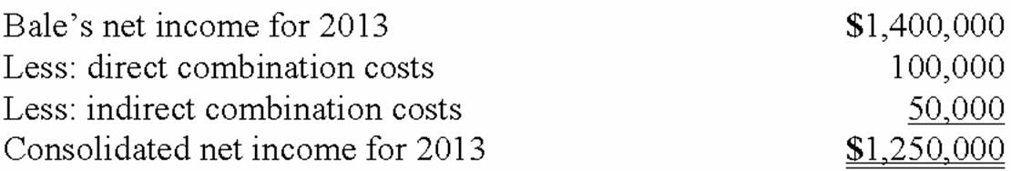  Note: Silo's net income does not affect consolidated net income until after the date of acquisition. The combination costs belong to Bale only.

AACSB: Analytic
AICPA BB: Critical Thinking
AICPA FN: Measurement
Blooms: Apply
Difficulty: 2 Medium
Learning Objective: 02-05 Determine the total fair value of the consideration transferred for an acquisition and allocate that fair value to specific subsidiary assets acquired (including goodwill); and liabilities assumed; or a gain on bargain purchase.
Learning Objective: 02-06 Prepare the journal entry to consolidate the accounts of a subsidiary if dissolution takes place.
Learning Objective: 02-07 Prepare a worksheet to consolidate the accounts of two companies that form a business combination if dissolution does not take place.
Topic: Acquisition Method When Dissolution Takes Place
Topic: The Acquisition Method When Separate Incorporation Is Maintained

107. | Fine Co. issued its common stock in exchange for the common stock of Dandy Corp. in an acquisition. At the date of the combination, Fine had land with a book value of $480,000 and a fair value of $620,000. Dandy had land with a book value of $170,000 and a fair value of $190,000.  Required:  What was the consolidated balance for Land in a consolidated balance sheet prepared at the date of the acquisition combination?  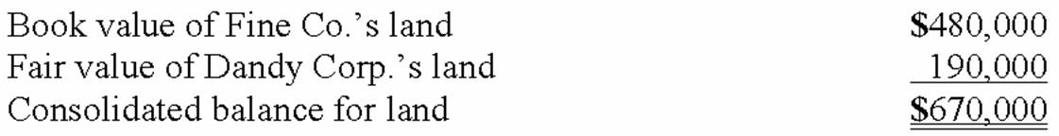

AACSB: Analytic
AICPA BB: Critical Thinking
AICPA FN: Measurement
Blooms: Apply
Difficulty: 2 Medium
Learning Objective: 02-05 Determine the total fair value of the consideration transferred for an acquisition and allocate that fair value to specific subsidiary assets acquired (including goodwill); and liabilities assumed; or a gain on bargain purchase.
Learning Objective: 02-06 Prepare the journal entry to consolidate the accounts of a subsidiary if dissolution takes place.
Learning Objective: 02-07 Prepare a worksheet to consolidate the accounts of two companies that form a business combination if dissolution does not take place.
Topic: Acquisition Method When Dissolution Takes Place
Topic: The Acquisition Method When Separate Incorporation Is Maintained

108. | Jernigan Corp. had the following account balances at 12/1/12:  Several of Jernigan's accounts have fair values that differ from book value. The fair values are: Land — $480,000; Building — $720,000; Inventory — $336,000; and Liabilities — $396,000.  Inglewood Inc. acquired all of the outstanding common shares of Jernigan by issuing 20,000 shares of common stock having a $6 par value, but a $66 fair value. Stock issuance costs amounted to $12,000.  Required:  Prepare a fair value allocation and goodwill schedule at the date of the acquisition.  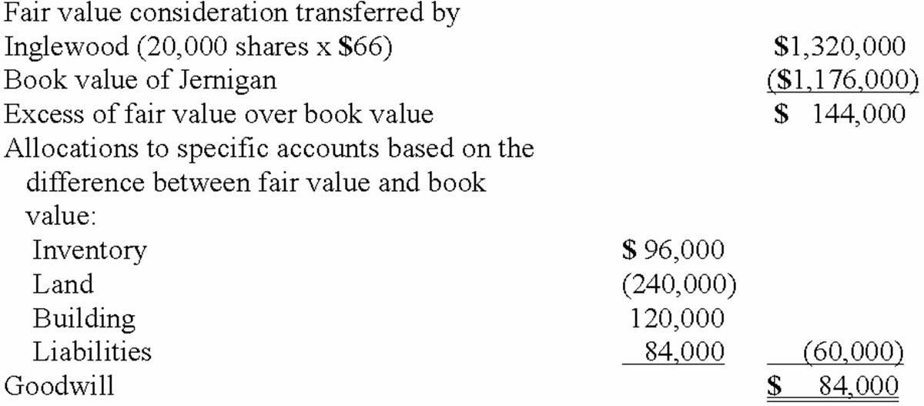

AACSB: Analytic
AICPA BB: Critical Thinking
AICPA FN: Measurement
Blooms: Apply
Difficulty: 2 Medium
Learning Objective: 02-04 Describe the valuation principles of the acquisition method.
Learning Objective: 02-05 Determine the total fair value of the consideration transferred for an acquisition and allocate that fair value to specific subsidiary assets acquired (including goodwill); and liabilities assumed; or a gain on bargain purchase.
Learning Objective: 02-06 Prepare the journal entry to consolidate the accounts of a subsidiary if dissolution takes place.
Learning Objective: 02-07 Prepare a worksheet to consolidate the accounts of two companies that form a business combination if dissolution does not take place.
Topic: Acquisition Method When Dissolution Takes Place
Topic: Financial Reporting for Business Combinations
Topic: The Acquisition Method When Separate Incorporation Is Maintained

109. | Salem Co. had the following account balances as of December 1, 2012:  Bellington Inc. transferred $1.7 million in cash and 12,000 shares of its newly issued $30 par value common stock (valued at $90 per share) to acquire all of Salem's outstanding common stock.  Determine the balance for Goodwill that would be included in a December 1, 2012, consolidation.  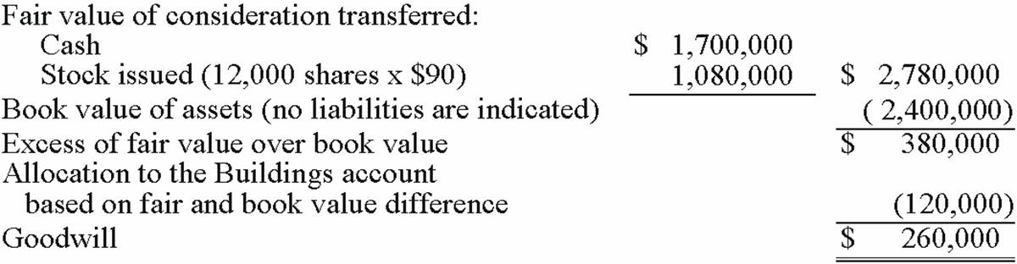

AACSB: Analytic
AICPA BB: Critical Thinking
AICPA FN: Measurement
Blooms: Apply
Difficulty: 2 Medium
Learning Objective: 02-04 Describe the valuation principles of the acquisition method.
Learning Objective: 02-05 Determine the total fair value of the consideration transferred for an acquisition and allocate that fair value to specific subsidiary assets acquired (including goodwill); and liabilities assumed; or a gain on bargain purchase.
Learning Objective: 02-06 Prepare the journal entry to consolidate the accounts of a subsidiary if dissolution takes place.
Learning Objective: 02-07 Prepare a worksheet to consolidate the accounts of two companies that form a business combination if dissolution does not take place.
Topic: Acquisition Method When Dissolution Takes Place
Topic: Financial Reporting for Business Combinations
Topic: The Acquisition Method When Separate Incorporation Is Maintained

110. | Salem Co. had the following account balances as of December 1, 2012:  Bellington Inc. transferred $1.7 million in cash and 12,000 shares of its newly issued $30 par value common stock (valued at $90 per share) to acquire all of Salem's outstanding common stock.  Assume that Bellington paid cash of $2.8 million. No stock is issued. An additional $50,000 is paid in direct combination costs.  Required:  For Goodwill, determine what balance would be included in a December 1, 2012 consolidation.  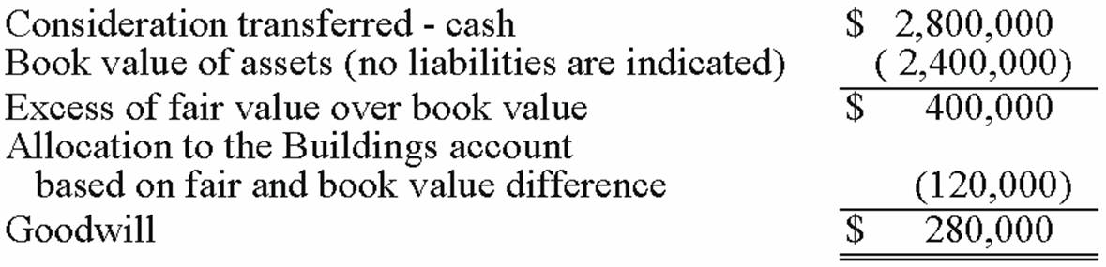

AACSB: Analytic
AICPA BB: Critical Thinking
AICPA FN: Measurement
Blooms: Apply
Difficulty: 2 Medium
Learning Objective: 02-04 Describe the valuation principles of the acquisition method.
Learning Objective: 02-05 Determine the total fair value of the consideration transferred for an acquisition and allocate that fair value to specific subsidiary assets acquired (including goodwill); and liabilities assumed; or a gain on bargain purchase.
Learning Objective: 02-06 Prepare the journal entry to consolidate the accounts of a subsidiary if dissolution takes place.
Learning Objective: 02-07 Prepare a worksheet to consolidate the accounts of two companies that form a business combination if dissolution does not take place.
Topic: Acquisition Method When Dissolution Takes Place
Topic: Financial Reporting for Business Combinations
Topic: The Acquisition Method When Separate Incorporation Is Maintained

111. | On January 1, 2013, Chester Inc. acquired 100% of Festus Corp.'s outstanding common stock by exchanging 37,500 shares of Chester's $2 par value common voting stock. On January 1, 2013, Chester's voting common stock had a fair value of $40 per share. Festus' voting common shares were selling for $6.50 per share. Festus' balances on the acquisition date, just prior to acquisition are listed below.  Required:  Compute the value of the Goodwill account on the date of acquisition, 1/1/15.  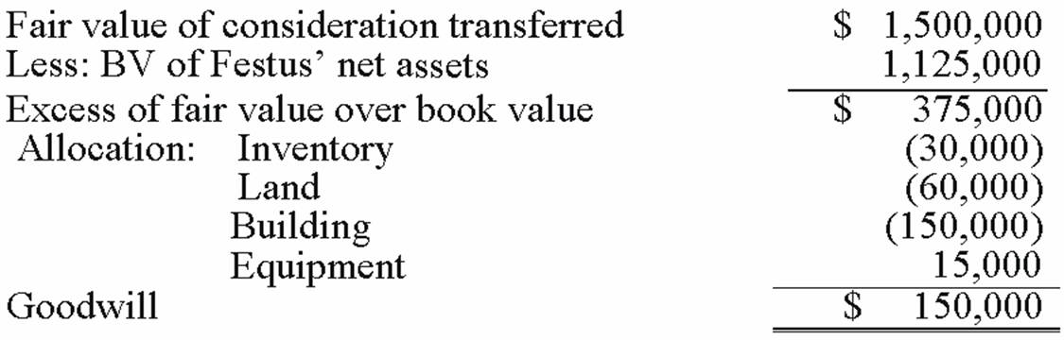

AACSB: Analytic
AICPA BB: Critical Thinking
AICPA FN: Measurement
Blooms: Apply
Difficulty: 2 Medium
Learning Objective: 02-04 Describe the valuation principles of the acquisition method.
Learning Objective: 02-05 Determine the total fair value of the consideration transferred for an acquisition and allocate that fair value to specific subsidiary assets acquired (including goodwill); and liabilities assumed; or a gain on bargain purchase.
Learning Objective: 02-06 Prepare the journal entry to consolidate the accounts of a subsidiary if dissolution takes place.
Learning Objective: 02-07 Prepare a worksheet to consolidate the accounts of two companies that form a business combination if dissolution does not take place.
Topic: Acquisition Method When Dissolution Takes Place
Topic: Financial Reporting for Business Combinations
Topic: The Acquisition Method When Separate Incorporation Is Maintained

112. | The financial statements for Jode Inc. and Lakely Corp., just prior to their combination, for the year ending December 31, 2012, follow. Lakely's buildings were undervalued on its financial records by $60,000.  On December 31, 2012, Jode issued 54,000 new shares of its $10 par value stock in exchange for all the outstanding shares of Lakely. Jode's shares had a fair value on that date of $35 per share. Jode paid $34,000 to an investment bank for assisting in the arrangements. Jode also paid $24,000 in stock issuance costs to effect the acquisition of Lakely. Lakely will retain its incorporation.  Prepare the journal entries to record (1) the issuance of stock by Jode and (2) the payment of the combination costs.  Entry One - To record the issuance of common stock by Jode to execute the purchase.  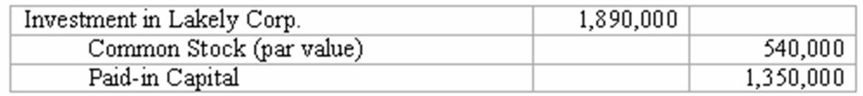  Entry Two - To record the combination costs.  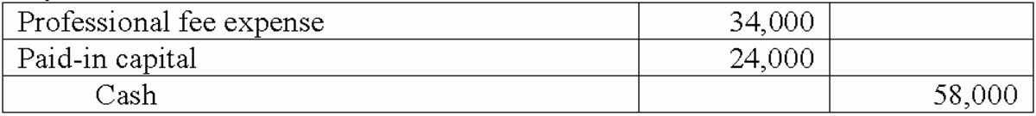

AACSB: Analytic
AICPA BB: Critical Thinking
AICPA FN: Measurement
Blooms: Apply
Difficulty: 2 Medium
Learning Objective: 02-04 Describe the valuation principles of the acquisition method.
Learning Objective: 02-05 Determine the total fair value of the consideration transferred for an acquisition and allocate that fair value to specific subsidiary assets acquired (including goodwill); and liabilities assumed; or a gain on bargain purchase.
Learning Objective: 02-07 Prepare a worksheet to consolidate the accounts of two companies that form a business combination if dissolution does not take place.
Topic: Acquisition Method When Dissolution Takes Place
Topic: Financial Reporting for Business Combinations
Topic: The Acquisition Method When Separate Incorporation Is Maintained

113. | The financial statements for Jode Inc. and Lakely Corp., just prior to their combination, for the year ending December 31, 2012, follow. Lakely's buildings were undervalued on its financial records by $60,000.  On December 31, 2012, Jode issued 54,000 new shares of its $10 par value stock in exchange for all the outstanding shares of Lakely. Jode's shares had a fair value on that date of $35 per share. Jode paid $34,000 to an investment bank for assisting in the arrangements. Jode also paid $24,000 in stock issuance costs to effect the acquisition of Lakely. Lakely will retain its incorporation.  Required:  Determine consolidated net income for the year ended December 31, 2012.  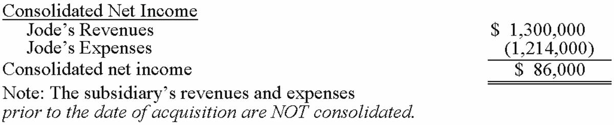

AACSB: Analytic
AICPA BB: Critical Thinking
AICPA FN: Measurement
Blooms: Apply
Difficulty: 2 Medium
Learning Objective: 02-07 Prepare a worksheet to consolidate the accounts of two companies that form a business combination if dissolution does not take place.
Topic: The Acquisition Method When Separate Incorporation Is Maintained

114. | The financial statements for Jode Inc. and Lakely Corp., just prior to their combination, for the year ending December 31, 2012, follow. Lakely's buildings were undervalued on its financial records by $60,000.  On December 31, 2012, Jode issued 54,000 new shares of its $10 par value stock in exchange for all the outstanding shares of Lakely. Jode's shares had a fair value on that date of $35 per share. Jode paid $34,000 to an investment bank for assisting in the arrangements. Jode also paid $24,000 in stock issuance costs to effect the acquisition of Lakely. Lakely will retain its incorporation.  Determine consolidated Additional paid-in Capital at December 31, 2012.  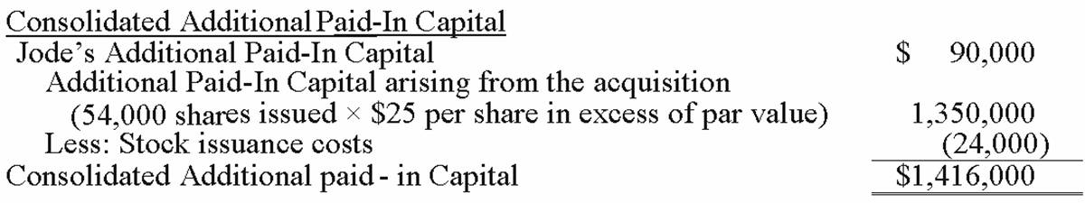

AACSB: Analytic
AICPA BB: Critical Thinking
AICPA FN: Measurement
Blooms: Apply
Difficulty: 2 Medium
Learning Objective: 02-04 Describe the valuation principles of the acquisition method.
Learning Objective: 02-05 Determine the total fair value of the consideration transferred for an acquisition and allocate that fair value to specific subsidiary assets acquired (including goodwill); and liabilities assumed; or a gain on bargain purchase.
Learning Objective: 02-07 Prepare a worksheet to consolidate the accounts of two companies that form a business combination if dissolution does not take place.
Topic: Acquisition Method When Dissolution Takes Place
Topic: Financial Reporting for Business Combinations
Topic: The Acquisition Method When Separate Incorporation Is Maintained

115. | The following are preliminary financial statements for Black Co. and Blue Co. for the year ending December 31, 2013.  On December 31, 2013 (subsequent to the preceding statements), Black exchanged 10,000 shares of its $10 par value common stock for all of the outstanding shares of Blue. Black's stock on that date has a fair value of $50 per share. Black was willing to issue 10,000 shares of stock because Blue's land was appraised at $204,000. Black also paid $14,000 to several attorneys and accountants who assisted in creating this combination.  Required:  Assuming that these two companies retained their separate legal identities, prepare a consolidation worksheet as of December 31, 2013.  Bargain Purchase Acquisition Consolidation Worksheet  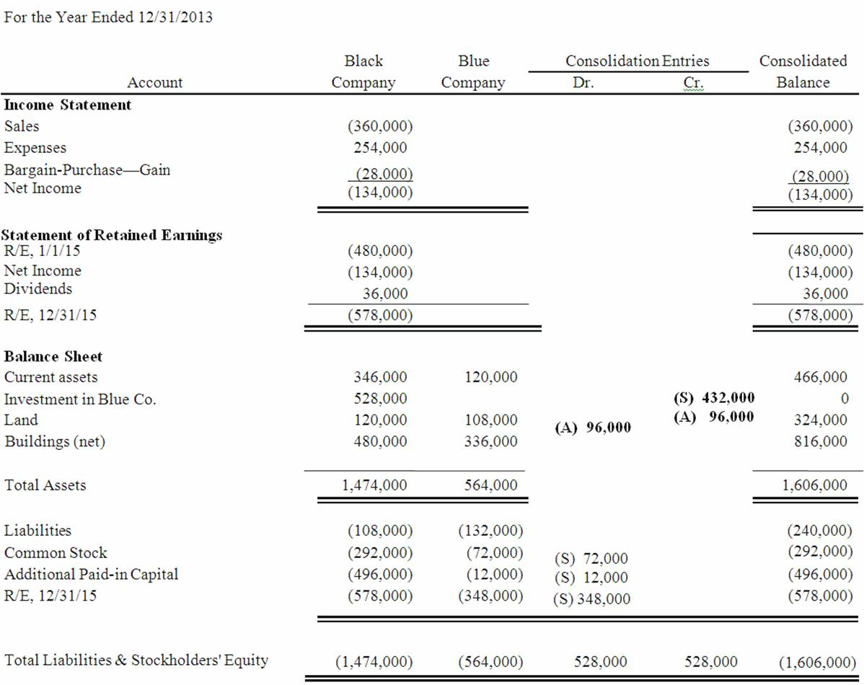  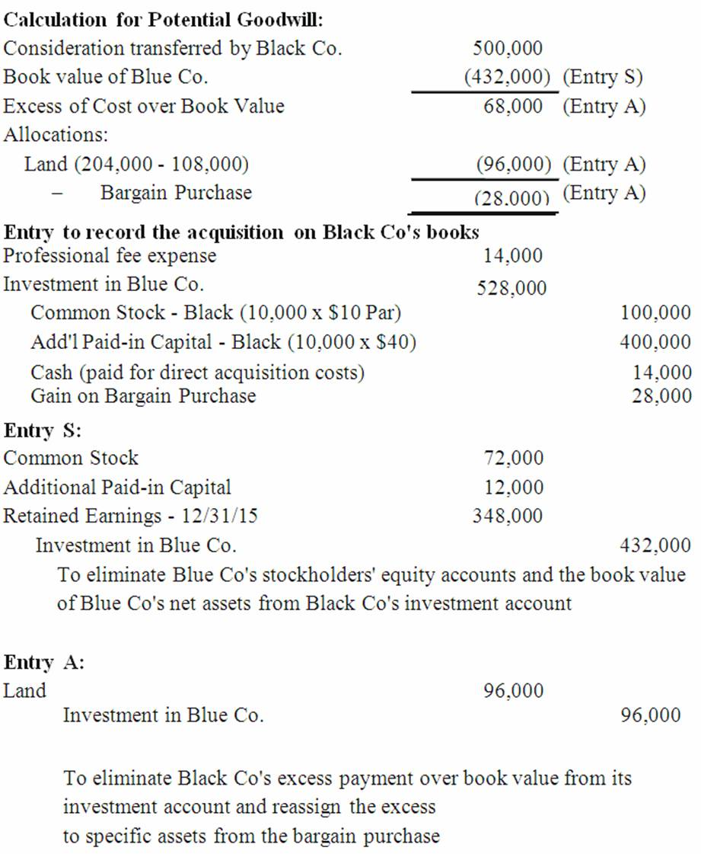

AACSB: Analytic
AICPA BB: Critical Thinking
AICPA FN: Measurement
Blooms: Apply
Difficulty: 3 Hard
Learning Objective: 02-04 Describe the valuation principles of the acquisition method.
Learning Objective: 02-05 Determine the total fair value of the consideration transferred for an acquisition and allocate that fair value to specific subsidiary assets acquired (including goodwill); and liabilities assumed; or a gain on bargain purchase.
Learning Objective: 02-07 Prepare a worksheet to consolidate the accounts of two companies that form a business combination if dissolution does not take place.
Topic: Acquisition Method When Dissolution Takes Place
Topic: Financial Reporting for Business Combinations
Topic: The Acquisition Method When Separate Incorporation Is Maintained

116. | The following are preliminary financial statements for Black Co. and Blue Co. for the year ending December 31, 2013 prior to Black's acquisition of Blue.  On December 31, 2013 (subsequent to the preceding statements), Black exchanged 10,000 shares of its $10 par value common stock for all of the outstanding shares of Blue. Black's stock on that date has a fair value of $60 per share. Black was willing to issue 10,000 shares of stock because Blue's land was appraised at $204,000. Black also paid $14,000 to several attorneys and accountants who assisted in creating this combination.  Required:  Assuming that these two companies retained their separate legal identities, prepare a consolidation worksheet as of December 31, 2013 after the acquisition transaction is completed.  Acquisition Consolidation Worksheet  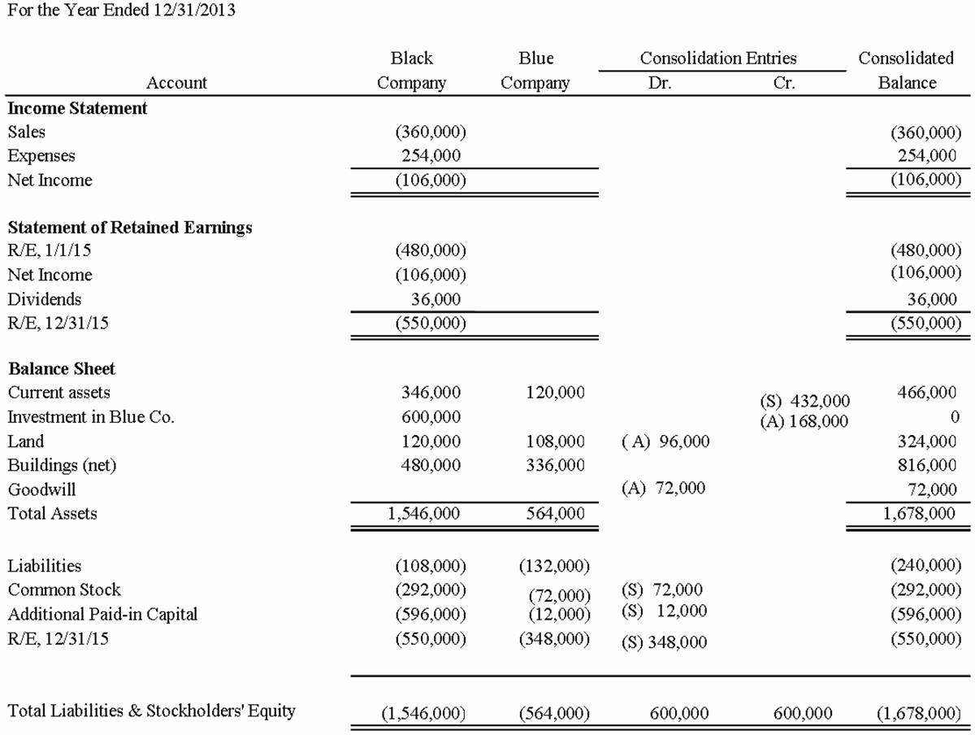  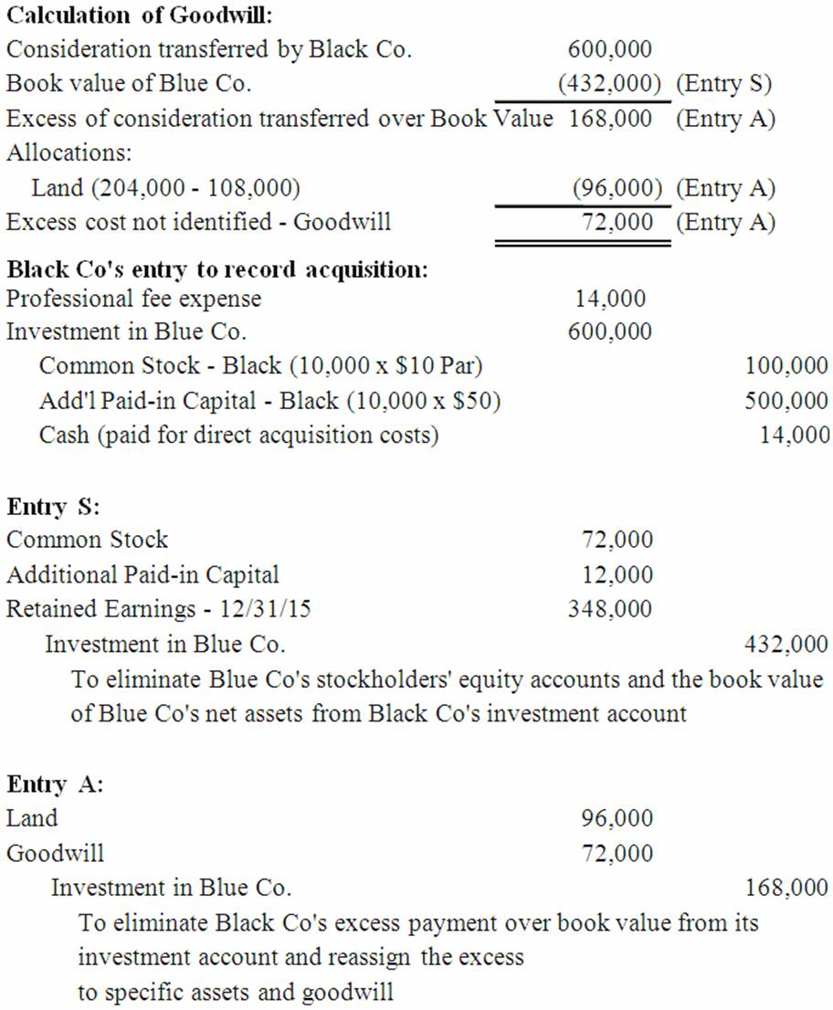

AACSB: Analytic
AICPA BB: Critical Thinking
AICPA FN: Measurement
Blooms: Apply
Difficulty: 3 Hard
Learning Objective: 02-04 Describe the valuation principles of the acquisition method.
Learning Objective: 02-05 Determine the total fair value of the consideration transferred for an acquisition and allocate that fair value to specific subsidiary assets acquired (including goodwill); and liabilities assumed; or a gain on bargain purchase.
Learning Objective: 02-07 Prepare a worksheet to consolidate the accounts of two companies that form a business combination if dissolution does not take place.
Topic: Acquisition Method When Dissolution Takes Place
Topic: Financial Reporting for Business Combinations
Topic: The Acquisition Method When Separate Incorporation Is Maintained

117. | For each of the following situations, select the best letter answer to reflect the effect of the numbered item on the acquirer's accounting entry at the date of combination when separate incorporation will be maintained. Items (4) and (6) require two selections.  (A) Increase Investment account.  (B) Decrease Investment account.  (C) Increase Liabilities.  (D) Increase Common stock.  (E) Decrease common stock.  (F) Increase Additional paid-in capital.  (G) Decrease Additional paid-in capital.  (H) Increase Retained earnings.  (I) Decrease Retained earnings.  _____1. Direct costs.  _____2. Indirect costs.  _____3. Stock issue costs.  _____4. Contingent consideration.  _____5. Bargain purchase.  _____6. In-process research and development acquired.  (1) I; (2) I; (3) G; (4) A, C; (5) H; (6) A, I

AACSB: Reflective thinking
AICPA BB: Critical Thinking
AICPA FN: Measurement
Blooms: Understand
Difficulty: 2 Medium
Learning Objective: 02-04 Describe the valuation principles of the acquisition method.
Learning Objective: 02-05 Determine the total fair value of the consideration transferred for an acquisition and allocate that fair value to specific subsidiary assets acquired (including goodwill); and liabilities assumed; or a gain on bargain purchase.
Learning Objective: 02-06 Prepare the journal entry to consolidate the accounts of a subsidiary if dissolution takes place.
Learning Objective: 02-07 Prepare a worksheet to consolidate the accounts of two companies that form a business combination if dissolution does not take place.
Learning Objective: 02-08 Describe the two criteria for recognizing intangible assets apart from goodwill in a business combination.
Topic: Acquisition Method When Dissolution Takes Place
Topic: Acquisition-Date Fair-Value Allocations-Additional Issues
Topic: Financial Reporting for Business Combinations
Topic: The Acquisition Method When Separate Incorporation Is Maintained

