Chapter 02
Competitiveness, Strategy, and Productivity

True / False Questions
1. | An example of a strategic operations management decision is the choice of where to locate.  True False

2. | An example of an operational operations management decision is inventory level management.  True False

3. | Government statistics are a good source of data about productivity trends in the service sector.  True False

4. | An example of a tactical operations management decision is determining employment levels.  True False

5. | Productivity is defined as the ratio of output to input.  True False

6. | Productivity is defined as the ratio of input to output.  True False

7. | Competitiveness relates to the profitability of an organization in the marketplace.  True False

8. | If people would only work harder, productivity would increase.  True False

9. | Tracking productivity measures over time enables managers to judge organizational performance and decide where improvements are needed.  True False

10. | Productivity is directly related to the ability of an organization to compete.  True False

11. | A characteristic that was once an order winner may become an order qualifier, and vice versa.  True False

12. | Outsourcing tends to improve quality but at the cost of lowered productivity.  True False

13. | Productivity tends to be only a very minor factor in an organization's ability to compete.  True False

14. | An organization that is twice as productive as its competitor will be twice as profitable.  True False

15. | National productivity is determined by averaging the productivity measures of various companies or industries.  True False

16. | Wage and salary increases that are not accompanied by productivity increases tend to exert inflationary pressures on a nation's economy.  True False

17. | Global competition really only applies to multinational organizations.  True False

18. | A business that is rated highly by its customers for service quality will tend to be more profitable than a business that is rated poorly.  True False

19. | Services often don't fit simple yield measurements.  True False

20. | A mission statement should provide a guide for the formulation of strategies for the organization.  True False

21. | The hierarchy and sequence of planning and decision making is: mission, organizational strategy, tactics, and operational decisions.  True False

22. | Strategy includes both organizational and functional strategies.  True False

23. | Organizational strategy should be determined without considering the realities of functional area strengths and weaknesses since they can be changed to meet our strategy.  True False

24. | Mission statements should be as specific as possible regarding exactly how they will be accomplished.  True False

25. | Improving efficiency will guarantee a similar improvement in productivity.  True False

26. | As long as we match a competitor on quality and price we will gain market share.  True False

27. | Environmental scanning is a search for events or trends that present either threats or opportunities to the organization.  True False

28. | Standardization has the advantage of reducing variability.  True False

29. | Traditional strategies of business organizations have tended to emphasize cost minimization or product differentiation.  True False

30. | The majority of our textbook deals with tactical operations that support established functional strategies.  True False

Multiple Choice Questions
31. | Which of the following is least likely to affect the cost an organization incurs in producing its products or services?  A. price  B. productivity  C. location  D. quality  E. inventory management

32. | Where a firm locates would typically not affect that firm's:  A. costs.  B. convenience for customers.  C. delivery times.  D. strategy.  E. transportation costs.

33. | Which of the following is not among the chief reasons organizations fail?  A. overemphasis on short-term financial performance  B. emphasizing labor productivity in labor-intensive environments  C. poor internal communications  D. not investing in capital and human resources  E. overemphasis on product (or service) design

34. | The key to successfully competing is understanding what customers want and then __________ satisfy those wants.  A. training production workers to  B. finding suppliers who can  C. finding the best way to  D. designing products and services that  E. hiring enough workers to

35. | An organization's mission statement serves as the basis for:  A. environmental scanning.  B. core competencies.  C. operating procedures.  D. distinctiveness.  E. organizational goals.

36. | Which of the following would be least important in the pursuit of a time-based strategy?  A. cost minimization  B. quick changeover times  C. operational agility  D. reduced complaint resolution times  E. flexible technology

37. | Competitiveness doesn't include:  A. productivity.  B. effectiveness.  C. profitability.  D. operations strategy.  E. operations management.

38. | Product design and choice of location are examples of _______ decisions.  A. strategic  B. tactical  C. operational  D. customer-focused  E. design

39. | Scheduling personnel is an example of an operations management:  A. mission implementation.  B. operational decision.  C. organizational strategy.  D. functional strategy.  E. tactical decision.

40. | Productivity is expressed as:  A. output plus input.  B. output minus input.  C. output times input.  D. output divided by input.  E. input divided by output.

41. | In the 1970s and early 1980s in the United States, organizations concentrated on:  A. operations strategies.  B. improving quality.  C. marketing and financial strategies.  D. revising mission statements.  E. environmental issues.

42. | Which of the following is not a factor that affects productivity?  A. computer viruses  B. design of the workspace  C. use of the Internet  D. standardizing processes  E. product price

43. | Which of these factors would be least likely to affect productivity?  A. methods and technology  B. workers  C. management  D. product mix  E. advertising

44. | Which of the following is not a key step toward improving productivity?  A. developing productivity measures for all operations  B. improving the bottleneck operations  C. establishing reasonable goals for improvement  D. considering incentives to reward workers  E. converting bond debt to stock ownership

45. | For an organization to grow its market share, it must:  A. advertise using multimedia.  B. reduce prices.  C. exceed minimum standards of acceptability for its products or services.  D. establish an Internet Web site.  E. broaden its mission statement.

46. | The ratio of good output to quantity of raw material input is called  A. nondefective productivity.  B. process yield.  C. worker quality measurement.  D. total quality productivity.  E. quantity/quality ratio.

47. | The fundamental purpose for the existence of any organization is described by its:  A. policies.  B. procedures.  C. corporate charter.  D. mission statement.  E. bylaws.

48. | A productivity increase in one operation that does not improve overall productivity of the business is not  A. worthwhile.  B. trivial.  C. competence-destroying.  D. an order winner.  E. an order qualifier.

49. | Value added can be calculated by:  A. average productivity gains over time.  B. inputs divided by the outputs.  C. outputs divided by the inputs.  D. input plus output divided by two.  E. outputs minus inputs.

50. | Which of the following is true?  A. Corporate strategy is shaped by functional strategies.  B. Corporate mission is shaped by corporate strategy.  C. Functional strategies are shaped by corporate strategy.  D. External conditions are shaped by corporate mission.  E. Corporate mission is shaped by functional strategies.

51. | Core competencies in organizations generally do not relate to:  A. cost.  B. quality.  C. time.  D. flexibility.  E. sales price.

52. | With regard to operations strategy, organization strategy should, ideally, take into account:  A. operations' strengths and weaknesses.  B. inventory levels.  C. labor productivity.  D. product mix.  E. production processes.

53. | Which of the following is not typically considered a cure for poor competitiveness?  A. Remove communications barriers within organizations.  B. Minimize attention to the operations function.  C. Put less emphasis on short-term financial results.  D. Recognize labor as a valuable asset and act to develop it.  E. Improve quality.

54. | Time-based approaches of business organizations focus on reducing the time to accomplish certain necessary activities. Time reductions seldom apply to:  A. product/service design time.  B. processing time.  C. delivery time.  D. response time for complaints.  E. internal audits.

55. | The external elements of SWOT analysis are:  A. strengths and weaknesses.  B. strengths and threats.  C. opportunities and threats.  D. weaknesses and opportunities.  E. strengths and opportunities.

56. | In an assembly operation at a furniture factory, six employees assembled an average of 450 standard dining chairs per five-day week. What is the labor productivity of this operation?  A. 90 chairs/worker/day  B. 20 chairs/worker/day  C. 15 chairs/worker/day  D. 75 chairs/worker/day  E. 60 chairs/worker/day

57. | Which of the following is not a reason for poor performance of our organization in the marketplace?  A. placing too much emphasis on product/service design and too little on process design  B. failing to take into account customer wants and needs  C. putting too much emphasis on short-term financial performance  D. taking advantage of strengths/opportunities, and recognizing competitive threats  E. failing to monitor the external environment

58. | The manager of a carpet store is trying to determine the best installation crew size. He has tried various crew sizes with the results shown below. Based on productivity, what crew size do you recommend?  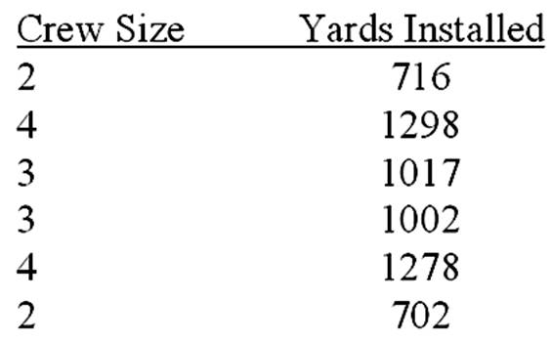  A. 2  B. 3  C. 4

59. | Which of the following is not a key factor of competitiveness?  A. price  B. product differentiation  C. flexibility  D. after-sale service  E. size of organization

60. | Gourmet Pretzels bakes soft pretzels on an assembly line. It currently bakes 800 pretzels each eight-hour shift. If the production is increased to 1,200 pretzels each shift, then productivity will have increased by:  A. 50 percent.  B. 33 percent.  C. 25 percent.  D. 67 percent.

61. | The weekly output of a fabrication process is shown below, together with data for labor and material inputs. Standard selling price is $125 per unit. Overhead is charged weekly at the rate of $1,500 plus .5 times direct labor cost. Assume a 40-hour week and an hourly wage of $16. Material cost is $10 per foot. What is the average multifactor productivity?  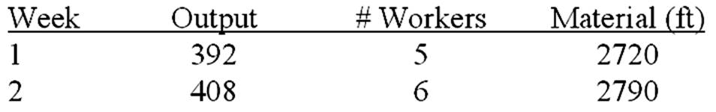  A. 1.463  B. 1.457  C. 1.431

62. | The Balanced Scorecard is a useful tool for helping managers translate their strategy into action in the following areas:  A. Sustainability; Flexibility; Efficiency; Technology  B. Customers; Financial; Internal Business Processes; Learning and Growth  C. Customization; Standardization; Efficiency; Effectiveness  D. The Environment; The Community; Suppliers; Other Stakeholders  E. Strategy; Tactics; Productivity; Profitability

63. | A firm pursuing a strategy based on customization and variety will tend to structure and manage its supply chain to accommodate more _____________ than a firm pursuing a strategy based on low cost and high volume.  A. variation  B. streamlined flow  C. quality  D. capacity  E. productivity

64. | Unique attributes of firms that give them a competitive edge are called:  A. functional strategies.  B. Balanced Scorecards.  C. supply chains.  D. core competencies.  E. sustainable initiatives.

65. | Years ago in the overnight delivery business, providing package tracking capability gave some firms a competitive advantage. Now, all firms must offer this capability simply to be in this line of business. This is an example of ______________ becoming ____________ over time.  A. tactical implications; strategic  B. strategic implications; tactical  C. order winners; order qualifiers  D. profitability factors; productivity factors  E. order qualifiers; order winners

66. | For firms competing in worldwide markets, conducting __________________ is more complex, since what works in one country or region might not work in another.  A. productivity analysis  B. environmental analysis  C. strategy implementation  D. sustainability analysis  E. growth forecasting

67. | Increasing the service offered to the customer makes it more difficult to compete on the basis of:  A. order qualifiers.  B. customization.  C. quality.  D. price.  E. flexibility.

68. | ___________ is generally used to facilitate an organization strategy that emphasizes low cost.  A. Speed to market  B. Flexibility  C. Customization  D. Sustainability  E. Standardization

69. | Which of the following factors would tend to reduce productivity?  A. improvements in workplace safety  B. reductions in labor turnover  C. more inexperienced workers  D. reductions in the scrap rate  E. less variety in the product mix

70. | Suppose a country's productivity last year was 84. If this country's productivity growth rate of 5 percent is to be maintained, this means that this year's productivity will have to be:  A. 88.2.  B. 79.8.  C. 82.8.  D. 78.9.  E. 4.2.

Essay Questions
71. | The weekly output of a production process is shown below, together with data for labor and material inputs. The standard inventory value of the output is $125 per unit. Overhead is charged weekly at the rate of $1,500 plus .5 times direct labor cost. Assume a 40-hour week and an hourly wage of $16. Material cost is $10 per running foot. What is the average multifactor productivity for this process?  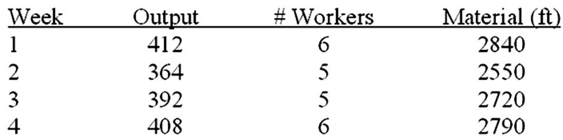

72. | A company has introduced a process improvement that reduces processing time for each unit; output is increased by 25 percent with less material, but one additional worker is required. Under the old process, five workers could produce 60 units per hour. Labor costs are $12/hour, and material input was previously $16/unit. For the new process, material is now $10/unit. Overhead is charged at 1.6 times direct labor cost. Finished units sell for $31 each. What increase in productivity is associated with the process improvement?

Chapter 02 Competitiveness, Strategy, and Productivity Answer Key
True / False Questions
1. | An example of a strategic operations management decision is the choice of where to locate.  TRUE  Location decisions are strategic in nature.

AACSB: Reflective Thinking
Accessibility: Keyboard Navigation
Blooms: Remember
Learning Objective: 02-04 Discuss and compare organization strategy and operations strategy; and explain why it is important to link the two.
Level of Difficulty: 3 Hard
Topic: Operations Strategy

2. | An example of an operational operations management decision is inventory level management.  TRUE  Inventory management is an operational decision.

AACSB: Reflective Thinking
Accessibility: Keyboard Navigation
Blooms: Remember
Learning Objective: 02-04 Discuss and compare organization strategy and operations strategy; and explain why it is important to link the two.
Level of Difficulty: 3 Hard
Topic: Operations Strategy

3. | Government statistics are a good source of data about productivity trends in the service sector.  FALSE  The service sector is often omitted in government statistics.

AACSB: Reflective Thinking
Accessibility: Keyboard Navigation
Blooms: Remember
Learning Objective: 02-07 Describe several factors that affect productivity.
Level of Difficulty: 2 Medium
Topic: Productivity

4. | An example of a tactical operations management decision is determining employment levels.  TRUE  Staffing is an ongoing, tactical decision.

AACSB: Reflective Thinking
Accessibility: Keyboard Navigation
Blooms: Remember
Learning Objective: 02-04 Discuss and compare organization strategy and operations strategy; and explain why it is important to link the two.
Level of Difficulty: 3 Hard
Topic: Operations Strategy

5. | Productivity is defined as the ratio of output to input.  TRUE  Divide outputs by inputs to get productivity.

AACSB: Reflective Thinking
Accessibility: Keyboard Navigation
Blooms: Remember
Learning Objective: 02-06 Define the term productivity and explain why it is important to organizations and to countries.
Level of Difficulty: 1 Easy
Topic: Transforming Strategy into Action: The Balanced Scorecard

6. | Productivity is defined as the ratio of input to output.  FALSE  Productivity is the ratio of outputs to inputs.

AACSB: Reflective Thinking
Accessibility: Keyboard Navigation
Blooms: Remember
Learning Objective: 02-06 Define the term productivity and explain why it is important to organizations and to countries.
Level of Difficulty: 1 Easy
Topic: Productivity

7. | Competitiveness relates to the profitability of an organization in the marketplace.  FALSE  Competitiveness relates to how effectively an organization meets the wants and needs of customers relative to other organizations that offer similar goods or services.

AACSB: Reflective Thinking
Accessibility: Keyboard Navigation
Blooms: Remember
Learning Objective: 02-02 Name several reasons that business organizations fail.
Level of Difficulty: 1 Easy
Topic: Competitiveness

8. | If people would only work harder, productivity would increase.  FALSE  Working harder can actually reduce productivity in some cases.

AACSB: Reflective Thinking
Accessibility: Keyboard Navigation
Blooms: Understand
Learning Objective: 02-07 Describe several factors that affect productivity.
Level of Difficulty: 2 Medium
Topic: Productivity

9. | Tracking productivity measures over time enables managers to judge organizational performance and decide where improvements are needed.  TRUE  Productivity trends direct attention toward problems and opportunities.

AACSB: Reflective Thinking
Accessibility: Keyboard Navigation
Blooms: Remember
Learning Objective: 02-07 Describe several factors that affect productivity.
Level of Difficulty: 2 Medium
Topic: Productivity

10. | Productivity is directly related to the ability of an organization to compete.  TRUE  A more productive organization is a more competitive organization.

AACSB: Reflective Thinking
Accessibility: Keyboard Navigation
Blooms: Remember
Learning Objective: 02-06 Define the term productivity and explain why it is important to organizations and to countries.
Level of Difficulty: 1 Easy
Topic: Productivity

11. | A characteristic that was once an order winner may become an order qualifier, and vice versa.  TRUE  Order qualifiers and order winners are shaped by the environment.

AACSB: Reflective Thinking
Accessibility: Keyboard Navigation
Blooms: Remember
Learning Objective: 02-03 Define the terms mission and strategy and explain why they are important.
Level of Difficulty: 2 Medium
Topic: Mission and Strategies

12. | Outsourcing tends to improve quality but at the cost of lowered productivity.  FALSE  Outsourcing can lead to both quality and productivity improvements.

AACSB: Reflective Thinking
Accessibility: Keyboard Navigation
Blooms: Understand
Learning Objective: 02-07 Describe several factors that affect productivity.
Level of Difficulty: 2 Medium
Topic: Productivity

13. | Productivity tends to be only a very minor factor in an organization's ability to compete.  FALSE  An organization's ability to compete is directly affected by its productivity.

AACSB: Reflective Thinking
Accessibility: Keyboard Navigation
Blooms: Remember
Learning Objective: 02-06 Define the term productivity and explain why it is important to organizations and to countries.
Level of Difficulty: 1 Easy
Topic: Productivity

14. | An organization that is twice as productive as its competitor will be twice as profitable.  FALSE  Productivity advantages don't necessarily translate into profitability advantages.

AACSB: Reflective Thinking
Accessibility: Keyboard Navigation
Blooms: Understand
Learning Objective: 02-06 Define the term productivity and explain why it is important to organizations and to countries.
Level of Difficulty: 2 Medium
Topic: Productivity

15. | National productivity is determined by averaging the productivity measures of various companies or industries.  FALSE  National productivity is determined by dividing inputs by outputs across a national economy; averaging industry measures would lead to a distorted estimate.

AACSB: Reflective Thinking
Accessibility: Keyboard Navigation
Blooms: Remember
Learning Objective: 02-06 Define the term productivity and explain why it is important to organizations and to countries.
Level of Difficulty: 2 Medium
Topic: Productivity

16. | Wage and salary increases that are not accompanied by productivity increases tend to exert inflationary pressures on a nation's economy.  TRUE  True increases in standards of living come about through productivity improvements.

AACSB: Reflective Thinking
Accessibility: Keyboard Navigation
Blooms: Remember
Learning Objective: 02-06 Define the term productivity and explain why it is important to organizations and to countries.
Level of Difficulty: 2 Medium
Topic: Productivity

17. | Global competition really only applies to multinational organizations.  FALSE  Domestic-only organizations experience competition from organizations in other countries.

AACSB: Reflective Thinking
Accessibility: Keyboard Navigation
Blooms: Understand
Learning Objective: 02-03 Define the terms mission and strategy and explain why they are important.
Level of Difficulty: 2 Medium
Topic: Mission and Strategies

18. | A business that is rated highly by its customers for service quality will tend to be more profitable than a business that is rated poorly.  TRUE  Service quality is a powerful tool for improving profitability.

AACSB: Reflective Thinking
Accessibility: Keyboard Navigation
Blooms: Understand
Learning Objective: 02-01 List several ways that business organizations compete.
Level of Difficulty: 1 Easy
Topic: Competitiveness

19. | Services often don't fit simple yield measurements.  TRUE  Comparing one service output to another is difficult to do accurately.

AACSB: Reflective Thinking
Accessibility: Keyboard Navigation
Blooms: Remember
Learning Objective: 02-07 Describe several factors that affect productivity.
Level of Difficulty: 1 Easy
Topic: Productivity

20. | A mission statement should provide a guide for the formulation of strategies for the organization.  TRUE  Strategy-making is constrained by the mission statement.

AACSB: Reflective Thinking
Accessibility: Keyboard Navigation
Blooms: Remember
Learning Objective: 02-03 Define the terms mission and strategy and explain why they are important.
Level of Difficulty: 1 Easy
Topic: Mission and Strategies

21. | The hierarchy and sequence of planning and decision making is: mission, organizational strategy, tactics, and operational decisions.  TRUE  Mission is at the highest level of the hierarchy, while operational decisions are at the lowest.

AACSB: Reflective Thinking
Accessibility: Keyboard Navigation
Blooms: Remember
Learning Objective: 02-04 Discuss and compare organization strategy and operations strategy; and explain why it is important to link the two.
Level of Difficulty: 2 Medium
Topic: Mission and Strategies

22. | Strategy includes both organizational and functional strategies.  TRUE  Organizational strategies shape functional strategies.

AACSB: Reflective Thinking
Accessibility: Keyboard Navigation
Blooms: Remember
Learning Objective: 02-04 Discuss and compare organization strategy and operations strategy; and explain why it is important to link the two.
Level of Difficulty: 1 Easy
Topic: Mission and Strategies

23. | Organizational strategy should be determined without considering the realities of functional area strengths and weaknesses since they can be changed to meet our strategy.  FALSE  Functional strengths and weaknesses serve as the building blocks of organizational strategy.

AACSB: Reflective Thinking
Accessibility: Keyboard Navigation
Blooms: Understand
Learning Objective: 02-04 Discuss and compare organization strategy and operations strategy; and explain why it is important to link the two.
Level of Difficulty: 2 Medium
Topic: Mission and Strategies

24. | Mission statements should be as specific as possible regarding exactly how they will be accomplished.  FALSE  Mission statements are very long-term and should provide enough room to accommodate major changes in direction.

AACSB: Reflective Thinking
Accessibility: Keyboard Navigation
Blooms: Understand
Learning Objective: 02-03 Define the terms mission and strategy and explain why they are important.
Level of Difficulty: 2 Medium
Topic: Mission and Strategies

25. | Improving efficiency will guarantee a similar improvement in productivity.  FALSE  Efficiency is narrower than productivity.

AACSB: Reflective Thinking
Accessibility: Keyboard Navigation
Blooms: Understand
Learning Objective: 02-07 Describe several factors that affect productivity.
Level of Difficulty: 2 Medium
Topic: Productivity

26. | As long as we match a competitor on quality and price we will gain market share.  FALSE  We usually have to better a competitor to win market share.

AACSB: Reflective Thinking
Accessibility: Keyboard Navigation
Blooms: Understand
Learning Objective: 02-02 Name several reasons that business organizations fail.
Level of Difficulty: 1 Easy
Topic: Competitiveness

27. | Environmental scanning is a search for events or trends that present either threats or opportunities to the organization.  TRUE  These events or trends should be taken into account when strategy is being formulated.

AACSB: Reflective Thinking
Accessibility: Keyboard Navigation
Blooms: Remember
Learning Objective: 02-03 Define the terms mission and strategy and explain why they are important.
Level of Difficulty: 2 Medium
Topic: Mission and Strategies

28. | Standardization has the advantage of reducing variability.  TRUE  Standardization leads to reduced variability.

AACSB: Reflective Thinking
Accessibility: Keyboard Navigation
Blooms: Understand
Learning Objective: 02-07 Describe several factors that affect productivity.
Level of Difficulty: 1 Easy
Topic: Productivity

29. | Traditional strategies of business organizations have tended to emphasize cost minimization or product differentiation.  TRUE  Time- and quality-based strategies are more recent developments.

AACSB: Reflective Thinking
Accessibility: Keyboard Navigation
Blooms: Remember
Learning Objective: 02-05 Describe and give examples of time-based strategies.
Level of Difficulty: 2 Medium
Topic: Operations Strategy

30. | The majority of our textbook deals with tactical operations that support established functional strategies.  TRUE  This represents the majority of ongoing decision making in operations.

AACSB: Reflective Thinking
Accessibility: Keyboard Navigation
Blooms: Remember
Learning Objective: 02-04 Discuss and compare organization strategy and operations strategy; and explain why it is important to link the two.
Level of Difficulty: 2 Medium
Topic: Mission and Strategies

Multiple Choice Questions
31. | Which of the following is least likely to affect the cost an organization incurs in producing its products or services?  A. price  B. productivity  C. location  D. quality  E. inventory management  Relative to the other choices, price is least likely to affect cost.

AACSB: Reflective Thinking
Accessibility: Keyboard Navigation
Blooms: Understand
Learning Objective: 02-01 List several ways that business organizations compete.
Level of Difficulty: 2 Medium
Topic: Competitiveness

32. | Where a firm locates would typically not affect that firm's:  A. costs.  B. convenience for customers.  C. delivery times.  D. strategy.  E. transportation costs.  Typically, strategy dictates where firms will locate, rather than location dictating strategy.

AACSB: Reflective Thinking
Accessibility: Keyboard Navigation
Blooms: Understand
Learning Objective: 02-01 List several ways that business organizations compete.
Level of Difficulty: 2 Medium
Topic: Mission and Strategies

33. | Which of the following is not among the chief reasons organizations fail?  A. overemphasis on short-term financial performance  B. emphasizing labor productivity in labor-intensive environments  C. poor internal communications  D. not investing in capital and human resources  E. overemphasis on product (or service) design  In labor-intensive environments, emphasizing labor productivity is a good idea.

AACSB: Reflective Thinking
Accessibility: Keyboard Navigation
Blooms: Remember
Learning Objective: 02-02 Name several reasons that business organizations fail.
Level of Difficulty: 1 Easy
Topic: Competitiveness

34. | The key to successfully competing is understanding what customers want and then __________ satisfy those wants.  A. training production workers to  B. finding suppliers who can  C. finding the best way to  D. designing products and services that  E. hiring enough workers to  To successfully compete, two basic issues must be addressed: What do the customers want? What is the best way to satisfy those wants?

AACSB: Reflective Thinking
Accessibility: Keyboard Navigation
Blooms: Understand
Learning Objective: 02-02 Name several reasons that business organizations fail.
Level of Difficulty: 2 Medium
Topic: Competitiveness

35. | An organization's mission statement serves as the basis for:  A. environmental scanning.  B. core competencies.  C. operating procedures.  D. distinctiveness.  E. organizational goals.  Organizations' missions serve as the broad underpinning for their goals.

AACSB: Reflective Thinking
Accessibility: Keyboard Navigation
Blooms: Remember
Learning Objective: 02-03 Define the terms mission and strategy and explain why they are important.
Level of Difficulty: 2 Medium
Topic: Competitiveness

36. | Which of the following would be least important in the pursuit of a time-based strategy?  A. cost minimization  B. quick changeover times  C. operational agility  D. reduced complaint resolution times  E. flexible technology  Many means for minimizing cost would have the effect of making a time-based strategy less feasible.

AACSB: Reflective Thinking
Accessibility: Keyboard Navigation
Blooms: Understand
Learning Objective: 02-05 Describe and give examples of time-based strategies.
Level of Difficulty: 2 Medium
Topic: Mission and Strategies

37. | Competitiveness doesn't include:  A. productivity.  B. effectiveness.  C. profitability.  D. operations strategy.  E. operations management.  A company can be competitive relative to similar companies and still be unprofitable if the competitive environment is inherently unprofitable.

AACSB: Reflective Thinking
Accessibility: Keyboard Navigation
Blooms: Understand
Learning Objective: 02-01 List several ways that business organizations compete.
Level of Difficulty: 3 Hard
Topic: Competitiveness

38. | Product design and choice of location are examples of _______ decisions.  A. strategic  B. tactical  C. operational  D. customer-focused  E. design  These decisions are made high in the hierarchy.

AACSB: Reflective Thinking
Accessibility: Keyboard Navigation
Blooms: Remember
Learning Objective: 02-03 Define the terms mission and strategy and explain why they are important.
Level of Difficulty: 3 Hard
Topic: Mission and Strategies

39. | Scheduling personnel is an example of an operations management:  A. mission implementation.  B. operational decision.  C. organizational strategy.  D. functional strategy.  E. tactical decision.  Staffing-level decisions are made low in the hierarchy.

AACSB: Reflective Thinking
Accessibility: Keyboard Navigation
Blooms: Remember
Learning Objective: 02-04 Discuss and compare organization strategy and operations strategy; and explain why it is important to link the two.
Level of Difficulty: 3 Hard
Topic: Operations Strategy

40. | Productivity is expressed as:  A. output plus input.  B. output minus input.  C. output times input.  D. output divided by input.  E. input divided by output.  Productivity is the ratio of outputs to inputs.

AACSB: Reflective Thinking
Accessibility: Keyboard Navigation
Blooms: Remember
Learning Objective: 02-06 Define the term productivity and explain why it is important to organizations and to countries.
Level of Difficulty: 1 Easy
Topic: Productivity

41. | In the 1970s and early 1980s in the United States, organizations concentrated on:  A. operations strategies.  B. improving quality.  C. marketing and financial strategies.  D. revising mission statements.  E. environmental issues.  This led to U.S. firms being not very competitive with regard to their operations.

AACSB: Reflective Thinking
Accessibility: Keyboard Navigation
Blooms: Remember
Learning Objective: 02-04 Discuss and compare organization strategy and operations strategy; and explain why it is important to link the two.
Level of Difficulty: 2 Medium
Topic: Operations Strategy

42. | Which of the following is not a factor that affects productivity?  A. computer viruses  B. design of the workspace  C. use of the Internet  D. standardizing processes  E. product price  These don't lead to fundamental changes in operations.

AACSB: Reflective Thinking
Accessibility: Keyboard Navigation
Blooms: Remember
Learning Objective: 02-07 Describe several factors that affect productivity.
Level of Difficulty: 2 Medium
Topic: Productivity

43. | Which of these factors would be least likely to affect productivity?  A. methods and technology  B. workers  C. management  D. product mix  E. advertising  Advertising could increase the value of the outputs, but it is less likely to affect productivity than these other factors.

AACSB: Reflective Thinking
Accessibility: Keyboard Navigation
Blooms: Understand
Learning Objective: 02-07 Describe several factors that affect productivity.
Level of Difficulty: 2 Medium
Topic: Productivity

44. | Which of the following is not a key step toward improving productivity?  A. developing productivity measures for all operations  B. improving the bottleneck operations  C. establishing reasonable goals for improvement  D. considering incentives to reward workers  E. converting bond debt to stock ownership  A firm's productivity is independent of its capital structure.

AACSB: Reflective Thinking
Accessibility: Keyboard Navigation
Blooms: Remember
Learning Objective: 02-07 Describe several factors that affect productivity.
Level of Difficulty: 2 Medium
Topic: Productivity

45. | For an organization to grow its market share, it must:  A. advertise using multimedia.  B. reduce prices.  C. exceed minimum standards of acceptability for its products or services.  D. establish an Internet Web site.  E. broaden its mission statement.  Only by exceeding standards can an organization grow its market share.

AACSB: Reflective Thinking
Accessibility: Keyboard Navigation
Blooms: Remember
Learning Objective: 02-03 Define the terms mission and strategy and explain why they are important.
Level of Difficulty: 3 Hard
Topic: Mission and Strategies

46. | The ratio of good output to quantity of raw material input is called  A. nondefective productivity.  B. process yield.  C. worker quality measurement.  D. total quality productivity.  E. quantity/quality ratio.  This is sometimes a useful productivity measure in service industries.

AACSB: Reflective Thinking
Accessibility: Keyboard Navigation
Blooms: Remember
Learning Objective: 02-06 Define the term productivity and explain why it is important to organizations and to countries.
Level of Difficulty: 3 Hard
Topic: Productivity

47. | The fundamental purpose for the existence of any organization is described by its:  A. policies.  B. procedures.  C. corporate charter.  D. mission statement.  E. bylaws.  A mission statement is the organization's attempt to justify its existence.

AACSB: Reflective Thinking
Accessibility: Keyboard Navigation
Blooms: Remember
Learning Objective: 02-03 Define the terms mission and strategy and explain why they are important.
Level of Difficulty: 1 Easy
Topic: Mission and Strategies

48. | A productivity increase in one operation that does not improve overall productivity of the business is not  A. worthwhile.  B. trivial.  C. competence-destroying.  D. an order winner.  E. an order qualifier.  Only system-wide productivity improvement makes the organization more productive.

AACSB: Reflective Thinking
Accessibility: Keyboard Navigation
Blooms: Understand
Learning Objective: 02-07 Describe several factors that affect productivity.
Level of Difficulty: 3 Hard
Topic: Productivity

49. | Value added can be calculated by:  A. average productivity gains over time.  B. inputs divided by the outputs.  C. outputs divided by the inputs.  D. input plus output divided by two.  E. outputs minus inputs.  Value added represents the change in value of the original inputs.

AACSB: Reflective Thinking
Accessibility: Keyboard Navigation
Blooms: Remember
Learning Objective: 02-06 Define the term productivity and explain why it is important to organizations and to countries.
Level of Difficulty: 2 Medium
Topic: Productivity

50. | Which of the following is true?  A. Corporate strategy is shaped by functional strategies.  B. Corporate mission is shaped by corporate strategy.  C. Functional strategies are shaped by corporate strategy.  D. External conditions are shaped by corporate mission.  E. Corporate mission is shaped by functional strategies.  Corporate strategy shapes strategies at lower levels.

AACSB: Reflective Thinking
Accessibility: Keyboard Navigation
Blooms: Remember
Learning Objective: 02-04 Discuss and compare organization strategy and operations strategy; and explain why it is important to link the two.
Level of Difficulty: 3 Hard
Topic: Mission and Strategies

51. | Core competencies in organizations generally do not relate to:  A. cost.  B. quality.  C. time.  D. flexibility.  E. sales price.  What a firm charges for its outputs is not a core competency. What it can charge, however, is potentially related to a core competency.

AACSB: Reflective Thinking
Accessibility: Keyboard Navigation
Blooms: Understand
Learning Objective: 02-04 Discuss and compare organization strategy and operations strategy; and explain why it is important to link the two.
Level of Difficulty: 2 Medium
Topic: Mission and Strategies

52. | With regard to operations strategy, organization strategy should, ideally, take into account:  A. operations' strengths and weaknesses.  B. inventory levels.  C. labor productivity.  D. product mix.  E. production processes.  Formulation of organization strategy should take into account the realities of operations' strengths and weaknesses, capitalizing on strengths and dealing with weaknesses.

AACSB: Reflective Thinking
Accessibility: Keyboard Navigation
Blooms: Understand
Learning Objective: 02-04 Discuss and compare organization strategy and operations strategy; and explain why it is important to link the two.
Level of Difficulty: 1 Easy
Topic: Operations Strategy

53. | Which of the following is not typically considered a cure for poor competitiveness?  A. Remove communications barriers within organizations.  B. Minimize attention to the operations function.  C. Put less emphasis on short-term financial results.  D. Recognize labor as a valuable asset and act to develop it.  E. Improve quality.  Operations is a prime area for improving competitiveness.

AACSB: Reflective Thinking
Accessibility: Keyboard Navigation
Blooms: Remember
Learning Objective: 02-02 Name several reasons that business organizations fail.
Level of Difficulty: 3 Hard
Topic: Competitiveness

54. | Time-based approaches of business organizations focus on reducing the time to accomplish certain necessary activities. Time reductions seldom apply to:  A. product/service design time.  B. processing time.  C. delivery time.  D. response time for complaints.  E. internal audits.  Internal audits have little to do with core value-adding efforts.

AACSB: Reflective Thinking
Accessibility: Keyboard Navigation
Blooms: Remember
Learning Objective: 02-05 Describe and give examples of time-based strategies.
Level of Difficulty: 2 Medium
Topic: Operations Strategy

55. | The external elements of SWOT analysis are:  A. strengths and weaknesses.  B. strengths and threats.  C. opportunities and threats.  D. weaknesses and opportunities.  E. strengths and opportunities.  Opportunities and threats relate to the organization and its external environment.

AACSB: Reflective Thinking
Accessibility: Keyboard Navigation
Blooms: Remember
Learning Objective: 02-03 Define the terms mission and strategy and explain why they are important.
Level of Difficulty: 2 Medium
Topic: Mission and Strategies

56. | In an assembly operation at a furniture factory, six employees assembled an average of 450 standard dining chairs per five-day week. What is the labor productivity of this operation?  A. 90 chairs/worker/day  B. 20 chairs/worker/day  C. 15 chairs/worker/day  D. 75 chairs/worker/day  E. 60 chairs/worker/day  Divide the output of 450 chairs by the inputs of 30 worker-days.

AACSB: Analytic
Accessibility: Keyboard Navigation
Blooms: Remember
Learning Objective: 02-06 Define the term productivity and explain why it is important to organizations and to countries.
Level of Difficulty: 1 Easy
Topic: Productivity

57. | Which of the following is not a reason for poor performance of our organization in the marketplace?  A. placing too much emphasis on product/service design and too little on process design  B. failing to take into account customer wants and needs  C. putting too much emphasis on short-term financial performance  D. taking advantage of strengths/opportunities, and recognizing competitive threats  E. failing to monitor the external environment  Taking advantage of strengths/opportunities and recognizing competitive threats would enable good performance.

AACSB: Reflective Thinking
Accessibility: Keyboard Navigation
Blooms: Remember
Learning Objective: 02-02 Name several reasons that business organizations fail.
Level of Difficulty: 3 Hard
Topic: Competitiveness

58. | The manager of a carpet store is trying to determine the best installation crew size. He has tried various crew sizes with the results shown below. Based on productivity, what crew size do you recommend?  A. 2  B. 3  C. 4  Crews of two workers are most productive.

AACSB: Analytic
Blooms: Evaluate
Learning Objective: 02-06 Define the term productivity and explain why it is important to organizations and to countries.
Level of Difficulty: 2 Medium
Topic: Productivity

59. | Which of the following is not a key factor of competitiveness?  A. price  B. product differentiation  C. flexibility  D. after-sale service  E. size of organization  Competitiveness often has nothing to do with organization size.

AACSB: Reflective Thinking
Accessibility: Keyboard Navigation
Blooms: Remember
Learning Objective: 02-02 Name several reasons that business organizations fail.
Level of Difficulty: 3 Hard
Topic: Productivity

60. | Gourmet Pretzels bakes soft pretzels on an assembly line. It currently bakes 800 pretzels each eight-hour shift. If the production is increased to 1,200 pretzels each shift, then productivity will have increased by:  A. 50 percent.  B. 33 percent.  C. 25 percent.  D. 67 percent.  Divide the difference in productivity by the original productivity.

AACSB: Analytic
Accessibility: Keyboard Navigation
Blooms: Apply
Learning Objective: 02-06 Define the term productivity and explain why it is important to organizations and to countries.
Level of Difficulty: 2 Medium
Topic: Productivity

61. | The weekly output of a fabrication process is shown below, together with data for labor and material inputs. Standard selling price is $125 per unit. Overhead is charged weekly at the rate of $1,500 plus .5 times direct labor cost. Assume a 40-hour week and an hourly wage of $16. Material cost is $10 per foot. What is the average multifactor productivity?  A. 1.463  B. 1.457  C. 1.431  Calculate multifactor productivity for each week, then average the two.

AACSB: Analytic
Blooms: Apply
Learning Objective: 02-06 Define the term productivity and explain why it is important to organizations and to countries.
Level of Difficulty: 2 Medium
Topic: Productivity

62. | The Balanced Scorecard is a useful tool for helping managers translate their strategy into action in the following areas:  A. Sustainability; Flexibility; Efficiency; Technology  B. Customers; Financial; Internal Business Processes; Learning and Growth  C. Customization; Standardization; Efficiency; Effectiveness  D. The Environment; The Community; Suppliers; Other Stakeholders  E. Strategy; Tactics; Productivity; Profitability  These are the four core areas addressed by the Balanced Scorecard.

AACSB: Reflective Thinking
Accessibility: Keyboard Navigation
Blooms: Remember
Learning Objective: 02-04 Discuss and compare organization strategy and operations strategy; and explain why it is important to link the two.
Level of Difficulty: 2 Medium
Topic: Transforming Strategy into Action: The Balanced Scorecard

63. | A firm pursuing a strategy based on customization and variety will tend to structure and manage its supply chain to accommodate more _____________ than a firm pursuing a strategy based on low cost and high volume.  A. variation  B. streamlined flow  C. quality  D. capacity  E. productivity  Customization and variety lead to variation that must be accommodated.

AACSB: Reflective Thinking
Accessibility: Keyboard Navigation
Blooms: Remember
Learning Objective: 02-04 Discuss and compare organization strategy and operations strategy; and explain why it is important to link the two.
Level of Difficulty: 2 Medium
Topic: Operations Strategy

64. | Unique attributes of firms that give them a competitive edge are called:  A. functional strategies.  B. Balanced Scorecards.  C. supply chains.  D. core competencies.  E. sustainable initiatives.  Core competencies can be translated into competitive advantage.

AACSB: Reflective Thinking
Accessibility: Keyboard Navigation
Blooms: Remember
Learning Objective: 02-04 Discuss and compare organization strategy and operations strategy; and explain why it is important to link the two.
Level of Difficulty: 2 Medium
Topic: Mission and Strategies

65. | Years ago in the overnight delivery business, providing package tracking capability gave some firms a competitive advantage. Now, all firms must offer this capability simply to be in this line of business. This is an example of ______________ becoming ____________ over time.  A. tactical implications; strategic  B. strategic implications; tactical  C. order winners; order qualifiers  D. profitability factors; productivity factors  E. order qualifiers; order winners  What is an order qualifier and what is an order winner changes over time.

AACSB: Reflective Thinking
Accessibility: Keyboard Navigation
Blooms: Understand
Learning Objective: 02-03 Define the terms mission and strategy and explain why they are important.
Level of Difficulty: 2 Medium
Topic: Mission and Strategies

66. | For firms competing in worldwide markets, conducting __________________ is more complex, since what works in one country or region might not work in another.  A. productivity analysis  B. environmental analysis  C. strategy implementation  D. sustainability analysis  E. growth forecasting  Environmental analysis takes into account the relevant factors in the environment; there are more of these if there are more markets to consider.

AACSB: Reflective Thinking
Accessibility: Keyboard Navigation
Blooms: Remember
Learning Objective: 02-03 Define the terms mission and strategy and explain why they are important.
Level of Difficulty: 2 Medium
Topic: Mission and Strategies

67. | Increasing the service offered to the customer makes it more difficult to compete on the basis of:  A. order qualifiers.  B. customization.  C. quality.  D. price.  E. flexibility.  More extensive service can be more costly, and more costly outputs make price-based strategies more difficult.

AACSB: Reflective Thinking
Accessibility: Keyboard Navigation
Blooms: Remember
Learning Objective: 02-04 Discuss and compare organization strategy and operations strategy; and explain why it is important to link the two.
Level of Difficulty: 1 Easy
Topic: Implications of Organization Strategy for Operations Management

68. | ___________ is generally used to facilitate an organization strategy that emphasizes low cost.  A. Speed to market  B. Flexibility  C. Customization  D. Sustainability  E. Standardization  Standardization is a powerful means of achieving low-cost production.

AACSB: Reflective Thinking
Accessibility: Keyboard Navigation
Blooms: Understand
Learning Objective: 02-04 Discuss and compare organization strategy and operations strategy; and explain why it is important to link the two.
Level of Difficulty: 1 Easy
Topic: Implications of Organization Strategy for Operations Management

69. | Which of the following factors would tend to reduce productivity?  A. improvements in workplace safety  B. reductions in labor turnover  C. more inexperienced workers  D. reductions in the scrap rate  E. less variety in the product mix  More inexperienced workers tend to be less productive.

AACSB: Reflective Thinking
Accessibility: Keyboard Navigation
Blooms: Understand
Learning Objective: 02-07 Describe several factors that affect productivity.
Level of Difficulty: 2 Medium
Topic: Productivity

70. | Suppose a country's productivity last year was 84. If this country's productivity growth rate of 5 percent is to be maintained, this means that this year's productivity will have to be:  A. 88.2.  B. 79.8.  C. 82.8.  D. 78.9.  E. 4.2.  Multiply 84 by 1.05 and then subtract 84 from this product.

AACSB: Analytic
Accessibility: Keyboard Navigation
Blooms: Apply
Learning Objective: 02-06 Define the term productivity and explain why it is important to organizations and to countries.
Level of Difficulty: 3 Hard
Topic: Productivity

Essay Questions
71. | The weekly output of a production process is shown below, together with data for labor and material inputs. The standard inventory value of the output is $125 per unit. Overhead is charged weekly at the rate of $1,500 plus .5 times direct labor cost. Assume a 40-hour week and an hourly wage of $16. Material cost is $10 per running foot. What is the average multifactor productivity for this process?  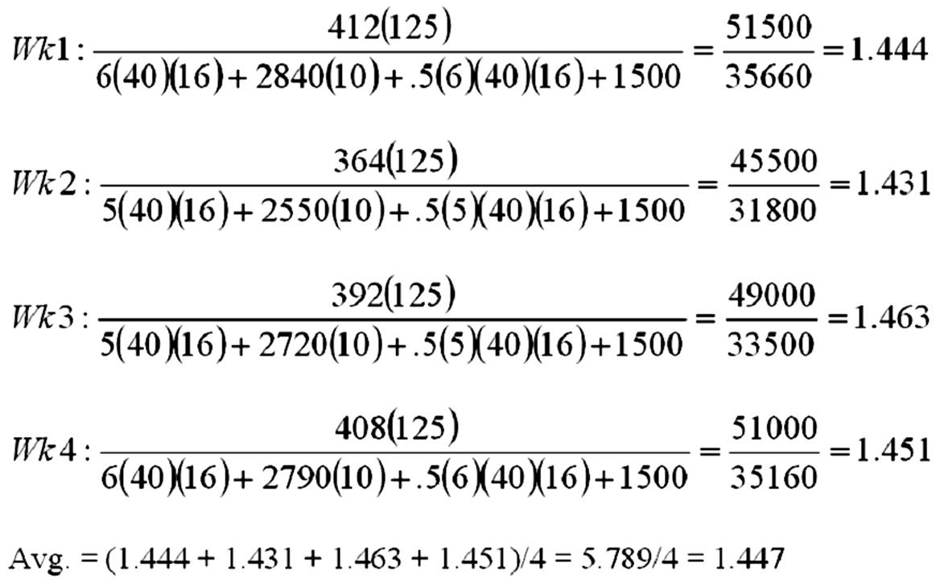  Feedback: Calculate the weekly multifactor productivities and then average.

AACSB: Analytic
Blooms: Apply
Learning Objective: 02-06 Define the term productivity and explain why it is important to organizations and to countries.
Level of Difficulty: 3 Hard
Topic: Productivity

72. | A company has introduced a process improvement that reduces processing time for each unit; output is increased by 25 percent with less material, but one additional worker is required. Under the old process, five workers could produce 60 units per hour. Labor costs are $12/hour, and material input was previously $16/unit. For the new process, material is now $10/unit. Overhead is charged at 1.6 times direct labor cost. Finished units sell for $31 each. What increase in productivity is associated with the process improvement?  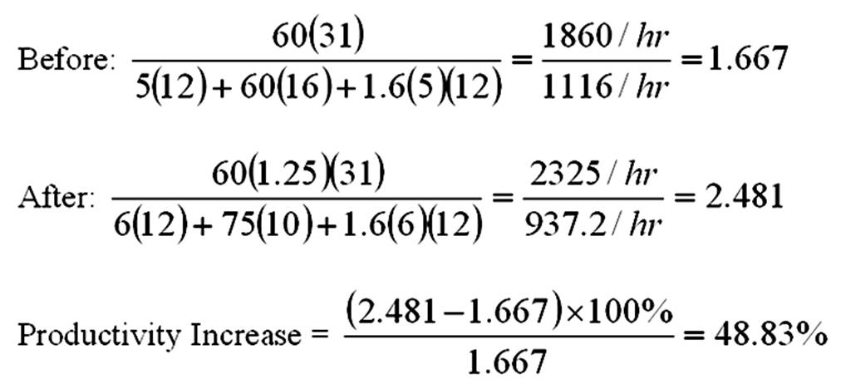  Feedback: Divide the improvement in productivity by the productivity before the change. Multiply this ratio for the percent increase.

AACSB: Analytic
Blooms: Apply
Learning Objective: 02-06 Define the term productivity and explain why it is important to organizations and to countries.
Level of Difficulty: 3 Hard
Topic: Productivity

