**SOLUTIONS MANUAL: CHAPTER 2 END OF CHAPTER ANSWERS**

**ANSWERS TO STOP AND CHECK EXERCISES**

**What’s in the File?**

1. A, B, D, E

2. B

3. D

4. A

5. C

**Who Are You?**

1. Student answers will vary. One possible way to prove both identity and employment is a current U.S. passport. Alternatively, a current state-issued driver’s license and a Social Security card will work for the purposes of the I-9.

2. Student answers will vary. When evaluating the earnings of more than one job, the breakdown of includable amount by pay period is often overlooked.

3. Student answers will vary. Examples of statutory employees include: A driver who distributes beverages (other than milk) or meat, vegetable, fruit, or bakery products or who picks up and delivers laundry or dry cleaning, if the driver is a single company’s agent or is paid on commission. A full-time life insurance sales agent whose principal business activity is selling life insurance or annuity contracts, or both, primarily for one life insurance company. An individual who works at home on materials or goods that a company supplies and that must be returned to that company or a designated agent in accordance with furnished specifications for the work to be done. A full-time traveling or city salesperson who works on a single company’s behalf and turns in orders from wholesalers, retailers, contractors, or operators of hotels, restaurants, or other similar establishments. The goods sold must be merchandise for resale or supplies for use in the buyer’s business operation. The work performed for that single company must be the salesperson’s principal business activity.

**Exempt vs. Nonexempt**

1. Exempt workers are exempt from the overtime provisions of FLSA. Exempt workers tend to be employees in a company’s managerial or other leadership functions, in which they may need to work more than 40 hours per week to complete their tasks. Exempt workers usually receive a fixed salary per period that is not based on the number of hours worked. Nonexempt workers tend to be compensated on an hourly basis and often do not have managerial or leadership responsibilities. It should be noted that some nonexempt workers do have managerial or leadership responsibilities and may receive a fixed salary; however, these employees are covered by the overtime provisions of FLSA.
2. C (40 hours)
3. The leased employee is a common-law employee of the firm, whereas the temporary employee is an employee of the temporary agency.

**Worker Facts**

1. Hourly workers and nonexempt employees are protected by the FLSA

2. Exempt workers receive a fixed amount of money and generally direct the actions of other employees; nonexempt workers are eligible for overtime and generally have their work directed by a manager.

3. Commission workers are typically tied to sales completed by the individual; piece rate pay is determined by the number of pieces the employee completes during a shift or period.

4. Student answers may vary but should include: Minimum hourly rate is set by the U.S. Federal government. Minimum wage rates can and do vary per state, and different parts of the same state may have different minimum wages. The minimum wage may differ from a “living wage,” which is an amount needed to meet basic subsistence needs. A calculating tool was provided in the chapter for discussion on various location living wages.

**Who Does Which Job?**

Student answers will vary. The answer should reflect a clear separation of duties, cross-training, rotation of tasks, and security protocols.

**Internal Controls and Audits**

1. B

2. C

**Destroy and Terminate**

1. Paper payroll records should be shredded or burned. Computer records should be purged from the server and all other storage devices.

2. Charlie should receive his final pay on October 11, and not later than October 12. His employer is not required to provide him with a severance package, although he may be eligible for his accrued vacation pay.

**ANSWERS TO END-OF-CHAPTER MATERIALS**

**REVIEW QUESTIONS**

1. What are necessary elements of internal controls for a payroll department?
2. Payroll system design, authorized signers, documentation, and review of the process
3. Why should more than one person prepare/verify payroll processing?
4. Internal controls and verification to avoid fraud or theft
5. What documents should be included in all new hire packets?
6. I-9 and W-4
7. Why are new hires required to be reported to the state’s employment department?
8. The enforcement of child support and legal withholdings, ensuring immigrants are still eligible to work, verification of professional licensing/qualifications, administration of COBRA benefits
9. When must a terminated employee be paid his or her final paycheck for the state in which you live?
10. Student answers will vary. This is a state specific regulation time ranging from the point of discharge to no time requirements.
11. What are the five main payroll frequencies?
12. Daily, weekly, biweekly, semimonthly, monthly
13. What are two of the best practices in establishing a payroll system?
14. Student answers will vary but should include: keep any requests for leave with the related paystubs, file retention schedule, have more than one person responsible for the duties/verification, and separation of duties
15. What are the important considerations in setting up a payroll system?
16. Pay frequency, pay types, method of payment, benefits, manual/computerized/outsourced payroll processing, file security system
17. What are the different tasks involved in payroll accounting?
18. Entering the employees, entering the hours, calculation of gross wages, preparation of paychecks, payment of taxes, reporting requirements
19. What agencies or organizations can audit a company’s payroll records?
    1. The Internal Revenue Service (IRS)
    2. Federal and State Departments of Labor
    3. Department of Homeland Security
    4. Other state and local agencies
    5. Labor unions
20. How long should employee records be retained?
21. For a three-year period, with some records being required for up to 6 years
22. Why are independent contractors not paid through a company’s payroll?
23. Individuals classified as independent contractors are treated as vendors and paid outside of payroll.
24. What is the difference between termination and resignation?
25. An employee is terminated by the employer; when the employee initiates the separation, it is a resignation. Employees who resign will receive their final paycheck in the normal payroll cycle, whereas terminated employees may be required to receive theirs sooner.
26. What is the difference between weekly, biweekly, semimonthly, and monthly pay periods?
27. A weekly pay period is for one-week, biweekly pay period is two weeks long, semi-monthly pay period is twice a month, and monthly pay period is once a month.

15. What differentiates exempt and nonexempt employees?

1. Nonexempt employees are covered under the Fair Labor Standards Act (FLSA) and are typically in non-supervisory positions. Exempt employees are typically in managerial positions, are exempt from overtime pay requirements, and the FLSA.

16. What categories exist for the purposes of document retention?

1. Payroll Records (time sheets, electronic records, etc.)

2. Employee federal, state, and local income tax records

3. Form I-9 and accompanying employee eligibility documents

4. Employee benefits and contributions

5. Health plan documentation

17. What two regulations pertain to employee paycard use?

a. Regulation E and Regulation Z

**EXERCISES SET A**

E2-1A.    Kira Tran, a nonexempt employee at Winslow Woods, works a standard 7:00–4:00 schedule with an hour for lunch. Kira received overtime pay for hours in excess of 40 per week. During the week, she worked the following schedule:

How many hours of overtime did Kira work this week?

1. 0.50

|  |  |
| --- | --- |
| Monday | 9.25 hours |
| Tuesday | 7.5 hours |
| Wednesday | 8.75 hours |
| Thursday | 6.75 hours |
| Friday | 8.25 hours |

Total 40.50

40.50-40.00=0.50

E2-2A. Lillian Weatherby receives her pay every other week while working for the federal government. Which of the following choices describes her pay frequency?

1. Biweekly

E2-3A. Lila Rivera is a new employee for Divera Glass. Which Federal forms must he complete as part of the hiring process?

1. W-4

4. I-9

E2-4A. Wilbur Matthews, a resident of Texas, resigned from his employment with Grand Lake Cattle Farms on October 7, 2021. The next pay date for the company is October 11. By what date should he receive his final pay?

2. October 11

E2-5A. Charlene Kelley is a new nonexempt sales associate for Oyondo Retail Stores. She completes her timecard for the pay period. To ensure proper internal control, what is the next step in the payroll review process?

3. Submit the timecard to her manager for review.

E2-6A. Alfonso Silva needs additional filing space at the end of the year in the company’s offsite, secured storage. He sees several boxes marked for the current year’s destruction. What methods can Alfonso use to dispose of the payroll records? (Select all that apply.)

1. Contact an offsite record destruction service.

3. Shred the records, then dispose of the shredded paper.

4. Incinerate the payroll records marked for destruction.

E2-7A. Jacqueline Blue is a payroll clerk at Quaking Aspens Antiques. As she reviews employee files, what should be present in the employee information? (Select all that apply.)

2. Pay rate

3. Occupation

E2-8A. Ginger Klein is the payroll clerk for Neolane Transportation. A colleague who is classified as an independent contractor requests to be classified as an employee. What factors should Ginger consider? (Select all that apply.)

1. Relationship of the Parties

2. Behavioral Control

4. Financial Control

E2-9A. What are the forms of identification that establish *employment authorization* for the I-9? (Select all that apply.)

1. Native American Tribal document.

2. Social security card

E2-10A. What are the forms of identification that establish *identity* for the I-9? (Select all that apply.)

1. State-issued driver’s license

2. U.S. Passport.

E2-11A. Jamie Patil is a candidate for the position of sales manager with Retrozz Furniture. She is going to be required to supervise several employees and can determine the direction in which she will complete the assignments given to her. What guidelines should she follow when classifying workers as exempt or nonexempt? (Select all that apply.)

2 FLSA

3. Department of Labor

4. IRS

E2-12A. Susana Robledo is the office manager for Wardley and Sons Auto Detailing. Because it is a small office she is required to keep track of all employee records and pay both employees and contractors. Which of the following are legal factors that will differentiate between exempt and nonexempt employees? (Select all that apply.)

2. Type of work performed

4. Amount of supervisor-given direction

**PROBLEM SET A**

P2-1A.  Louis Trivaldi is a Vice President of Sales at Fields Brothers Autos and earns a salary of $59,000. What is Louis’s period pay for each of the following pay frequencies:

a.    Biweekly $59,000/26 = $2,269.23  
b.    Semimonthly $59,000/24 = $2,458.33  
c.    Weekly $59,000/52 = $1,134.62  
d.    Monthly $59,000/12 = $4,916.67

P2-2A. Reuben Walker is a part-time worker for Senior Solvers who uses company equipment in the performance of his job duties. He asks the payroll supervisor, Gina Turner, to grant him independent contractor status. What should Gina tell him?

1. Since Reuben uses the company’s equipment in the performance of his duties, there he would not qualify for an independent contractor since he does not have financial control of the equipment.

P2-3A. You are the new payroll supervisor for your company. Which payroll documentation control procedures are now your responsibility?

1. Payroll system security, Maintenance of paid time off (i.e., vacation, sick, etc.), Access to payroll data, Separation of duties, Training of payroll staff

P2-4A. Leona Figueroa is a new employee in the payroll department of Octolium Computers. After working at the company for one week, she asks you why it is so important to submit new hire documentation. What guidance will you offer her?

1. Reporting creates a registry to monitor child support obligations, tracks immigration to ensure individuals are legal to work in the United States, ensures that individuals in professions that can have sanctions are legally able to continue to work, finally to enable the tracking of COBRA benefits.

P2-5A. You are the payroll accounting clerk for your company, Conose Advertising, which has 50 employees. The controller has recently switched the firm from an in-house payroll system to an outsourced payroll provider. What are your responsibilities within the company for payroll records and employee file issues?

1. Even with outsourced payroll the company is responsible for maintaining records, responsible retention periods, ensuring timely filing of tax and withholding amount, and document destruction.

P2-6A. Aaron Tallchief is a citizen of the Northern Pomo Indian Nation. In completing his I-9, he provides an official Northern Pomo Nation birth certificate to establish identification and employment eligibility. Is this sufficient documentation? Why or why not?

a. Yes, these are acceptable since this would fulfill the requirements of items from type B and type C of the acceptable documents.

P2-7A. Maria Rupert is the payroll supervisor at All Family Investments. Management is requesting to have the investment salespeople, who are paid on an hourly basis, be classified as exempt employees because their job duties occasionally require evening and weekend work. What tests should the investment salespeople meet to achieve exempt status?

a. The U.S. Department of Labor requires that employees meet all tests to achieve exempt status under one of the following: executive exemption, administrative exemption, and professional exemption. Since the investment salespeople do not meet the qualifications for exemption, they would need to stay non-exempt.

P2-8A. Twinte Cars, a California corporation, has internal corporate requirements that stipulate a three-year payroll document retention period. They enter into a contract with an international company that mandates a six-year payroll document retention requirement. How should Twinte Cars balance these requirements?

a. The longer retention period would be appropriate to satisfy the record retention requirements under the contract.

P2-9A. Ted McCormick is a full-time life insurance agent with Centixo Insurance, a small insurance company. The company has classified him as an employee, and he feels that he should be classified as an independent contractor because he receives no company benefits and sets his own office hours. Should he be reclassified as an independent contractor? Why or why not?

a. Of the three tests, Ted does not meet the relationship of the parties and should be treated as an employee.

P2-10A. Evelyn Hardy is an employee of Polyent Plastics, a company with headquarters in Rock Island, Illinois. She lives and works in Doha, Qatar, and earns an annual salary of $97,300. The company has been withholding U.S. federal income taxes from her pay, but Evelyn believes that she should be exempt because she is an expatriate. What course of action should Evelyn take?

a. Evelyn would need to file IRS Foreign Earned Income Exclusion

P2-11A. Complete the W-4 for employment at Plexivent Plastics starting 9/6/2021. The employers address is 1 Plastics Way, Lincoln Valley, ND 58430, and EIN is 56-4658631.

Henry Walker Pierce

2024 Denhoff Highway, Apartment 12

Lincoln Valley, ND 58430

SSN: 687-55-4658

Marital status: Married filing jointly with 2 Dependents under 17

One job and spouse does not work

Does not require any additional amount to be withheld

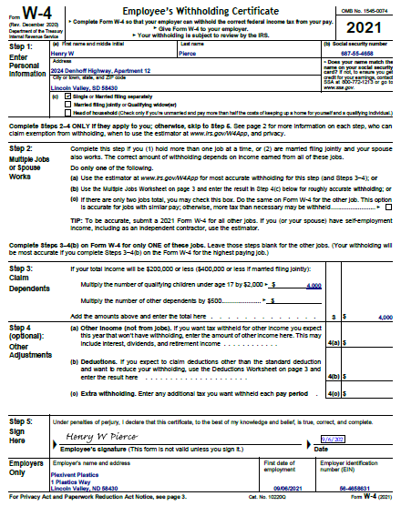

P2-12A. Complete the I-9 for employment at Plexivent Plastics starting 9/6/2021. The employer’s address is 1 Plastics Way, Lincoln Valley, ND 58430, and EIN is 56-4658631. Henry is starting work on 9/6/2021. Be sure to complete Section 2 of Form I-9.

Henry Walker Pierce

2024 Denhoff Highway, Apartment 12

Lincoln Valley, ND 58430

SSN: 687-55-4658

Marital status: Married

Date of Birth: 8/15/1999

U.S. Citizen

Henry’s North Dakota driver’s license number is MKJ-462856 and expires on his birthday in 2024.

Office Manager James MacMillan verified the information for the company.

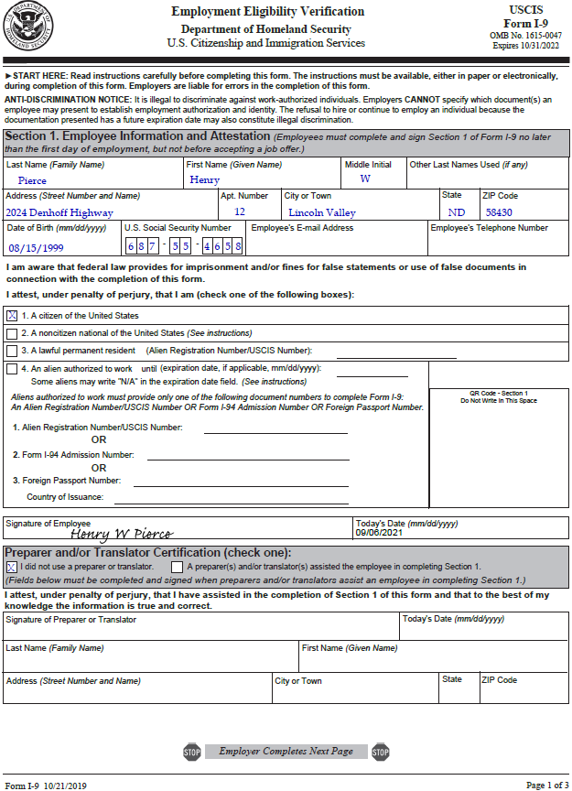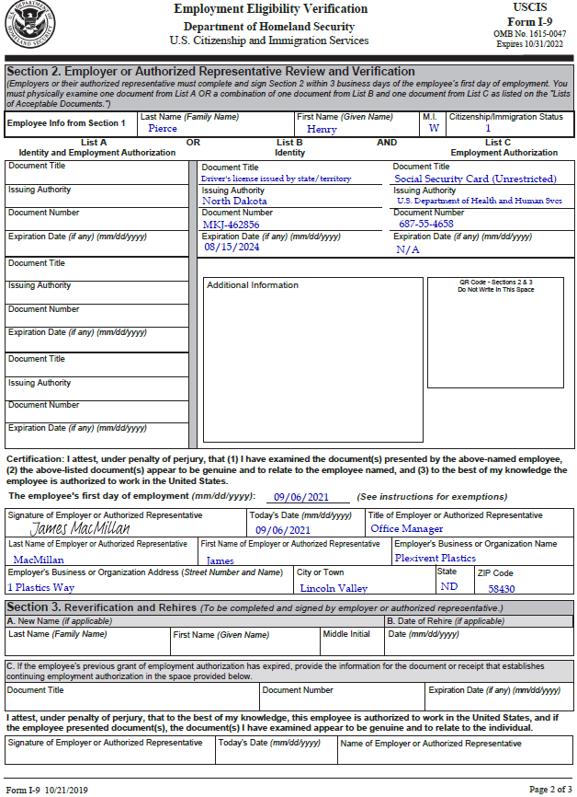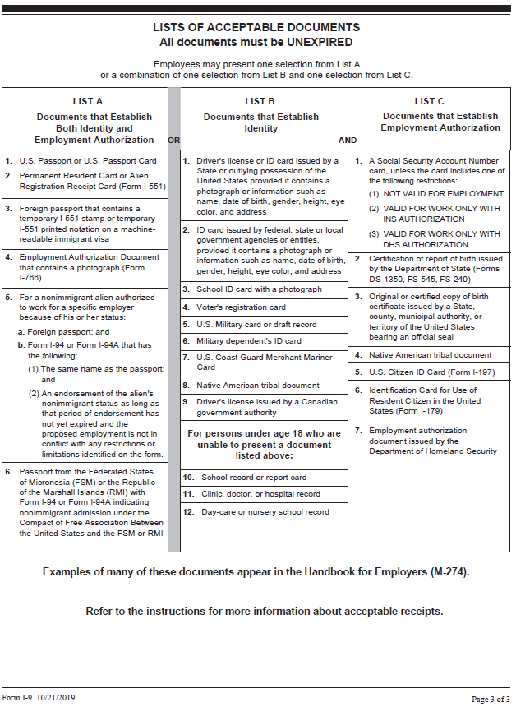

**EXERCISE SET B**

E2-1B.    Howard Walters, a nonexempt employee of Consolidated Utilities, works a standard 10:00 a.m. to 7:00 p.m. schedule with an hour for lunch. Howard works in California, a state requiring overtime for hours exceeding 8 per day and for those over 40 in a week. During the week, he worked the following schedule:

|  |  |
| --- | --- |
| Monday | 8.75 hours |
| Tuesday | 7.75 hours |
| Wednesday | 8.50 hours |
| Thursday | 8.00 hours |
| Friday | 8.25 hours |

Based on the state’s requirements, how much overtime has Howard worked during the period?

4. 2.75 hours

8.75 + 7.75 + 8.50 + 8.00 + 8.25 = 41.25 hours for 1.25 hours of overtime over 40 per week

.75 + .50 + .25 = 1.5 hours over 8 per day for a total of 2.75 hours overtime in the period

E2-2B. Michael Hatton is a salaried employee earning $49,850 per year who receives twice a month. Which of the following best describes the pay frequency?

2. Semimonthly

E2-3B. On June 21, 2021, Dolores Goodman was terminated from her job at Black Diamond Sports in New Hampshire. Black Diamond pays its employees biweekly on Fridays, and the next payday is 7/2/2021. When must she receive her final paycheck?

4. Within 72 hours.

E2-4B. Leonard Andrews ended his employment at Atlas Inks on March 20, 2021. When is the earliest that Atlas Inks may destroy his payroll records?

3. March 21, 2024

E2-5B. Elijah Brown is a new payroll clerk at Zata Imports, a company with 250 employees. He has completed entering all timecard data for the pay period. What should Elijah's next step in the payroll review process be?

3. Ask his supervisor to verify the accuracy of the payroll data.

E2-6B. Elaine Wheeler needs additional filing space at the end of the year in the company’s office and chooses to use offsite, secured storage. Upon arriving at the storage facility, she discovers that the unit is nearly full and sees several boxes marked for destruction at the end of the calendar year. What are Elaine’s obligations regarding the destruction of the payroll records marked for destruction? (Select all that apply.)

2. She should make arrangements to pulp or burn the payroll records marked for destruction.

3. She should arrange to have a document destruction service pick up the boxes marked for destruction.

4. She should bring a shredding machine to the storage facility and prepare to shred the records marked for destruction.

E2-7B. Gerardo Rogers is conducting a review of the payroll files for each employee at Meejo Games. Which of the following items must be present in the file? (Select all that apply.)

1. Basis upon which compensation is paid.

2. Overtime pay earned during each pay period.

3. Hours worked during each pay period.

E2-8B. Jane McCarthy is preparing to compute employee pay and needs to determine the amount of employee federal income taxes to be withheld. Which of the following should she consult?

2. IRS Publication 15-t

E2-9B. Judy Baker is a new employee of Farnsdel and Brothers, LLP. Which of the following will provide proof of *employment authorization* for the completion of the I-9? (Select all that apply.)

1. U.S. Passport – a U.S. Passport will establish both identity and employment authorization.

3. U.S. citizen identification card

E2-10B. Rupert Pelliere is completing the I-9 for her new employment with the state of New Mexico. Which of the following provides proof of her *identity*? (Select all that apply.)

3. New Mexico driver’s license

4. U.S. passport – a U.S. passport will establish both identity and employment authorization.

E2-11B. Laverne Watkins is a candidate for the position of marketing clerk with the promotions department of Paramba Productions, earning $10.25 per hour. She will work occasional overtime in her new position and will not have managerial or supervisory duties as a regular part of her job description. Why should Laverne be classified as a nonexempt employee? (Select all that apply.)

2. She has no supervisory or managerial duties

3. She has the term *clerk* in her job title

E2-12B. Rex Marshall manages a ski resort with year-round and seasonal employees. Assuming that the ski resort engages in interstate commerce, which are the FLSA requirement(s) that Rex should consider?

1. Hourly wages paid to employees

3. Number of hours worked per week

4. Employee age and weekly work schedule

**PROBLEM SET B**

P2-1B. Tasha Webb is an independent contractor for Antimbu Exports, where you are the payroll accountant. She feels that she should receive employee benefits because of the number of hours that she dedicates to the company. What guidance can you offer Tasha?

1. Independent contractors are most frequently treated as a vendor and would not be included in employee benefits. There are specific tests that determine the relationship between employer and employee; however, the number of hours committed is not one of the defining traits.

P2-2B. Roland Wexler was terminated for cause from Santel Auto Parts in North Carolina on July 20, 2021. As of the date of his termination, he had worked 22 hours of regular time. Employees at Santel Auto Parts are paid semimonthly on the 15th and last day of the month. Roland would like to know when he will be paid for the accrued hours. What will you tell him?

1. North Carolina states that terminated employees should receive their paycheck on the next regularly scheduled payday, so it will be the end of the month.

P2-3B. Sara Northman, a member of the Algonquin Indian Nation, is a new employee at Predeo Game Design. During the process of completing her I-9, she claims that the only way to prove her identity is the Algonquin Indian National official birth certificate. Is this document sufficient to verify her employment eligibility? Explain.

1. Algonquin Indian National official birth certificate would be sufficient only to establish Employment Authorization and not for both.

P2-4B. Abraham Manning is a new employee of Symity Batteries. He is curious about the purpose of the requirements for new hire documentation to be forwarded to government agencies. What should you tell him?

1. Reporting creates a registry to monitor child support obligations, tracks immigration to ensure individuals are legal to work in the United States, ensures that individuals in professions that can have sanctions are legally able to continue to work, finally to enable the tracking of COBRA benefits.

P2-5B. Pedro Arturo wants to start his own company and hire employees. Because you are a seasoned payroll professional, he approaches you for guidance about the differences between exempt and nonexempt employees. What would you tell him?

1. Exempt employees must meet the requirements to be considered exempt: Executive exemption, administrative exemption, professional exemption. Exempt employees are not subject to FLSA wage and hour provisions and they typically work more than 40 hours per week. Nonexempt employees are covered by FLSA wage and hour provisions and do not meet the exceptions requirements.

P2-6B. Katrina Wilkins is a new payroll clerk for Remm Plumbing. She is curious about the purpose of the different steps in the payroll review process and asks you, her supervisor, for guidance. What would you tell her?

1. The payroll review process is designed to verify the information so that employees are paid correctly, and the data is correct. Starting with the employee completing their timecard, the information is then verified by the manager. After the manager has agreed that the employee has accurately portrayed the hours worked, the payroll clerk will prepare the information for the manager to review and approve. Once the information has been approved, the payroll checks can be issued to the employees.

P2-7B. Francesca Aldri started as a payroll accountant at Sticktoit Adhesives, a company with 100 employees. She soon notices that the former payroll accountant had been processing payroll manually and suggests that the company immediately switch to cloud-based payroll. What types of documentation must be maintained in employee records?

1. Employers retain physical copies of employees’ time records, pay advice, and any other documentation processed with the paycheck. Some other types of documentation include: Request for a day off; reports of tardiness or absenteeism; detailed records of work completed during that day’s shift.

P2-8B. Tara Morris, a payroll clerk, has received a promotion and is now the payroll supervisor for Fligen Enterprises. What document control items could now become her responsibility?

1. Payroll system security, Maintenance of paid time off (i.e., vacation, sick, etc.), Access to payroll data, Separation of duties, Training of payroll staff

P2-9B. Herman Watkins is in the payroll department of Neombee Plastics, a multistate company. The company has historically been filing employee information with each state. What alternative exists for multistate employers?

1. Multistate Employer Notification Form allows centralized reporting from the Office of Management and Budget

P2-10B. Derek Allen is the payroll supervisor for Caposis Freight. His company is preparing to merge with another distribution company that has a different pay cycle. The president of the company wants to know the difference between biweekly and semimonthly pay cycles as far as pay dates and pay amounts. What should Derek tell him?

a. Moving between biweekly (26 pay periods per year with the possibility of 27) to a semimonthly system (24 pay periods per year) would cause individual to see increases per pay period since there are more days being covered on the pay period under semimonthly than on biweekly. This could also result in higher taxes per pay period.

P2-11B. Complete the W-4 for employment starting 5/21/2021 at Martel Semiconductors, located at 2445 Manchester Road, Lakehurst, NJ 08733, EIN of 26-4684136.

Terence A. Noren

221 First Street

Lakehurst, NJ 08733

SSN: 785-56-4321

Single with no dependents

No additional tax withholding

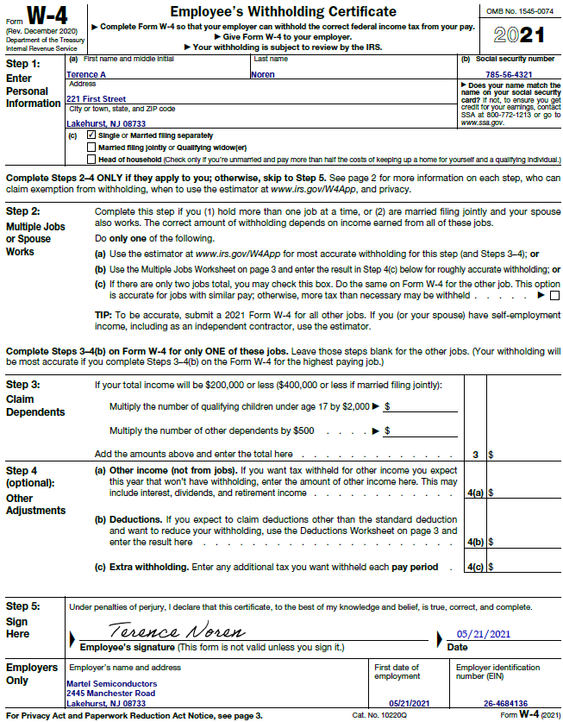

P2-12B. Complete the I-9 for employment starting 5/21/2021 at Martel Semiconductors, located at 2445 Manchester Road, Lakehurst, NJ 08733, EIN of 26-4684136. Be sure to complete Section 2 of Form I-9.

Terence A. Noren

221 First Street

Lakehurst, NJ 08733

SSN: 785-56-4321

Birthdate: 6/5/1998

Terence presented his driver’s license and Social Security card to the Human Resources Manager, Bree Andrews, to review.

New Jersey Driver’s License #N15368497531246, Expires on his birthday in 2023

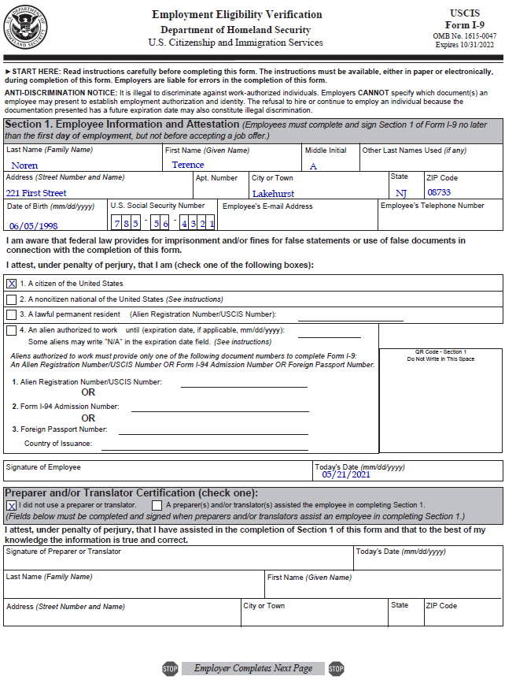 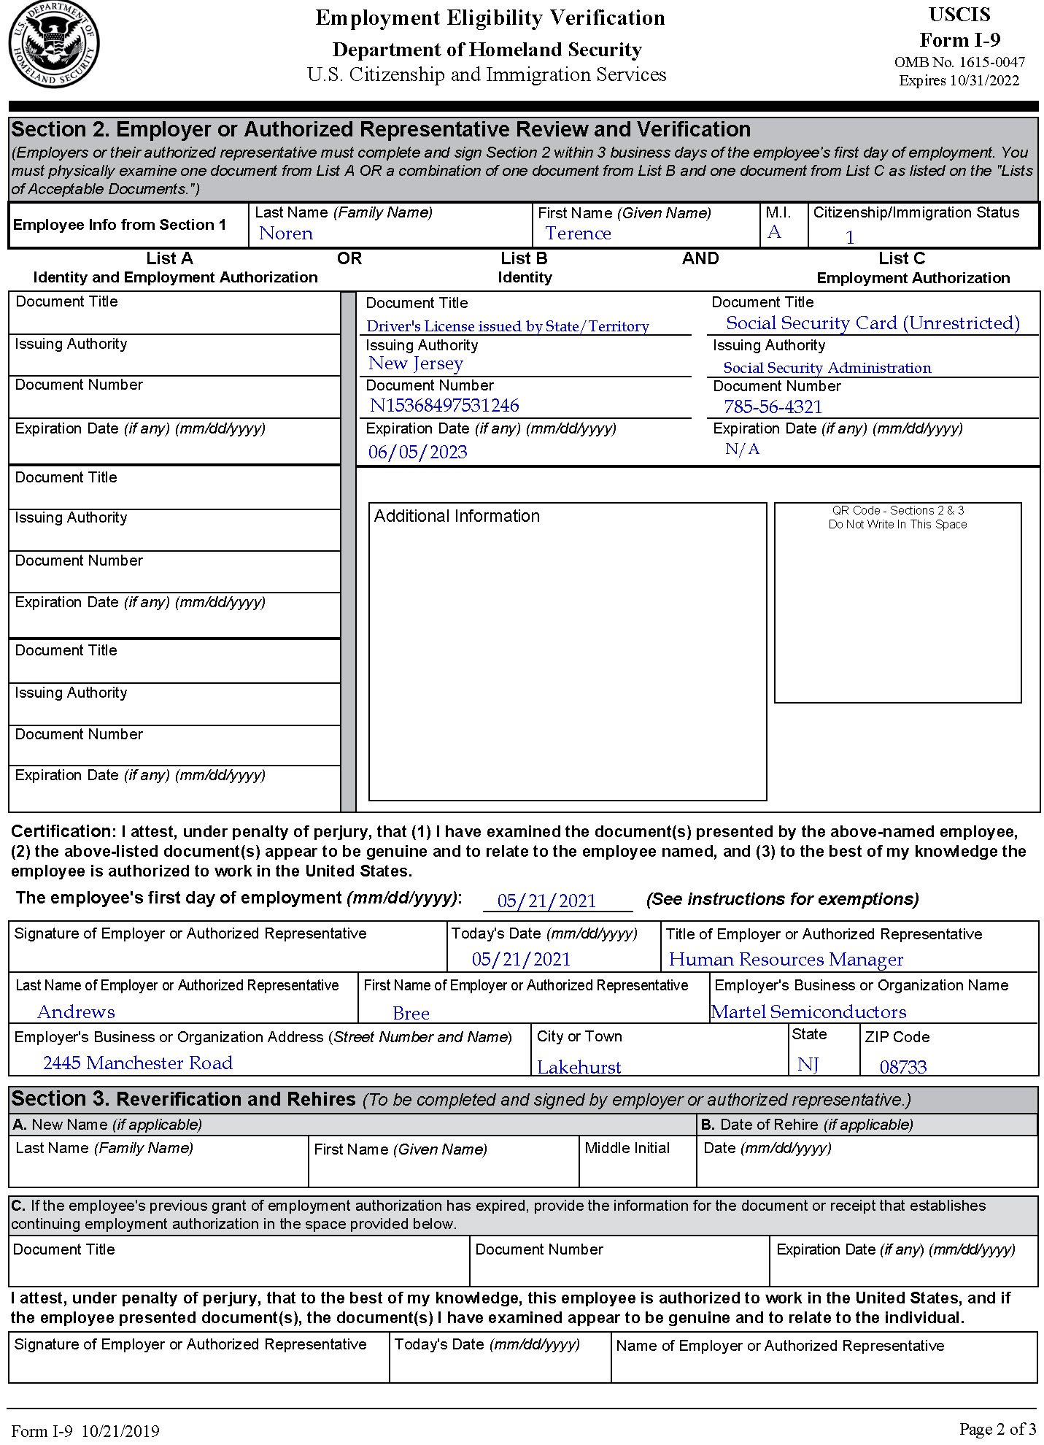 

**CRITICAL THINKING**

2-1. When Omnimia Graphics was looking to implement a payroll accounting system, the manufacturing firm had several options. With only 40 employees, the manual preparation of payroll through spreadsheets and handwritten timecards was a comfortable option for the firm. Another option is to convince the senior management of Omnimia Graphics to implement a software program for payroll processing. How should the company handle maintenance of the current payroll records? What internal control issues should be addressed?

1. Student responses will vary. Key points that need to be included: confidentiality of records, retention period, separation of duties, verification of payroll.

2-2. You have been hired as a consultant for Semiva Productions, a company facing an IRS audit of their accounting records. During your review, you notice anomalies in the payroll system involving overpayments of labor and payments to terminated employees. What would you do?

1. When the anomalies are discovered, the management of the company should be made aware of the situation. Since the IRS audit is imminent, documenting the date of the find and attempts to rectify the error would be advisable. Depending upon the nature of the anomalies, the company or payroll employees may have made some serious errors.

**IN THE REAL WORLD: CASE FOR DISCUSSION**

Student response will vary.

**CONTINUING PAYROLL PROJECT: PREVOSTI FARMS AND SUGARHOUSE**

Prevosti Farms and Sugarhouse pays its employees according to their job classification. The following employees make up Sugarhouse’s staff:

|  |  |  |
| --- | --- | --- |
| Employee Number | Name and Address | Payroll information |
| A-Mille | Thomas Millen  1022 Forest School Rd  Woodstock, VT 05001  802-478-5055  SSN:031-11-3456  401(k) deduction: 3%  Section 125 deduction: $155 | Hire Date: 2-1-2021  DOB: 12-16-1992  Position: Production Manager  PT/FT: FT, exempt  M/S: Married/Joint  Pay Rate: $35,000/year  Dependents under 17: 3  Dependents over 17: 1  Step 4 information: none |
| A-Towle | Avery Towle  4011 Route 100  Plymouth, VT 05102  802-967-5873  SSN:089-74-0974  401(k) deduction: 5%  Section 125 deduction: $100 | Hire Date: 2-1-2021  DOB: 7-14-2001  Position: Production Worker  PT/FT: FT, nonexempt  M/S: Single  Pay Rate: $12.00/hour  Dependents under 17: 0  Dependents over 17: 0  Step 4 information: none |
| A-Long | Charlie Long  242 Benedict Road S.  Woodstock, VT 05002  802-429-3846  SSN: 056-23-4593  401(k) deduction: 2%  Section 125 deduction: $155 | Hire Date: 2-1-2021  DOB: 3-16-1997  Position: Production Worker  PT/FT: FT, nonexempt  M/S: Married/Joint  Pay Rate: $12.50/hour  Dependents under 17: 2  Dependents over 17: 0  Step 4 information: none |
| B-Shang | Mary Shangraw  1901 Main Street #2  Bridgewater, VT 05520  802-575-5423  SSN: 075-28-8945  401(k) deduction: 3%  Section 125 deduction: $100 | Hire Date: 2-1-2021  DOB: 8-20-1999  Position: Administrative Assistant  PT/FT: PT, nonexempt  M/S: Single  Pay Rate: $10.50/hour  Dependents under 17: 0  Dependents over 17: 1  Step 4 information: none |
| B-Lewis | Kristen Lewis  840 Daily Hollow Road  Bridgewater, VT 05523  802-390-5572  SSN: 076-39-5673  401(k) deduction: 4%  Section 125 deduction: $155 | Hire Date: 2-1-2021  DOB: 4-6-1985  Position: Office Manager  PT/FT: FT, exempt  M/S: Married/Joint  Pay Rate: $32,000/year  Dependents under 17: 2  Dependents over 17: 1  Step 4 information: none |
| B-Schwa | Joel Schwartz  55 Maple Farm Way  Woodstock, VT 05534  802-463-9985  SSN: 021-34-9876  401(k) deduction: 5%  Section 125 deduction: $100 | Hire Date: 2-1-2021  DOB: 5-23-1993  Position: Sales  PT/FT: FT, exempt  M/S: Married/Joint  Pay Rate: $24,000/year base plus 3% commission per case sold  Dependents under 17: 2  Dependents over 17: 0  Step 4 information: none |
| B-Prevo | Toni Prevosti  820 Westminster Road  Bridgewater, VT 05520  802-555-3456  SSN: 055-22-0443  401(k) deduction: 6%  Section 125 deduction: $155 | Hire Date: 2-1-2021  DOB: 9-18-1987  Position: Owner/President  PT/FT: FT, exempt  M/S: Married/Joint  Pay Rate: $45,000/year  Dependents under 17: 3  Dependents over 17: 2  Step 4 information: none |

The Departments are as follows:

Department A: Agricultural Workers

Department B: Office Workers

1. You have been hired to start on February 1, 2021, as the new accounting clerk. Your employee number is B-STUDE, where “B” denotes that you are an office worker. Your Social Security number is 555-55-5555, you are full-time, nonexempt, and paid at a rate of $34,000 per year. You have elected to contribute 2 percent of your gross pay to your 401(k) and will have $100 per pay period for Section 125. Complete the W-4 and the I-9 to start your own employee file. You are single with only one job. You live at 1644 Smitten Road, Woodstock, VT 05001. Your phone number is (555) 555-5555. Your date of birth is 01/01/2001. You are a citizen of the United States and provide a Vermont driver’s license #88110009 expiring 01/01/23 in addition to your Social Security card for verification of your identity. Mary Shangraw verified the information for the company. Prevosti Farms and Sugarhouse is located at 820 Westminster Road, Bridgewater, Vermont, 05520. Prevosti has an EIN of 22-6654454.

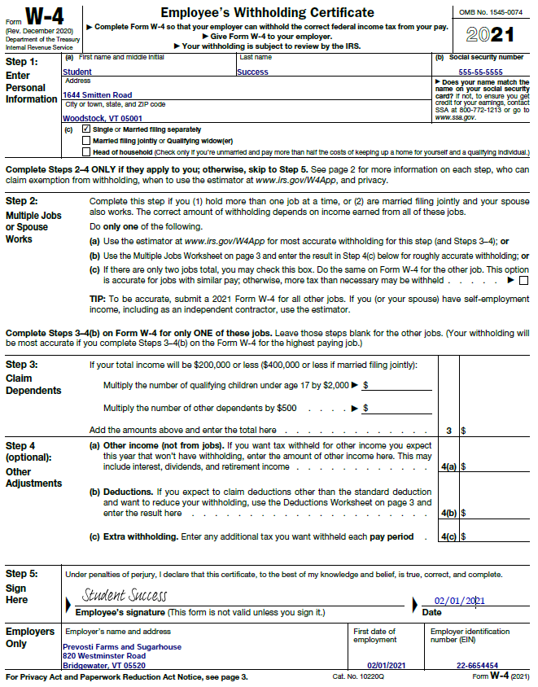

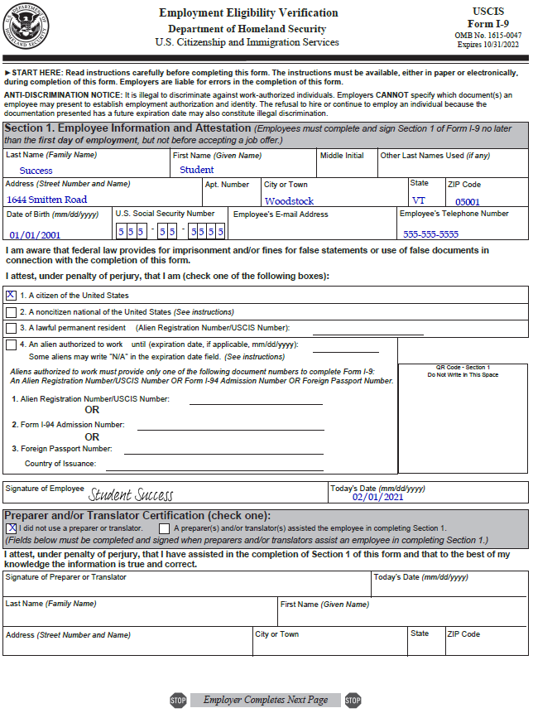 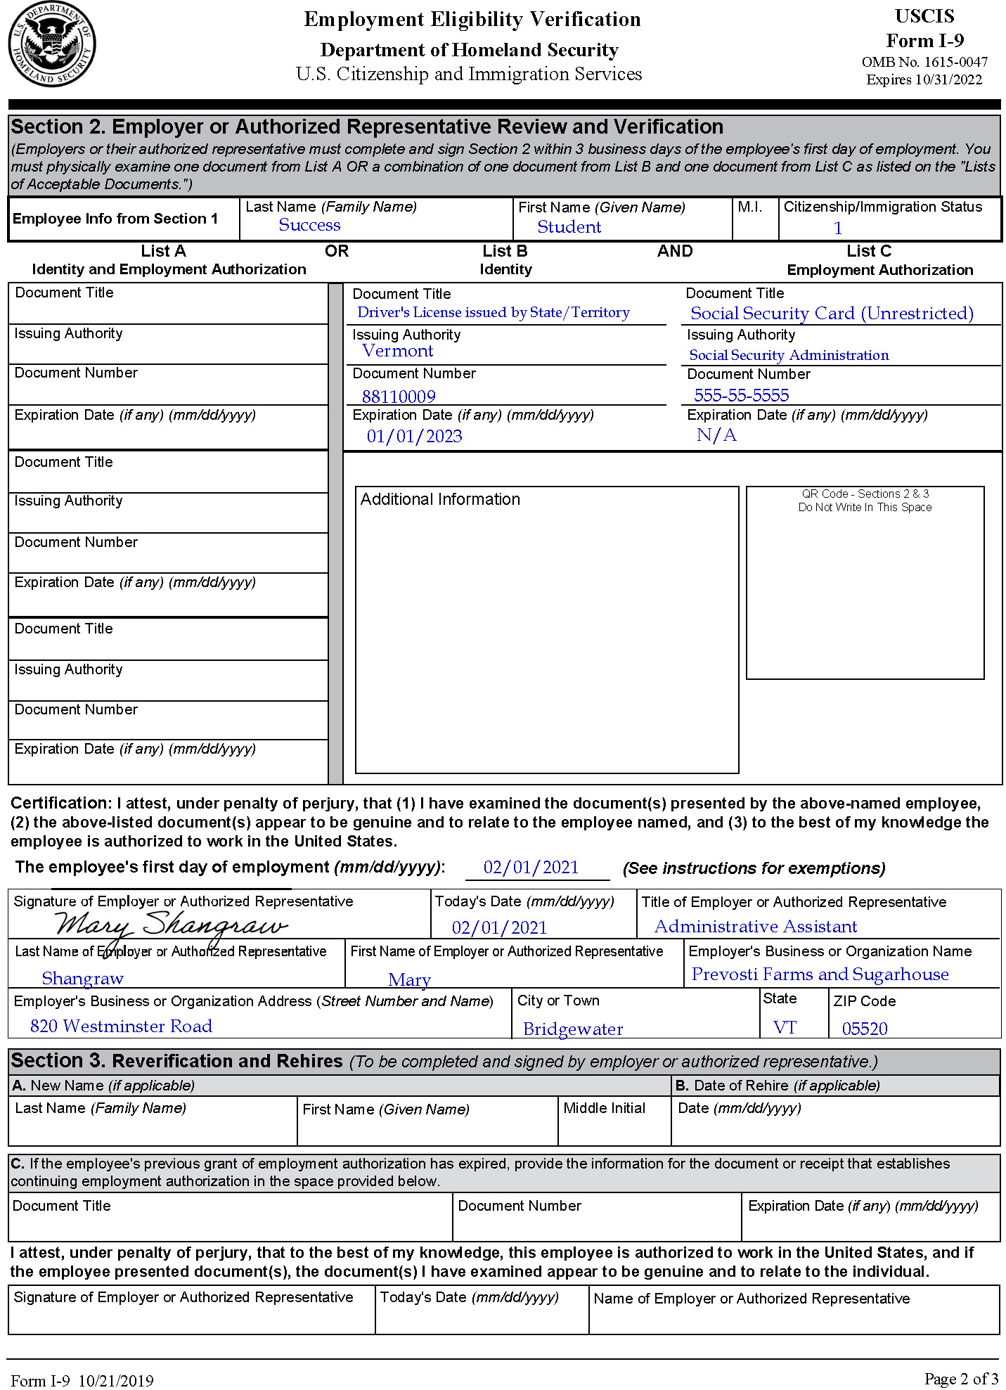

2. Complete the headers of the employee earnings register for each employee. Enter the pay rate for each employee.



