ANSWERS TO QUESTIONS - CHAPTER 2

1. A fixed cost is a cost that in total remains constant as volume of activity changes but on a per unit basis varies inversely with changes in volume of activity. A variable cost is a cost that in total changes directly and proportionately with changes in volume of activity but on a per unit basis is constant as volume of activity changes. An example of a fixed cost is a supervisor’s salary in relation to units produced. An example of a variable cost is direct materials cost in relation to units produced.

2. Most business decisions are based on cost information. The behavior of cost in relation to volume affects total costs and cost per unit. For example, knowing that total fixed cost stays constant in relation to volume and that total variable cost increases proportionately with changes in volume affects a company’s cost structure decisions. Knowing that volume is expected to increase would favor a fixed cost structure because of the potential benefits of operating leverage.

3. Operating leverage is the condition whereby a small percentage increase in sales volume can produce a significantly higher percentage increase in profitability. It is the result of fixed cost behavior and measures the extent to which fixed costs are being used. The higher the proportion of fixed cost to total cost the greater the operating leverage. As sales increase, fixed cost does not increase proportionately but stays the same, allowing greater profits with the increased volume.

4. Operating leverage is calculated by dividing the contribution margin by net income. The result is the number of times greater the percentage increase in profit is to a percentage increase in sales. For example, if operating leverage is four, a 20% increase in sales will result in an 80% increase in profit.

5. The concept of operating leverage is limited in predicting profitability because in practice, changes in sales volume are usually related to changes in sales price, variable costs, and fixed costs, which all affect profitability.

6. With increasing volume, a company would benefit more from a fixed cost structure because of operating leverage, where each sales dollar represents pure profit once fixed costs are covered. If volume is decreasing, the variable cost structure would be more advantageous because costs would decrease proportionately with decreases in volume. With a pure fixed cost structure, costs stay constant even when sales revenue is decreasing, eventually resulting in a loss.

7. A company with a variable cost structure would not suffer a loss as long as its sales price is equal to or greater than its variable cost per unit (i.e., the contribution margin is equal to or greater than zero.) This condition is not affected by decreasing volume of sales. On the other hand, another company with a fixed cost structure would need to have a positive contribution margin per unit and sufficient volume of sales to accumulate enough total contribution margin to offset its total fixed cost before any profit can be realized. In conclusion, a variable cost structure is more advantageous if volume is decreasing.

8. Fixed costs can provide financial rewards with increases in volume, since increases in volume reduce fixed costs per unit, thereby increasing profits. The risk involved with fixed costs is that decreases in volume are not accompanied by decreases in costs, eventually resulting in losses.

9. Fixed costs can provide financial rewards with increases in volume, since increases in volume do not cause corresponding increases in fixed costs. This kind of cost behavior results in increasing profits (decreases in cost per unit). But this does not mean that companies with a fixed cost structure will be more profitable. Predominately fixed cost structures entail risks. Decreases in volume are not accompanied by decreases in costs, which can eventually result in losses (increases in cost per unit).

10. The definitions of both fixed and variable costs are based on volume being within the relevant range (normal range of activity). If volume is outside the relevant range, fixed costs may increase in total if volume increases require that additional fixed assets be acquired (whereby, depreciation charges would increase). Likewise, variable costs may decrease per unit if increases in volume allow quantity discounts on materials. Increases or decreases in volume that are outside the relevant range can invalidate the definitions of fixed and variable costs.

11. The average is more relevant for pricing purposes. Customers want standardized pricing in order to know the price of a service in advance. They don’t want to wait until after the service is performed to know how much it costs. Average cost is also more relevant for performance evaluation and for control purposes. Knowing the actual cost of each service is usually of little value in evaluating cost efficiency and knowing when to take corrective action.

12. The high-low method is the appropriate method when simplicity is more important than accuracy. Least squares regression is more appropriate when accuracy is more important.

13. A fixed cost structure would have more risk because profits vary more with changes in volume. Small changes in volume can cause dramatic changes in profits. In addition, with a fixed cost structure, losses occur until fixed costs are covered. Given high fixed costs, a company would need high volume to reap the rewards associated with this cost structure.
14. The president appears to be in error because fixed costs frequently can be changed. For example, fixed costs such as advertising expense, training, and product improvement result from short-term decisions and may be easily changed. While it is more difficult, even fixed costs such as depreciation expense can be reduced and changed by selling long-term assets.

15. The statement is false for two reasons. More importantly, the statement ignores the concept of relevant range. The terms fixed cost and variable cost apply over some level of activity within which the company normally operates. Accordingly, the definitions of fixed and variable costs only apply within the relevant range. Secondly, even if a business ceases operation and produces zero products, it incurs some fixed costs such as property taxes, maintenance, and insurance.

16. Norel could calculate the average heating cost by dividing total annual expected heating cost by total annual production. The result could then be multiplied by monthly production to determine the amount of monthly heating cost to assign to inventory. This procedure would have the effect of averaging the seasonal fluctuations and would, therefore, result in a more stable unit cost figure.

17. Verna is confused because the terms apply to total cost rather than to per unit cost. Total fixed cost remains constant regardless of the level of production. Total variable cost increases or decreases as production increases or decreases. Verna is correct in her description of unit cost behavior. She is incorrect about the use of the terms, for the reasons above.

SOLUTIONS TO EXERCISES - SERIES A - CHAPTER 2

EXERCISE 2-1A

Requirement | Fixed | Variable | Mixed
a. | x
b. |  | x
c. | x
d. |  | x
e. |  |  | x
f. |  | x

EXERCISE 2-2A

Requirement | Fixed | Variable | Mixed
a. | x
b. |  |  | x
c. |  | x
d. | x
e. |  |  | x
f. |  | x
g. | x
h. | x
i. |  | x
j. |  | x

EXERCISE 2-3A

Total Fixed Cost:

Item | Cost
Depreciation | $ 80,000
Officers' salaries | 190,000
Long-term lease | 42,000
Property taxes | 48,000
Total fixed | $360,000

Units Produced (a) | 4,000 | 4,500 | 5,000
Total fixed cost (b) | $360,000 | $360,000 | $360,000
Fixed cost per unit (b a) | $90.00 | $80.00 | $72.00

EXERCISE 2-4A

Units Produced (a) | 4,000 | 8,000 | 12,000
Variable cost per unit (b) | $12.50 | $12.50 | $12.50
Total variable cost (a x b) | $50,000 | $100,000 | $150,000

EXERCISE 2-5A

a.

 | March | April
Units Produced (a) | 300 | 600
Total rent cost (b) | $1,800 | $1,800
Rent cost per unit (b a) | $6.00 | $3.00
Total utility cost (c) | $600 | $1,200
Utility cost per unit (c a) | $2.00 | $2.00

b. Since the total rent cost remains unchanged when the number of units produced changes, it is a fixed cost. Since the total utility cost changes in direct proportion with changes in the number of units, it is a variable cost.

EXERCISE 2-6A
a.
Number of Trophies | 6,000 | 8,000 | 10,000 | 12,000
Total costs incurred
Fixed | $ 60,000 | $ 60,000 | $ 60,000 | $ 60,000
Variable | 60,000 | 80,000 | 100,000 | 120,000
Total costs | $120,000 | $140,000 | $160,000 | $180,000
Cost per unit
Fixed | $10.00 | $ 7.50 | $ 6.00 | $ 5.00
Variable | 10.00 | 10.00 | 10.00 | 10.00
Total cost per trophy | $20.00 | $17.50 | $16.00 | $15.00

b. The total cost per trophy declines as volume increases because the same amount of fixed cost is spread over an increasingly larger number of units of product.

EXERCISE 2-7A

a.
Number Attending (a) | 2,000 | 2,500 | 3,000 | 3,500 | 4,000
Total cost of concert (b) | $84,000 | $84,000 | $84,000 | $84,000 | $84,000
Cost per person (b) ÷ (a) | $42.00 | $33.60 | $28.00 | $24.00 | $21.00

b. Since the cost of hiring a band remains at $84,000 regardless of the number attending, it is a fixed cost.

c.
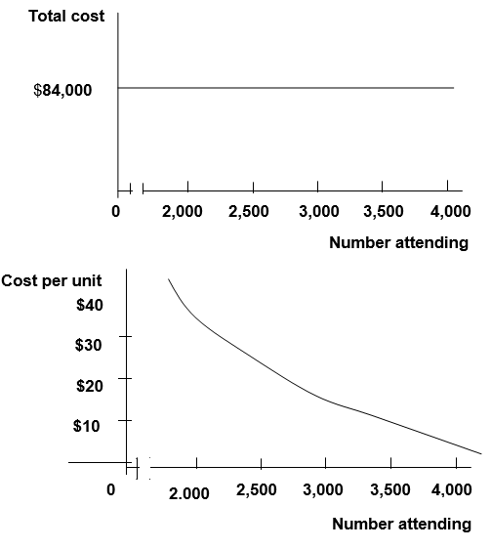
EXERCISE 2-7A (continued)

d. Bell’s major business risk is the uncertainty about whether it can generate enough revenue to cover the fixed cost. Bell must pay the $84,000 cost even if no one buys a ticket. Accordingly, there is a potential for Bell to experience a significant financial loss. Since the cost per ticket decreases as volume increases, Bell can sell tickets for less if the band attracts a large crowd. Also, lower ticket prices encourage higher attendance. Bell must set a price that encourages attendance and produces sufficient revenue to cover the fixed cost and provide a reasonable profit.

To a large extent, Bell’s business risk is the result of its cost structure. To minimize the risk, Bell could possibly change that structure. For instance, Bell may want to negotiate with the band to set a flexible compensation scheme. The band may be paid a particular percentage of the revenue instead of a fixed fee. In other words, the cost structure could be changed from fixed to variable. In this arrangement, Bell’s risk of suffering a loss is virtually eliminated. On the other hand, the variable cost structure does not allow Bell to benefit from operating leverage thereby limiting profitability. Therefore, there is a risk of lost profitability. Risk minimization does not mean risk elimination altogether.

Other business risks that may adversely affect Bell’s profit include competition, unfavorable economy, security, and litigation.

EXERCISE 2-8A

a.
Number shirts sold (a) | 2,000 | 2,500 | 3,000 | 3,500 | 4,000
Total cost of shirts $7 x (a) | $14,000 | $17,500 | $21,000 | $24,500 | $28,000
Cost per shirt | $7 | $7 | $7 | $7 | $7

b. Since the total cost of shirts increases proportionately to the number of shirts sold, it is a variable cost.
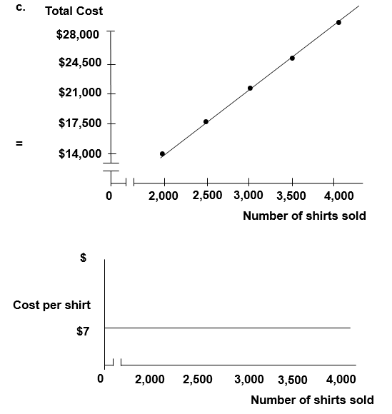

EXERCISE 2-8A (continued)

d. Bell’s major business risk is the uncertainty about whether it can generate a desirable profit. The cost and the revenue are both variable if Bell can return unsold shirts. As long as the selling price is greater than the cost per shirt, Bell will make a profit. However, it is impossible to know for sure how many shirts will be eventually sold. Bell should set a competitive price for quality T-shirts. Advertising may be necessary to attract customers. The ultimate goal is to generate the maximum profit.

Bell’s other business risks that may adversely affect its profit include competition and unfavorable general economy.

EXERCISE 2-9A
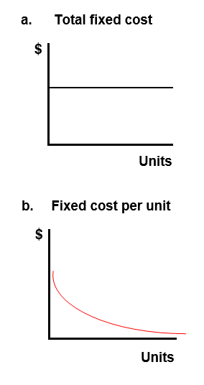

EXERCISE 2-10A

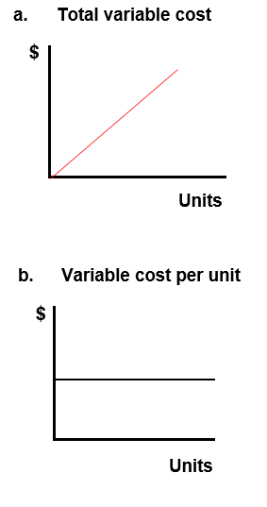

EXERCISE 2-11A

Begin by calculating the fixed cost based on the March sales. Calculate the fixed cost by subtracting the variable cost from the total cost.

 | March
Total costs incurred | $4,000
Less: Variable cost ($10 x 300) | 3,000
Fixed cost | $1,000

The fixed portion of the mixed cost will remain at $1,000 for any volume of sales within the relevant range. Accordingly, this cost will be the same for all the months under consideration.

Month | April | May | June | July
Number of units | 320 | 180 | 360 | 200
Total costs incurred
Total variable cost | $3,200 | $1,800 | $3,600 | $2,000
Total fixed cost | 1,000 | 1,000 | 1,000 | 1,000
Total salary cost | $4,200 | $2,800 | $4,600 | $3,000

EXERCISE 2-12A
a. & b.
Income Statements
 |  | a. |  | b.
Company Name |  | Hill |  | Creek
Number of Customers (n) |  | 400 |  | 400
Sales revenue (n x $120) |  | $48,000 |  | $48,000
Variable cost (n x $140) |  |  |  | (56,000)
Contribution margin |  | 48,000 |  | (8,000)
Fixed cost |  | (28,000) |  | 0
Net income (loss) |  | $20,000 |  | $ (8,000)

c. The strategy of cutting prices increases Hill’s revenue by $8,000 (i.e., $48,000 – $40,000). In other words, selling 400 units at $120 each produces more revenue (i.e., $48,000) than selling 200 units at $200 each (i.e., $40,000). Since Hill’s costs are fixed, the entire $8,000 increase in revenue increases net income. In contrast, Creek’s costs vary in relation to the number of units sold. Accordingly, the 200-unit increase in volume increases Creek’s expenses by $28,000 (i.e., 200 units x $140). Since the price-cutting strategy produces a $10,000 decline in profitability (i.e., $8,000 of additional revenue less $28,000 in additional expenses), Creek’s profit drops from a net income of $12,000 to a $8,000 loss.

EXERCISE 2-13A
a.
Income Statement
Sales Revenue (2,000 units x $125) |  | $250,000
Less: Variable costs
Cost of goods sold (2,000 units x $65) |  | (130,000)
Sales commissions (10% of Sales) |  | (25,000)
Shipping and handling expenses (2,000 units x $1.00) |  | (2,000)
Contribution margin |  | 93,000
Less: Fixed costs
Administrative salaries |  | (30,000)
Advertising expense |  | (20,000)
Depreciation expense |  | (24,000)
Net income |  | $ 19,000

b. |  |  | Contribution margin
 | Operating leverage | = | —––——————––—
 |  |  | Net income

 |  |  | $93,000
 | Operating leverage | = | ——————— | = | 4.89 times
 |  |  | $19,000 |  | (rounded)

c. A 10 percent increase in sales revenue will produce a 48.90 percent increase in net income (i.e., 10 percent x 4.89 = 48.90 percent). Accordingly, net income would increase to $28,291 [i.e., $19,000 + ($19,000 x .489)].

EXERCISE 2-14A

a. |  |  | Contribution margin
 | Operating leverage | = | —–––———————
 |  |  | Net income

 |  |  | $4,800
 | Operating leverage | = | ——————— | = | 1.5
 |  |  | $3,200

b. (10% Change in rev. x 1.5 Oper. leverage) = 15% change in net inc.
15% x $3,200 = $480 change
Revised net income = $3,200 + $480 = $3,680
c.
Annual Income Statements
Sales volume in units (a) |  | 200 | % Change | 220
Sales revenue (a x $60) |  | $12,000 | ⇒ +10% ⇒ | $13,200
Variable costs (a x $36) |  | (7,200) |  | (7,920)
Contribution margin |  | 4,800 |  | 5,280
Fixed costs |  | (1,600) |  | (1,600)
Net income |  | $ 3,200 | ⇒ +15% ⇒ | $ 3,680

($3,680 – $3,200) $3,200 = 15%

EXERCISE 2-15A

The price charged should be the same for each month regardless of how many customers are served. Accordingly, the fixed cost must be averaged over the annual total number of campers. Using a cost-plus pricing strategy, the price would be set as follows: Price = Average fixed cost per camper + variable cost per camper + desired profit. The appropriate computations are shown below:

Computation of fixed cost per unit:

 |  | $2,500 x 12
Fixed rent cost per camper | = | ———————— | = | $7.50
 |  | 4,000

Price = Fixed cost (rent) per camper + Variable cost per camper + $7.50
Price = $7.50 + $6 + $5.50
Price = $19

EXERCISE 2-16A

a.
 |  | Change in total cost |  | $720,000 – $450,000
Variable cost per unit | = | —––———————— | = | ––————————— | = | $2,700
 |  | Change in volume |  | 200 Units – 100 Units

The fixed cost can be determined by the following formula. The computations shown below are based on the high point. Computations at the low point would produce the same result.

Fixed Cost = Total Cost – Variable Cost
Fixed Cost = $720,000 – (200 Units x $2,700)
Fixed Cost = $720,000 – $540,000
Fixed Cost = $180,000

b. Total cost = Fixed cost + (Variable cost per unit x Number of units)
Total cost = $180,000 + ($2,700 x 150) = $585,000

c. The primary strength of the high-low method is that it is easy to compute. The primary weakness of the method is that it uses only two data points in the computation of the cost estimates. Accuracy can be affected if the two data points used are not representative of the underlying data set.

d. A visual fit scatter graph reveals data points that are not representative of the underlying data set. The management accountant can adjust for such outliers when drawing the line that determines the cost estimates.

SOLUTIONS TO PROBLEMS - SERIES A - CHAPTER 2

PROBLEM 2-17A

Requirement | Fixed | Variable
a. |  | x
b. |  | x
c. |  | x
d. | x
e. | x
f. |  | x
g. |  | x
h. |  | x
i. | x
j. |  | x
k. | x
l. | x
m. |  | x
n. | x
o. | x
p. |  | x
q. |  | x
r. | x
s. | x
t. | x

PROBLEM 2-18A

a. | No. of Houses Cleaned (a) | 10 | 20 | 30
 | Total expected rental cost (b) | $600 | $600 | $600
 | Average per unit rental cost (b a) | $60 | $30 | $20

Type of Cost: Since the total rental cost remains constant at $600 regardless of the number of houses cleaned, it is a fixed cost.

b. | No. of Houses Cleaned (a) | 10 | 20 | 30
 | Average per unit labor cost (b) | $50 | $50 | $50
 | Total labor cost (a x b) | $500 | $1,000 | $1,500

Type of Cost: Since the total labor cost increases proportionately with the number of houses cleaned, it is a variable cost.

c. | No. of Houses Cleaned (a) | 10 | 20 | 30
 | Average per unit supplies cost (b) | $7 | $7 | $7
 | Total cost of supplies (a x b) | $70 | $140 | $210

Type of Cost: Since the total cost of supplies increases proportionately with the number of houses cleaned, supplies cost is a variable cost.

d. | No. of Houses Cleaned | 10 | 20 | 30
 | Total expected rental cost | $ 600 | $ 600 | $ 600
 | Total labor cost | 500 | 1,000 | 1,500
 | Total cost of supplies | 70 | 140 | 210
 | Total cost | $1,170 | $1,740 | $2,310

PROBLEM 2-18A (continued)

e. The amount of total cost shown below was determined in part d.

No. of Houses Cleaned (a) | 10 | 20 | 30
Total cost (b) | $1,170 | $1,740 | $2,310
Cost per unit (b a) | $ 117 | $87 | $77

The decline in the cost per unit is caused by the fixed cost behavior that is applicable to the equipment rental.

f. Ms. Huffman means average cost per unit. It would be virtually impossible to determine actual cost per unit. Consider these questions. Exactly how much window cleaner was used in one house versus another? Did the maids stay in one house a few minutes longer than another? Obviously, it would not be practical to determine the exact cost of cleaning any specific house. The average cost is much easier to determine and more practical for pricing purposes.

PROBLEM 2-19A

a. If a branch fails to process at least 60,000 transactions, the branch is closed. Branches that process more than 90,000 transactions are transferred out of the start-up division. Accordingly, the relevant range is 60,000 to 90,000 transactions.

b. | No. of Transactions (a) | 60,000 | 70,000 | 80,000 | 90,000
 | Total teller cost (b) | $96,000 | $96,000 | $96,000 | $96,000
 | Average per unit teller cost (b a) | $1.60 | $1.37 | $1.20 | $1.07

Type of Cost: Since the total teller cost remains constant at $96,000 regardless of the number of transactions processed, it is a fixed cost.

c. | No. of Branches (a) | 10 | 15 | 20 | 25
 | Teller costs per branch (b) | $96,000 | $96,000 | $96,000 | $96,000
 | Total teller cost (a x b) | $960,000 | $1,440,000 | $1,920,000 | $2,400,000

Type of Cost: Since the total teller cost increases proportionately with the number of branches in operation, the cost is a variable cost.

PROBLEM 2-20A

a.
Sales Volume in Units (a) | 200 | 250 | 300 | 350 | 400
Total cost of software (a x $210) | $42,000 | $52,500 | $63,000 | $73,500 | $84,000
Total cost of booth rental | 8,400 | 8,400 | 8,400 | 8,400 | 8,400
Total cost of sales (b) | $50,400 | $60,900 | $71,400 | $81,900 | $92,400
Average cost per unit (b a) | $252.00 | $243.60 | $238.00 | $234.00 | $231.00
The cost of booth space is fixed.

b.
Sales Volume | 200 | 250 | 300 | 350 | 400
Average cost per unit (a) | $252.00 | $243.60 | $238.00 | $234.00 | $231.00
Price per package (a + $50) | $302.00 | $293.60 | $288.00 | $284.00 | $281.00

c.
Trade Shows Attended (a) | 1 | 2 | 3 | 4 | 5
Cost of booth rental (a x $8,400) | $8,400 | $16,800 | $25,200 | $33,600 | $42,000
The cost of booth space is variable.

d. The additional cost is $30 50 units = $0.60 per unit.
The cost would be treated as a variable cost for decision making purposes. While it is not purely proportional, its behavior pattern closely approximates a variable cost pattern.

PROBLEM 2-21A

Part 1

a. Since the total cost remains constant at $6,000 regardless of how many students attend the course, the cost of instruction is a fixed cost.

b. c. and d.

Number of Students | 18 | % Change | 20 | % Change | 22
Revenue ($700 per student) | $12,600 | ⇐(10%)⇐ | $14,000 | ⇒+10%⇒ | $15,400
Cost of instruction (fixed) | 6,000 |  | 6,000 |  | 6,000
Profit | $ 6,600 | ⇐(17.5%)⇐ | $ 8,000 | ⇒+17.5%⇒ | $ 9,400
Percentage change in revenue: ± $1,400 $14,000 = ±10%
Percentage change in profit: ± $1,400 $8,000 = ±17.5%

e. Operating leverage caused the percentage increase in profitability to be greater than the percentage increase in revenue. Since the fixed costs have been covered and no variable costs exist, each additional dollar of revenue contributes directly to additional profitability.

Part 2

f. Since the total cost changes proportionately with changes in the number of students, the cost of instruction is a variable cost.

g. h. and i.

Number of Students | 18 | % Change | 20 | % Change | 22
Revenue ($700 per student) | $12,600 | ⇐(10%)⇐ | $14,000 | ⇒+10%⇒ | $15,400
Cost of instruction (Variable) | 5,400 |  | 6,000 |  | 6,600
Profit | $ 7,200 | ⇐(10%)⇐ | $ 8,000 | ⇒+10%⇒ | $ 8,800
Percentage Change in Revenue: ±$1,400 $14,000 = ±10%
Percentage Change in Profit: ±$800 $8,000 = ±10%

PROBLEM 2-21A (continued)

Part 2

j. Since costs as well as revenue change with changes in the number of students attending the course, the change in profit is proportional to the change in revenue.

Part 3

k.
Number of Students Completing the Course | 18 | 20 | 22
Number of plaques available for sale (a) | 18 | 20 | 20
Total cost of plaques (b=[20 x $30]) | $600 | $600 | $600
Cost per unit (b a) | 33.33 | 30 | 30

l. Since the plaques must be produced in advance, the total cost is incurred before any plaque is sold. Subsequently, the number of plaques sold does not affect the total cost. This is, therefore, a fixed cost.

m. FTS faces the risk of preordering too few or too many plaques. When too many are ordered, the company will incur expenses due to waste. When too few are ordered, the company will miss the opportunity to earn additional profits. Also, FTS faces risk associated with incurring holding costs such as storage, maintenance, and interest.

n. A just-in-time inventory system would produce goods as needed to meet sales demand. Accordingly, there would be no risk of over or under production. Further, there would be no stockpiling of inventory; therefore, inventory holding costs such as storage, maintenance, and interest would be avoided.

PROBLEM 2-22A

a. | University | Kenton |  | Denton
 | Tuition revenue (20 x $450) | $9,000 |  | $9,000
 | Total cost of instruction | (5,000) | (20 x $250) | (5,000)
 | Net income | $4,000 |  | $4,000

b. | University | Kenton
 | Tuition revenue (40 x $240) | $9,600
 | Total cost of instruction (fixed) | (5,000)
 | Net income | $4,600

c. | University |  | Denton
 | Tuition revenue | (40 x $240) | $ 9,600
 | Total cost of instruction (variable) | (40 x $250) | (10,000)
 | Net income (loss) |  | $ (400)

d. The strategy in Requirement b produced a profit because Kenton’s cost of instruction is fixed. Accordingly, the increase in the number of students did not increase the total cost of instruction. In contrast, the cost of instruction for Denton is variable. As a result, when the number of students increased, the total cost of instruction increased as well. Since the increase in revenue was not sufficient to cover the increase in the cost of instruction, the strategy in Requirement c produced a loss.

PROBLEM 2-22A (continued)

e. | University | Kenton |  | Denton
 | Tuition revenue (10 x $450) | $4,500 |  | $ 4,500
 | Total cost of instruction | (5,000) | (10 x $250) | (2,500)
 | Net income (loss) | $ (500) |  | $ 2,000

f. When volume is insufficient to produce revenue that is above the level of fixed cost, the enterprise will produce a loss. This condition is demonstrated in Requirement e above. The loss could be avoided if the cost of instruction were variable. Accordingly, fixed costs are not always better than variable costs.

g. When the revenue per unit is below the variable cost per unit, the enterprise will incur additional losses for each unit produced and sold. This condition is depicted in Requirement c above. As demonstrated in Requirement b lower per unit revenue can be offset by increases in sales volume when costs are fixed. Accordingly, variable costs are not always better than fixed costs.

PROBLEM 2-23A

a.
Company Name |  | Larson |  | Benson
Contribution margin |  | $72,000 |  | $144,000
Divided by net income |  | ÷ 48,000 |  | ÷ 48,000
Operating leverage |  | 1.50 |  | 3.00

b.

Company Name |  | Larson |  | Benson
Variable cost per unit (a) |  | $16.00 |  | $7.00
Sales revenue (8,000 units x 110% x $25) |  | $220,000 |  | $220,000
Variable cost (8,000 units x 110% x a) |  | (140,800) |  | (61,600)
Contribution margin |  | 79,200 |  | 158,400
Fixed cost |  | (24,000) |  | (96,000)
Net income |  | $55,200 |  | $62,400
Percentage change * |  | 15.00% |  | 30.00%

* Larson: ($55,200 − $48,000) ÷ $48,000 = 15.00%
Benson: ($62,400 − $48,000) ÷ $48,000 = 30.00%

c.
Company Name |  | Larson |  | Benson
Variable cost per unit (a) |  | $16.00 |  | $7.00
Sales revenue (8,000 units x 90% x $25) |  | $180,000 |  | $180,000
Variable cost (8,000 units x 90% x a) |  | (115,200) |  | (50,400)
Contribution margin |  | 64,800 |  | 129,600
Fixed cost |  | (24,000) |  | (96,000)
Net income |  | $40,800 |  | $33,600
Percentage change ** |  | (15.00%) |  | (30.00%)
** Larson: ($40,800 − $48,000) ÷ $48,000 = (15.00%)
Benson: ($33,600 − $48,000) ÷ $48,000 = (30.00%)
PROBLEM 2-23A (continued)

d. The following memo is just an example. Students can form different opinions from their analyses. However, the main focus of the analyses should be the risk and reward relationship as demonstrated by the data of the two investment opportunities.

Memorandum

TO: Mr. Arnold Vimka
FROM: John Doe
SUBJECT: Analysis and Recommendation Regarding Investment Opportunities
DATE: October 20, 20XX

I have evaluated the income statements of Larson and Benson. Even though both companies have the same amounts of sales and net income last year, the risk and reward structures of the two companies are quite different. From my analysis, Larson’s operating leverage is 1.50 while Benson’s is 3.00. The analytical data suggests that Benson’s future income may be much more volatile than Larson’s.

If the economy prospers in the long run, Benson will be the better choice for investment. Otherwise, Larson will be better. If we can’t forecast future economic conditions with a reasonable degree of confidence, a conservative investor should choose Larson whereas an aggressive investor should choose Benson.

PROBLEM 2-24A

a. | Day | M | Tu | W | Th | F | Sat | Sun
 | Total cost (a) | $1,980 | $1,980 | $1,980 | $1,980 | $1,980 | $1,980 | $1,980
 | No. people (b) | 450 | 300 | 200 | 550 | 1,000 | 1,000 | 500
 | Per unit (a b) | $4.40 | $6.60 | $9.90 | $3.60 | $1.98 | $1.98 | $3.96

b. | Day | M | Tu | W | Th | F | Sat | Sun
 | Cost per unit | $4.40 | $6.60 | $ 9.90 | $3.60 | $1.98 | $1.98 | $3.96
 | Mark-up | 3.00 | 3.00 | 3.00 | 3.00 | 3.00 | 3.00 | 3.00
 | Ticket price | $7.40 | $9.60 | $12.90 | $6.60 | $4.98 | $4.98 | $6.96

c. A more rational pricing policy would base the computation of average cost on weekly totals. Total rental cost is $13,860 (i.e., $1,980 x 7 days). Total expected attendance for the week is 4,000. Average cost per ticket sold is $3.47 (i.e., $13,860 4,000 tickets). Given a desired profit of $3.00 per ticket, the price would be set at $6.47 (i.e., $3.47 + $3.00).

d. As indicated in Requirement b, prices based on daily attendance would vary from a low of $4.98 per ticket to a high of $12.90 per ticket. This pricing structure is unrealistic. It suggests that higher prices should be charged when demand is low. If implemented, the pricing policy would likely drive the small number of Wednesday night customers away. Very few people would be interested in $12.90 movie tickets.

PROBLEM 2-25A

Using information from a single climb can distort the predictive value of the data because certain variables may not represent normal averages. For example, the most recent climb served 10 climbers. The average number of climbers that normally makes a trip could be larger or smaller than the number that made the most recent trip. While recent data is more relevant, it can be distorted if the time frame is too short to provide representative results. Similarly, data that is too old may not be representative. For example, the cost of equipment, salaries, and food is likely different today as compared to five years ago. Accordingly, the data drawn from the one-year average is likely to provide the best indication of future conditions. Additional factors to be considered for pricing strategies include market demand, competition, and the general economy.

Memorandum

TO: John Doe, President
FROM: Jim Smith, Accountant
SUBJECT: Analysis and Recommendation Regarding the Use of per Unit Cost for Pricing Decisions
DATE: October 1, 20XX

I have evaluated the Company's data about cost per climb over three different time periods: recent, one year, and five years. It is my recommendation that the cost per climb data over the one-year period be used for pricing decisions.

The recent climb data pertains to only 10 climbers, a small number that may not represent normal operation. The five-year climb data extends too far to the past periods that may not reflect the current costs of operations. The one-year climb data represents an appropriate base for our cost estimation of the coming year.

I suggest that you consider other factors such as future market demand, competition, and the general economy to adjust the cost estimate and devise a successful pricing strategy.

PROBLEM 2-26A

a.

b.
Fixed cost = $11,200 − ($23 x 420) = $1,540 or,
÷
= $4,300 − ($23 x 120) = $1,540

c. Contribution margin per hour = $50 − $23 = $27

PROBLEM 2-26A (continued)

d.
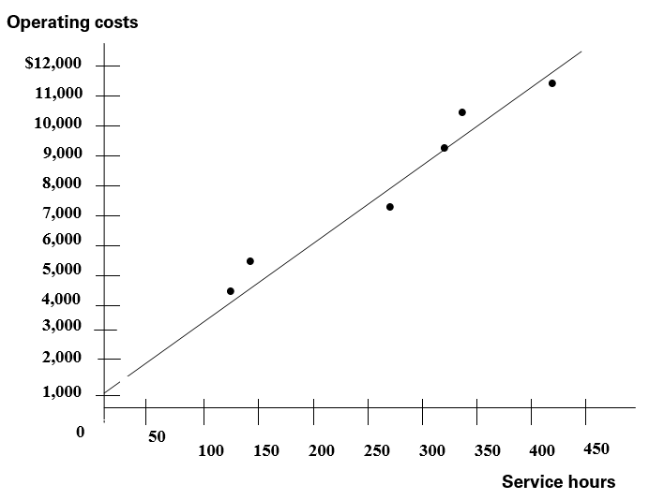

e. The results of the two methods are very similar. In Requirement b, the high-low method relies on the relationship between the highest point and the lowest point to define the variable cost and the fixed cost. In Requirement d., the scatter graph method relies on human observation to fit a straight line among the six given points. As it turns out, the variable cost per unit (the slope of the straight line) determined in the scatter graph method is greater than that determined in the high-low method. The fixed cost determined in the scatter graph is $1,200 which is lower than $1,540 determined in the high-low method.

PROBLEM 2-27A

a. (1)
Month | # of Cabinets  Produced | Total Cost
December | 400 | $16,500
April | 600 | 18,600
January | 800 | 21,000
July | 1,100 | 25,600
June | 1,300 | 27,000
May | 1,600 | 29,000
August | 1,800 | 31,000
March | 1,960 | 29,500
September | 2,280 | 32,000
October | 2,940 | 31,500
November | 3,280 | 32,000
February | 3,600 | 32,500

a. (2&3)
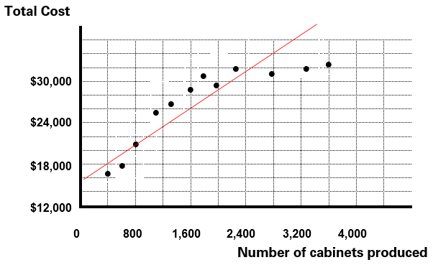

PROBLEM 2-27A (continued)

a. (4) The total cost of producing 2,000 units should be about $29,000.

b. (1)

 | Total Cost |  | # of Cabinets  Produced
High | $32,500 |  | 3,600
Low | 16,500 |  | 400
 | $16,000 | ÷ | 3,200 | = | $5 per cabinet (variable cost)

b. (2) Fixed cost = $32,500 – ($5 x 3,600) = $14,500

b. (3)
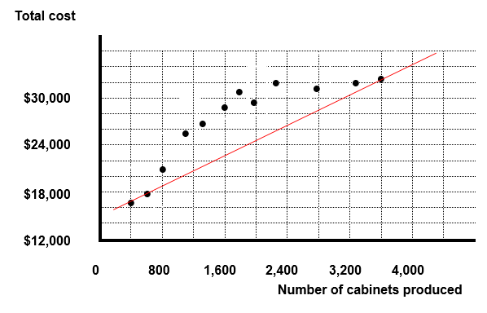

PROBLEM 2-27A (cont.)

b. (4) Total cost = Fixed cost + (Variable cost per unit x Number of cabinets)

Total cost = $14,500 + ($5 x 2,000) = $24,500

c. Neither method is accurate. However, judging from the data distribution as displayed on the sketch, the high-low method greatly distorts the underlying data because the observations for high and low points are both outliers to the down side. In other words, the estimates determined by the high-low method would significantly understate the reality. Consequently, the scatter graph method is a better one.

PROBLEM 2-28A

a. Assume the following:

X = the number of professional hours
Y = the dollar amount office support cost

The algebraic equation should be as follows :

Y = a + bX

Where a represents the fixed cost and b represents the variable cost per professional hour.

b. The result of regression analysis follows:

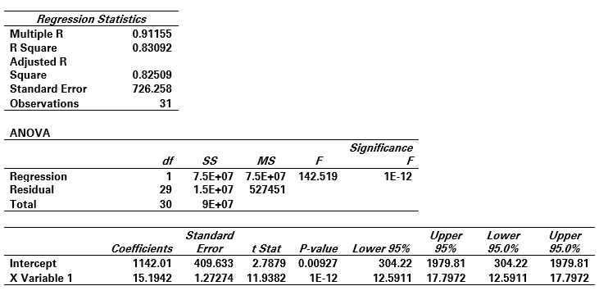
PROBLEM 2-28A (continued)

RESIDUAL OUTPUT
Observation | Predicted Y | Residuals
1 | 4560.7 | -319.7
2 | 2858.96 | 576.044
3 | 7022.16 | -624.16
4 | 7402.02 | -900.02
5 | 5062.11 | -922.11
6 | 3360.36 | 7.6362
7 | 5320.41 | -1500.4
8 | 6672.7 | -276.7
9 | 4028.91 | -82.908
10 | 8496 | -307
11 | 4955.75 | -449.75
12 | 6870.22 | -126.22
13 | 5153.28 | -508.28
14 | 3709.83 | 2363.17
15 | 6277.65 | 12.3526
16 | 7781.87 | 1331.13
17 | 3649.05 | 206.947
18 | 6581.53 | -645.53
19 | 8298.47 | 316.526
20 | 8617.55 | 1021.45
21 | 6125.71 | -157.71
22 | 6596.73 | 518.275
23 | 3785.8 | -498.8
24 | 7128.52 | 386.478
25 | 7006.97 | 367.032
26 | 5381.19 | -5.1905
27 | 5912.99 | -128.99
28 | 5441.97 | -15.967
29 | 4150.46 | 267.539
30 | 4575.9 | -69.899
31 | 6323.23 | 164.77

PROBLEM 2-28A (cont.)

Fixed cost = $1,142; Variable cost = $15.19 per professional hour

c. The R² statistic is 0.83092. This means that approximately 83% of the variation of the cost of office support (dependent variable) can be explained by variation in the number of professional hours (independent variable).

d. Total cost = Fixed cost + (Variable cost per professional hour x Number of professional hours)
Total cost = $1,142 + ($15.19 x 3,000) = $46,712

e. Factors other than professional hours (independent variable) may be affecting the cost of office support (dependent). Rather than limiting the analysis to a single independent variable, multiple regression enables the examination of the simultaneous effects of a number of independent variables.

SOLUTIONS TO EXERCISES - SERIES B - CHAPTER 2

EXERCISE 2-1B

Requirement | Fixed | Variable | Mixed
a. | x
b. | x
c. |  |  | x
d. |  | x
e. |  | x
f. | x

EXERCISE 2-2B

Requirement | Fixed | Variable | Mixed
a. | x
b. | x
c. |  | x
d. | x
e. |  |  | x
f. |  | x
g. | x
h. |  |  | x
i. |  | x
j. |  | x

EXERCISE 2-3B

Total Fixed Cost:
Item | Cost
Insurance | $ 26,000
Patent amortization | 400,000
Depreciation | 160,000
Property tax | 14,000
Total fixed | $600,000

Units Produced (a) | 10,000 | 20,000 | 50,000
Total fixed cost (b) | $600,000 | $600,000 | $600,000
Fixed cost per unit (b a) | $60 | $30 | $12

EXERCISE 2-4B

Units Produced (a) | 4,000 | 6,000 | 8,000
Variable cost per unit (b) | $9.00 | $9.00 | $9.00
Total variable cost (a x b) | $36,000 | $54,000 | $72,000

EXERCISE 2-5B

a.
 | January | February
Units Produced (a) | 1,000 | 500
Total depreciation cost (b) | $6,000 | $6,000
Depreciation cost per unit (b a) | $6.00 | $12.00
Total factory supplies cost (c) | $2,000 | $1,000
Factory supplies cost per unit (c a) | $2.00 | $2.00

b. Since the total depreciation cost remains unchanged when the number of units produced changes, it is a fixed cost. Since the total factory supplies cost changes in direct proportion to changes in the number of units, it is a variable cost.

EXERCISE 2-6B
a.
Number of Chairs | 2,000 | 3,000 | 4,000 | 5,000
Total costs incurred
Fixed | $ 80,000 | $ 80,000 | $ 80,000 | $ 80,000
Variable | 20,000 | 30,000 | 40,000 | 50,000
Total costs | $100,000 | $110,000 | $120,000 | $130,000
Per unit chair cost
Fixed | $40.00 | $26.67* | $20.00 | $16.00
Variable | 10.00 | 10.00 | 10.00 | 10.00
Total cost per chair | $50.00 | $36.67 | $30.00 | $26.00
*Rounded

b. The total cost per chair decreases as the number of chairs produced increases because the same amount of fixed cost is spread over an increasingly larger number of chairs.
EXERCISE 2-7B

a.
Number of Customers (a) | 5 | 10 | 15 | 20 | 25
Total rental cost (b) | $90 | $90 | $90 | $90 | $90
Cost per customer (b) ÷ (a) | $18.00 | $9.00 | $6.00 | $4.50 | $3.60

b. Since the cost of renting the booth is $90 regardless of the number of customers, it is a fixed cost.

c.
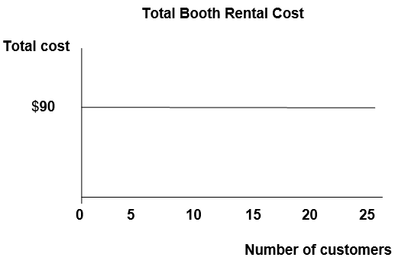

EXERCISE 2-7B (continued)

c.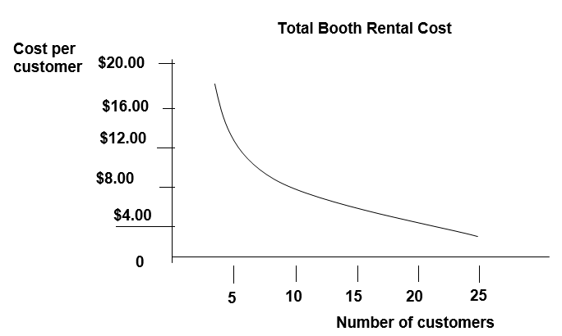

d. Corder’s major business risk is the uncertainty about whether he can generate enough revenue to cover the fixed cost. Corder must pay the $90 booth rental fee even if no one has their fortune told. Accordingly, there is a potential for Corder to experience a financial loss instead of income. Since the cost per fortune decreases as volume increases, Corder can sell fortunes for less if more people have their fortune told. Also, lower fortune prices encourage higher sales. Corder must set a price that encourages people to have their fortunes read but also produces sufficient revenue to cover the fixed cost of renting the booth and provide a reasonable profit.

EXERCISE 2-7B (cont.)

d. To a large extent, Corder’s business risk is the result of his cost structure. To minimize the risk, Corder could possibly change that structure. For instance, Corder may want to negotiate with the booth owner to set a flexible rental plan. The booth owner may be paid a particular percentage of the revenue instead of a fixed fee. In other words, the cost structure could be changed from fixed to variable. In this arrangement, Corder’s risk of suffering a loss is virtually eliminated. On the other hand, the variable cost structure does not allow Corder to benefit from operating leverage thereby limiting profitability. Therefore, there is a risk of lost profitability. Risk minimization does not mean risk elimination altogether.

Other business risks include competition, economic downturns, theft of cash receipts, and potential litigation. Corder will also likely need to advertise his booth to inform prospective customers about the opportunity to have fortunes told in the evening.

Since Corder's primary business risk results from the expected relationship between revenue and cost he could try to minimize that risk by changing that relationship. Perhaps he could negotiate a flexible cost scheme, offering to pay Molloy some percentage of revenue instead of a fixed booth rental amount. Such an arrangement would virtually eliminate Corder's risk of suffering a loss. It would not, however, ensure Corder his desired profit. Minimizing risk does not generally totally eliminate risk.

EXERCISE 2-8B

a.
Number of Customers (a) | 5 | 10 | 15 | 20 | 25
Total soft drink cost $0.50 x (a) | $2.50 | $5.00 | $7.50 | $10.00 | $12.50
Soft drink cost per customer | $0.50 | $0.50 | $0.50 | $0.50 | $0.50

b. Since the total soft drink cost increases proportionately as the number of customers increases, it is variable.

c.
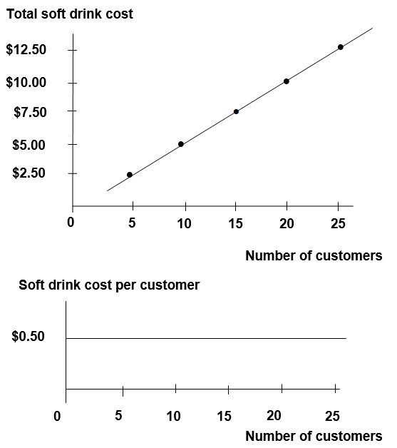
EXERCISE 2-8B (continued)

d. Corder’s major business risk is whether his business can generate a desired profit. The soft drink cost and the revenue are both variable. As long as the price he charges each customer is greater than the soft drink cost, Corder will make a profit. However, the number of customers he will serve is uncertain. Corder should set a competitive price for fortune reading. He may need to advertise to attract customers. His ultimate goal is to generate the maximum profit.

Corder’s other business risks include competition and unfavorable economic conditions.

EXERCISE 2-9B

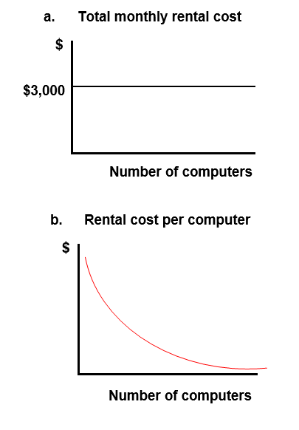

EXERCISE 2-10B

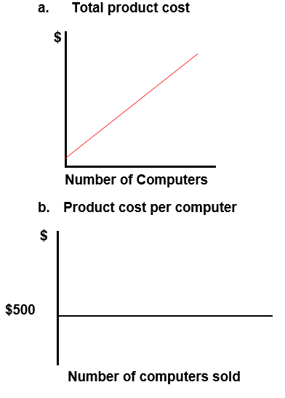
EXERCISE 2-11B

$95 – ($0.50 x 100) = $45
The fixed portion of the mixed cost is, therefore, $45 for any level of activity within the relevant range of production. This cost is the daily base wage and it will be the same each day.

Day | Monday | Tuesday | Wednesday | Thursday
Number of hats woven | 100 | 120 | 160 | 80
Total variable cost | $50 | $ 60 | $ 80 | $40
Total fixed cost | 45 | 45 | 45 | 45
Total wages cost | $95 | $105 | $125 | $85

EXERCISE 2-12B
a. & b.
Income Statements
 |  | a. |  | b.
Company |  | Standard |  | Variant
Number of customers (n) |  | 300 |  | 300
Sales revenue (n x $85) |  | $25,500 |  | $ 25,500
Variable cost: Variant (n x $90) |  |  |  | 27,000
Variable cost: Standard (n x $0) |  | 0
Contribution margin |  | 25,500 |  | (1,500)
Fixed cost |  | (13,500) |  | 0
Net income (loss) |  | $12,000 |  | $ (1,500)

c. The price-cutting strategy increases each company’s revenue by $1,500 ($25,500 – $24,000) because selling to 300 customers at $85 each ($25,500) produces more revenue than selling to 150 customers at $160 each ($24,000). Since Standard’s costs are fixed, the entire $1,500 increase in sales revenue increases net income. In contrast, Variant’s costs vary with the number of customers it serves. Increasing the number of customers by 150 increases Variant’s costs by $13,500 (150 units x $90). The price-cutting strategy increases Variant’s revenue by $1,500 and increases its costs by $13,500, resulting in a net decline in profitability of $12,000 ($1,500 of additional revenue less $13,500 in additional costs). Variant’s projected results change from $10,500 of net income to $1,500 of net loss.
EXERCISE 2-13B

Income Statement
a.
Sales revenue (2,400 units x $100) |  | $240,000
Less: Variable costs
Cost of goods sold (2,400 units x $65) |  | (156,000)
Sales commissions (10% of sales revenue) |  | (24,000)
Shipping and handling expense (2,400 units x $1) |  | (2,400)
Contribution margin |  | 57,600
Less: Fixed costs
Administrative salaries expense |  | (15,000)
Advertising expense |  | (20,000)
Depreciation expense |  | (10,600)
Net income |  | $ 12,000

b.
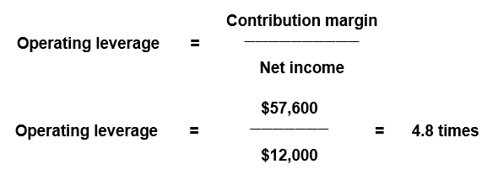

c. A 10 percent increase in sales revenue will produce a 48 percent increase in net income (10 percent x 4.8 = 48 percent) Nagano’s net income would increase to $17,760 [$12,000 + ($12,000 x 0.48)].

EXERCISE 2-14B

a.
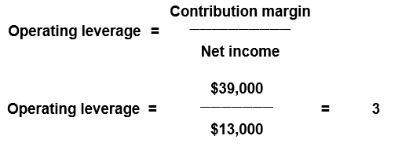

b. (10% Change in revenue x 3 Operating leverage) =
30% change in net income

30% x $13,000 = $3,900 Change
Revised net income = $13,000 + $3,900 = $16,900

c.
Annual Income Statements
Sales volume in units (a) |  | 1,000 | % Change | 1,100
Sales revenue (a x $89) |  | $89,000 | ⇒+10%⇒ | $97,900
Variable costs (a x $50) |  | (50,000) |  | (55,000)
Contribution margin |  | 39,000 |  | 42,900
Fixed cost |  | (26,000) |  | (26,000)
Net income |  | $ 13,000 | ⇒+30%⇒ | $ 16,900

($16,900 – $13,000) $13,000 = 30%

EXERCISE 2-15B

Century should charge the same amount per ticket throughout the year regardless of the number of patrons expected in a given month. Using a cost-plus pricing strategy, Century would set the ticket price as follows: Price = Average fixed cost per patron + Variable cost per patron + Desired profit per patron. The fixed cost must be averaged over the annual total number of patrons. The computations are shown below:

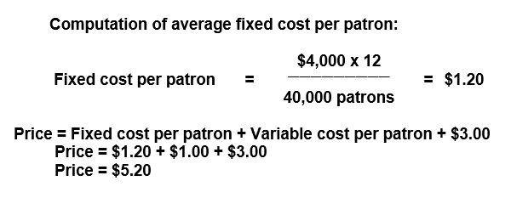

EXERCISE 2-16B

a.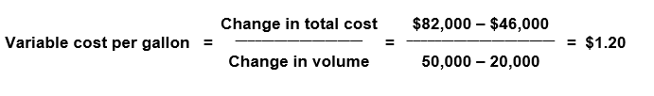

The fixed cost can be determined by the following formula. The computations shown below are based on the high point. Computations at the low point would produce the same result.

Fixed cost = Total cost – Variable cost
Fixed cost = $82,000 – (50,000 gallons x $1.20)
Fixed cost = $82,000 – $60,000
Fixed cost = $22,000

b. Total cost = Fixed cost + (Variable cost per unit x Number of units)
Total cost = $22,000 + ($1.20 x 40,000) = $70,000

c. If the high and/or low points are not representative of the underlying data set, the estimates will be inaccurate.

d. Regression analysis includes a statistic (R²) that represents the percentage of the variation in the dependent variable (total monthly cost) that is explained by variation in the independent variable (number of gallons). If the R² is low, multiple regression analysis can be employed to examine the simultaneous effects of a number of independent variables thereby offering the opportunity for improved accuracy by expanding the explanatory base (set of independent variables).

SOLUTIONS TO PROBLEMS - SERIES B - CHAPTER 2

PROBLEM 2-17B

Requirement | Fixed | Variable
a. | x
b. | x
c. |  | x
d. | x
e. | x
f. |  | x
g. |  | x
h. | x
i. | x
j. |  | x
k. | x
l. | x
m. | x
n. |  | x
o. | x
p. |  | x
q. | x
r. |  | x
s. |  | x
t. | x

PROBLEM 2-18B

a. | Number of Lawn Services (a) | 40 | 50 | 60
 | Total expected monthly depreciation cost (b) | $1,875 | $1,875 | $1,875
 | Average per unit depreciation cost (b a) | $46.88* | $37.50 | $31.25
*Rounded

Depreciation per month = $90,000 x 1/4 x 1/12 = $1,875

Type of cost: Since the total depreciation cost remains constant at $1,875 regardless of the number of lawn services, it is a fixed cost.

b. | Number of Lawn Services (a) | 40 | 50 | 60
 | Average per unit labor cost (b) | $20 | $20 | $20
 | Total labor cost (a x b) | $800 | $1,000 | $1,200
Type of cost: Since the total labor cost increases proportionately with the number of lawn services, it is a variable cost.

c. | Number of Lawn Services (a) | 40 | 50 | 60
 | Average per unit materials cost (b) | $ 10 | $ 10 | $ 10
 | Total cost of materials (a x b) | $400 | $500 | $600
Type of cost: Since the total cost of materials increases proportionately with the number of lawn services, it is a variable cost.

d. | Number of Lawn Services (a) | 40 | 50 | 60
 | Total expected depreciation cost | $ 46.88 | $37.50 | $31.25
 | Total labor cost | 800.00 | 1,000.00 | 1,200.00
 | Total cost of materials | 400.00 | 500.00 | 600.00
 | Total cost | $1,246.88 | $1,537.50 | $1,831.25

PROBLEM 2-18B (continued)

e. The amount of total cost shown below was determined in Requirement d.

Number of Lawn Services (a) | 40 | 50 | 60
Total cost (b) | $1,246.88 | $1,537.50 | $1,831.25
Cost per unit (b a) | $31.17* | $30.75 | $30.52
*Rounded

The decline in the cost per lawn service is caused by the fixed cost behavior that is applicable to the equipment depreciation.

f. Mr. Quill means average cost per unit. It would be virtually impossible to determine actual cost per unit. For instance, exactly how much pesticide was used in one lawn versus another? Did the service person work on one lawn a few minutes longer than another? Obviously, it would not be practical to determine the exact cost of servicing any specific lawn. The average cost is much easier to determine and more practical for pricing purposes.

PROBLEM 2-19B

a. If a branch fails to process at least 3,000 tax returns, the branch is closed. Branches that process more than 5,000 tax returns are transferred out of the Development Department. Accordingly, the relevant range is 3,000 to 5,000 tax returns.

b. | Number of Tax Returns (a) | 3,000 | 4,000 | 5,000
 | Total payroll cost (b) | $240,000 | $240,000 | $240,000
 | Average per unit payroll cost (b a) | $80.00 | $60.00 | $48.00
Type of Cost: Since the total payroll cost remains constant at $240,000 regardless of the number of tax returns filed, it is a fixed cost.

c. | Number of Branches (a) | 20 | 30 | 40
 | Payroll cost per branch (b) | $ 240,000 | $ 240,000 | $ 240,000
 | Total payroll cost (a x b) | $4,800,000 | $7,200,000 | $9,600,000
Type of cost: Since the total payroll cost increases proportionately with the number of branches in operation, the cost is a variable cost.

PROBLEM 2-20B

a.
Sales Volume in cameras (a) | 100 | 200 | 300 | 400 | 500
Total cost of cameras (a x $150) | $15,000 | $30,000 | $45,000 | $60,000 | $75,000
Total cost of store rental | 6,000 | 6,000 | 6,000 | 6,000 | 6,000
Total cost of sales (b) | $21,000 | $36,000 | $51,000 | $66,000 | $81,000
Average cost per camera (b a) | $210.00 | $180.00 | $170.00 | $165.00 | $162.00

b.
Sales Volume in cameras | 100 | 200 | 300 | 400 | 500
Average cost per unit (a) | $210 | $180 | $170 | $165 | $162
Price per package (a + $30) | $240 | $210 | $200 | $195 | $192

c.
Shopping Malls (a) | 1 | 2 | 3 | 4 | 5
Total cost of store rental  (a x $6,000) | $6,000 | $12,000 | $18,000 | $24,000 | $30,000

Type of cost: Since the total rental cost increases proportionately with the number of stores in operation, it is a variable cost.

d. The additional cost is $150 100 units = $1.50 per camera sold.
The cost would be treated as a variable cost for decision making purposes. While it is not purely proportional, its behavior pattern closely approximates a variable cost pattern.

PROBLEM 2-21B

Part 1
a. Since the total cost remains constant at $5,000 regardless of how many CFE candidates attend the course, the cost of instruction is a fixed cost.

b. c. & d.
Number of Candidates | 45 | % Change | 50 | % Change | 55
Revenue ($400 per candidate) | $18,000 | ⇐(10%)⇐ | $20,000 | ⇒+10%⇒ | $22,000
Cost of instruction (fixed) | 5,000 |  | 5,000 |  | 5,000
Gross profit | $13,000 | ⇐(13%)⇐ | $15,000 | ⇒+13%⇒ | $17,000
Percentage change in revenue: ±$2,000 $20,000 = ±10%
Percentage change in profit: ±$2,000 $15,000 = ±13% (rounded)

e. Operating leverage caused the percentage change in profitability to be higher than the percentage change in revenue. Since the fixed costs have been covered and no variable costs exist, each additional dollar of revenue contributes directly to additional profitability and vice versa.

Part 2
f. Since the total cost changes proportionately with changes in the number of candidates, the cost of instruction is a variable cost.

g. h. and i.
Number of Candidates | 45 | % Change | 50 | % Change | 55
Revenue ($400 per candidate) | $18,000 | ⇐(10%)⇐ | $20,000 | ⇒+10%⇒ | $22,000
Cost of instruction (variable) | 4,500 |  | 5,000 |  | 5,500
Gross profit | $13,500 | ⇐(10%)⇐ | $15,000 | ⇒+10%⇒ | $16,500
Percentage change in revenue: ±$2,000 $20,000 = ±10%
Percentage change in profit: ±$1,500 $15,000 = ±10%

PROBLEM 2-21B (continued)

Part 2 (cont.)
j. Since costs as well as revenue change in direct proportion to changes in the number of CFE candidates attending the course, the change in profit is proportional to the change in revenue.

Part 3
k.
Number of Candidates Attempting to Attend | 45 | 50 | 55
Number of candidates accepted (a) | 45 | 50 | 50
Total cost of workbooks [b = (50 x $32)] | $1,600 | $1,600 | $1,600
Cost per candidate (b a) | 35.56 | 32.00 | 32.00

l. Since the workbooks must be produced in advance, the total cost is incurred before any workbook is sold. Subsequently, the number of workbooks sold does not affect the total cost. This is, therefore, a fixed cost.

m. CFEs R Us faces the risk of producing too many or too few workbooks. When too many are produced, the company will incur expenses due to waste. When too few are produced, the company will miss the opportunity to earn additional profits. Also, CFEs R Us faces the risk associated with the incursion of costs such as storage, maintenance, and interest.

n. A just-in-time inventory system would produce goods as needed to meet sales demand. Accordingly, there would be no risk of over or under production. Further, there would be no stockpiling of inventory; therefore, inventory holding costs such as storage, maintenance, and interest would be avoided.

PROBLEM 2-22B

a. | Club | Canton |  | Tobin
 | Tuition revenue (40 x $200) | $8,000 |  | $8,000
 | Total cost of instruction (Fixed) | (4,800) | (40 x $120) | (4,800)
 | Net income | $3,200 |  | $3,200

b. | Club | Canton
 | Tuition revenue (80 x $112) | $8,960
 | Total cost of instruction (fixed) | 4,800
 | Net income | $4,160

c. | Club |  | Tobin
 | Tuition revenue | (80 x $112) | $8,960
 | Total cost of instruction (variable) | (80 x $120) | (9,600)
 | Net loss |  | $ (640)

d. The strategy in Requirement b produced a profit because Canton’s cost of coaching was fixed. Accordingly, the increase in the number of students did not increase the total cost of coaching. In contrast, the cost of coaching for Tobin was variable. As a result, when the number of students increased, the total cost of coaching increased as well. Since the increase in revenue was not sufficient to cover the increase in the cost of coaching, the strategy in Requirement c produced a loss.

e. | Club |  | Canton |  | Tobin
 | Tuition revenue | (20 x $200) | $4,000 |  | $4,000
 | Total cost of instruction | (fixed) | (4,800) | (20 x $120) | (2,400)
 | Net income (loss) |  | $(800) |  | $1,600

PROBLEM 2-22B (continued)

f. When volume is insufficient to produce revenue that is above the level of fixed cost, the enterprise will produce a loss. This condition is demonstrated in Requirement e above. The loss could be avoided if the cost of instruction were variable. Accordingly, fixed costs are not always better than variable costs.

g. When the revenue per unit is below the variable cost per unit, the enterprise will incur additional losses for each unit produced and sold. This condition is depicted in Requirement c above. As demonstrated in Requirement b, lower per unit revenue can be offset by increases in sales volume when costs are fixed. Accordingly, variable costs are not always better than fixed costs.

PROBLEM 2-23B

a.
Company Name |  | Cook |  | Penn
Contribution margin |  | $72,000 |  | $136,000
Divided by net income |  | ÷ 32,000 |  | ÷ 32,000
Operating leverage |  | 2.25 |  | 4.25
b.
Company Name |  | Cook |  | Penn
Variable cost per unit (a) |  | $16 |  | $8
Sales revenue (8,000 units x $25 x 110%) |  | $220,000 |  | $220,000
Variable cost (8,000 units x a x 110%) |  | (140,800) |  | (70,400)
Contribution margin |  | $ 79,200 |  | $149,600
Fixed cost |  | (40,000) |  | (104,000)
Net income |  | $ 39,200 |  | $ 45,600
Percentage change * |  | 22.5% |  | 42.5%
*Cook: $39,200 − $32,000 = $7,200; $7,200 ÷ $32,000 = 22.5%
Penn: $45,600 − $32,000 = $13,600; $13,600 ÷ $32,000 = 42.5%

c.
Company Name |  | Cook |  | Penn
Variable cost per unit (a) |  | $16 |  | $8
Sales revenue (8,000 units x 90% x $25) |  | $180,000 |  | $180,000
Variable cost (8,000 units x 90% x a) |  | (115,200) |  | (57,600)
Contribution margin |  | $ 64,800 |  | $122,400
Fixed cost |  | (40,000) |  | (104,000)
Net income |  | $ 24,800 |  | $ 18,400
Percentage change ** |  | (22.5%) |  | (42.5%)

** Cook: $24,800 − $32,000 = $(7,200); $(7,200) ÷ $32,000 = (22.5%)
Penn: $18,400 − $32,000 = $(13,600); $(13,600) ÷ $32,000 = (42.5%)

PROBLEM 2-23B (continued)

d. The following memo is just an example. Students can form different opinions from their analyses. However, the main focus of the analyses should be the risk and reward relationship as demonstrated by the data of the two investments.

Memorandum

TO: Ms. June Wade
FROM: John Doe
SUBJECT: Analysis and Recommendation Regarding Investments
DATE: October 23, 20XX

I have evaluated the income statements of Cook and Penn. Even though both companies had the same amounts of sales and net income last year, the risk and reward structures of the two companies are quite different. From my analysis, Cook’s operating leverage is 2.25 while Penn’s is 4.25. The analytical data suggests that Penn’s future income may be much more volatile than Cook’s.

If the economy prospers in the long run, Penn will be the better choice for investment. Otherwise, Cook will be better. If we can’t forecast future economic conditions with a reasonable degree of confidence, a conservative investor should choose Cook whereas an aggressive investor should invest in Penn.

PROBLEM 2-24B

a. | Day | M | Tu | W | Th | F | Sat | Sun
 | Total cost (a) | $3,000 | $3,000 | $3,000 | $3,000 | $3,000 | $3,000 | $3,000
 | No. people (b) | 400 | 350 | 300 | 500 | 800 | 1,250 | 1,400
 | Per unit (a b) | $7.50 | $8.57 | $10.00 | $6.00 | $3.75 | $2.40 | $2.14

b. | Day | M | Tu | W | Th | F | Sat | Sun
 | Per unit cost | $7.50 | $ 8.57 | $10.00 | $6.00 | $3.75 | $2.40 | $2.14
 | Mark-up | 2.00 | 2.00 | 2.00 | 2.00 | 2.00 | 2.00 | 2.00
 | Ticket price | $9.50 | $10.57 | $12.00 | $8.00 | $5.75 | $4.40 | $4.14

c. A more rational pricing policy would base the computation of average cost on weekly totals. Total contract cost is $21,000 (i.e., $3,000 x 7 days). Total expected attendance for the week is 5,000. Average cost per ticket sold is $4.20 (i.e., $21,000 5,000 tickets). Given a desired profit of $2.00 per ticket, the price would be set at $6.20 (i.e., $4.20 + $2.00).

d. As indicated in Requirement b, prices based on daily attendance would vary from a low of $4.14 per ticket to a high of $12.00 per ticket. This pricing structure is unrealistic. It suggests that higher prices should be charged when demand is low. If implemented, the pricing policy would likely drive the small number of Wednesday customers away. Very few people would be interested in $12.00 circus tickets if the same tickets were available for much less the day before or after.
PROBLEM 2-25B

Using information from a single recent tour can distort the predictive value of the data because certain variables may not represent normal averages. For example, the most recent tour served 32 tourists. The average number of tourists that normally makes a trip could be larger or smaller than the number that made the most recent trip. While recent data is more relevant, it can be distorted if the time frame is too short to provide representative results. Similarly, data that is too old may not be representative. For example, the cost of equipment, salaries, and food is likely different today as compared to ten years ago. Accordingly, the data drawn from the one-year average is likely to provide the best indication of future conditions. Additional factors to be considered for pricing strategies include market demand, competition, and the general economy.

Memorandum

TO: Dan Silva, President
FROM: John Doe, Accountant
SUBJECT: Analysis and Recommendation Regarding the Use of Per Unit Cost for Pricing Decisions
DATE: October 1, 20XX

I have evaluated the Company's data about cost per tour over three different time periods: recent, one year, and ten years. It is my recommendation that the cost per tour data over the one-year period be used for pricing decisions.

The recent tour data includes only 32 tourists, a small number that may not represent normal operations. The ten-year tour data extends too far to past periods that may not reflect the current costs of operations. The one-year tour data represents an appropriate base for our cost estimation for the coming year.

I suggest that you consider other factors such as future market demand, competition, and the general economy to adjust the cost estimate and devise a successful pricing strategy.

PROBLEM 2-26B

a.
b.
÷
Fixed cost = $11,600 − ($30 x 220) = $5,000 or,

= $7,400 − ($30 x 80) = $5,000

c. Contribution margin per hour = $100 − $30 = $70

PROBLEM 2-26B (continued)

d.

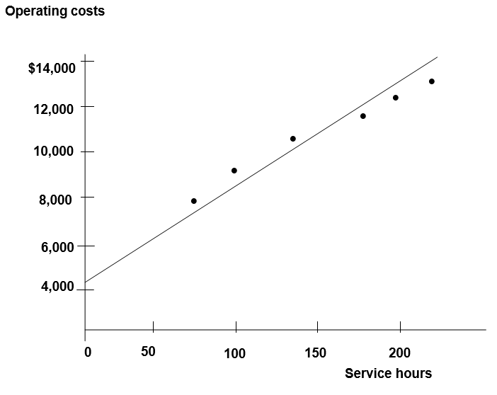

PROBLEM 2-26B (cont.)

e. The results of the two methods are very similar. In b, the high-low method relies on the relationship between the highest point and the lowest point to define the variable cost and the fixed cost. In d, the scatter graph method relies on human observation to fit a straight line among the six given points. As it turns out, the variable cost per unit (the slope of the straight line) determined in the scatter graph method is less than that determined in the high-low method. The fixed cost determined in the scatter graph is about $4,600, which is less than $5,000 as determined in the high-low method.

PROBLEM 2-27B

a. (1)
Month | # of Frames  Produced | Total Cost
December | 800 | $33,000
April | 1,200 | 37,200
January | 1,600 | 42,000
July | 2,200 | 51,200
June | 2,600 | 54,000
May | 3,200 | 58,000
August | 3,600 | 62,000
March | 3,920 | 59,000
September | 4,560 | 64,000
October | 5,880 | 63,000
November | 6,560 | 64,000
February | 7,200 | 65,000

a. (2 & 3)
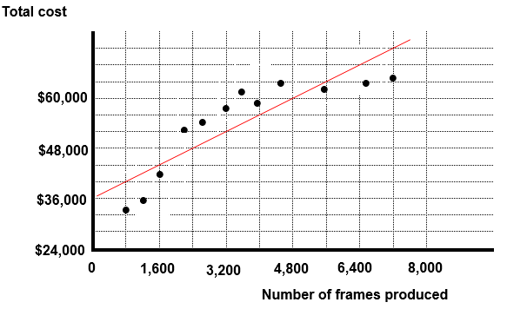

PROBLEM 2-27B (continued)

a. (4) The total cost of producing 4,000 frames should be about $56,000.

b. (1)

 | Total Cost |  | # of Frames  Produced
High | $65,000 |  | 7,200
Low | 33,000 |  | 800
 | $32,000 | ÷ | 6,400 | = | $5 per frame (variable cost)

b. (2) Fixed cost = $65,000 – ($5 x 7,200) = $29,000

b. (3)

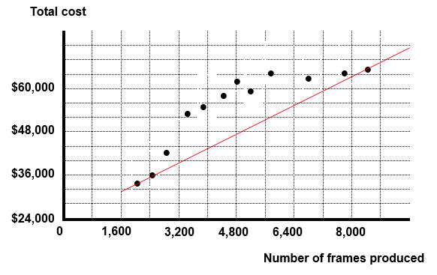
PROBLEM 2-27B (cont.)

b. (4) Total cost = Fixed cost + (Variable cost per frame x Number of frames)

Total cost = $29,000 + ($5 x 4,000) = $49,000

c. A third method that could be used is regression analysis. The regression method produces statistics that help in determining the reliability of the cost estimates. Multiple regression can be used to evaluate the simultaneous effect of a number of independent variables as opposed to being limited to a single variable analysis.

PROBLEM 2-28B

a. Assume the following:

X = the number of machine hours
Y = the dollar amount supplies cost

The algebraic equation should be as follows:

Y = a + bX

Where a represents the fixed cost and b represents the variable cost per machine hour.

b. The result of regression analysis follows:

Regression Statistics
Multiple R | 0.95883
R Square | 0.91936
Adjusted R Square | 0.91667
Standard Error | 339.596
Observations | 32
ANOVA
 | df | SS | MS | F | Significance F
Regression | 1 | 3.9E+07 | 3.9E+07 | 342.002 | 6E-18
Residual | 30 | 3459755 | 115325
Total | 31 | 4.3E+07

PROBLEM 2-28B (continued)
b.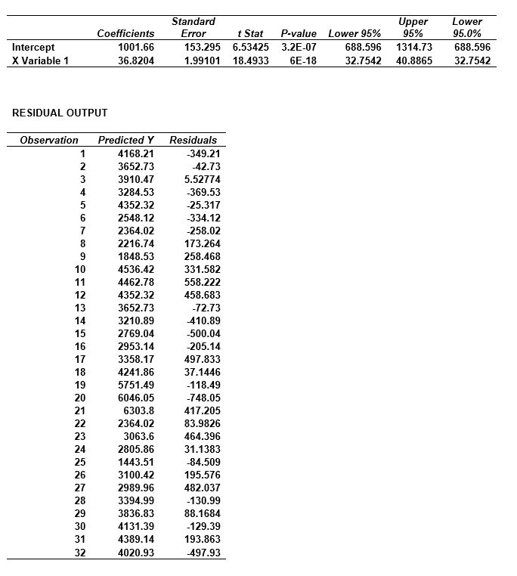
PROBLEM 2-28B (cont.)

Fixed cost = $1,002 (rounded)
Variable cost per machine hour = $36.82 (rounded)

c. The R² statistic is 0.91936. This means that approximately 92% of the variation of the cost of supplies (dependent variable) can be explained by variation in the number of machine hours (independent variable).

d. Outliers in the data set can skew the cost estimates. A visual fit scattergraph highlights the outliers so that analysts can adjust for their impact.
PROBLEM 2-28B (cont.)

e. Total cost = $1,002 + ($36.82 x 100) = $4,684

Total cost = Fixed cost + (Variable cost per machine hour x Number of machine hours)

SOLUTIONS TO ANALYZE, THINK, COMMUNICATE - CHAPTER 2

ATC 2-1

a. Delta experienced a 5.8% increase in revenue ([$47,007− $44,438] ÷ $44,438). This increase in revenue produced a 25.7% increase in operating income ([$6,618 − $5,264] ÷ $5,264), suggesting that the company experienced operating leverage. Home Depot experienced a 1.9% increase in revenue ([$110,225− $108,203] ÷ $108,203) that produced a 2.0% increase in operating income ($15,843 − $15,530] ÷ $15,530). The change in income relative to the change in revenue is much higher for Delta [25.7% ÷ 5.8% = 4.43] than for Home Depot, [2.0% ÷ 1.9% = 1.05]. This shows that for this fiscal year, Delta’s operating leverage is higher than Home Depot’s.

b. Many rational explanations are possible. However, the student’s answer should in some fashion make note of the fact that Delta must have a higher portion of fixed costs versus variable costs than Home Depot. A logical explanation is that Delta has a lot of fixed cost compared to its variable costs. The cost of an airplane is much higher than the cost of food served to a passenger, and the sized of the flight crew is not based on the number of passengers on a particular flight. A high percent of Home Depot’s expenses consists of cost of goods sold, which are variable in relation to sales.

c. If each company experienced a 5% increase in revenues, an investor should expect Delta to have the greatest percentage increase in operating income, assuming neither company experiences a significant increase in fixed costs.

ATC 2-2 Group Assignment

a. | Revenue ($28 x 500) | $14,000
 | Cost of speaker* | 10,000
 | Net income | $ 4,000
*With an audience of 500, the cost of the speaker is the same whether a fixed fee ($10,000) is paid or a fee of $20 per ticket sold is paid ($20 x 500 = $10,000).

b. Group Task (1) Assuming growth of 10% in revenue and speaker’s fee is fixed at $10,000.

 | Revenue | $14,000 | x 1.10 = | $15,400
 | Cost of speaker | 10,000 |  | 10,000
 | Net income | $ 4,000 |  | $ 5,400
Growth in net income is 35% [ ($5,400 − $4,000) / $4,000]

Group Task (2) Assuming a decline of 10% in revenue and speaker’s fee is fixed at $10,000.

 | Revenue | $14,000 | x 0.90 = | $12,600
 | Cost of speaker | 10,000 |  | 10,000
 | Net income | $ 4,000 |  | $ 2,600
Decline in net income is 35% [ ($2,600 − $4,000) / $4,000]

ATC 2-2 Group Assignment (continued)

Group Task (3) Assuming growth of 10% in revenue and speaker’s fee is variable at $20 per unit (500 x 1.10 x $20 = $11,000):

 | Revenue | $14,000 | x 1.10 = | $15,400
 | Cost of Speaker | 10,000 |  | 11,000
 | Net Income | $ 4,000 |  | $ 4,400
Growth in net income is 10% [ ($4,400 − $4,000) / $4,000]

Group Task (4) Assuming a decline of 10% in revenue, speaker’s fee is variable at $20 per unit (500 x 0.90 x $20 = $9,000):

 | Revenue | $14,000 | x 0.90 = | $12,600
 | Cost of speaker | 10,000 |  | 9,000
 | Net income | $ 4,000 |  | $ 3,600
Decline in net income is 10% [($3,600 − $4,000) / $4,000]

c. In-class assignment requiring no written solution.

d.
(1) A fixed cost structure provides greater growth potential in profitability due to operating leverage.
(2) A fixed cost structure faces the greater risk of declining profitability due to operating leverage.
(3) A fixed cost structure should be used if volume of sales is expected to increase.
(4) A variable cost structure should be used if volume of sales is expected to decline.

ATC 2-3

a. Change in sales from 2018 to 2020: $ 32,655*

Sales of 2018 $110,360

= % increase in sales 29.6%

* ($143,015 - $110,360 = $32,655)

Change in earnings from continuing operations
from 2018 to 2020: $17,901*

Earnings from continuing operations of 2018 $35,058

= % decrease in operating earnings 51.1%

* ($52,959 - $35,058 = $17,901)

b. Fixed costs would best explain why the percentage increase in income was greater than the percentage increase in sales.

c. Research and development costs should not vary with the number of units produced and sold. Therefore, these costs would be considered fixed in the context of the number of units sold.

d. Research and development costs probably would vary with the number of new products being developed. Therefore, these costs would be considered variable in the context of the number of products developed. (In reality, these cost probably would be mixed, but the way the question is worded, “variable” is an acceptable answer.)

ATC 2-4 Writing Assignment

The memo should give recognition to the use of an average cost that is based on annual expectations rather than monthly expectations. The average annual fixed cost per visit is $12.80 per visit [($300 rent + $180 other) x 12 ÷ 450 visits = $12.80). Total cost per visit amounts to $22.80 ($12.80 fixed + $10 variable). A price of $22.80 would spread all costs evenly throughout the year. While Dr. Sterling may lose money in the months of low volume she will earn enough in the months of high volume to break even. As a result, service for the year will be provided at cost.

ATC 2-5 Ethical Dilemma

a. | Accounting period | Year 1 | Year 2
 | Amount of Scientific seed sold in pounds(a) | 2,400,000 | 1,300,000
 | Royalty per pound (b) | $0.50 | $0.50
 | Total royalty paid (a x b) | $1,200,000 | $650,000
 | Total cost savings:
 | Year 1 royalty payment | $1,200,000
 | Less: Year 2 royalty payment | 650,000
 | Royalty cost savings | 550,000
 | Less: cost of ad campaign | 100,000
 | Total savings for World Agra | $ 450,000
World Agra’s sales revenue remained the same in the second year after Mr. Borrough’s new policy. However, World Agra paid $550,000 less royalty to Scientific Associates after spending $100,000 on the ad campaign. These events increased World Agra’s net income by $450,000.

b. World Agra’s customers and society in general suffered from the move to promote the Bio Labs seed. The Scientific Associates seed would have produced greater yields and better flavor.

c. While it could be argued that Mr. Borrough’s actions violated some of the ethical standards such as engaging in activities that would discredit the profession, it is highly unlikely that such argument would prevail if he were charged with an ethics violation. Mr. Borrough acted in the financial interest of his company and his conduct did not blatantly violate any of the standards of ethical conduct. While he may have pushed the envelope, Mr. Borrough’s behavior would most likely be viewed as in compliance with contemporary ethical standards.

ATC 2-5 Ethical Dilemma (continued)

d. (This requirement asks for the opinion of the respondent. There is no right or wrong response.)

e. The Sarbanes-Oxley Act requires public companies to set up a code of ethics. Mr. Borrough’s action may have violated the company’s code of ethics and, in turn, may have infringed the law. However, the unethical behavior is not a criminal offense under the law.
ATC 2-6

Screen capture of cell values:

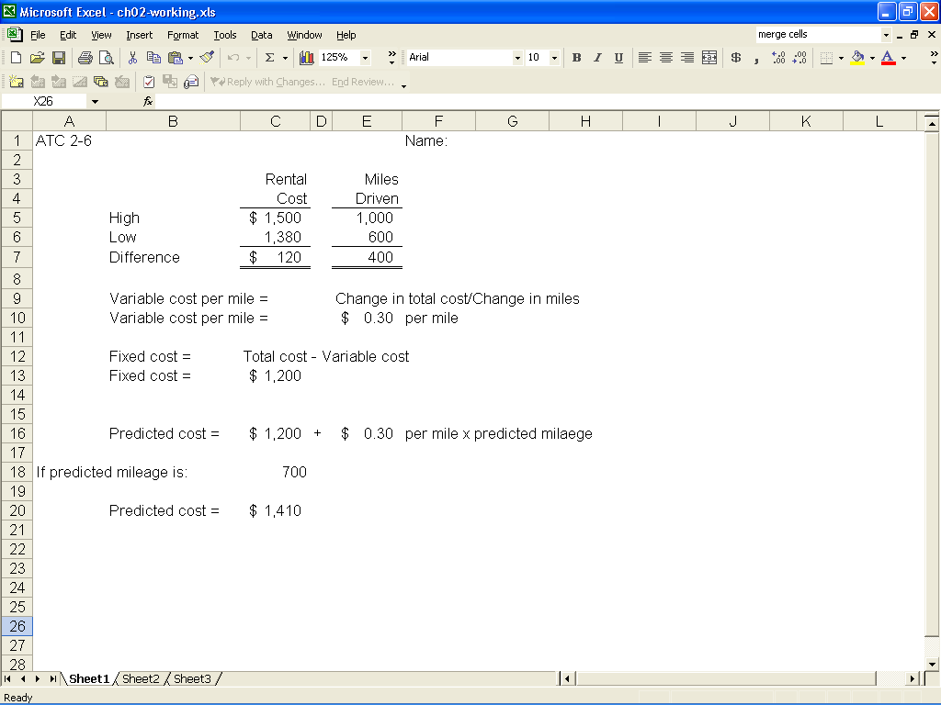

ATC 2-6 (continued)

Screen capture of cell formulas:

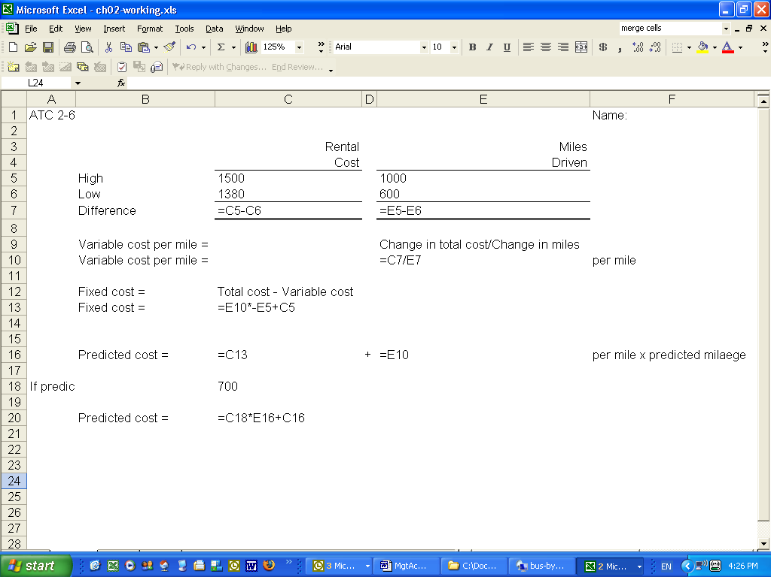

ATC 2-7

Screen capture of cell values:

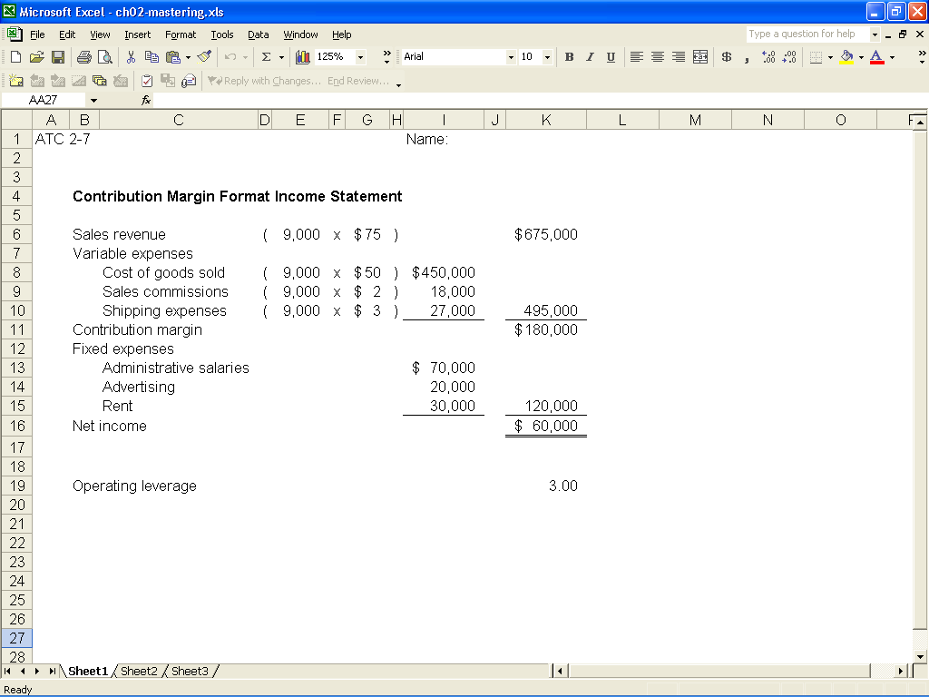

ATC 2-7 (continued)

Screen capture of cell formulas:

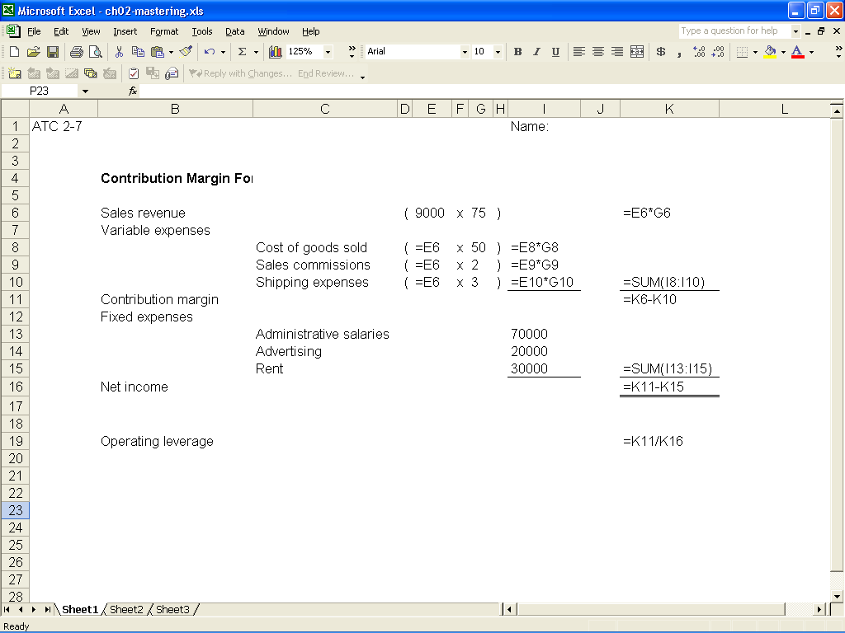

SOLUTION TO COMPREHENSIVE PROBLEM - CHAPTER 2

Requirement a
Review the accounting events experienced by Magnificent Modems, Inc. during its Year 1 accounting period. Identify each cost incurred by the
company as (1) fixed versus variable relative to the number of units produced and sold; and (2) product versus general, selling and administrative (G, S, and A).
The solution for the first item is shown as an example below.
Cost Item |  |  |  |  |  |  | Fixed |  | Variable |  | Product |  | S, G, & A
Depreciation on manufacturing equipment |  |  |  |  |  |  | X |  |  |  | X
Direct materials |  |  |  |  |  |  |  |  | X |  | X
Direct labor |  |  |  |  |  |  |  |  | X |  | X
Manufacturing supplies |  |  |  |  |  |  |  |  | X |  | X
Rent on manufacturing facility |  |  |  |  |  |  | X |  |  |  | X
Sales commissions |  |  |  |  |  |  |  |  | X |  |  |  | X
Depreciation on administrative equipment |  |  |  |  |  |  | X |  |  |  |  |  | X
Administrative costs (rent and Salaries) |  |  |  |  |  |  | X |  |  |  |  |  | X

COMPREHENSIVE PROBLEM (continued)

Requirement b
Replace the question marks in the following table to indicate the product cost per unit assuming levels of production of 5,000, 6,000, 7,000 and 8,000. Use
the power of Excel to perform the division necessary to determine the cost
per unit amounts shown in the bottom row of the table.
 | Cost of goods sold* |  |  | $455,000 | $524,000 | $593,000 | $662,000
 | Divided by number of units |  |  | 5,000 | 6,000 | 7,000 | 8,000
 | Cost per unit |  |  | $91 | $87.33 | $84.71 | $82.75 | (rounded)
*Fixed cost of goods sold = $60,000 (Depreciation on manuf. equip.) + $50,000 (Rent on manuf. facility) = $110,000

Variable cost / unit = ($455,000 – $110,000) ÷ 5,000 = $69 / unit

Cost of goods sold at 6,000 units = $69 x 6,000 + $110,000 = $524,000
Cost of goods sold at 7,000 units = $69 x 7,000 + $110,000 = $593,000
Cost of goods sold at 8,000 units = $69 x 8,000 + $110,000 = $662,000

