True / False

1. Purchasing can be broadly classified into two categories: merchants and industrial buyers.
 | a. | True
 | b. | False

ANSWER: | True

2. Merchant buyers primary task is to purchase raw materials for resale purposes.
 | a. | True
 | b. | False

ANSWER: | True

3. A low ROA suggests that management is capable of generating large profits with relatively small investments.
 | a. | True
 | b. | False

ANSWER: | False

4. The procedures for public procurement differ from the private sector.
 | a. | True
 | b. | False

ANSWER: | True

5. The supply base refers to the list of suppliers that a firm uses to acquire its materials, services, supplies, and equipment.
 | a. | True
 | b. | False

ANSWER: | True

6. The goal of a good purchasing system is to ensure efficient information transitions between the materials users, the purchasing personnel, and the suppliers.
 | a. | True
 | b. | False

ANSWER: | True

7. The purchase order is NOT a legally binding contract until it is accepted by the supplier.
 | a. | True
 | b. | False

ANSWER: | True

8. A material requisition and a purchase requisition are the same thing.
 | a. | True
 | b. | False

ANSWER: | True

9. The Uniform Commercial Code (UCC) governs the purchase and sale of goods in every state in the U.S.
 | a. | True
 | b. | False

ANSWER: | False

10. Procurement credit cards can be used for small purchases including meals, lodging, and travel expenses.
 | a. | True
 | b. | False

ANSWER: | True

11. Blank check purchase orders, Corporate purchasing cards, Petty cash, and Open-end purchase orders are all possible alternatives to dealing with small value purchases such as those for office supplies.
 | a. | True
 | b. | False

ANSWER: | True

12. Generally, firms outsource noncore activities while focusing on core competencies.
 | a. | True
 | b. | False

ANSWER: | True

13. If the break-even point in a typical make-buy scenario is 19,000 units and 10,000 units are required by the firm, then the firm should choose to make the units.
 | a. | True
 | b. | False

ANSWER: | False

14. A reason for making items instead of buying them would include better quality control.
 | a. | True
 | b. | False

ANSWER: | True

15. The Total Cost of Ownership Concept includes qualitative costs.
 | a. | True
 | b. | False

ANSWER: | True

16. The total cost analysis demonstrates how the unit cost alone can affect purchase decisions.
 | a. | True
 | b. | False

ANSWER: | False

17. The possibility of events like strikes, assembly line breakdowns, and natural disasters are all reasons a company should favor using a single supplier.
 | a. | True
 | b. | False

ANSWER: | False

18. Centralized purchasing is the practice where individual, local purchasing departments throughout a single corporation make their own, individual purchasing decisions to fulfill their individual local needs.
 | a. | True
 | b. | False

ANSWER: | False

19. USMCA and the EU are trade organizations seeking to reduce tariff and non-tariff barriers among its member countries.
 | a. | True
 | b. | False

ANSWER: | True

20. Foreign suppliers located farther away may be able to deliver goods faster than domestic suppliers due to more efficient transportation and logistical systems.
 | a. | True
 | b. | False

ANSWER: | True

Multiple Choice

21. The primary goals of purchasing include all EXCEPT:
 | a. | Secure materials at the lowest cost
 | b. | Maximize customer satisfaction
 | c. | Improve the quality of finished goods produced
 | d. | Ensure the highest quality raw materials are purchased

ANSWER: | d

22. Which of the following refers to the measurement of the impact of change in purchase spend on a firm’s profit before taxes, assuming gross sales and other expenses remain unchanged?
 | a. | Break-Even Analysis
 | b. | Profit-Leverage Effect
 | c. | Direct Offset
 | d. | Leveraging Purchase Volume

ANSWER: | b

23. When calculating Return on Investment, fixed assets include:
 | a. | Cash, Accounts Receivable, and Inventory
 | b. | Cash, Accounts Receivable, and Equipment
 | c. | Accounts Receivable, Equipment, and Real Estate
 | d. | Equipment, Buildings, and Real Estate

ANSWER: | d

24. Inventory Turnover can be calculated by:
 | a. | Ratio of cost of goods sold over average inventory cost
 | b. | Ratio of average inventory cost over cost of goods sold
 | c. | Ratio of inventory days in stock over average inventory cost
 | d. | Ratio of average inventory cost over inventory days in stock

ANSWER: | a

25. Which type of requisition is used for materials and standard parts that are requested on a recurring basis?
 | a. | Open requisition
 | b. | Blanket requisition
 | c. | Traveling requisition
 | d. | Recyclable requisition (Cyc-Rec)

ANSWER: | c

26. Which of the following is a form of purchasing that is placed directly to the supplier and suitable when firms use the same components to make standard goods over a relatively long period of time?
 | a. | Material requisition
 | b. | Green purchasing
 | c. | Planned order release
 | d. | Distributed purchasing

ANSWER: | c

27. When a product is purchased that is complicated or highly technical, what may be issued instead of a request for quotation?
 | a. | Request for proposal
 | b. | Purchase order
 | c. | Contract for sale
 | d. | Sales order

ANSWER: | a

28. Benefits derived from implementing e-procurement systems include all of the following EXCEPT:
 | a. | Allows buyers to submit bids and suppliers to respond to those bids in real time
 | b. | Increases the accuracy in communication between buyers and suppliers
 | c. | Creates numerous additional job opportunities in the purchasing department
 | d. | Allows buyers to support minority or locally owned businesses by storing this supplier information

ANSWER: | c

29. While most public procurement is focused on goals like those of purchasing departments in the private sector, U.S. federal government purchases must comply with the:
 | a. | Services and Materials Acquisition Act
 | b. | Fair Standards and Equitable Purchases Act
 | c. | Federal Code of Conduct for Procurement
 | d. | Federal Acquisition Regulation

ANSWER: | d

30. Petty cash is being phased out in favor of:
 | a. | Hard cash
 | b. | A blank check
 | c. | P-card
 | d. | Wire transferring

ANSWER: | c

31. Blanket or open-end purchase orders are suitable for buying
 | a. | Computers
 | b. | Heavy equipment
 | c. | Custom built components
 | d. | Office supplies

ANSWER: | d

32. Which of the following is a reason small value purchases are handled differently?
 | a. | To give the buyer additional supplier choices
 | b. | To obtain a higher quality product
 | c. | To have better tracking of material usage
 | d. | To control unnecessary administrative costs

ANSWER: | d

33. Which of the following illustrates Forward Vertical Integration?
 | a. | Microsoft starting a new division that designs and manufactures clothing
 | b. | Ford automotive buying additional machines for production
 | c. | Subway sandwich company buying a bakery to make the bread for their sandwiches
 | d. | Dell Computers buying retail computer stores to sell computers to the public

ANSWER: | d

34. Which of the following would be a good reason to outsource (buy) versus making?
 | a. | To utilize existing capacity within a company's own firm
 | b. | A firm is running at or near capacity and is unable to meet demand requirements
 | c. | To have more direct control over the design and production of an end item
 | d. | No competent supplier presently produces the needed item

ANSWER: | b

35. Given the following make-buy information, what would be the break-even point?
 | Make Option | Buy Option
Fixed Costs | $6500 | $2500
Variable Costs | $ 5 | $ 9

 | a. | 1500 units
 | b. | 1000 units
 | c. | 800 units
 | d. | 250 units

ANSWER: | b

36. Given the following make-buy information, what would be the break-even point?
 | Make Option | Buy Option
Fixed Costs | $13,000 | $1600
Variable Costs | $ 5 | $ 10

 | a. | 2280 units
 | b. | 1550 units
 | c. | 1080 units
 | d. | 550 units

ANSWER: | a

37. As firms seek to improve the products they offer to the market, companies are seeking help from their suppliers in new product design and development through:
 | a. | Supplier certification programs
 | b. | Heuristics
 | c. | Early supplier involvement
 | d. | Focused Work Centers

ANSWER: | c

38. Firms typically use all of the following factors when considering which suppliers to select for important materials EXCEPT:
 | a. | Order system and cycle time
 | b. | Location
 | c. | Process and product technologies
 | d. | Slotting fees

ANSWER: | d

39. Total Cost of Ownership does NOT consider which of the following factors?
 | a. | Purchase order costs
 | b. | Freight costs
 | c. | Currency exchange fees
 | d. | Tooling costs

ANSWER: | a

40. The total cost of ownership for Supplier A is $1,670,000. The total cost of ownership for Supplier B is $2,250,000. The total cost of ownership for Supplier C is $1,990,000. Using Total Cost Analysis, it will be more cost-effective to use
 | a. | Supplier A
 | b. | Supplier B
 | c. | Supplier C
 | d. | Cannot be determined

ANSWER: | a

41. Which of the following is a reason for favoring single sourcing?
 | a. | Encourages competition among suppliers
 | b. | Spreads the risk of supply interruption
 | c. | Reduces variabilities in quality levels
 | d. | Reduces information about new processing technologies

ANSWER: | c

42. Which of the following is a reason that single sourcing is considered risky/bad?
 | a. | There could be supplier interruptions due to political instability
 | b. | It could establish close relationships with the supplier
 | c. | Larger orders make quantity discounts more likely
 | d. | Decreases the item quality variability of items purchased

ANSWER: | a

43. Which of the following is an advantage of a centralized purchasing department?
 | a. | Less bureaucracy
 | b. | More frequent shipments
 | c. | Common supply base
 | d. | Closer contact between buyer and user

ANSWER: | c

44. Which of the following statements is FALSE?
 | a. | Centralized purchasing is where individual, local purchasing departments, such as at the plant level, make their own purchasing decisions.
 | b. | Centralized purchasing minimizes the competition problem when scarce materials are purchased from the same supplier.
 | c. | Centralized purchasing eliminates the duplication of job functions.
 | d. | Centralized purchasing allows larger shipments to be made which can decrease overall transportation costs.

ANSWER: | a

45. Which of the following is NOT a potential challenge for global sourcing?
 | a. | Long delivery lead times
 | b. | Costs involved in selecting foreign suppliers
 | c. | Reduction of international trade barriers
 | d. | Labor and legal problems

ANSWER: | c

46. Which of the following is NOT a form of countertrade?
 | a. | Barter
 | b. | Kaizen blitz
 | c. | Offset
 | d. | Counterpurchase

ANSWER: | b

47. According to the Buy American Act, which of the following does the Buy American Act apply to?
 | a. | The procurement is intended for public use within the U.S.
 | b. | The materials to manufacture the goods are available in the U.S.
 | c. | U.S. government purchasers must purchase domestically produced goods
 | d. | All of the choices are correct

ANSWER: | d

48. Which of the following would decrease purchase spend?
 | a. | Increasing safety stock levels
 | b. | Increasing queue management
 | c. | Decreasing information visibility along the supply chain
 | d. | Purchasing materials at a lower total acquisition cost

ANSWER: | d

49. Return on assets (ROA) can be calculated by:
 | a. | Ratio of cost of goods sold over total assets
 | b. | Ratio of net income over total assets
 | c. | Ratio of average inventory cost over total assets
 | d. | Ratio of net income over average inventory cost

ANSWER: | b

50. Which of the following states is NOT governed by the Uniform Commercial Code (UCC) in the purchase and sale of goods in the United States?
 | a. | Delaware
 | b. | Louisiana
 | c. | Texas
 | d. | Maine

ANSWER: | b

51. Which of the following best describes incoterms?
 | a. | Incoterms deal with dispute resolutions.
 | b. | Incoterms are a substitute for a sales contract.
 | c. | Incoterms simplify international transactions of goods with respect to transport obligations.
 | d. | Incoterms deal with consequences for breach of performance.

ANSWER: | c

Subjective Short Answer

52. When using the Total Cost of Ownership concept, explain how a supplier with a higher unit price and higher tooling cost can end up being more cost effective than another supplier with a lower unit price and tooling cost.
ANSWER: | When calculating the Total Cost of Ownership, unit price and tooling cost are not the only criterion used in supplier selection. Other qualitative and quantitative factors, including freight and inventory costs, tariffs and duties, currency exchange fees, payment terms, maintenance and nonperformance costs should be considered. After calculating these other factors, the Total Cost of Ownership may have been lower with the second supplier.

53. Use what you understand about the outsourcing decision (Make vs. Buy) to answer this question. List and explain three reasons a restaurant might decide to buy pre-made desserts from a supplier rather than making the goods from scratch.
ANSWER: | Reasons a restaurant might decide to buy pre-made desserts from a supplier.  ​  a. Cost – Creating a high-quality dessert might require unusual, as well as, a large number of ingredients. They may not be able to take advantage of economies of scale, if they do not sell a lot of desserts. It also may be quite costly to hire a specialist to make the desserts.  b. Insufficient Capacity – A restaurant may not have the capacity to make fresh desserts daily to fulfill the demand. They might not be able to offer a large selection of desserts.  c. Lack of expertise – The restaurant personnel may not know how to make specialized desserts. Or perhaps it is difficult to hire a dessert specialist.  d. Quality – While they may have the time, money, and skill to make desserts, they may not be able to make them as well as a place which specializes in desserts.  ​  Similar answers with slightly different rationale may also be acceptable.

54. Answer the questions that follow, based on the diagram provided below
​
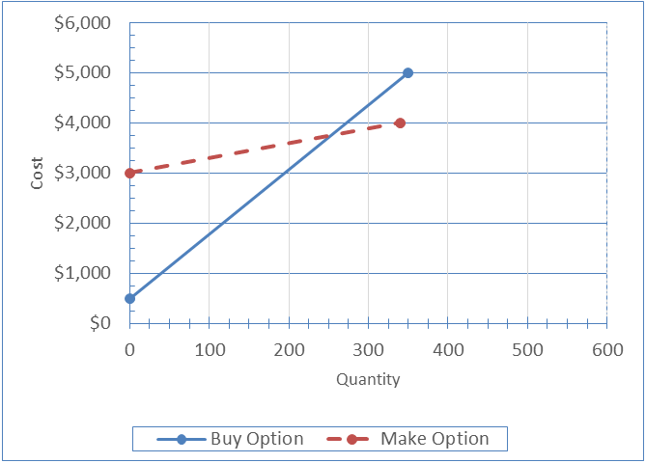

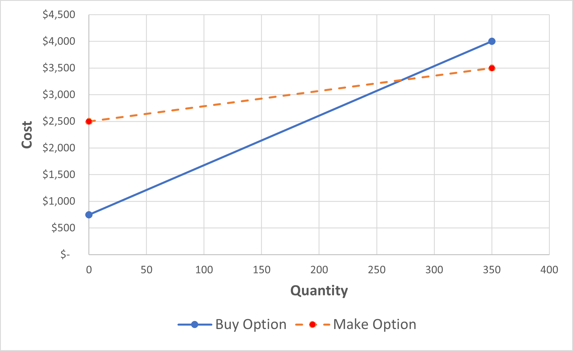
a. | What are the fixed costs for the buy decision?
b. | What is the breakeven quantity for the two options illustrated?
c. | At Q = 250, would you choose the make or buy option? Why?
d. | At Q = 300, what will be the total cost associated with the best decision at this quantity?
​
​

ANSWER: | a. What are the fixed costs for the buy decision?  $750  b. What is the breakeven quantity for the two options illustrated?  The Break-even quantity seems to be near 225 units. Using this chart, anything within 205 and 245 would probably be deemed acceptable.  c. At Q = 250, would you choose the make or buy option? Why?  The choice is close, but technically, the buy option is better since the total costs for buying are about $3100 versus about $3250 for making.  d. At Q = 300, what will be the total cost associated with the best decision at this quantity?  The best decision is to make, and the total cost is around $3400.

55. Global sourcing has become commonplace. Many companies now consider expanding their supply base to include foreign suppliers. List three reasons why companies choose to source globally.
ANSWER: | Lower price of materials (and services)  Overseas products may be of higher quality  Faster delivery times  Better array of services offered by the material supplier  Favorable exchange rates  Support local economies  Countertrade contracts  ​

Essay

56. The BOEHM Cell Phone Company has developed a new series of phones that it plans to bring to the market in the next 18 months. Management is considering whether to produce the product in-house or to contract out the purchasing and manufacturing of their new cell phones.
​
Provide FOUR conditions that would favor outsourcing and FOUR conditions that would favor making the cell phones in-house.
​
ANSWER: | Conditions that favor outsourcing:  a. If other firms are offering cost advantages.  b. If Boehm Cell Phone does not have sufficient capacity to meet the expected demand for the new line of cell phones.  c. Perhaps Boehm is largely a design company that does not have expertise in purchasing and manufacturing. An outside firm might be better qualified to deliver a high quality product at a lower price.  d. Outside companies may offer higher quality due to advantages in areas of skill, technology, and business processes.  Conditions that favor making the cell phones in-house:  a. If the technology associated with the new lines of phones is proprietary, it may be easier to maintain secrecy in both manufacturing and in first-to-market marketing.  b. Perhaps no one is capable of producing this product or a necessary component.  c. If the firm feels that its quality programs are superior to any potential business partner, they may prefer to do it themselves to preserve the integrity of the brand.  d. The company expects manufacturing capacity to be available once the product goes into production.  e. If the company prefers to have more control over distribution related activities.  f. If the company has the capability to produce the product at a lower cost if advantages in supply chain capabilities and/or economies of scale exist.

57. Under which conditions would you most likely utilize a centralized purchasing system? List two advantages that would be gained by utilizing a centralized purchasing system.
​
Under which conditions would you most likely utilize a decentralized purchasing system? List two advantages that would be gained by utilizing a decentralized purchasing system.
ANSWER: | Under which conditions would you most likely utilize a centralized purchasing system?  A centralized purchasing system would be favored by a company that is looking to reduce safety stocks, increase control in purchasing, centralize decision making, avoid duplicate purchases, centrally manage supplier relationships, and maximize available quantity discounts.  List two advantages that would be gained by utilizing a centralized purchasing system.  a. Concentration of purchasing leading to lower purchase costs  b. Avoiding duplication of job functions  c. Buyer specialization  d. Lower transportation costs  e. Easier to negotiate contracts and manage relationships with a common supplier base  f. No competition between units when purchasing the same material  Under which conditions would you most likely utilize a decentralized purchasing system?  A decentralized purchasing system would be favored by a company that is looking to make quicker decisions, maintain stocks that are closer to their customers, and identify and respond to changing customer needs at the local level.  List two advantages that would be gained by utilizing a decentralized purchasing system.  a. Individual and decentralized buyers often have a greater knowledge of the exact needs for each individual unit utilized by organization.  b. Decentralization is more conducive to local sourcing. Local sourcing offers an organization the opportunity to obtain faster delivery times, more frequent deliveries, while still maintaining very close supplier ties.  c. Decentralization allows quicker response because the decentralized purchasing allows for faster decisions because of decreased bureaucracy.

58. The term Supply Management is used to describe responsibilities above and beyond those of traditional purchasing. What are three of these key activities and why are they considered important to Supply Management?
ANSWER: | Other answers are possible.  a. Supply Management is responsible for the uninterrupted flow of raw materials.  b. Supply Management is responsible for the acquisition of materials at lowest total cost.  c. Supply Management is responsible for improving the quality of finished goods through the purchase of high-quality components and/or raw materials.  d. Modern supply chains require close partnerships with suppliers; Supply Management departments are very often responsible for maintaining those relationships.  e. Pushing suppliers to improve the quality of their raw materials and/or components.  f. Supply Management departments are often responsible for assisting in collapsing design-to-production cycle time.  g. Supply Management departments are often seen as a conduit between external suppliers and internal design and/or operations people.  ​

59. Use the following information to determine which supplier for steering wheels is more cost-effective using total cost analysis. Late delivery of the component results in 50% lost sales and 50% back orders of finished goods.
​
Table 1
Order lot size | 300
Annual Requirements | 3600 units
Weight per steering wheel | 20 pounds
Order processing cost | $125
Inventory carrying rate | 20% per year
Cost of working capital | 10% per year
Profit margin | 20%
Price of finished golf cart | $5000
Back order cost | $15 per unit
​
Table 2
Unit Price | Supplier A | Supplier B
1 to 999 units/order | $50 | $52
1000 to 2,999 units/order | $48 | $50
Tooling cost | $1000 | $1000
Terms | 2/10 net 30 | 1/10, net 30
Distance | 120 miles | 100 miles
Supplier Quality Rating (defects) | 3% | 2%
Supplier Delivery Rating (late) | 1% | 2%
​
Here are the freight rates for
Truckload (TL ≥ 40,000 lbs): $0.90 per ton-mile
Truckload Less-than-truckload (LTL): $1.10 per ton-mile
Note: per ton-mile = 2000 lbs. per mile; number of days per year = 365
ANSWER: | Total cost of ownership = Total steering wheel cost - Cash Discount + Tooling cost + Transportation cost + Ordering cost + Carrying Cost + Quality cost + Delivery rating (Back Order Cost and Lost Sales).  Supplier A  1. Total steering wheel cost = 3600 x 50 = $180,000  2.  -Cash Discount A = 180,000 x (10% x 30/365) = $1479  - Cash Discount B = 180,000 x (10% x 10/365 + 2%) = $4093 use this for biggest savings  3. Tooling cost = 1000  4. Transportation cost = (300 x 20) = 6000 so must use LTL shipment at $1.10 per ton-mile 120 x 3600 x 20 x 1.10/2000 = 4752  5. Ordering cost = (3600/300) x 125 = $1500  6. Carrying Cost = (300/2) x 50 x 20%= $1500  7. Quality cost = 230,400 x 3% = $6912  8. Delivery rating - Back order cost (50%) = 4800 x 1% x 50% x 15 = $360  Lost Sales (50%) = 4800 x 1% x 50% x 5000 x 20% = $24,000  Total cost of ownership = 180,000 - 4093 + 1000 + 4752 +1500 + 1920 + 6912 + 360 + 24,000 = $267,189  Supplier B  1.Total steering wheel cost = 3600 x 52 = $187,200  2.  - Cash Discount A = $187,200x (10% x 30/365) = $1539  - Cash Discount B = 187,200 x (10% x 10/365 + 2%) = $4257 use this for biggest savings  3. Tooling cost = 1000  4. Transportation cost = (300 x 20) = 6000 so must use LTL shipment at $1.10 per ton-mile 100 x 3600 x 20 x 1.10/2000) = 3960  5. Ordering cost = (3600/300) x 125 = $1500  6. Carrying Cost = (360/2) x 52 x 20%= $1872  7. Quality cost = 187,200 x 2% = $3744  8. Delivery rating - Back order cost (50%) = 3600 x 2% x 50% x 15 = $540  Lost Sales (50%) = 3600 x 2% x 50% x 5000 x 20% = $3600  Total cost of ownership = 187,200 - 4257 + 1000 + 3960 +1500 + 1872 + 3744 + 540 + 36,000 = $231,559  The total cost analysis shows that Supplier A is more cost-effective. Supplier A has a better unit price, cash discount rate, and better delivery performance rating.

